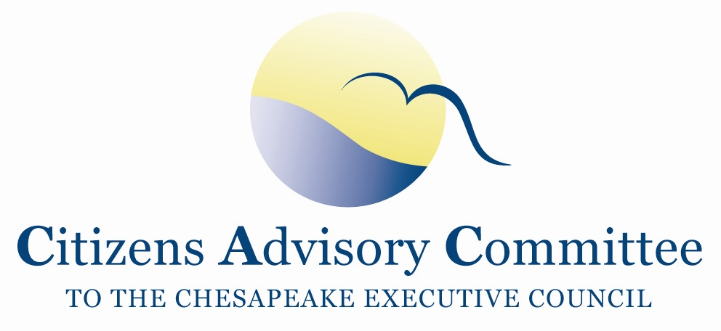
Citizens Advisory Committee
Meeting Agenda
November 29-30, 2017

______________________________________________________________________________________________________________________________________

National Arboretum
3501 New York Ave, NE
Washington, D.C. 20002

Meeting Theme: Urban Stormwater and Stakeholder Engagement

Meeting Goals: (1) Provide advice and feedback to DC on their local engagement plans for the Phase III WIPs.
(2) Discuss CAC positions on Midpoint Assessment decisions for the December PSC retreat. (3) Provide advice and feedback on the Chesapeake Bay Program’s Stewardship Index and plans for outreach.

Wednesday, November 29- Administration Building Classroom

11:00 a.m. Call to Order………………………………………………………….…..Paula Jasinski, Chair
- Introduction of Members and Guests
- Opening Remarks about the meeting theme and objectives

11:10 a.m. Welcome…………………………………………………………………….……..Richard Olsen
National Arboretum Director
11:15 a.m. District Department of Energy and Environment
Opening Remarks: Insights and Highlights…………………………………..…Tommy Wells
Director
DC’s Phase III WIP Local Engagement Strategy………………………….... Katherine Antos
Chief, Partnering and Environmental Conservation Branch
12:15 p.m. Lunch

1:00 p.m. DC Water
Opening Remarks: Insights and Highlights……………………....………..…...…Matt Brown
Chief Financial Officer
Pay for Success Model: DC’s Environmental Impact Bond………..…...….Maureen Holman
Sustainability Chief, Office of the General Manager

2:00 p.m. Federal Funding cut impacts on Susquehanna Basin ….....................................Adam Garber
Deputy Director, Penn Environment
A briefing on a report by Penn Environment as a follow-up from September CAC Meeting in PA

2:30 p.m. Onsite Visit of Stream Restoration……………………………………………..Bill Matuszeski
The tour will be of a recently-completed stream restoration of Springhouse Run, a stream that enters the Arboretum as a storm sewer and used to run down a concrete channel. It has been converted to a set of pools, riffles, rocks and waterfalls lined with newly planted native plants. Much of the water now filters underground where it cleanses itself. Fish and turtles are already appearing along the new stream.

3:30 p.m. Water Quality Nutrient Trading Basics and Examples………….………….Jenny McGarvey
Chesapeake Forests Program Manager, Alliance for the Chesapeake Bay
An introduction to non-point source nutrient trading as a tool for helping private landowners achieve their conservation goals, the basic practical details of generating nutrient credits, and some non-comprehensive observations about the current function of the nutrient trading program and demand for credits.

4:15 p.m. Business Meeting
- Approve September 2017 Meeting Minutes
- CAC Officer Elections
- Reflections and Debrief from the day’s meeting

5:00 p.m. Recess / Check-in at Capitol Hill Hotel

7:00 p.m. Reception and Dinner- Matuszeski House (approximate 10 min walk from Hotel)
Meet at the Hotel Lobby at 6:45p.m.

Methodist Building
100 Maryland Ave, NE
Washington, D.C. 20002
(Approximate 12 min walk from hotel)

Thursday, November 30- Conference Room #3
If you stayed overnight at the hotel…
Breakfast will be available at the hotel.
Check-out of your room before the meeting. You can leave your luggage at the front desk.
You can leave your car parked at the hotel.

8:45 a.m. Call to Order…………………………….…………………………….…..Paula Jasinski, Chair

Welcome………………………………………………………………………………... John Hill
General Board of Church and Society of the United Methodist Church
Director of Economic and Environmental Justice

9:00 a.m. Updates: Chesapeake Bay TMDL Midpoint Assessment………………. James Davis Martin
Virginia Department of Environmental Quality
Lucinda Power
EPA Chesapeake Bay Program Office
10:00 a.m. Break

10:15 a.m. Chesapeake Bay Program Stewardship Index…………..............Steve Raabe, Opinion Works

11:15 a.m. CAC Discussion, Final Thoughts and Action Items
- What are the findings and action items from the discussion?
- How can CAC engage on these topics after the meeting?
- Share ideas for February 2018 meeting in Maryland
  - Most Recent MD meeting locations: Feb ’17- Baltimore; Nov ’16 Cambridge;
Nov ’15 North Beach; Sept ’15 Havre de Grace
12:00 p.m. Adjourn

Next CAC Meeting is February 22-23, 2018 in Maryland.

