SAV Scenarios & Strawman Actions
Scenario 1: Homeowner initiated SAV restoration project.
Background: The homeowner is very environmentally-minded and has a large piece of property on Kirwans Landing Lane on Kent Island, MD. He has contacted DNR on several occasions to express interest in restoring SAV along his shoreline. Should this action be adopted and implemented, and if so, how can we help this homeowner take climate change into consideration when restoring sea grass?
Strawman Project: Implement SAV restoration, focusing on Ruppia maritima, along the shoreline of the property on Kirwans Landing Lane on Kent Island, MD. The primary method will be seeding of Ruppia. Associated habitat restoration could include removal of rip-rap and replacement with hybrid/natural shoreline.
Information and considerations:
1. Kirwan Creek is a small tributary off Eastern Bay, south of Kent Island.
2. The region in question is mesohaline.
3. Agriculture is the dominant land-use in the watershed.
4. Part of the peninsula on which the homeowner lives is armored with riprap.
5. He is considering removing the riprap and replacing with hybrid/natural shoreline
6. There is a large stand of invasive Phragmites on the property that he is actively controlling in hopes of eradication with aerially released herbicides.
7. SAV is naturally recovering in the Eastern Chesapeake Bay.
8. Multiple species may be recovering, but evidence for species other than Ruppia maritima is anecdotal and undocumented.
9. This project represents a partnering opportunity - the homeowner is willing to pay for the restoration (seeds, not manpower, though he and his friends will help) and has financed other restoration efforts.
10. Based on the property-owner’s description, there is suitable sediment and depth for active restoration efforts.
11. Stingrays are often seen in this vicinity – stingrays love to forage in SAV beds.
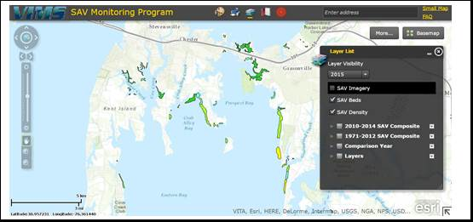

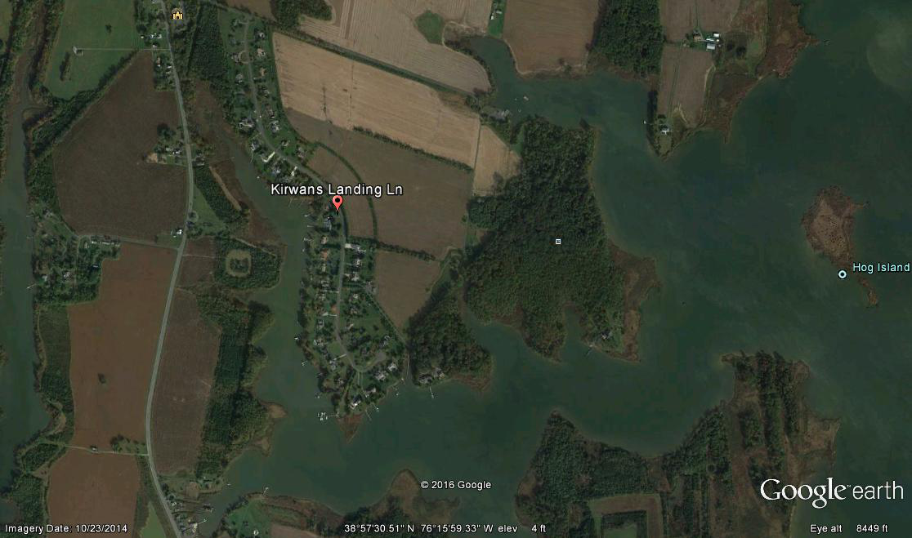
Scenario 2: Eelgrass restoration in Virginia Coastal Bays
Background: Zostera marina, or eelgrass, suffered a massive die off throughout the Chesapeake Bay region in the early to mid 1900’s. The plant was absent from the Virginia Coastal Bays from that time until VIMS began an active restoration program in the late 1990s. Millions of dollars and thousands of man-hours have been spent planting this SAV via seed and vegetative plantings. The effort has been successful and Zostera has spread throughout the bays in which restoration is active. This effort has been expensive and time-consuming. How can this venture continue successfully while accounting for climate change?
Strawman Project: Continue to restore SAV beds in the Virginia Coastal Bays. One way to incorporate climate change into this project is to but consider switching from seed and vegetative plantings of Zostera marina, a cold-water species, to Halodule wrightii, a sub-tropical species. Halodule wrightii has been observed in small but persistent populations in North Carolina.
Information and considerations
1. The region in question is polyhaline.
2. Zostera marina is the dominant plant in the polyhaline region.
3. Virginia is near the southern limit of the plant’s geographic range – it is a cold water plant.
4. Many species of native fish and invertebrates use Zostera as habitat and refuge.
5. Ruppia maritima co-occurs with eelgrass but is more ephemeral.
6. Sub-tropical species have never been seen in the Chesapeake or adjacent coastal bays.
7. Halodule wrightii, a sub-tropical species, has been observed in small but persistent populations in North Carolina.
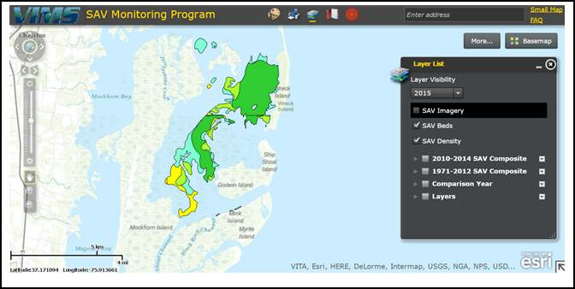

Scenario 3: Protection of the Susquehanna Flats SAV bed
In the mid- to late-1900s, poor water quality and heavy sedimentation during hurricanes reduced the historically lush SAV meadows in the Flats to near zero., In the early 2000s the SAV beds began a recovery that has exhibited impressive resiliency. In 2015, there were over 5500 acres of SAV in one contiguous bed, with a few thousand acres in smaller nearby beds also within the Flats. Because of the ecological significance of this bed, there is strong interest in setting it aside as an Estuarine Protected area with strict regulations on boating and fishing to reduce physical damage and preserve it for decades to come. How can this be done in a way that incorporates climate change?
Strawman Project: Designate an Estuarine Protected Area, selecting replicate areas of the existing Susquehanna Flats SAV beds, including sufficiently large contiguous areas to provide ecosystem services & benefits such as wildlife habitat and water quality improvement. Restrictions in this protected area will include regulations on boating and fishing to reduce physical damage.
Information and considerations:
1. The region in question is oligohaline.
2. There are at least 11 species of SAV in the Flats.
3. Coverage of SAV in this area was reduced by but withstood the effects of Hurricane Irene and Tropical Storm Lee in 2011 (increased wave energy, sedimentation, burial, turbidity).
4. The bed has been expanding outwards from the center since 2012 – recovering from those storms through both seeds and vegetative expansion.
5. The SAV beds in the Flats are prime fish habitat and thousands of fishermen flock to the area each summer.
6. Propeller scars are prevalent as the Flats are quite shallow.
7. There are navigation channels surrounding the Flats SAV bed for easy boating access.
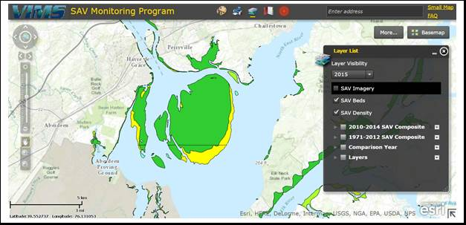
Scenario 4: SAV and conflicting uses of potential shallow water habitat
The shallow waters of the Chesapeake Bay and its tributaries are home to a number of SAV species, which function as habitat and a source of food for many recreationally and commercially important species. A number of potentially damaging fishery practices occur directly within and adjacent to SAV beds. In the mesohaline portion of Maryland’s tidal waters, SAV is afforded protection from a few fishery practices, including hydraulic clam dredging and shellfish aquaculture. Can the current regulations adequately protect SAV in the face of climate change effects?
Strawman Project: Designate SAV beds dominated by widgeon grass in the mesohaline portion of the Maryland Bay on the eastern shore, in the vicinity of the mouth of the Choptank and the Tred Avon Rivers, for implementation of protective fisheries regulations. Regulations should include, but need not be limited to, protections from hydraulic clam dredge use and oyster aquaculture. Determine whether the regulations are sufficiently protective based on degree of protection afforded the SAVs.
Information and considerations:
1. The area of conflicting use is the mid to lower mesohaline portion of Maryland’s Chesapeake Bay.
2. This area is dominated by widgeon grass.
3. Commercial clammers use a hydraulic clam dredge to harvest mostly soft shell clams (and some hard clams in lower portions).
4. Hydraulic dredges use jets of waters to stir up the bottom which can uproot SAV and cause turbidity.
5. Oyster aquaculture can either be on bottom (on shell, in cages) or in the water column (floats).
6. SAV impacts from aquaculture include direct burial, shading, and turbidity from harvesting.
7. SAV protection zones from clamming include some areas which have been vegetated for the last 3 years.
8. SAV protection zones from shellfish aquaculture include all areas where SAV has been present for the past 5 years.
9. SAV protection zones from clamming are updated every 3 years and delineated from the annual SAV aerial survey.
10. SAV protection zones from aquaculture are updated annually and delineated from the annual SAV aerial survey.
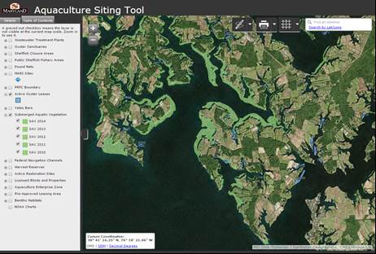

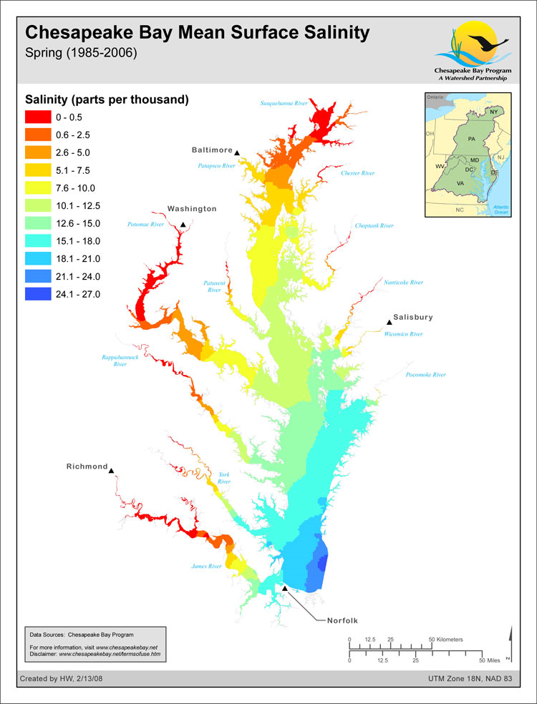
#1
#2
#3
#4
Map showing surface salinities of Chesapeake Bay, with the general locations of the 4 actions.

