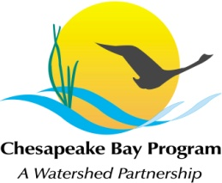
Stream Health Workgroup Meeting
Wednesday, April 5th, 2017
10:00AM- 12:00PM

Chesapeake Bay Program Office
Conference Room 305
410 Severn Ave, Annapolis, MD 21403

Conference Line: 866-299-3188 Code: 410-267-5731
Adobe Connect: https://epawebconferencing.acms.com/streamhealthworkgroup (Note: Enter as Guest)

10:00 Welcome (Rich Starr, FWS & Mike Lovegreen, USC)
- Review & Approval of October meeting minutes

10:10 Workplan Action Item Updates (Action Item Leads)
- Updates from action items identified in the October 2016 meeting

10:50 Stream Health Outcome Management Strategy Biennial Work Plan (Rich Starr)
- Management Board review scheduled for May 11 – ideas, suggestions, and/or concerns to be carried to the management board

11:45 Member Updates

11:55 Next Steps for the Workgroup

12:00 Adjourn

