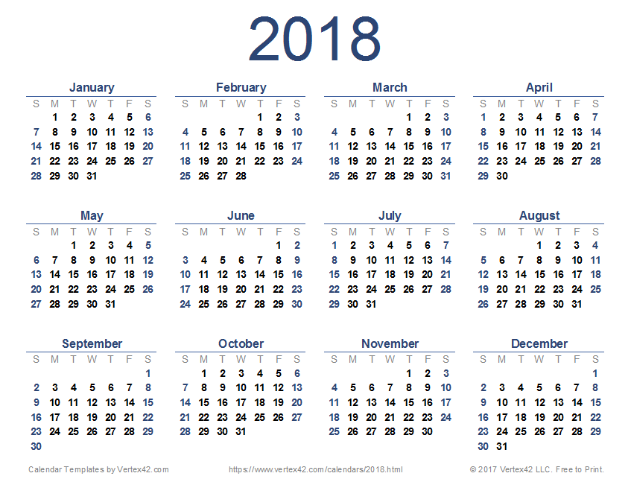

Monday, April 23, 2018 – 1pm-3pm – Conference Call
Monday, May 21, 2018 – 1pm-3pm – Conference Call
June Full GIT meeting – week of 11th?

