Quarterly Progress Meeting
To be prepared by an Outcome’s lead GIT in advance of its Quarterly Progress Meeting

Step 1: Summarize your outcome.

Outcome:
Continually increase urban tree canopy capacity to provide air quality, water quality and habitat benefits throughout the watershed. Expand urban tree canopy by 2,400 acres by 2025.

Lead and Supporting Goal Implementation Teams (GITs):
Water Quality GIT; Habitat and Stewardship GITs

Participating Partners:
- USDA Forest Service
- Delaware Forest Service
- Delaware Natural Resources and Environmental Control
- DC DOT Urban Forestry Division
- DC Department of Energy and Environment
- Maryland DNR Forest Service
- New York State Department of Environmental Conservation Division of Lands and Forests
- Pennsylvania Department of Conservation and Natural Resources Bureau of Forestry
- Virginia Department of Forestry
- West Virginia Department of Environmental Protection
- West Virginia Division of Forestry
- Cacapon Institute
- Alliance for the Chesapeake Bay
- Chesapeake Bay Commission
- National Park Service
- US Department of Defense
- US Environmental Protection Agency
- US Geological Survey

Progress:
Although we have had general partnership goals supporting urban tree canopy since 2003, the Chesapeake Bay Watershed Agreement (2014) was the first time we set a quantitative target for expanding tree canopy. Therefore, we are still in the early stages of having data and tracking tools to assess progress towards the outcome. In 2018, the Forestry Workgroup developed and approved a proposed methodology for the Tree Canopy Indicator to measure progress on this outcome. This Indicator proposal is currently making its way through Partnership approval (see materials). In short, it consists of two complementary measures – 1) annual BMP progress data submitted to NEIEN by jurisdictions for 3 BMPs: urban tree planting, urban forest planting, and urban forest buffers, and 2) community tree canopy as assessed through high resolution land cover data updates, approximately every 5 years.

Based on the 2013 land cover dataset and our Indicator methodology, the baseline for our Tree Canopy outline is as follows:

Jurisdictions | Total Tree Canopy (acres) | Forest in Urban Areas & Clusters (acres) | Tree Canopy + Urban Forest
Delaware | 6,320 | 3,414 | 9,734
District of Columbia | 8,073 | 4,477 | 12,550
Maryland | 317,076 | 331,308 | 648,384
New York | 50,840 | 22,058 | 72,898
Pennsylvania | 293,821 | 148,724 | 442,545
Virginia | 407,940 | 303,375 | 711,315
West Virginia | 46,069 | 15,481 | 61,549
Watershed | 1,130,139 | 828,837 | 1,958,976

Tree Canopy = Tree Canopy over Turf Grass and Tree Canopy over Impervious (both from Phase 6 land use)
Forest = Forest as defined in Phase 6 model land use, exclusive of tree canopy; filtered to only 2010 Census Urban Areas and Urban Clusters

We expect to have the first official progress update on this Outcome around May 2019, when the latest 2018 BMP progress and history have been approved by the partnership. The state forestry agency partners are working with their counterparts in NEIEN reporting to make sure these progress data will capture all currently available data on the urban tree BMPs. In the interim, for the purposes of the SRS review, we asked each state forestry agency to provide their best estimate of new acres of tree canopy planted since 2010 through state programs they are currently tracking, and these draft progress numbers are provided here, relative to the initial annual and 2025 targets set by the states when the Watershed Agreement was drafted:

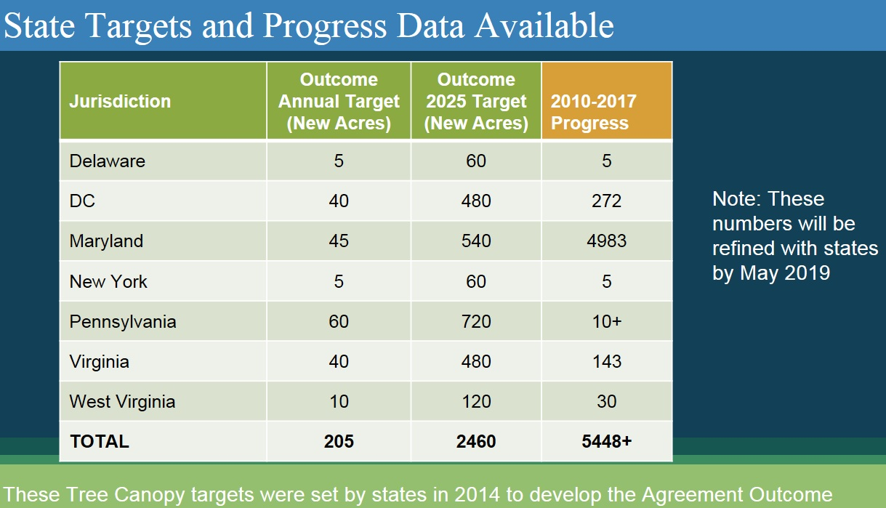

Step 2: Explain the logic behind your work toward an Outcome (see Logic Table).

Step 3: Craft a compelling narrative.

What are our assumptions?
- What original assumptions did we make in our Management Strategy that we felt were important to our success?
  - What “Factors Influencing Success” were originally identified in your Management Strategy?
- Funding/partnerships (1st highest influencing factor)
  - State Funding
  - Local Funding
  - Private/foundation/other funding
- Policies/ordinances (2nd highest influencing factor)
  - State policies/regulation
  - Local policies/ordinance
  - TMDL/stormwater program priorities
- Key drivers of canopy loss (3rd highest influencing factor)
  - Development, storms, pests/diseases, utility-related clearings, homeowner/property removals, natural mortality, poor maintenance and site condition moralities, and deer browse
- Knowledge/technical capacity (4th highest influencing factor)
  - Of local governments
  - Of nonprofit/volunteers/partner groups
  - Of private sector
- Community outreach and education (5th highest influencing factor)
  - State or CB-wide outreach campaigns
  - Locally driven outreach campaigns

  - What programmatic gaps that fail to address those factors did you originally identify in your Management Strategy?
- Assessment and Planning Gaps
  - Limited examples/data on communities using UTC data and goals to make progress on the ground
  - Less than a third of assessed localities have developed implementation plans
  - Green infrastructure plans are lacking in most counties to provide protections for the remaining natural resources
- Tree Canopy Protection Gaps
  - Lack of data on tree canopy loss and effectiveness/scope of local policies in place
  - Need to assess and strengthen as needed local and/or state policy tools available to protect canopy (e.g. in development/ stormwater related permitting)
  - TMDL framework credits tree planting but not protection of canopy
  - Health of the urban forest needs more attention, e.g. managing threats such as invasive species, impact of pollutants on trees (exhaust, salt), and climate change impacts
  - Need for more protective policies for riparian forest buffers in urban/suburban areas
- Tree Planting Gaps
  - Most local programs cite inadequate funding/staffing to achieve UTC goals
  - State funding programs generally not robust enough to meet local needs
  - Lack of data on local tree planting accomplishments and funding mechanisms
  - Most tree planting opportunity is on private land but there are few incentive programs to promote private planting
  - Tree planting has not been well integrated into TMDL/WIP/stormwater goals
  - Limited programs available to support riparian forest buffer plantings in non-agricultural areas
- Tree Survival/Maintenance Gaps
  - Lack of proper maintenance results in short life spans
  - Major lack of funding for tree maintenance/survival by local governments and nonprofit partners
  - Need to develop and use common standards/best practices for tree planting and maintenance to enhance survival
- Community Engagement/Outreach Gaps
  - Local government and community buy-in often cited as major challenge (and opportunity) for meeting UTC goals
  - Lack of robust, targeted outreach/ education resources and tools and mechanisms for assisting network of local practitioners
- Tracking Progress Gaps
  - Tree Planting – need to develop a tracking support system for tree planting that can capture state/local/NGO data; meets BMP verification/quality control standards; and feeds good data into the Chesapeake Bay Model/TMDL accounting
  - Tree Canopy – no Bay-wide high-resolution UTC dataset currently in place, but CB partners are currently pursuing it

  - What were the “Management Approaches” you chose to include in your Management Strategy and Two-Year Work Plan in order to address those gaps?
- Bolster Funding and Partnerships
- Strengthen Policy and Ordinance
- Increase Technical Capacity and Knowledge
- Expand Community Outreach and Education

Are we doing what we said we would do?
- Are you on track to achieve your Outcome by the identified date?
  - What is your target? What does this target represent (e.g., the achievement we believed could be made within a particular timeframe; the achievement we believed would be necessary for an Outcome’s intent to be satisfied; etc.)?
- Overall target of 2,400 acres of new urban/community tree canopy by 2025
  - DE – 5 acres annually; 60 acres by 2025
  - DC – 40 acres annually; 480 acres by 2025
  - MD – 45 acres annually; 540 acres by 2025
  - NY – 5 acres annually; 60 acres by 2025
  - PA – 60 acres annually; 720 acres by 2025
  - VA – 40 acres annually; 480 acres by 2025
  - WV – 10 acres annually; 120 acres by 2025

  - What is your anticipated deadline? What is your anticipated trajectory?
- 2025; 205 acres annually

  - What actual progress has been made thus far?
See Progress section above for more explanation

  - What could explain any existing gap(s) between your actual progress and anticipated trajectory?
- There are several factors which contribute to the gap between targets set and actual progress reported.
  - Some states do not yet have robust tracking systems for capturing local government, nonprofit and other partner tree planting activities beyond what is accomplished through state urban forestry grants
  - States set their original targets based on the old urban tree planting BMP credit which estimated that 1 acre of new canopy = 100 trees planted. The trees-to-acres conversion of the new credit defined through the Expert Panel process is 300 trees planted = 1 acre of canopy. Therefore, states in essence have to plant 3 times as many trees to reach the initial target they committed to.
  - For some states, the target set was a “stretch” goal and there have not yet been enhancements to funding, capacity, policy or local commitment to help attain the stretch goal yet; some states are in the process of refining their targets, based on more realistic and locally-engaged WIP planning, and this may prompt us to revisit the 2400-acre goal

- Which of your management actions have been the most critical to your progress thus far? Why? Indicate which influencing factors these actions were meant to manage.
- Factor: Funding/Partnerships
  - Action 1.1 State urban forestry grant programs and policies/regulations (where they exist) are our primary source of tree canopy progress at this time
  - Actions 1.2/1.3 – Tree Canopy Funding/Financing Guide Project by MD Environmental Finance Center/Alliance for the Chesapeake Bay/MWCOG will be completed by Dec. 2018 and will provide a platform for addressing funding challenges and opportunities across the region (NFWF-funded)
- Factor Policy/Ordinances
  - Action 2.2 – Completed actions to credit/incentivize urban tree canopy in the TMDL framework through incorporating tree canopy data layers/loading rates into the Bay Land Use Model and defining/approving urban tree planting and urban forest planting BMP credits
- Factor: Technical Capacity/Knowledge
  - Action 3.2 – Through high resolution land cover data project, tree canopy data are now available for the entire watershed and have been incorporated into the free online analysis tool i-Tree Landscape
- Factor: Education and Outreach
  - Action 4.2 – Established the Chesapeake Tree Canopy Network website and e-newsletter to provide a hub of technical and funding information, best practices, community case studies, etc. (www.chesapeaketrees.net)
  - Actions 4.1 and 4.4 – Tree Canopy, Environmental Justice & Community Engagement Project - led 2017 CB regional workshop, completing pilot community projects in Anacostia, will publish case study/resources in 2018 (USFS grant-funded)

- Which of your management actions will be the most critical to your progress in the future? Why? What barriers must be removed—and how, and by whom—to allow these actions to be taken? Indicate which influencing factors these actions will be meant to manage.
- Factor: Funding/Partnerships
  - Action 1.1 State urban forestry grant programs and policies/regulations (where they exist) will continue to be primary drivers of progress – sustained and/or enhanced investments will be needed to meet state targets
  - Actions 1.4, 1.5 – Need high-level support from federal, state, ngo’s and other funders to help leverage and “grow the pot” of resources and incentives that directly support local tree canopy expansion, using the Tree Canopy Funding Guide (1.2/1.3 above) as a starting point
- Factor Policy/Ordinances
  - Action 2.1 – Funding/partnership support is needed to provide a robust assessment and guidance on policy/ordinance enhancements needed to meet tree canopy goals
  - Action 2.3 – Work with stormwater program managers (federal/state/local) to better integrate tree canopy goals with TMDL/WIP implementation and MS4 programs
- Factor: Technical Capacity/Knowledge
  - Action 3.2 – Work with states to develop user-friendly tracking and verification systems for groups to report urban tree planting to the Chesapeake Bay model for BMP credit
- Factor: Education and Outreach
  - Actions 4.1 and 4.4 – Develop communication and outreach strategies targeted to areas of greatest need and opportunity…with a priority focus on a) underserved/vulnerable/EJ communities and b) schools; need enhanced collaboration with other CBP workgroups/outcomes (e.g. Diversity, Education, Citizen Stewardship)

Are our actions having the expected effect?
- What scientific, fiscal, or policy-related developments or lessons learned (if any) have changed your logic or assumptions (e.g., your recommended measure of progress; the factors you believe influence your ability to succeed; or the management actions you recommend taking) about your Outcome?

No changes to our basic logic as of yet, but we still are in information gathering and capacity building mode for a lot of issues and will not be able to truly gauge progress and change on the ground until the next land cover assessment. So far, the main learning has been that sustained and increased effort across the partnership will be needed to meet our collective target. Based on the data so far, the tree canopy planting and preservation spurred by Maryland’s Forest Conservation Act stand out. Is more focus on comparable legislation in other watershed states needed?

How should we adapt?
- What (if anything) would you recommend changing about your management approach at this time? Will these changes lead you to add, edit, or remove content in your Work Plan? Explain.

Most of our actions will be continuing in the new workplan, with some refinement as to specific tasks and timelines based on Management Board and stakeholder input. Our first work plan laid out a long-term, multi-faceted plan of many actions, which in hindsight was too much to take on in a 2-year period. Therefore, in our next workplan, we will hone in and focus our partnership energies on the actions that are highest priority for the Forestry Workgroup/Tree Canopy state leads and probably remove or postpone to the next workplan several of the lower priority actions.

The SRS Review process with the Forestry Workgroup was helpful in identifying some high-level priorities and actions that will be emphasized in our next Workplan, which are summarized below in Question #8.

- What opportunities exist to collaborate across GITs? Can we target conservation or restoration work to yield co-benefits that would address multiple factors or support multiple actions across Outcomes?

There are many opportunities to collaborate more with specific efforts that complement other GIT activities. Local Leadership – including collaboration with LGAC and the Local Government Engagement Initiative (LGEI) - is a prime area of need and opportunity, as we continue to try to build capacity, support and best practices for local funding and ordinances that support tree canopy. The Healthy Watersheds GIT’s Forest Retention project will provide insight for tree canopy preservation, and the project’s work related to crediting conservation is vital to tree canopy. We will continue to stay engaged in the Diversity Workgroup and coordinate our future tree canopy/Environmental Justice engagement efforts. There is much interest in collaborating with the Education Workgroup and related goals on tree canopy implementation and education efforts on school grounds. We would like to be integrated with the Citizen Stewardship metrics/efforts where appropriate and engage with cross-GIT social marketing approaches that could be used for tree canopy. And, in the future, we would like to engage with the Climate Change Workgroup to promote tree canopy as a mitigation strategy that is particularly helpful with addressing urban heat island and public health priorities.

- What is needed from the Management Board to continue or accelerate your progress? Multiple requests for action, support or assistance from the Management Board should be prioritized, where possible, and all requests should be “traceable” to the factors influencing progress toward your Outcome. Because a limited number of agencies and organizations are represented in the Management Board’s membership, we recommend naming those agencies and/or organizations that may play a key role in fulfilling your request for action, support, or assistance, in order to guide the Management Board in its work to contact, consult, or coordinate with partners.

The following priority actions will be our focal point in the next 2 Year Workplan, and specific Management Board “asks” to support these actions are noted below. We will use the discussion and feedback from the Management Board SRS review on November 15 to further refine these “asks” as needed.

- Build state and local capacity through new funding and policy strategies
- Use forthcoming Tree Canopy Financing Guide, Healthy Watershed Forest Retention Study, and proposed TC Communications and Outreach plan as a platform for new strategies and local capacity building
- Build demand through compelling messaging/outreach materials that highlight latest research on tree canopy co-benefits and new partnership opportunities
- MB Ask: Provide CBP Communications, LGAC, and cross-outcome support for integrated messaging and outreach campaign. Support action team on Tree Canopy Funding and Policy Strategies with high-level state and local representation; report recommendations to Executive Council

- Promote tree canopy more vigorously through state and local stormwater programs and WIP efforts
- Bolster tree canopy BMPs in WIP planning efforts
- Overcome barriers to tree protection and planting in urban stormwater programs
- MB Ask: Assure agency teamwork in integrating tree canopy goals in stormwater program delivery and WIP planning

- Increase local and partner engagement in tree canopy strategies and tracking progress
- Develop user-friendly BMP Tree Tracking tool to capture local/partner efforts not currently reported
- With the help of LGAC, identify and engage local partners in latest tools, data, and strategies through Chesapeake Tree Canopy Summit 2.0
- MB Ask: Help and encourage your local partners participate and identify funding for support.

