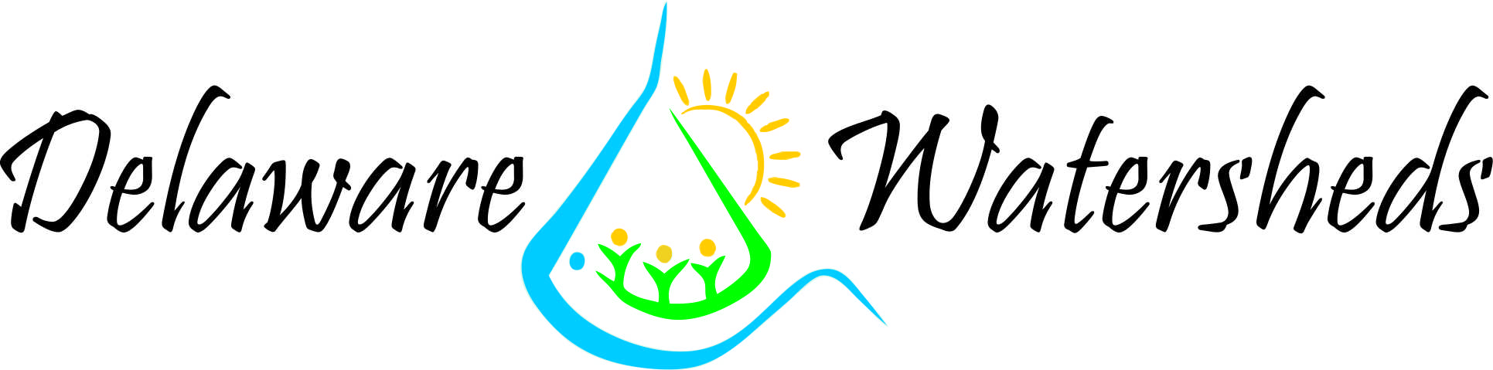
Chesapeake Bay
Phase III WIP Strategic Communications Plan

Mission: Create an informed, diverse community of citizens and local leaders with the knowledge and resources to achieve the goals of the Chesapeake Bay Watershed Implementation Plan.

Communications Subcommittee: This group will meet quarterly to implement the Phase III WIP Communications Plan. Establishing and using a calendar of outreach opportunities, the subcommittee will internally share information and resources for conducting outreach and communications; publicly share messaging of various local, state, and federal programs that support the goals of the WIP; strengthen partnership involvement in development of communications strategies and work plans by the subcommittee; and encourage other organizations and agencies with similar goals to join the subcommittee.

Communication Channels:

Websites  Social Media  Press  Handouts | Email  Events  Workshops  Presentations | Interviews  TV/Radio  Newsletter

Potential Partners:
- Nanticoke Watershed Alliance  - United States Department of Agriculture/ Natural Resources Conservation Service  - Delaware Nature Society/ Abbotts Mill Nature Center  - University of Delaware  - Delaware Department of Transportation  - Delaware Department of Agriculture  - Chesapeake Bay Program  - Nanticoke Watershed Conservancy  - New Castle Conservation District –Mike Harris  - Kent County Conservation District  - Sussex county conservation District  - The Nature Conservancy | - Delmarva Poultry Industry  - Delaware Department of Agriculture  - Trap Pond State Park  - Elected officials  - Town of Hartly  - Town of Farmington  - Town of Greenwood  - Town of Bridgeville  - City of Seaford  - Town of Blades  - Town of Bethel  - Town of Laurel  - Town of Delmar

Goal I: Citizen Stewardship -Increase the number of trained and mobilized citizen volunteers who have the knowledge and skills needed to enhance the health of their local watersheds.

Audience: General Public/ stakeholders

Messages:

- Human’s actions on land directly affect the quality of water in rivers, streams, ponds, lakes, and bays
- Definition of nutrient and sediment pollution
- Nutrient and sediment pollution causes poor health of waterways, wildlife, and humans
- There are ways everyone can reduce nutrient and sediment pollution
- Opportunities for learning about voluntary activities that support the WIP
- Resources for information on voluntary activities that support the WIP
    - Creating Rain Gardens
    - Planting buffers and trees
    - Installing pervious surfaces
    - Volunteering for stream cleanup or monitoring
    - Maintaining, upgrading or replacing septic systems
    - Reducing use of lawn chemicals and fertilizers
    - Using rain barrels
    - Reducing harmful chemicals down the drain
    - Cleaning up pet waste
    - Composting
    - Natives
    - Pollinators
- Value of voluntary activities –When quantitative, share #’s with local officials
- Funding available to support voluntary activities

Strategy:

- Websites
- Update websites with information providing support and guidance for citizens to learn how to achieve the goals of the WIP
- Update websites with information on programs that provide funding resources for projects that support the WIP
- Social Media
- Maintain a consistent social media presence
- Share partner’s messaging
- Hold social media campaigns to increase reach
- Outreach
- Participate/exhibit at public events
- Host workshops on practices that improve water quality
- Present information on the WIP to various groups and organizations
- Provide opportunities for citizens and leaders to connect with local waterways

- Press
- Issue media alerts and press releases
- Conduct interviews with local media
- Email
- Quarterly newsletter
- Deliver updates from CB Communications team to subcommittee and stakeholders
- Communications Materials
- Update existing materials
- Distribute to State Service Centers
- Distribute to Libraries
- Distribute at outreach events
- Contests
- Hold Delaware Watersheds Photo Contest
- Create New Face of Wet Waste Contest

Goal II: Diversity -Identify minority stakeholder groups not currently represented in the leadership, decision-making or implementation of current conservation and restoration activities. Create meaningful opportunities and programs to recruit and engage these groups.

Audience: Minorities and underserved communities

Messages:
- All information listed in Citizen Stewardship Messages
- Availability of meaningful opportunities and programs for underserved communities
- Spanish Fish Consumption Advisories
- Spanish Nonpoint Source pollution reduction materials

Strategy:
- Identify and work with underserved communities
- Develop Meaningful opportunities and Programs
- Submerged Aquatic Vegetation growings/plantings
- Tree plantings
- Use Diversity sign in sheets at workshops to track progress
- Distribute Spanish communications materials
- Post Spanish materials on websites
- Distribute Spanish materials to State Service Centers
- Distribute Spanish materials to Libraries
- All information listed in Citizen Stewardship Strategy

Goal III: Local Leadership -Continually increase the knowledge and capacity of local officials on issues related to water resources and in the implementation of economic and policy incentives that will support local conservation actions.

Audience: Local officials and leaders

Messages:
- Opportunities for learning about WIP
- Current data on status of water quality
- The reasons for improved management of activities that impact water quality
- The value of improved water quality for Delawareans
  - Healthy watersheds are good for the economy
  - Healthy watersheds provide quality of life
  - Healthy watersheds improve public health
- The WIP goals and the necessary activities, regulations and policies to accomplish those goals
- The opportunities for public involvement
- Local governments should be actively involved in Phase III WIPs so they can tie-in their own local priorities and constraints
- Local governments can take credit for practices and programs they are already doing
- The Bay Model has improved, reflecting more refined local land use data
- Tools are available to help implementation planning and decision-making processes for BMP funding, targeting, and implementation
- What funding is available to publics and entities for stakeholders affected by regulations and/or policies that are part of the WIP
- Resources for obtaining information related to the WIP
- Results of the WIP

Strategy:

- Local Government mailers on what Local Governments need to know about the WIP
- Work with Local Engagement Action Team & Local Government Advisory committee
- Meet one-on-one with Local Government officials
- Plan Local Government Engagement workshop
- Websites
  - Update websites with information providing support and guidance for local leaders to learn how to achieve the goals of the WIP
  - Update websites with information on programs that provide funding resources for projects that support the WIP

Implementation Timeline

