April 13, 2018

Dear [Recipient]:

On behalf of Governor Hogan’s Chesapeake Bay Cabinet, I am writing to update you about a major initiative to support local clean water, a healthy Chesapeake Bay and to reiterate our commitment to working with local jurisdictions to achieve our goals. As you know, between now and June 2019, Maryland and the other Bay states will develop Phase III Watershed Implementation Plans (WIPs) to restore Chesapeake Bay. These plans, required by the federal Clean Water Act, will chart a course for achieving each state’s share of the Bay cleanup goal by 2025.

Local goals and intergovernmental collaboration are central to Maryland’s WIP process. In the Phase II WIP, counties and conservation districts submitted detailed plans to the Maryland Department of the Environment (MDE) and the Maryland Department of Agriculture (MDA). Since then Bay Cabinet agencies have been working with you on stormwater and wastewater permit commitments, agriculture plans, forest conservation, and other local planning efforts to achieve our restoration goals. In Phase III we plan to build on this foundation and identify other strategies and commitments to get to 2025. Working together with you, we will set realistic, achievable goals, both statewide and locally.

Currently, we are reviewing draft pollution planning targets assigned to Maryland in December 2017. We then plan to use improved modeling tools to evaluate attainment of our 2025 pollution goals and work with you on updating local plans and identifying local priorities, as necessary, to fill remaining gaps. This information will be compiled in a draft Phase III WIP that is planned for public review in March 2019.

We invite you and your staff to regional stakeholder meetings scheduled for May and June 2018, where you can learn more about the Phase III WIP and provide feedback to better shape this plan. For dates, locations, and registration information, please visit http://mde.maryland.gov/programs/
Water/TMDL/TMDLImplementation/Pages/WIP-3-Vision.aspx. This will be followed by summer technical webinars on related topics of local interest, a planned state/local panel discussion at the MACo Summer Conference, and follow-up fall regional meetings. The Governor’s Bay Cabinet looks forward to continued discussions and collaboration with you and other local leaders about the connection between clean water and a healthy economy. We are also happy to meet with you and your team upon request to discuss Bay restoration.

Thank you for your partnership, progress and continued support of Maryland’s clean water goals. Your local jurisdiction’s efforts are critical to Bay restoration success. For questions please contact Lee Currey, Coordinator for the Chesapeake Bay Cabinet, at 410-537-3818.

Sincerely,
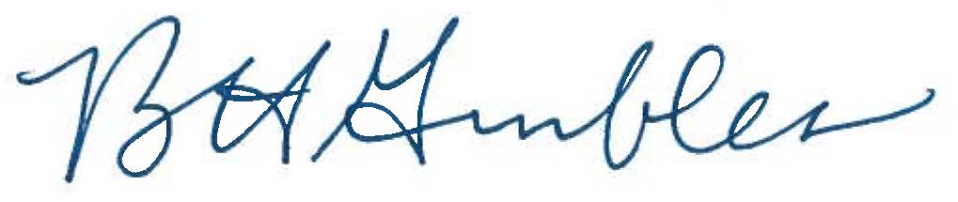

Ben Grumbles
Secretary

cc: Governor Larry Hogan
Joseph Bartenfelder, Secretary of Agriculture
Mark J. Belton, Secretary of Natural Resources
Wendi W. Peters, Special Secretary of Smart Growth
Rob McCord, Acting Secretary of Planning
Pete Rahn, Secretary of Transportation

