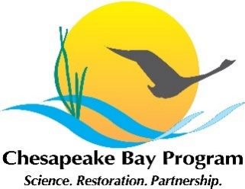
Wetland Workgroup Revitalization Meeting
US Fish and Wildlife Service Chesapeake Bay Field Office
Conference Room
Conference Line: (929) 205-6099
Conference Code: 480 759 439
https://zoom.us/j/480759439
Purposes:
1) Assess Wetland Workgroup structure and membership.
2) Identify priority actions to focus on in 2019-2020 workplan.
10:30 am Welcome and Introductions (Christine Conn, HGIT Chair)

10:35 am Overview and Background (Jennifer Greiner/Carin Bisland)
- Workgroup history, evolution, and current status

10:50 am Status: Data and Indicator (Laura Drescher / Jeff Sweeny)
- Review of reporting progress toward the wetland indicator

11:05 am Workgroup member survey - Results and Perspectives (Margot Cumming)
- Open discussion of what has worked / not worked in recent past
- Which functions provide value-added for members and organizations?

11:20 am Identify path forward for this workgroup (Christine, everyone)
- Brainstorm options for operations and how best to proceed
11:50 am Next Steps (Jennifer, Margot, Carin)
- Meeting schedule (when / where/ how often?)
- Awareness of SRS Timeline
- Priority setting (homework and focus for next meeting)
- Reporting back to/requests of Management Board

12:00 pm Adjourn

