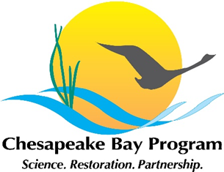
Fish Passage Workgroup Outcome Discussion
10:00-11:00am, Wednesday, September 4, 2019
Conference Room 303, 410 Severn Avenue, Annapolis, MD 21401
Webinar*: https://zoom.us/j/699188061
Conference Line : +1 929 205 6099 Meeting ID: 699 188 061
Meeting Materials: https://www.chesapeakebay.net/what/event/fish_passage_workgroup_outcome_discussion
* If you are joining by webinar, please open the webinar first, then dial in.
AGENDA

10:00 | Introductions and review of agenda
10:05 | Overview of Fish Passage Workgroup – Mary Andrews (NOAA)  Mary will discuss how does the Fish passage workgroup and NOAA’s CRP fit together and the distinctions between the two programs. The focus will be on differentiating the goals of the Fish Passage Workgroup and the goals of the nationwide agency.
10:20 | Monitoring for fish return after fish passage projects -Mary Andrews (NOAA)  Mary Andrews will discuss the difference between Tier I and Tier II monitoring. We will discuss which is most applicable for the fish passage outcome
10:35 | Opportunities to increase USGS Fish Passage Support – Scott Phillips (USGS) and Tom O’Conell (USGS)  Scott and Tom will discuss the USGS new science plan and the opportunities it presents to increase support of the fish passage work group at the Chesapeake Bay Program. They will discuss the groups’ management strategy and Workplan as well as the NOAA Fish Passage Program review.
10:50 | Final Decisions and Next Steps

