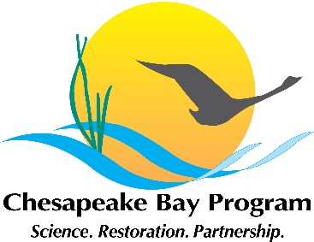
Stream Health Workgroup Meeting
October 16, 2020, 10:00-12:00
Join Microsoft Teams Meeting
+1 202-991-0477 Conference ID: 278 829 084#

10:00 | Introductions and Announcements – Co-Chairs Neely Law (Fairfax County) and Alison Santoro (MD DNR), Vice-chair Sara Weglein (MD DNR)  Points of Discussion  - Funding of proposed GIT funding project  - BMP impact on stressors publication  - Habitat GIT fall meeting on November 16 and 17, 2020
10:10 | Latent health factor index (LHFI): statistical model-based inference for stream health– Dr. Grace Chiu (VIMS)
10:40 | Linking altered flow regimes to stream biological condition in the Chesapeake Bay watershed- Kelly Maloney (USGS)
11:10 | Advancing multiple Stream Health Metrics – Neely Law (Fairfax County), Alison Santoro (MD DNR), Sara Weglein (MD DNR)  Points of Discussion  - Responses to pre-meeting survey of desired metrics  - What are priority metrics for the Stream Health WG and how do they relate to the stream’s functional processes?  - What scale would be most useful for a metric to describe stream health? (Bay-wide, HUC 10/12, ecoregion)  - Are we interested in modeled metrics or monitoring metrics? Combination of both?  Points of Decision  - Workgroup agreement to develop stream health metrics as a priority in 2021 workplan  - Development of a draft matrix
11:50 | Member updates and wrap-up
12:00 | Adjourn

