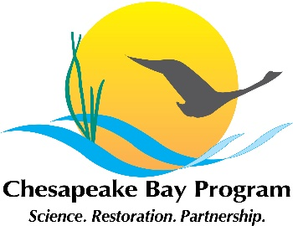
Brook Trout Workgroup meeting
Monday, September 28, 3:00pm-5:00pm
Microsoft Teams Meeting (click to join)
+1 202-991-0477 , Conference ID: 826 270 948#
https://www.chesapeakebay.net/what/event/brook_trout_workgroup_meeting

Time | Topic | Points of discussion and decision
3:00 pm | Introductions and announcements – Steve Faulkner (USGS)
3:05pm | Developing a conservation and restoration tracking system – Steve Faulkner (USGS) | - What is the best approach to document the conservation and restoration activities of the workgroup?  - What metrics/data should this tool track/collect?  - What groups/POCs are potential data sources?
3:35 pm | Brook Trout Genetics STAC workshop -Steve Faulkner | - What are specific things that the workgroup would like to see?
3:50 pm | Improving temperature predictions for karst streams in the Chesapeake Bay watershed – Than Hitt (USGS) | - Overview of new project related to climate change Action 2.1
4:00 pm | Update 2020-2021 workplan – Julianna Greenberg (CRC) | - Update Actions
4:20 pm | Better alignment of BTWG Action Plan with the member activities and needs– Steve Faulkner (USGS), Julianna Greenberg (CRC) | - How can the workgroup better align its activities with the needs of the members?  - What current activities are not being captured?  - What added value can the BTWG bring to your work
4:45pm | Other new items | - Updates from members
5:00pm | Adjourn

