Discussion Paper: Enhancing Monitoring to Address the CBP Toxic Contaminant Outcomes
Updated Nov 9, 2021
Purpose: The Chesapeake Bay Program Principal Staff Committee (PSC) requested information to enhance the Chesapeake Bay Program (CBP) monitoring networks. While the request is focused on the existing CBP networks, information is being included on monitoring needs of selected outcomes in the Chesapeake Watershed Agreement.
This paper summarizes potential enhanced monitoring to address the Toxic Contaminant Outcomes in the Chesapeake Watershed Agreement. The goal and outcomes were developed because of the widespread occurrence of toxic contaminants in the Bay and its watershed (EPA, 2012). In tidal waters the impairments from toxic contaminants increased between 2010 and 2016 (Fig. 1).
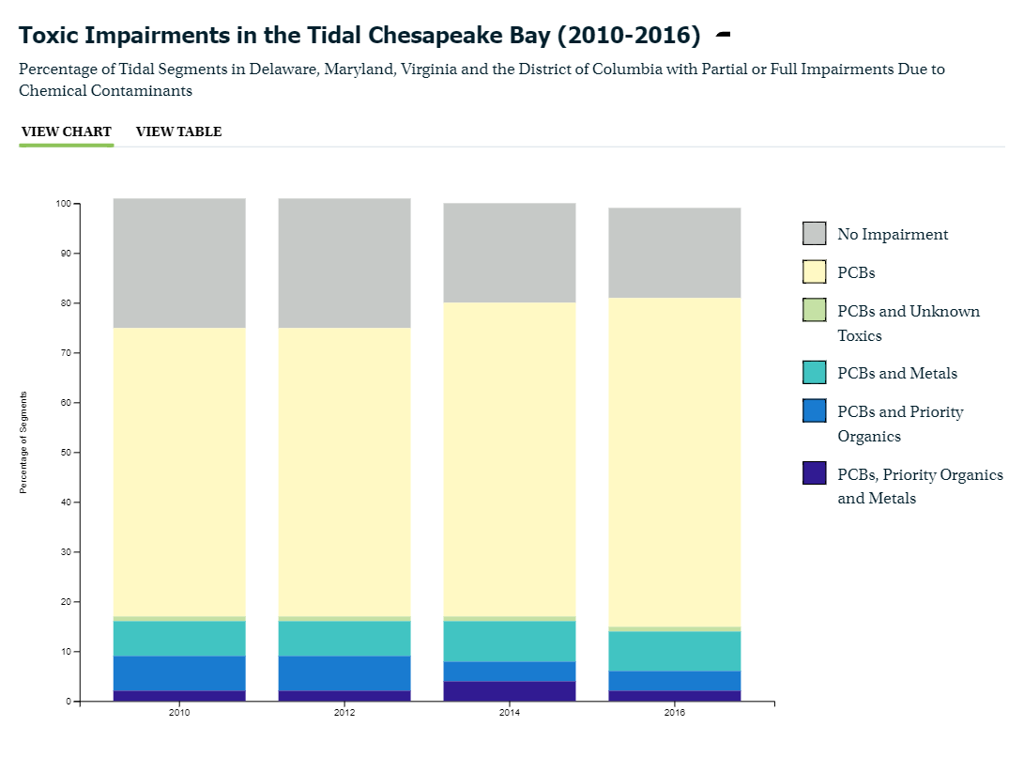
Figure 1 (from Chesapeake Progress) Toxic Impairments in the Tidal Chesapeake Bay (2010-2016) (PCBs, polychlorinated biphenyls)

Organization of the Discussion Paper
The Toxic Contaminant Workgroup (TCW) developed this paper based on the information requested by the CBP Science and Technical Assessment and Reporting (STAR) team, which included:
- Need for enhanced monitoring: how would the monitoring address CBP goals and outcomes. (explained further in section 1)
- Objectives of enhanced monitoring: The outcomes would be used to define monitoring objectives and priorities. (explained further in section 2)
- Existing monitoring: Assess monitoring that can be utilized to address the objectives and design considerations. (explained further in section 3)
- Remaining gaps: identify gaps that cannot be filled with existing monitoring. (explained further in section 4)
- Monitoring design considerations and options: These are general considerations for enhanced monitoring, not the design of a monitoring network, which would be a follow-up action if more funding became available. Identify options to address the gaps and recommend which may be most realistic. An estimate of funding needed to address the recommendations would be useful. (explained further in section 5)

The TCW undertook the effort during the summer and fall of 2021 and used these guiding principles for the discussions:
- A monitoring network for a wide range of contaminants would be extremely difficult and costly, so we need to prioritize the contaminant(s) to be addressed. For example, PCBs and mercury are listed in our outcomes so they could be a high priority.
- The monitoring objectives need to be specific to help focus the design considerations including the types of monitoring for different media.
- We need to take advantage of ongoing monitoring as a foundation for a network.

Section 1: Need for Enhanced Monitoring
The TCW reviewed the two toxic contaminant outcomes in the Chesapeake Bay Agreement to identify items related to monitoring. The outcomes are:
Policy and Prevention Outcome:
“Continually improve practices and controls that reduce and prevent the effects of toxic contaminants below levels that harm aquatic systems and humans. Build on existing programs to reduce the amount and effects of PCBs in the Bay and watershed. Use research findings to evaluate the implementation of additional policies, programs and practices for other contaminants that need to be further reduced or eliminated”.

Research Outcome:
“Continually increase our understanding of the impacts and mitigation options for toxic contaminants. Develop a research agenda and further characterize the occurrence, concentrations, sources and effects of mercury, PCBs and other contaminants of emerging and widespread concern. In addition, identify which best management practices might provide multiple benefits of reducing nutrient and sediment pollution as well as toxic contaminants in waterways”

The TCW identified four monitoring needs associated with the two outcomes:
- Changes to PCBs levels as total maximum daily loads (TMDLs) and associated management actions are implemented.
- Changes to mercury as TMDLs and associated management actions are implemented.
- Assessing contaminants of widespread concern (such as pesticides).
- Assessing contaminants of emerging concern (such as per and polyfluoroalkyl substances [PFAS] and microplastics).
These four needs were prioritized by the TCW as follows, presented in priority order:
- PCBs and emerging contaminants (specifically, PFAS and microplastics)
- Contaminants of widespread concern (specifically, pesticides)
- Mercury

Section 2: Monitoring Objectives
The TCW developed an initial objective for each monitoring need:
- Enhance PCB monitoring to establish current conditions and determine if remediation or management actions are resulting in downstream reductions of PCBs.
- Determine occurrence or status of PFAS and microplastics in surface waters of the major tributaries of the Chesapeake Bay with varied land use to establish a baseline to track concentration and loading changes through time using consistent methods and analyses.
- Determine if implementation of BMPs and conservation practices over time results in declines in pesticide concentrations using a prioritized/standardized list of pesticides, and consistent sampling and analytical methods.
- Determine if reductions in air deposition of mercury reflected in fish tissue declines, specifically focused on food/recreational fish trends in urban and non-urban areas.
The TCW decided to focus efforts on the first objective for PCBs since it was one of highest priority needs. The other high priority need for emerging contaminants is being addressed through other efforts including (1) a CBP plastic pollution action team (monitoring for microplastics), and (2) an upcoming STAC workshop with a focus on PFAS monitoring.
The PCB objective was expanded to have multi-pronged approach with several inter-related components (Figure 2): “Enhance PCB monitoring to (1) establish current baseline conditions and identify impairments, (2) help refine previously identified sources, (3) determine PCB response to mitigation efforts and (4) assess fish conditions in relation to consumption thresholds.
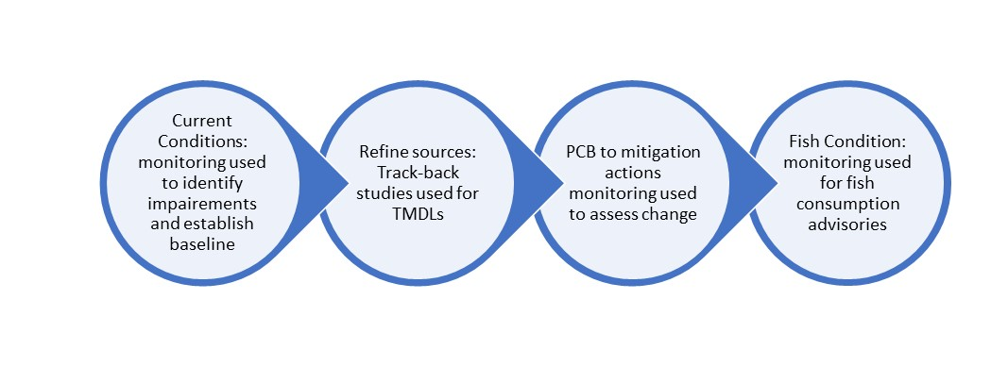
Figure 2: Components of the PCB monitoring objective.

Section 3: Existing Monitoring that Support the Objective and Remaining Gaps
A data inventory for PCBs was conducted by USGS and additional information was requested from each jurisdiction and federal partners related to the components of the monitoring objective. Some of the findings are summarized below and are presented in accordance with Figure 2 topics (shown in underlined italics in the paragraphs below).
Assess current conditions: Fish Tissue monitoring is done by all the jurisictions to assess current conditions and to track progress for fish consumption advisories. Sampling is usually done on a rotational basis to cover an entire jurisdctions every several years. These results are used to establish baseline conditions and identify impaired waters in each state (Figure 3a), that is updated every two years, and development of local TMDLs to address the impairments (Figure 3b). In selected places with impairments, additional sampling is often conducted to help develop and implement a local TMDL.
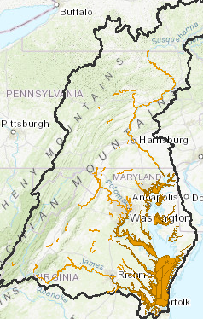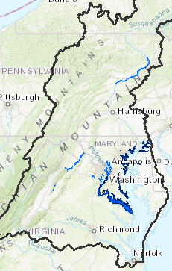
Figure 3a (left panel)—impaired waters based on PCBs, 3b (right panel)—TMDLs developed as of 2017.
Refining known and identifying unknown sources: If a PCB TMDL is developed to address an impairment, “track-back studies” are often employed to refine the driving sources (or identify unknown sources) of PCBs in a watershed and better focus mitigation efforts. The number of current track-back studies vary by jurisdiction. For example, MD has a strong focus on track-back studies in selected places where TMDLs have been approved and DC is conducting source studies in the Anacostia watershed. VA currently has a significant focus on TMDL development and has in some instances (such as the Potomac TMDL) identified loads associated with unknown sources that necessitate track-back studies, but these are just getting underway. No additional monitoring for PCBSs is planned at this time in PA.
PCB respone to migitation actions. In general, there is very limited monitoring for this component of the monitoring objective, particularly at a scale of interest to the CBP (i.e., broader than a single contaminated site). The primary reason is there are limited management actions being implemented for PCB at this time across the watershed.
Some additional considerations discussed by the TCW in reference to this portion of the monitoring objective (PCB response to mitigation actions) included:
(1) a regional approach to detecting changes in PCBs is not practical for the entire Bay watershed.
(2) a more geographically-targeted approach that focuses on places where actions are being or plan to be implemented to address a local TMDL (including gray infrastructure improvements), where remediation has occurred, or a combination of these efforts would be more practical.
Fish conditions: Monitoring of PCBs in fish is usually done across a state through rotational sampling as part of their impaired waters identification and fish consumption advisories. Each jurisdiction uses a PCB threshold level (which varies between jurisdictions) to issue fish consumption advisories. In addition, TMDLs are based on the fish condition in the estuary, with sediment and surface water targets based on the bioaccumulation modeling and criteria to meet the fishing designated use for the waterway. While the criteria may differ between states, all approved TMDLs in the Chesapeake Bay watershed are based on the fishing designation in the tidal estuary.

Section 4: Remaining Gaps to Address the Objective
With the current monitoring programs focused on assessing impaired waters and condition of fish, the primary remaining gap is addressing PCBs response to mitigation efforts.
A synthesis of feedback from TCW contributing to the formation of gaps:
- Jurisdictions and federal agencies reported limited monitoring that directly assess changes in PCBs due to mitigation actions outside of the site scale. Aside from limited assessments in DE and by District of Columbia Department of Energy and Environment (DOEE) in Anacostia, there are gaps to assess PCB reductions from mitigation actions in places where TMDLs have been established or are planned.
- The PCB data for fish are more robust than surface water in terms of record and frequency of collection. A focus on fish data and sampling would provide more opportunities for leveraging existing monitoring efforts and in some cases a comparison to historical data, but may take longer to detect.
- Some of the states (DE and D.C.) are using EPA method 1668A for their fish analysis, which provides an ability to produce more detailed PCB “fingerprints” and low detection limits for PCBs and could be very helpful for assessing response. PA did not specify an analytical method. MD and VA use a modified EPA method 8082, which provides similar detection limits to method 1668A and quantifies about 140 of the 209 critical congeners. Historical data with differing methods are not comparable to other jurisdictions.
- Methods to collect and analyze surface water samples vary among jurisdictions and federal agencies (including both EPA methods 1668A and modified 8082). Types of field sample collection include both grab samples and use of passive polyethylene samplers. The lab methods and their detection limits are not consistent and would require the establishment of a collective baseline event(s).
- The sampling locations near local TMDLs are limited both in number and frequency that samples are collected. The number of monitoring stations are lacking in many places to detect a PCB response to mitigation efforts. Many non-tidal sites lack streamflow gages for calculation of PCB loads. Temporal and spatial variability in surface water is high and would require a considerable quantity of samples to establish a representative condition in surface water.
- Limited numbers of samples in sediment and other media (e.g., shellfish) exist in more spatially limited locations of the watershed.

Section 5: Monitoring Design Considerations and Options
The TCW brainstormed various approaches and their advantages and disadvantages to fill the primary gap described in Section 4. These approaches included targeted head of tide sampling in surface water (similar to the proposed sampling program described by Delaware Natural Resources Environmental Control) ) to inform either ambient contaminant concentrations or loads (with corresponding co-located flow information), or targeted fish concentrations (of species to be determined) or a hybrid approach including various media. Each approach has distinct advantages and disadvantages that may differ between geographic areas depending on the conditions downstream (tidal, non-tidal, known flow rates, etc.), the desired observable response, or desired timeframe for response.
The TCW endorsed an overall approach for enhanced monitoring to help jurisdictions assess the PCB response to mitigation actions in selected geographic areas. If endorsed by the PSC, enhanced monitoring site selection would occur through the TCW according to steps in Figure 4. The primary recommendations for this monitoring design are bolded and summarized below.
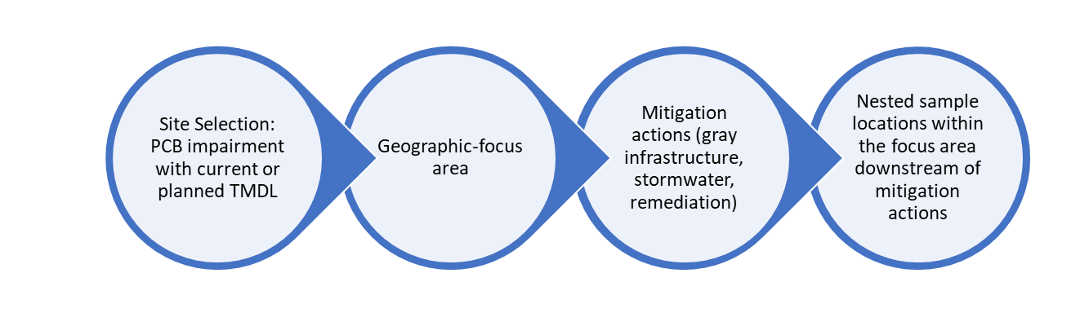
Figure 4. Components of Sampling Site Selection

Recommendation 1: Focus monitoring in geographic areas to help the jurisdictions assess PCB response where mitigation actions are being implemented and or planned
With enhanced monitoring, the CBP can tailor data collecting in geographically-focused areas to help the jurisdictions assess PCB response in places where mitigation actions are being implemented and are ongoing. Due to the variability discussed above, jurisdictions suggested providing some flexibility in the geographically-focused areas to allow for the consideration of variable ongoing or historical monitoring and specific activities in their respective locations. In general, the conceptual design would build from existing monitoring to add sites to detect PCB response (Figure 4).
Recommendation 2: Geographic focus areas should be in places with PCB reductions can be detected. Geographic focus areas should be in major river basins of the Chesapeake Bay, with PCB impairments and existing or planned TMDLs, and centered in areas with enough action/mitigation for collective, predicted reductions of greater than 25% (or a more appropriate reduction later specified) in concentration and/or loading.
Monitoring of these locations will fill the gaps associated with addressing PCBs response to mitigation efforts and help to answer the following questions:
- At what spatial scale can a response (PCB decline) be observed downstream of actions?
- At what timescale can a response (PCB decline) be observed downstream of actions?
- Are there observable differences in the mitigation actions taken and the resulting PCB response?
An adequate sample location would:
- Be downstream of mitigation actions but in close enough proximity to detect PCB changes resulting from collective actions. Visual observations of decline (similar to the indicator representation) would require less locations compared to a design for assessment of statistical decline. Less frequent monitoring (of fish for example) may allow for a higher number of individual samples to be collected and analyzed.
- Each geographic area will be individually assessed for appropriate media to be sampled, with a similar approach across media for different areas depending on conditions present in each area.
- Be sampled at a frequency often enough to detect a change over time, after establishment of a baseline sampling event. Options include:
  - Sampling fish (or shellfish) every 1-2 years. Consideration should be given to young of the year collection at this time interval. For larger game fish, longer times may be required to observe a change (lesser frequency may be adequate).
  - Time-integrated surface-water samples every quarter to estimate annual variability for a specified timeframe, then possibly less frequent (biannual at times of highest noted variability). If variability in flow conditions (e.g., storm events) was to be considered, baseline costs would need to be updated. Current cost estimates assume passive sampling of the water column.
  - At this time, bulk sediment sampling as a stand-alone media is not being considered due to the inability to assess bioavailability of mass detected. Other considerations for sediment assessment include passive sampling of sediment porewater, which can assess bioavailability and inform sediment concentrations and passive sediment traps in non-tidal environments. (Current cost estimates do not include these alternate sediment considerations, are but noted here for consideration).
- Be focused on sampling fish or shellfish (as indicator) or surface water and the uniformity of field and analytical methods for low-level detection of PCBs.
- Be opportunistic with ongoing monitoring efforts to supplement jurisdiction efforts and capitalize on mobilizations to the areas/locations. This may require consideration of the sampling frequency.
Recommendation 3: Initiate monitoring in a single geographic-focus area as a pilot test Since there are many unknowns related to this monitoring, including reduction required to detect a response, timeframe to detect a response, proximity to collection actions to detect a response in surface water, fish, or other designated media, we propose initiating monitoring in a single geographic-focus area as a pilot test. Lessons learned from this pilot test could be translated to other geographic focus area.
Possible options for geographic-focus areas were identified by the TCW and reflect efforts to implement TMDLs and clean-up activities and WWTP upgrades (listed below). One consideration could be to align with the EPA-designated Urban Waters Federal Partnership locations in the watershed, including Patapsco and Anacostia.
Jurisdiction | Geographic-focus Areas
DC | Anacostia
MD | Tidal Patapsco River (Baltimore Harbor/Curtis Bay/Middle Branch), Anacostia tributaries (eg, Lower Beaverdam Creek)
VA | Potomac tributaries at head of tide
DE | Nanticoke River

Potential Costs
Given the site-specific nature of ongoing work and variability in geographic areas already highlighted, it is possible that a hybrid approach may be adopted with mixed media sampling. For estimating purposes only, the following general cost estimates are provided:
- With a focus on fish or shellfish sampling, the estimated cost of per sample location, per event would be approximately $22,000, for a total of $22,000 to $66,000 per year for 1-3 locations, respectively. This includes analysis of 10 individual samples at each location with time for sample collection, processing, and analysis. Fish composites, instead of individual samples, could be considered to provide a representative sample and added cost-savings with loss of statistical power and should be considered depending on data use.
- With a focus on quarterly surface water (water column) sampling, the estimated cost per sampling location would be approximately $70,000 per sample location, per event, for a total of $70,000 to $210,000 per year for 1-3 locations, respectively. This assumes that there is not an existing streamflow gage for estimated loads, and this would have to be constructed and installed at 1-2 locations, and that passive, time integrated sampling methods would be employed.

