Executive Summary: Enhancing Monitoring to Address the CBP Toxic Contaminant Outcomes
Draft November 9, 2021
To address the PSC request for information on enhanced monitoring, the CBP Toxic Contaminant Workgroup (TCW) reviewed the two outcomes in the Chesapeake Bay Agreement for the Toxic Contaminant Goal. The Policy and Prevention outcome addresses PCB reductions, while the Research outcome is focused on increasing our understanding of the impacts and mitigation options for toxic contaminants. The TCW developed a discussion paper on enhanced monitoring to reflect their approach and decisions, and this document serves as its Executive Summary.

Need for Enhanced Monitoring
The TCW identified four monitoring needs associated with the two outcomes:
- Changes to PCBs levels as total maximum daily loads (TMDLs) and associated management actions are implemented.
- Changes to mercury as TMDLs and associated management actions are implemented.
- Assessing contaminants of widespread concern (such as pesticides).
- Assessing contaminants of emerging concern (such as per and polyfluoroalkyl substances [PFAS] and microplastics).
The TCW decided the two highest monitoring priorities were (1) PCBs and (2) emerging contaminants (specifically, PFAS and microplastics); The lower priorities were (3) contaminants of widespread concern (specifically, pesticides), and (4) mercury.

Monitoring Objectives
The TCW developed monitoring objectives for all four needs (as summarized in the discussion paper) but decided to focus efforts for the PSC request on PCBs since it was one of highest priorities. The other high priority need, emerging contaminants, is being addressed within the CBP Partnership by (1) a CBP plastic pollution action team (monitoring for microplastics), and (2) an upcoming PFAS STAC workshop with a focus on monitoring.
The PCB objective has a multi-pronged approach with several inter-related components (Figure 1): “Enhance PCB monitoring to (1) establish current baseline conditions and identify impairments, (2) help refine previously identified sources, (3) determine PCB response to mitigation efforts and (4) assess fish conditions in relation to consumption thresholds. 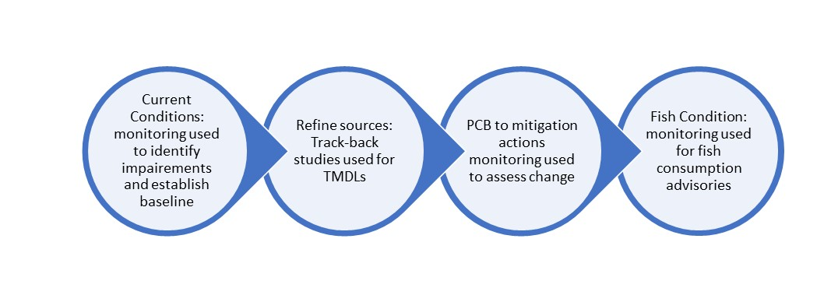
Figure 1: Components of the PCB monitoring objective.

Existing Monitoring that Support the Objective and Remaining Gaps
A data inventory for PCBs was conducted by USGS and additional information was requested from each jurisdiction and federal partner related to the components of the monitoring objective (Fig. 1). The inventory revealed adequate monitoring for the components shown in Figure 1 except for the third component: PCB respone to migitation actions.

Monitoring Design Considerations and Recommendations
The TCW endorsed an overall approach for enhanced monitoring to help jurisdictions assess the PCB response to mitigation actions in selected geographic areas. The primary recommendations for this monitoring design are bolded and summarized below.
Focus monitoring in geographic areas to help the jurisdictions assess PCB response where mitigation actions are being implemented and or planned. Due to the variability discussed above, jurisdictions suggested providing some flexibility in the geographically-focused areas to allow for the consideration of variable ongoing or historical monitoring and specific activities in their respective locations. In general, the conceptual design would build from existing monitoring to add sites to detect PCB response (Figure 2).
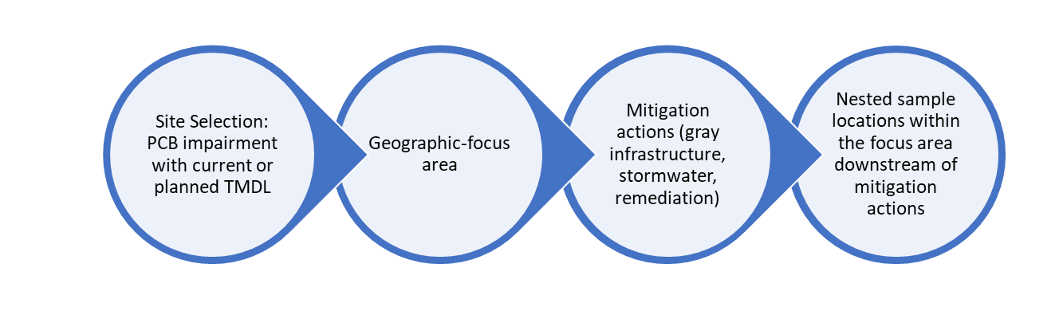
Figure 2. Components of Sampling Site Selection
Geographic focus areas should be in places with PCB reductions can be detected. The monitoring should be in areas with enough action/mitigation ongoing or planned for collective, predicted reductions of greater than 25% (or a more appropriate reduction later specified) in concentration and/or loading. Based on input from the jurisdictions, some potential geographic-focus areas include:
Jurisdiction | Geographic-focus Areas
DC | Anacostia River
MD | Patapsco River, tributaries of Anacostia
VA | Potomac River tributaries (at head of tide)
DE | Nanticoke River

Initiate monitoring in a single geographic-focus area as a pilot test. There are many unknowns related to proposed monitoring, including reduction required to detect a response, timeframe to detect a response, proximity to collection actions to detect a response, and the type of media (such as surface water, fish). Conducting monitoring in a pilot area should be done so lessons learned can be developed before monitoring in other geographic areas.
Potential Costs in one geographic-focus area could range depending on media and number of locations (ranging from 1-3) sampled:
- Fish or shellfish focused sampling per event (conducted at time intervals greater than 1 year): $22,000-$66,000.
- Time-integrated, water column (surface water) sampling (quarterly, non-storm) including installation of streamflow gage per year: $70,000-$210,000

