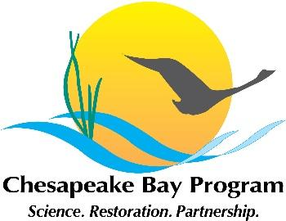

Maryland Oyster Restoration Workgroup Meeting Agenda
November 15, 2021 9:30am – 12:30pm

Google Meet Link: meet.google.com/oxw-ugvj-mzw

Call in #: 617-675-4444‬
Pin: 599 025 000 4849#‬

Agenda
- Review MD acres, seed planted, and dollars; these will go into the 2021 MD Annual Oyster Update document-- past versions are here for reference.
- Discussion of adding a Bay-wide graphic to the front of the 2021 MD and VA annual update, so it is easier to see Bay-wide progress at a glance.
- Update on MD reef construction
- Review text that describes the revised pre-restoration growth truthing protocol
- Fall 2021 monitoring- update
- Bay Program strategy Review System- presentation Nov 18; after that, start developing 2-year work plan.
- Direct setting update-- fall video survey work on Tred, and where to next.
- Other updates, business, etc

