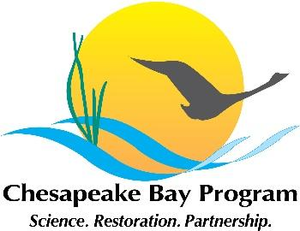

Joint Hampton Roads and Western Shore VA Oyster Team
Meeting Agenda
November 10, 2021 1:00 - 3:00pm

Google Meet Link: meet.google.com/msh-coxy-xnq

Call in info:
+1 617-675-4444‬
PIN: 660 426 107 3652#‬
Agenda

- Welcome, and note that this meeting is open to the public
- Presentation by Andrew Button (VMRC) on plans for 2022 lower York River reef construction
- General updates on reef construction, project status, etc.
- Review draft acres completed and dollars spent in VA in 2021 toward the ’10 tributaries’ outcome; these will feed into the 2021 VA Annual Update (past Annual Update docs here).
- Piankatank and Great Wicomico completion event- update. Can we use the numbers above for messaging?
- Bay Program Strategy Review System (SRS) overview: Nov 18 presentation to the Bay Program Management Board (oysters and a few other outcomes will report that day) after that, we need to develop a two-year-work plan for oysters- our current work plan is here, for reference.
- Discussion: what are the opportunities to better incorporate diversity, equity, inclusion, and justice into the ’10 tribs’ work? What about beyond the 10- tribs, or beyond 2025?
- Partner updates: Piankatank River signs; Great Wicomico and Lower York completion event/s; CBF Rod and Reef tournament; Bay Program executive committee meeting at Brock Center; other updates
- General partner updates; other business; future meeting agenda items.

