CAC Subcommittee for Emerging Issues
Internal Briefing Document for the Citizens Advisory Committee

Why are we learning about solar development?
- Renewable energy is a positive move toward reducing greenhouse gasses from fossil fuels to address climate change impacts and reduce our dependence on foreign oil
- According to the Solar Energy Industries Association, the solar industry is set to quadruple over the next decade

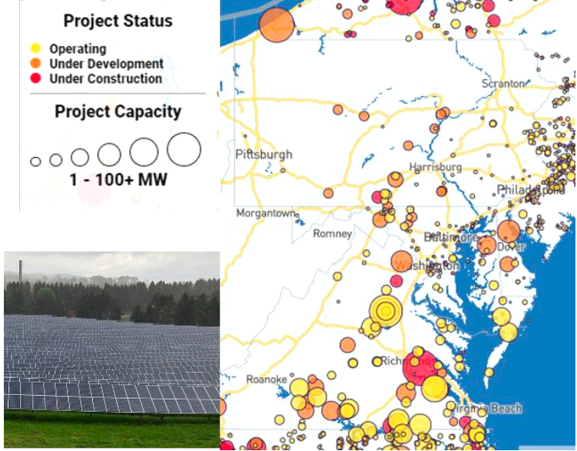
Map of existing and proposed major solar projects with example photo
(Map/data source: SEIA 2022)

The Chesapeake Bay Program recognized the need to utilize their scientific, modeling, monitoring and planning capabilities to prioritize the communities, working lands and habitats that are most vulnerable to the risks of a changing climate
- The 2021Chesapeake Executive Council: Directive No. 21-1 Collective Action for Climate Change
- 2022 Bay 101 Climate Change video
  - (CAC Member Cameo!)

What are some of the challenges? What are some reasons that make large-scale solar development controversial?
- Land use changes for forests and agricultural lands
- Erosion from site affecting nearby streams and properties
- Change in viewscape, nuisance glare from panels
- Perceived or feared decline in nearby property values
What is the connection between solar development and local water quality?
- Siting on agricultural lands that could be used for sustainable farming that provides food and healthy soils that capture carbon
- Siting on forested lands that clean air, capture carbon, filter water, control erosion, and sustain biodiversity, habitat and recreation
- Erosion and sediment control during construction
- Post - construction stormwater runoff from impervious surface of solar arrays and surrounding land

Some Chesapeake Bay Watershed Agreement goals and outcomes that could be impacted by large scale solar development without careful siting and stormwater management considerations:
- Forest Buffers Outcome
- Protected Lands Outcome for wetlands and forest lands
- Stream Health Outcome
- Water Quality and 2025 Watershed Implementation Plan (WIP) Outcome

According to an April 2022 Bay Journal article entitled, More than 800 solar projects in Bay states stuck waiting for review
- Bay states have adopted aggressive climate-change mitigation policies that rely on renewable energy.
- Solar made up more than half of all new electricity generated in the United States during the first three quarters of 2021, according to the Solar Energy Industries Association.
- There will be a proposed fast-tracked process to relieve the log jam of reviews
- Solar projects waiting for review
  - Maryland: 48 projects, potential power capacity of 2,502 megawatts (enough to power 410,000 homes)
  - Pennsylvania: 443 projects, potential power capacity of 8,854 megawatts (enough to power 1.4 million homes)
  - Virginia: 416 projects, potential power capacity of 22,679 megawatts (enough to power 3.7 million homes)

The Issue: While renewable energy is a positive move toward reducing greenhouse gasses from fossil fuels to address climate change impacts on the Chesapeake Watershed, is the recent boom in solar farms increasing the challenge to meet water quality goals in unintended but avoidable ways?

What the panel aims to uncover
Objective: Understand the trends and drivers of large-scale solar development, the associated water quality impacts and some best practices to protect local water quality.

Section One: Research & Science
- Land Consumption
- Local Opposition
- Co-location
- State and local tensions
- Competing Policies
- Examples of Ordinances/Recommended Practices to protect water quality

Section Two: Perspectives
- Snapshot of issues in VA/MD/PA from a state agency level
- Industry insights

Post-Meeting:
The EI Subcommittee will discuss and develop recommendations for CAC consideration based on: CAC feedback during the discussion, learning from the speakers and additional research.

Upcoming
- STAC – Chesapeake Bay Scientific and Technical Advisory Committee
FY22 State of Science Workshop: Best Management Practices to minimize impacts of solar farms on landscape hydrology and water quality
- Impacts of solar development in Bay Model

Additional Background:

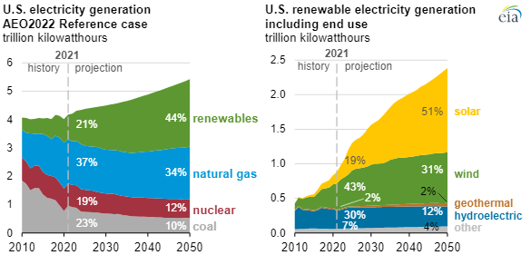

Renewable energy is projected to be 44% of electricity generation in 2050. Of the renewable energy projection, 51% is solar. https://www.eia.gov/outlooks/aeo/pdf/AEO2022_ChartLibrary_Electricity.pdf

Who is involved in the decision making?
- Permission from Independent System Operators (ISO) for interconnection to electricity transmission network - Most of the Bay Watershed falls under the PJM Interconnection
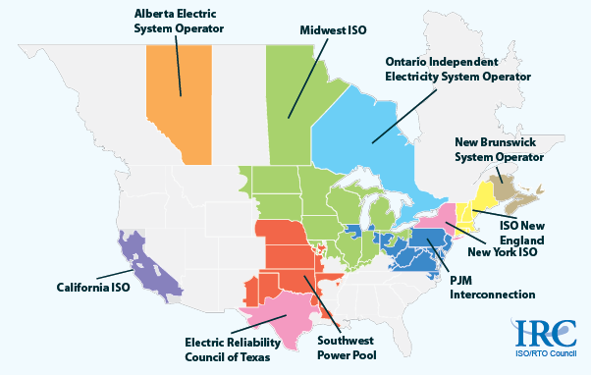
- Certificate from State utilities regulator (Virginia State Corporation Commission, MD Public Service Commission, PA Public Utility Commission), depending on size of project
- Environmental permits (state and/or local), depending on size of project and impacts
- Local government certification or recommendation for siting based on compliance with local land use ordinances

