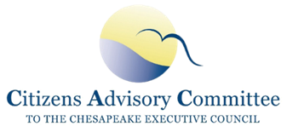
Citizens Advisory Committee
[DRAFT] Meeting Minutes
February 24-25, 2022
Virtual Meeting (Zoom)
______________________________________________________

CAC Members Present: Xavier Brown, John Dawes, Andrew Der, Matt Ehrhart, Bill Fink, Brenna Goggin, Donna Harris-Aikens, Verna Harrison, Charles Herrick, Ann Jurczyk (Vice-Chair), Anna Killius, Julie Lawson (Chair), David Lillard, Mike Lovegreen, Joe Maroon, Bill Matuszeski, Abel Olivo, Kate Patton, Daphne Pee, BeKura Shabazz, Charlie Stek, Dana Wiggins, and CAC Staff Jessica Blackburn and Adam Bray

Speakers/Guests Present: Deni Chambers, Jeff Corbin, Jeffrey Cornwell, Megan Diehl, Ted Evgeniadis, Rachel Felver, Amy Handen, Sam Merrill, Andy Miller, Doug Myers, Betsy Nicholas, Lucinda Power, Matthew Rowe, Martha Shimkin, Jennifer Starr, Kathy Stecker, Patrick Thompson, Jill Whitcomb, Marjorie Zeff

Meeting presentations and materials are located at:
Citizens Advisory Committee Quarterly Meeting (February 2022) | Chesapeake Bay Program

Thursday, Feb 24, 2022
The CAC Chair, Julie Lawson, called the meeting to order at 10:00 AM. She gave an overview of the agenda and highlighted the meeting’s goal: to continue building community among CAC members and to learn more about a key priority of the Water Quality Subcommittee.

CAC Business Meeting
CAC voted to approve the draft Dec 2021 meeting minutes as submitted. Julie shared the recent Chesapeake Bay Program (CBP) blog post about common advisory committee themes, the first of four blog posts CAC is responsible for writing each year. These posts will be written by the chairs of each subcommittee about the panels and learning sessions the subcommittee organizes. Julie highlighted the Chesapeake Behavior Change website which is now live and will be the topic for the next CAC learning session. Subcommittee Chairs provided updates on their recent meetings. The Stewardship & Engagement subcommittee is planning an event in Fall 2022 that will focus on equity and diversity in capacity building grant funding opportunities. Chuck also shared that Environmental Literacy Planning templates are being created to help jurisdictions ensure coherent programs in K-12 education. The Water Quality Subcommittee planned this meeting’s Conowingo panel. They have additionally discussed infrastructure funding and how it relates to meeting the 2025 goals. The Emerging Issues Subcommittee is focusing on water quality issues related to large-scale solar farms and planning a panel for the May meeting.

Member Spotlights
As part of a new standing item on the agenda, three CAC members, Ann Jurczyk, Abel Olivo, and Brenna Goggin, gave short 5-minute presentations on their work and interests. The purpose of this new session is to help the Committee better learn and understand each other’s expertise and perspectives. Future agendas will allow more time for these sessions.

New CBP Communications and Engagement Products
Rachel Felver, Communications Director, Chesapeake Bay Program Office
Rachel Felver presented on the Beyond Environmental Benefits Database and Search Tool, a searchable database on the CBP website that outlines case studies of projects throughout the watershed and the benefits they have on the environment, community and economy. The intended audience is government staff, local planners, non-profit organizations, communities, elected officials, and academia. Rachel shared that they intend to create two-page success story templates for each project that can be printed and distributed. She also shared infographics that show how fishing license purchases and outdoor recreation are benefitting the economies of each jurisdiction in the watershed.
Discussion: CAC Members expressed interest in seeing a cumulative economic benefit for all the practices in the database and recommended including data from other sources, including industry. Rachel said they are currently working to improve and refine the tool but plan to update it quarterly with new data and capabilities. Members discussed whether load reduction values can translate to show progress on climate and resiliency metrics and the database could be used to inform behavior change campaigns.

Committee Tune-up
This session was designed to build community and shared vision among CAC members, provide time for members to share ideas for improvement, and identify possible changes to CAC’s Bylaws. Julie presented potential changes to the Bylaws including new additions of previously drafted values and principles statements. After discussing the pros and cons of revising current minimum qualifications for membership and changing the word ‘citizen’ in the CAC name, members took brief polls to ascertain the majority of opinion.

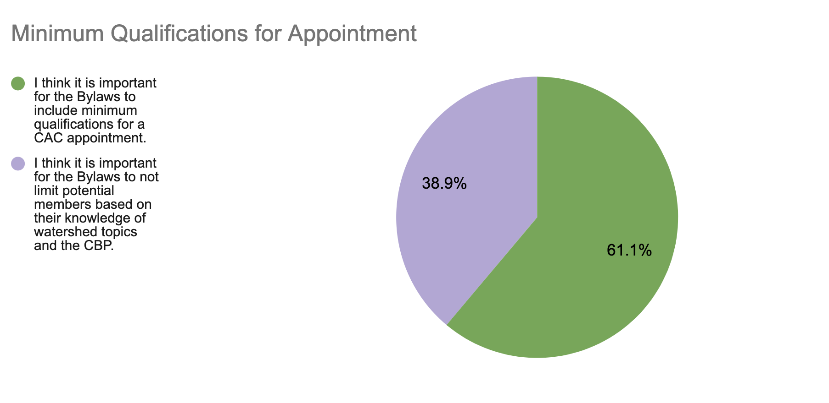

Members highlighted the value of CAC being seen as informed experts on watershed issues as well as the need to have expertise and experience beyond the environmental sector to better represent all communities.
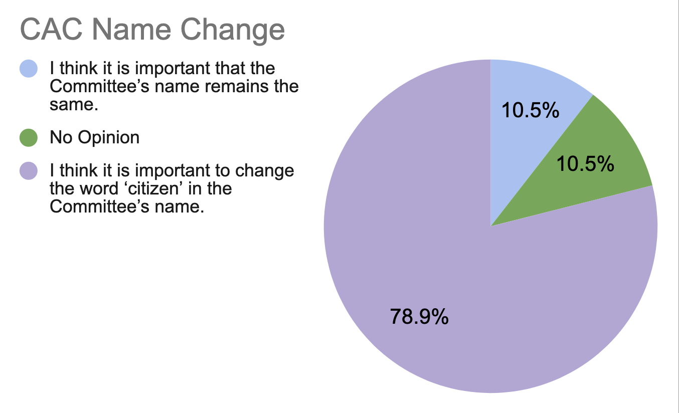

CAC discussed the pros and cons of removing ‘citizen’ from the committee’s name, whether CAC has the authority to do so, and the desire to have a name that is both accurate and inclusive.
The committee broke into small groups to discuss overall impressions of the suggested changes and provided guidance on expectations of their membership. After reconvening members offered these brief answers to topics from the small group discussion:
What benefits do you get from being a CAC member?:
- Take what I’ve learned to my work
- Learning about different activities around the watershed
- Contribute to important policy implementation
- Hearing directly from senior leadership of CBP federal and state partners
- Hearing from people on the Committee- their breadth and depth of experiences
- Voice, Insights, Consensus of priorities for watershed communities
- Collaboration and learning from members
- Being able to talk about chicken poop at a CAC diner without anyone saying I’m weird
- Breadth of perspectives, new perspectives, relationships with great people
- Ability to contribute to Bay improvements, learning opportunities, high level impact
- Public service calling
- Learning more everyday about the environment my family lives in currently and will inherit for the future
- Access to decision makers
- It is a benefit to learn how diverse disciplines can have an impact on Bay restoration
- Learning about many perspectives, the feeling that it’s One Watershed
- Reconnecting to my watershed work earlier in my career
- Meeting others working on issues of interest
- Professional and personal satisfaction. Making a difference. Never too old to learn things. Presenters are always a learning experience.

Are the expectations of your membership clear to you?:
Members replied yes, almost, and getting more clear. It is not always clear to others outside the Committee what the CAC role is.

Takeaways from Discussion about the CAC Bylaws:
Members felt the proposed changes to the bylaws are moving in the right direction, but a closer look at them would help with any final edits and wordsmithing. The CAC should continue to discuss minimum qualifications for membership, clarify during the onboarding process the contribution of time outside of quarterly meetings, determine what principles should be included in the values statement, and explore creating a separate document for operational guidelines like travel reimbursement which should not be included in the bylaws.

Friday, Feb 25, 2022
Member Reflections & Updates
CAC reflected on the previous day’s presentations and their takeaways from the small group discussions. Members do not want to lose sight of meeting the 2025 Bay Cleanup Goals, being a voice for committing resources, and holding jurisdictions accountable. Members identified the need to find better ways of reaching individuals and communities to get involved in land-use decisions. CAC discussed advocating for more funding for behavior change and community engagement. Members appreciated the conversations on CAC identity and purpose and expressed the need for continued listening and dialogue, with possible assistance from outside facilitation.
Chesapeake Bay Program Updates
Martha Shimkin, Deputy Director, EPA Chesapeake Bay Program
Lucinda Power, Implementation & Evaluation Team Leader, EPA Chesapeake Bay Program
Lucinda updated CAC on the EPA letter sent to PA regarding their expectations for the draft amended Phase III Watershed Implementation Plan (WIP). The EPA is currently evaluating the PA WIP and hopes to release their reactions this Spring.
She briefed CAC on EPA’s Evaluation of the Final Conowingo WIP (CWIP) released to the Principle Staff Committee (PSC). Strengths of the CWIP include: the strong collaborative approach; targeting of cost-effective practices in the most effective areas in the Susquehanna basin; and the detailed strategy for stakeholder outreach. EPA critiqued the lack of funding commitments and low confidence that reductions can be achieved by 2025. EPA requires more details on which programs will be targeted and how resources and technical assistance will be balanced with jurisdictional WIPs to alleviate competition. PSC did not approve the CWIP Financing Strategy because of significant comments and concerns. EPA’s letter expressed that if financial commitments are not addressed in the 60 days since the letter (March 25), nutrient loads will be redistributed to the jurisdictions.
Martha walked CAC through the March 2 PSC agenda and addressed CAC’s recommendations to the Executive Council (EC) from December. She said that the EPA is creating an overview/matrix of all of the infrastructure funding available to federal agencies to show what can be used to support Bay activities. They hope to share this at the Management Board meeting in March. There will be strict reporting requirements. Requests for Applications (RFAs) for competitive grants will have to provide accountability for infrastructure funding. They are developing a framework for advancing the commitments outlined in the EC’s Climate Directive and a broader planning tool for the entire partnership to use. She explained that match requirements for EPA grants are based on the Clean Water Act but they have requested the EPA Administrator to waive the match requirements for infrastructure funding for at least one year.
Discussion: CAC members reiterated the concerns in the EPA letter of meeting Conowingo goals by 2025 without funding. They also talked about the challenge of reducing the loads behind the dam while also implementing practices upstream to prevent pollution loads from traveling to the dam. Members want to know if state grants will have similar reporting requirements for infrastructure-related grants and how the CBP imagines social sciences being integrated into their work long-term beyond the Chesapeake Behavior Change website tool.

Conowingo Dam Panel - Part One
Jill Whitcomb, Director, PA Dept of Environment’s Chesapeake Bay Office; Andy Miller, Professor of Geography and Environmental Systems, University of Maryland’s Center for Urban Environmental Research and Education.
Matt Ehrhart introduced the panelists and provided preliminary background information on why the Conowingo Dam matters to Bay restoration. Jill stated that PA sees the CWIP as complementary rather than competitive to PA’s Phase III WIP. They both contribute to local water quality improvements and lead to innovative approaches. Freshwater mussel restoration was an example. PA is focusing on ways to utilize current resources along with new funding to meet multiple goals in both WIPs.
Andy briefed CAC on the science of BMP implementation and dredging. The key problem is nutrients, not sediment, and reducing nutrients at the source is the most effective way to decrease loads. The science is not clear about the water quality impacts of dredging; nor whether increased reservoir storage from dredging would be temporary or would require permanent annual investments. STAC recommends that MDE consider using some of the funds from the Excelon settlement to pay for new monitoring programs to better understand geochemistry trends.
Discussion: CAC discussed potential infrastructure funding directed towards the CWIP and capacity challenges for Pennsylvania to utilize the additional funding. Jill shared that they have tapped out of “shovel-ready” projects and need funding for things like staffing, training, engineering, design, and outreach. She said they have done an assessment of their needs and CAC could help by advocating for increased staffing.

Conowingo Dam Panel - Part Two
Matt Rowe, MD Department of the Environment and co-chair for CWIP Steering Committee; Doug Myers, Chesapeake Bay Foundation; Jeff Corbin, Restoration Systems; and Betsy Nicholas, Waterkeepers Chesapeake
Panelists took turns responding to EPA’s evaluation letter and shared their perspectives about the best path forward for the Conowingo Dam. Matt Rowe shared how a lot about the CWIP is good - it encourages innovation, collaboration, and finding new financing solutions. MD is poised to contribute $31M to Conowingo based on Governor Hogan’s proposed budget ($25M for the CWIP and $6 million for dredging). If the CWIP pollution loads are reallocated to the jurisdictions, MD will want to know how much federal infrastructure funding will also be provided for CWIP implementation. There will be a full report on findings after the dredging pilot is wrapped up this summer, but some obstacles include power lines at the bottom of the reservoir and having to receive permits from Exelon.
Doug explained how the Exelon settlement was a lost opportunity to receive necessary funding. He shared that the Chesapeake Bay Foundation is opposed to dredging as a solution and thinks that optimizing upstream BMPs in south-central PA (focusing on durable BMPs like riparian buffer plantings and stream exclusion) will have the most impact. Increased funding for regulation, compliance inspections, and enforcement would also have a big impact.
Jeff presented on the value of dredging and its ecological and economic impacts. He believes that dredging should be the primary option and can address the root problem for less than the ongoing costs of the CWIP. In order to return to trapping capacity, he estimates a cost-effective ~10-year project that would be privately funded and not require public subsidy. He acknowledged challenges of: where to place dredged material; impacts of possible contaminants; securing commitments to purchase reduction credits for trading markets; and ensuring dredging becomes a Bay Program approved BMP.
Betsy expressed her concern that if funding is not found for the CWIP, it could be decades or never before the 2025 goals are reached. The dam prevents coarse sediment from getting downstream to create wildlife habitat and prevents freshwater mussels from migrating upstream. The Waterkeepers believe Exelon is responsible for paying the costs. They filed a lawsuit against the Federal Energy Regulatory Commission (FERC) to challenge the settlement agreement in court. She said there needs to be financing commitments from all jurisdictions, a strong commitment from the federal government, and an emphasis on policy change and enforcement.
Discussion: CAC discussed legislative issues related to cross-state trading for dredging credits, the process for dredging to become a BMP, and the need for additional modeling and further study. Members discussed the length of time it would take to dredge Conowingo and it is unique compared to other river basins. Members discussed the failure to enforce sediment laws and how best to divvy out responsibility and fund enforcement.

Member Discussion and Action Items:
Members agreed the Water Quality Subcommittee will have aConowingo Dam follow-up conversation, open to all members who want to join. They will collect questions beforehand and retrieve any necessary information from panelists.
Members discussed how CAC can help keep the PSC focused on 2025 deadlines and get clarity on ARPA and Infrastructure funding.
Matt provided updates from the Verification Workgroup and a STAC workshop series on water temperature.
Abel shared that he will be giving presentations at upcoming conferences: Water Now Alliance, Choose Clean Water, and River Rally.
Andrew volunteered to present for the next meeting’s Member Spotlight.
Jess will email links to the State Fact Sheets, reach out to EPA to learn more about the new 401 certification rule, continue conversation with CBP about incorporating social science and behavior change long-term, and compile comments from Committee Tune-Up and send them to the Executive Committee for next steps.

With no further business, the meeting adjourned at 3:15pm.

