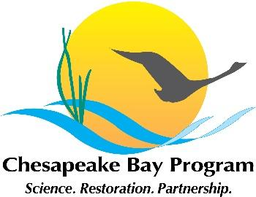

Joint Hampton Roads and Western Shore VA Oyster Team
Meeting Agenda
April 13, 2022 1:00 - 3:00pm

Google Meet joining info:
Join with Google Meet
meet.google.com/msh-coxy-xnq

Join by phone
(US) +1 617-675-4444‬ PIN: 660 426 107 3652‬#

Agenda

-Bay-Wide Annual Update document (spoiler: it is now cleared for posting)
-Update from team members on restoration work, planning, monitoring, etc
-Shout out to Pew for their blog post, which mentions the importance of REPI
- Andy Lacatell (TNC) will lead a discussion on the concept of a Piankatank retrospective, including a similar example from Australia.

