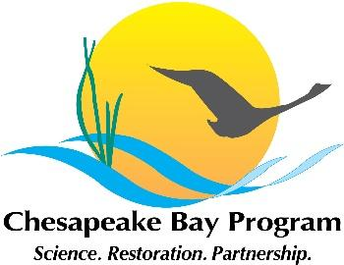

Joint Hampton Roads and Western Shore VA Oyster Team
Meeting Agenda
June 8, 2022 1:00 - 3:00pm

Google Meet joining info:

Join with Google Meet
meet.google.com/msh-coxy-xnq

Join by phone
(US) +1 617-675-4444‬ PIN: 660 426 107 3652‬#

Agenda

-Welcome, and note that this is a public meeting.
-Presentation by staff from the Smithsonian Environmental Research Center (SERC), describing their work toward a Rapid Assessment Protocol (RAP) for efficiently monitoring oyster reefs. Discussion to follow.
-Reef construction updates from the team
-Other updates from the team
-Reminder that, as always, the documentation from the MD and VA oyster workgroups can be found at https://www.chesapeakebay.net/who/group/maryland_and_virginia_oyster_restoration_interagency_teams This includes the 2021 Annual Update describing progress on the Bay Program ’10 tributaries’ oyster goal through December 2021.

