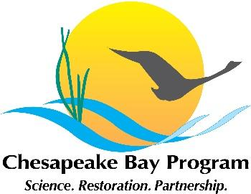

Joint Hampton Roads and Western Shore VA Oyster Team
Meeting Agenda
June 8, 2022 1:00 - 3:00pm

Agenda and Notes

Agenda and Notes:
-Welcome, and note that this is a public meeting.
- Request made that the announcements for these meetings on the Bay Program website be posted with more advance notice.

-Presentation by staff from the Smithsonian Environmental Research Center (SERC), describing their work toward a Rapid Assessment Protocol (RAP) for efficiently monitoring oyster reefs. Discussion to follow.

-Reef construction updates from the team

-Lynnhaven reef construction - LRNOW/CBF completed phases 1 and 2 of 25 acre project, still doing some clean up work, 11 acres done and have almost finished additional 3 acres; waiting for permits on the remaining 11 acres. Hope to have all 25 acres done by summer. USACE - 20+ acres still planned - in Broad Bay - permit application pending, public hearing to be held - potential design adjustments being considered - 23 acres likely, up to 31. Time frame for USACE: spring-summer 2023 construction expected to begin

-Lower York -VMRC has started construction on 150+ acres (with some funding from NOAA) - stone deployments started June 1 (near Gloucester Point). Fine shell added first, then stone. Expected completion in late summer/fall 2022. 2 different contractors – one doing higher relief reefs, other contractor doing lower relief reefs. Percentage of shell vs. stone – some are all shell, some are a 2-3” fine shell base covered by 6” of rock., some areas just stone (granite). 78,000 tons of rock material + 10,000 cubic yards of fine shell

-Other updates from the team

-Peyton Mowery has moved from CBF to USACE Norfolk, working with Heather Lockwood and Zach
-
-Reminder that, as always, the documentation from the MD and VA oyster workgroups can be found at https://www.chesapeakebay.net/who/group/maryland_and_virginia_oyster_restoration_interagency_teams This includes the 2021 Annual Update describing progress on the Bay Program ’10 tributaries’ oyster goal through December 2021.

