Assessment of all Bay Oxygen Water Quality Criteria for 2025
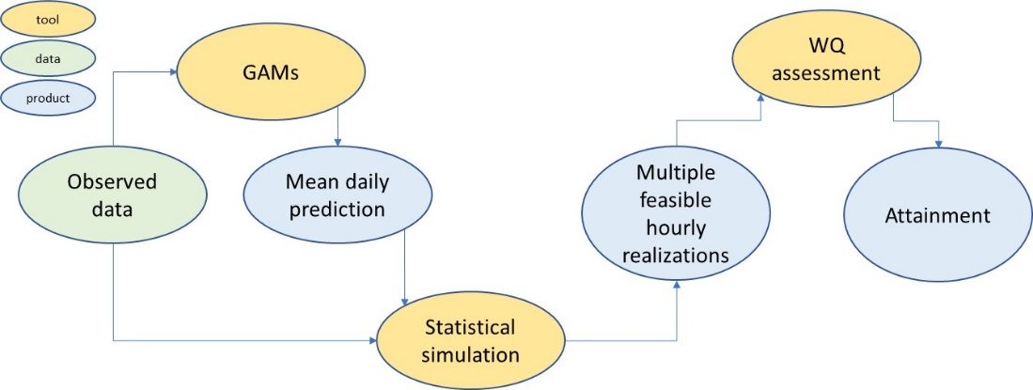
Beginning with initial assessments of dissolved oxygen water quality criteria in 2003 and continuing through the 2010 TMDL and 2017 Midpoint Assessment, the CBP has not had the ability to assess all water quality criteria and has therefore not been able to delist any of the 92 Chesapeake Bay segments. A new analysis system, built on an expanded data collection effort, is envisioned that will allow assessment of all water quality criteria. Figure 1 shows the flow of information in the proposed system.
Figure 1: Interpolation and attainment assessment system

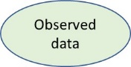
Observed Data consist of current and historical fixed tidal station monitoring, continuous monitoring, towed array, data flow, and more recent vertical profiler data. Dissolved oxygen, salinity, and temperature will be available from these data sources. Ancillary data used in prediction may include bathymetry, flow, wind, air temperature, and tides. These may come from nearby observations, dynamic process models, or both.

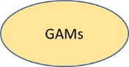
General Additive Models (GAMs) are being developed to predict salinity, water temperature, and dissolved oxygen. The spatial domain will be the entire tidal area. Salinity and temperature GAMs will likely use date, day of year, temperature, flow, wind, tide, depth, and position as predictors. Dissolved oxygen GAMs will use similar predictor variables and potentially use salinity and temperature predictions.

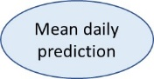
The GAMs will produce a spatially and temporally continuous estimate of the mean and distribution of daily time-averaged dissolved oxygen, temperature, and salinity. The GAMs will be evaluated at the centroids of a 4D interpolator grid. Values stored in the grid will represent the mean prediction of the daily average value of the parameter along with any distributional parameters.

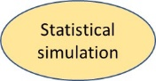
A statistical simulation will operate on the 4D interpolator grid using information from the GAMs along with additional simulation parameters developed through analysis of observed data. The statistical simulation will have a deterministic component that adds diel cycling and a stochastic component that can produce a realization of dissolved oxygen, salinity, and temperature that incorporates observed spatial and temporal correlation. It is anticipated that the vertical profiler, data flow, and continuous monitoring data will be critical for development of the statistical simulation.

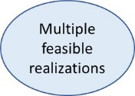
The statistical simulation will generate multiple feasible realizations of dissolved oxygen, salinity, and temperature in the 4D tidal water. Each realization will be stochastically generated consistent with GAM predictions and statistical spatial and temporal variance parameters found from monitoring data analysis.

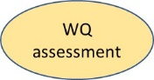
The Water Quality criteria assessment curve is a frequency distribution of spatial violation rates. A spatial violation rate is the fraction of space where the estimate of dissolved oxygen is below a criterion. Each realization of the 4D bay will contain multiple instances of a spatial violation rate, with the number depending on the averaging period. Using the example of a summer 30-day mean, a full 4D realization of 1993-1995 will contain 12 30-day periods. The fraction of space violating the criteria from the mean 30-day estimates in each area will be the spatial violation rate. To form a robust frequency distribution of the spatial violation rates, the 12 30-day summer periods in 1993-1995 can be simulated repeatedly.

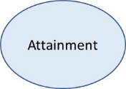
Attainment assessment is the comparison of the assessment curve with a reference curve. Any excursion of the assessment curve above the reference curve is a water quality standard violation. The reference curve is intended to protect living resources and can be generated from an analysis of assessment curves in areas of high living resource metrics relative to assessment curves in areas of low living resource metrics.

