Purpose and Background
The Chesapeake Bay Program (CBP) Management Board established an Indicators Framework Action Team in May 2015 to align the Indicators Framework with the Chesapeake Bay Watershed Agreement and ensure it supports our adaptive management and communication needs.

Indicators Framework
The Indicators Framework (Framework) is a conceptual model that demonstrates the relationships between indicators and describes how they will be used. The Framework is aligned with the Agreement at the Outcome level and includes the information needed to support and communicate progress towards these outcomes. This model is a mechanism to support external and internal communication.
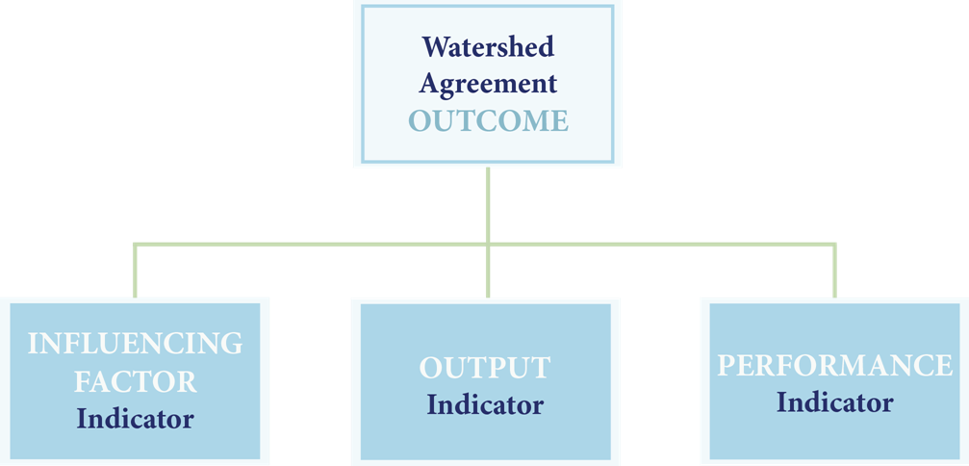

Information Support
Three information types are needed to support adaptive management and communication needs.
Influencing Factors – What KEY influencing factors are impacting the achievement of an outcome?
Outputs – Are we doing what we said we would do in our work plans and management strategies?
Performance – Are we achieving the outcome?

Using Indicators in a Simplified Decision Framework
Indicators support several steps within the Decision Framework. The blue circles denote steps within the Decision Framework that need indicators and metrics to guide implementation work.

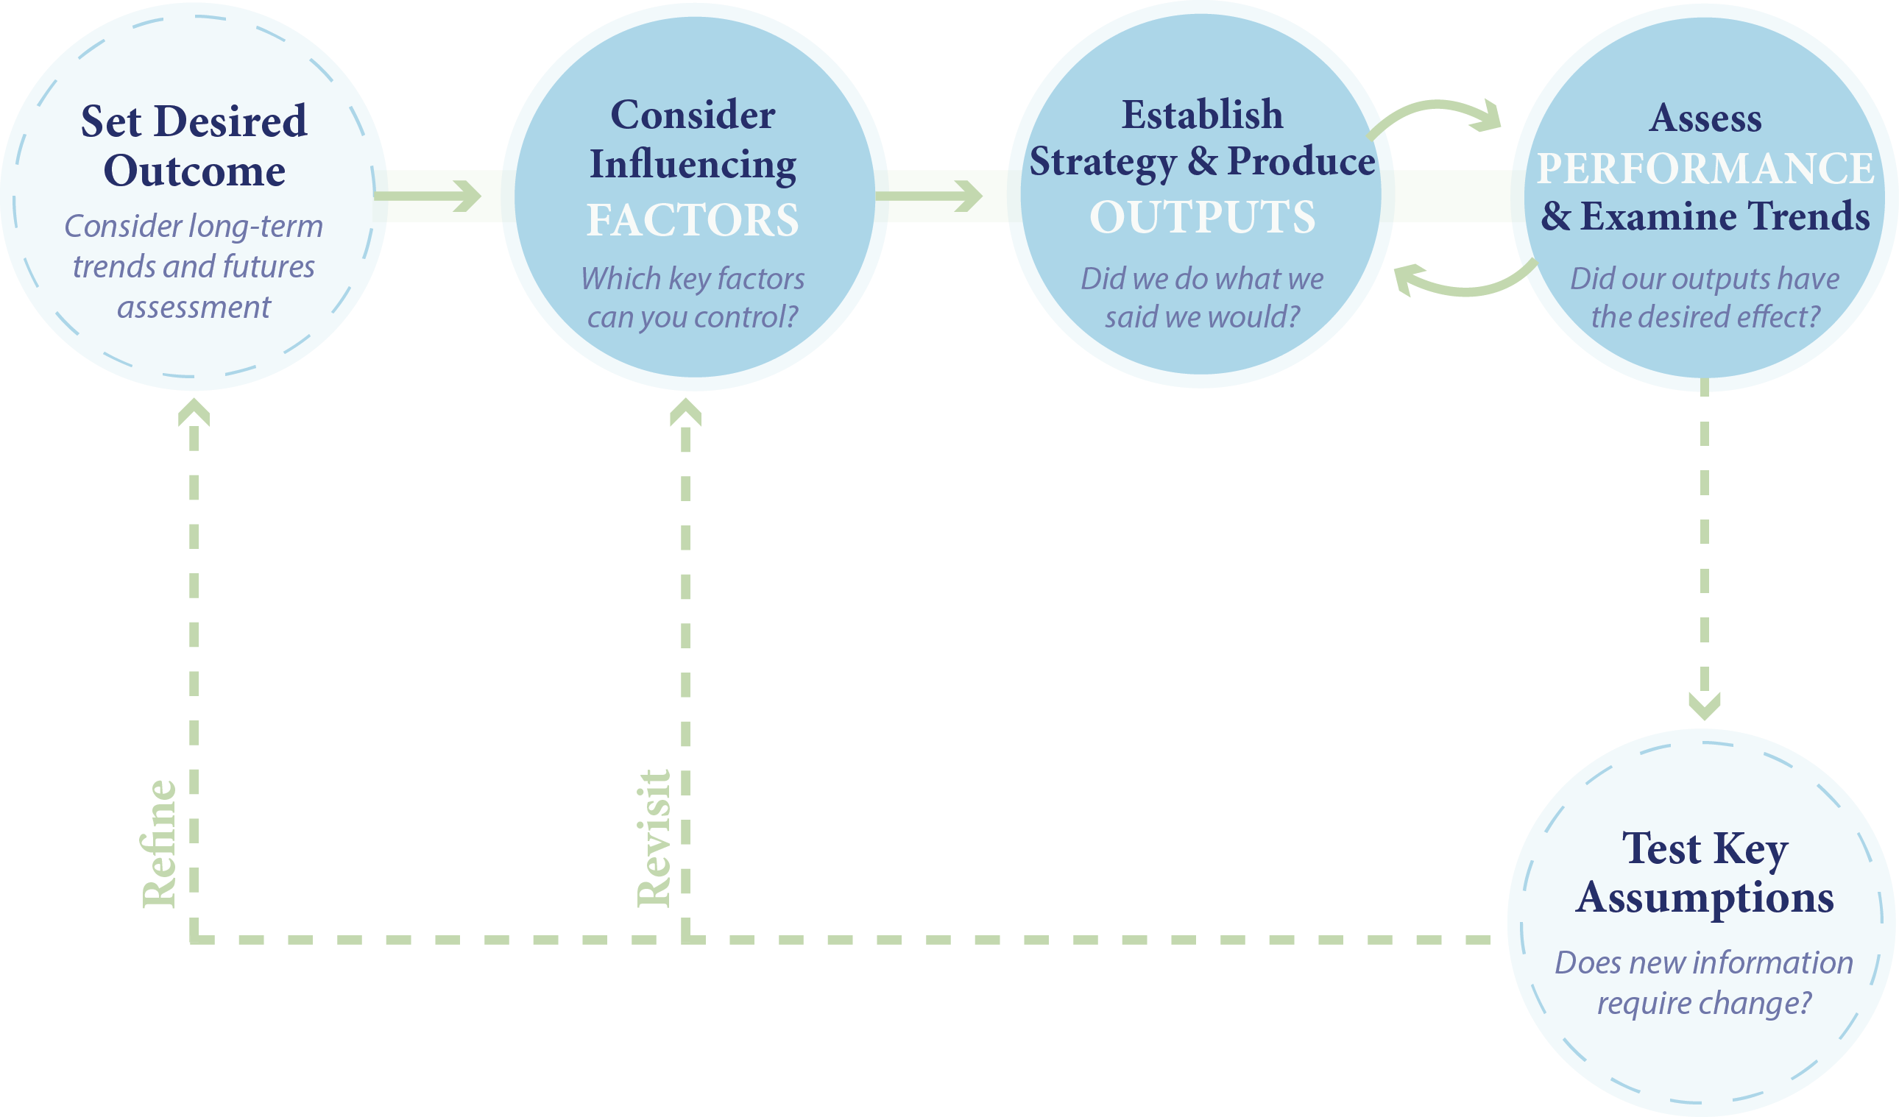

Indicator Development Steps
The Status and Trends Workgroup (under STAR) will work with the Goal Implementation Teams and STAC to identify indicator gaps for each outcome and develop a process for prioritizing indicator acquisition and a schedule consistent with available resources.
STAR and STAC will work together to prioritize the approval of new indicators if and/or when a large number is up for approval at the same time.

Creating and Maintaining a New Indicator
- Goal Implementation Team (GIT) Coordinator identifies and presents a monitoring, tracking or other need related to adaptively managing or tracking progress toward the Chesapeake Bay Watershed Agreement to the Status and Trends Workgroup.
Note: The Status and Trends Workgroup sits under STAR, and will have clear, defined criteria to help them maintain the integrity of the Indicators Framework and the products derived from it.
- Status and Trends Workgroup Coordinator works with GIT Coordinator to identify metrics and indicator(s) to meet monitoring or tracking need.
- Status and Trends Workgroup Coordinator informs Management Board and Communications Workgroup of new metrics and indicator(s).
- GIT Coordinator and Staffer (with assistance from STAR as needed) collate and send monitoring and tracking data, analysis and methods to Status and Trends Workgroup Coordinator.
- Status and Trends Workgroup Coordinator quality checks data, analysis and methods.
- GIS Team uses data to create or update maps.
- Web Content Specialist uses data, analysis and methods to create or update web content.
- Communications and Web Teams determine whether, when and how to promote indicator updates based on editorial calendar and newsworthy nature of information.
Note: An indicator update may be embargoed on a case-by-case basis, but these cases are rare (with the Chesapeake Bay Program erring on the side of transparency and timeliness).

Archiving an Indicator
- Goal Implementation Team (GIT) Coordinator notifies Status and Trends Workgroup when indicator no longer meets a monitoring need because (a) the goal or outcome has been achieved, or (b) the monitored information is no longer relevant to tracking progress toward the Chesapeake Bay Watershed Agreement.
- Status and Trends Workgroup Coordinator places most recent data, analysis and methods files and assets (charts, maps, etc.) on OneDrive to effectively archive information.
- Web Content Specialist archives relevant webpages and indicates (where appropriate) the achievement of a goal or outcome and/or explains any adjustments in our tracking methods.

