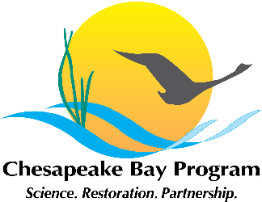

Toxic Contaminants Workgroup
Full Workgroup and Policy and Prevention Subgroup Meetings
FWS Annapolis Office
177 Admiral Cochrane Drive
Annapolis, MD 21401

December 10, 2014
1:00 p.m. – 4:00 p.m.

Conference Line: (866) 299-3188
Conference Code: (410) 267-5731
Web Access: https://epa.connectsolutions.com/tcw/

Agenda

- Welcome, Introductions (1:00 p.m. – 1:15 p.m.)
Greg Allen
- Update on Actions and Decisions from 11-5-14 kick off meeting and 11-18-14 policy and prevention subgroup meeting.
Materials:
I.a. - TCW Kick Off Meeting Summary
I.b. - TCW 11-18-14 Policy and Prevention Summary
- Update and Focused Discussion on Research Agenda (1:15 p.m. – 2:15 p.m.)
Scott Phillips
- Description of activities since last full workgroup meeting.
- Overview of the basic ideas for structuring the management strategy for each outcome.

- Update and Focused Discussion on Policy and Prevention (PCBs) (2:15 p.m. – 3:15 p.m.)
Greg Allen
- Description of activities since last full workgroup meeting.
- Overview of the basic ideas for structuring the management strategy for each outcome.
- Plans for Continued Management Strategy Development (3:15 p.m. – 4:00 p.m.)
All
- Determine make-up of writing teams

