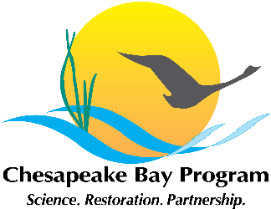

Toxic Contaminants Workgroup
Full Workgroup Conference Call
Chesapeake Bay Program Office
Room 305A
410 Severn Avenue
Annapolis, MD 21403

February 11, 2015
1:00 p.m. – 4:00 p.m.

Conference Line: (866) 299-3188
Conference Code: (267) 985-6222
Web Access: https://epa.connectsolutions.com/tcw/

Agenda

- Welcome, Introductions (1:00 - 1:15)
Greg Allen
- Update on workgroup activities since January meeting.
- Update on multiple benefit BMP project award.

- Policy and Prevention Draft Strategy Review (1:15 - 2:15)
Greg Allen
- Workgroup members will discuss and provide feedback on the current draft Policy and Prevention strategy. Written comments are needed by February 18.
Materials:
II.a. – Current Draft Policy and Prevention Strategy (2-4-15 version)

- Research Draft Strategy Review (2:15 - 3:15)
Scott Phillips
- Workgroup members will discuss and provide feedback on the current draft Research strategy. Written comments are needed by February 18.
Materials:
III.a. – Current Draft Research Strategy (2-4-15 version)

- Discussion of Management Strategy Deadlines (3:15 – 3:30)
Scott Phillips
- Feb. 2 - MB and Advisory Committee deadline for providing comments on preliminary drafts.
- Feb. 2 - Mar. 2 - GITs/workgroups refine draft strategies.
- Mar. 2 - GITs/workgroups send revised strategies to the MB for sufficiency review.
- March 6 - MB deadline for submitting fatal flaw comments to GITs/workgroups.
- Mar. 16 - Post/release management strategies public input.
- Apr. 20 - Public input period closes.
- May 4 - GITs/workgroups revise strategies and provide to MB for final review.
- June 15 - Final management strategies completed.
- Dec. 15 - First Biennial workplan due.

- Overview of Submissions for STAC Workshop (3:30 – 3:45)
Scott Phillips

- Next Steps and Review of Actions and Decisions (3:45 - 4:00) Scott Phillips

