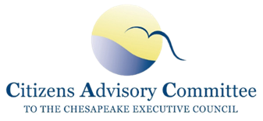
Citizens Advisory Committee
Meeting Minutes
September 18-19, 2019
Chester County, PA
___________________________________________________________

CAC Members Present: John Dawes, Andrew Der, Bill Dickinson, Matt Ehrhart (CAC Chair), Dale Gardner, Verna Harrison, Charles Herrick, Ann Jurczyk, Anna Killius, Julie Lawson, Mike Lovegreen, Bill Matuszeski, Jorge Ribas, Charlie Stek, Kendall Tyree, and CAC Staff Jessica Blackburn and Adam Bray

Speakers/Guests Present: Jim Edward (EPA CBP), Jenna Mitchell (Alliance), Kristen Wolf (PA DEP), Andy Johnson (Penn Foundation), John Jackson (Stroud), Louis Keddell (Chesapeake Conservancy), Rachel Felver (CBP Communications), Kathy Stecker (MD MDE), and Dave Arscott (Stroud).

Meeting presentations and materials are located at:
https://www.chesapeakebay.net/what/event/citizens_advisory_committee_quarterly_meeting_sept_2019

Wednesday, Sept 18, 2019
The CAC Chair, Matt Ehrhart, called the meeting to order at 11:06 AM. He gave an overview of the agenda and introduced the goals of the meeting - to receive updates on CAC priority topics and to learn about the region’s successful restoration partnerships. The Executive Director of the Stroud Water Research Center, Dave Arscott, welcomed CAC and introduced the mission and history of the organization and the property.

Updates on Chesapeake Bay Program- Jim Edward, Deputy Director Chesapeake Bay Program
Jim updated CAC on the Chesapeake Bay Program and discussed the EPA’s evaluation of draft Phase III WIPs, the Conowingo WIP grant award and Pennsylvania’s CBP grants and unliquidated obligations (ULOs). Jim described the strengths and potential enhancements of each jurisdiction’s plans and the Phase III WIP expectations for Federal Agencies. Jim updated CAC on the letter that the EPA sent to Pennsylvania regarding their ULOs. PA DEP was not spending their federal grant money efficiently and in order to get projects on the ground faster, funding will go to NFWF for PA restoration projects.

Discussion: CAC discussed how EPA was not enforcing MS4 permits in Maryland and how this can cause problems when other jurisdictions feel they are being held to an unequal, higher standard. This raises concern about consistency in enforcement. Members requested a presentation on EPA enforcement and a desire to learn more at a future meeting. Additionally, CAC learned that EPA has a limited role in enforcing federal agencies to comply with Phase III WIPs. CAC discussed writing a letter to federal agencies requesting that they take on leadership in working with jurisdictions. For Phase III WIPs, CAC suggested that it would be helpful if the Bay Program produced a table that compared the jurisdictions and showed where opportunities are. CAC discussed the timing of getting EPA comments on draft Phase III WIPs back to the jurisdictions and agreed to write a letter to encourage the EPA to give quick review and get comments to jurisdictions so they have time to incorporate them for the 2 year milestones due in December.

Working Lunch – Presentation: Private Businesses and Nonprofits Accelerating Conservation Practices – Jenna Mitchell, State Director of PA, Alliance for the Chesapeake Bay
Jenna briefed CAC on the Clean Water Partnership between the Alliance for the Chesapeake Bay, Turkey Hill and the Maryland & Virginia Milk Producers Cooperative Association (MDVA). The partnership started when leadership at Turkey Hill took interest in the impaired streams and rivers of Lancaster County and wanted to help improve them. Turkey Hill was able to make a significant impact by asking MDVA to make sure all farmers providing milk to Turkey Hill receive a conservation plan and reach compliance with on-the-ground BMPs. Once farmers have obtained a conservation plan, Turkey Hill will pay farmers a premium for the new added “quality” of their milk. Jenna shared that the Alliance is now interested in replicating this type of partnership with other companies who work with farmers.

Discussion: CAC discussed the unique attributes of Lancaster County, like the high density of agricultural lands that contribute to pollution problems. Mike Lovegreen shared that in Europe it is common for companies to pass along the costs of water restoration practices to consumers and recommended a study that compared the costs for companies to purify impaired water for production to the costs of implementing watershed practices.

Updates from PA DEP – Kristen Wolf, Chesapeake Bay Program Coordinator, PA Department of
Environmental Protection
Kristen updated CAC on Pennsylvania’s draft Phase III WIP process. She described it as a 2-year journey with more resources now committed to the 43 watershed counties than previously seen. She said that they are referring to the WIP as a “catalyst” because it has been an exercise in collaboration and opportunity, not blaming or finger pointing. She outlined the EPA’s expectations of both state programs and local level plans, and a summary of the public comments. PA believes that the final WIP is realistic, implementable and achievable. In its evaluation of the WIP, the EPA acknowledged the strong engagement and input from local partners, cross sector collaboration and their comprehensive roadmap.

Discussion: CAC discussed the importance of building public support in processes like this and acknowledged the need to get people out on the water and to communicate the public benefits of clean water when rates are rising. They also discussed confidentiality challenges for reporting and tracking BMPs. Members discussed the unique challenges of how the state is organized with counties, townships, cities and boroughs.

Delaware River Watershed Initiative – Andy Johnson, Watershed Protection Program, William Penn Foundation and John Jackson, Stroud Water Research Center
Andy gave an overview of the Delaware River Watershed Initiative (DRWI) and shared information about the William Penn Foundation’s environmental grant making which focuses on agricultural runoff, stormwater, and the loss of forests from development. They developed their Watershed Protection Program in 2011-2012 and found that many of the watershed-wide restoration efforts were underfunded and fragmented. The foundation prioritizes targeted areas, restoration goals and how to measure progress. While putting together their grant strategy, the foundation deliberately selected smaller sub-watersheds where they could concentrate aligned grants for on-the-ground conservation to address specific threats and measure impact.

John Jackson from the Stroud Water Research Center introduced the challenges of water pollution in Chester County and the Delaware River Watershed. He explained that Chester County has 957 miles worth of impaired streams and that ‘impaired’ means that 90% of pollution sensitive aquatic insects are gone. He described how there has been progress in the past but because water quality was not successfully monitored or measured they were not learning from their successes or failures. Monitoring has increased recently because the William Penn Foundation wants measurable change in water quality and quantifiable local goals. John said that monitoring will also lead to local wins because it will help citizens understand the local progress that is being made.

Discussion: CAC discussed the differences between the Chesapeake Bay watershed and the Delaware Bay watershed. Not as many people live along the Delaware Bay as do the Chesapeake Bay. CAC discussed William Penn’s funding strategy and how the foundation is supporting organizations collaboratively by funding strategy and constituency building.

Members were lead on a tour of the platinum LEED building, the educational and laboratory facilities and the stream restoration and riparian buffer research sites on White Clay Creek.

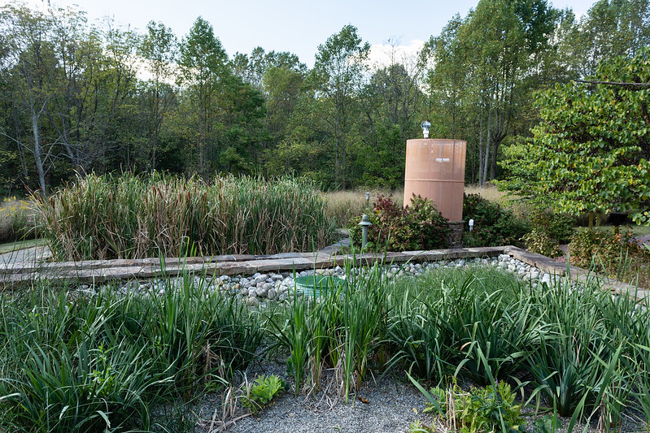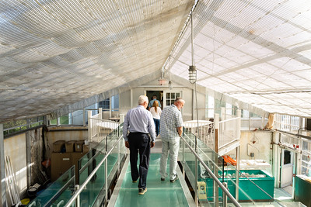

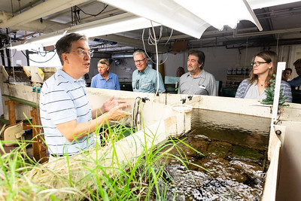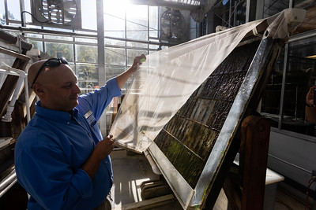

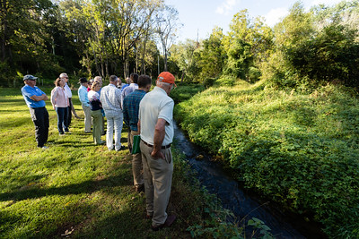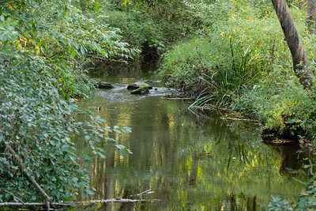

Thursday, Sept 19, 2019
The CAC Chair called to order the meeting at 8:32 AM.

Charlie motioned to adopt the May 2019 meeting minutes, Mike Lovegreen seconded and the minutes were adopted as submitted.

Chuck briefed CAC on the Environmental Summit he and Kendall attended. He said that it was encouraging to see so many educators passionate about the topic. The Summit was strongly framed in terms of DEIJ (Diversity, Equity, Inclusion and Justice) objectives. Chuck encouraged CAC to ensure the DEIJ buzz remains around issues of Environmental Education and Literacy. Chuck also suggested having a DC Environmental Education community from DC come present during the November CAC meeting in DC. Members added the importance of connecting restoration practices on school campuses to education, the need to prepare young people for future jobs in the environmental field, and the challenges of funding in DC public schools. Jess informed CAC that this is a topic that LGAC is interested in collaborating on and suggested that it should be a joint topic when CAC meets in December 2020. Matt shared that the Executive Council thanked him for CAC’s continued focus on environmental education.

The members approved the 2020 CAC meeting dates: Feb 20-21 in PA; May 21-22 in RVA; Sept 16-17 in WV; and Dec 3-4 in MD with LGAC.

Agricultural Conservation Practice Targeting, Monitoring and Tracking
Louis Keddell, Senior Geospatial Project Manager, Chesapeake Conservancy
Louis briefed CAC on the cooperative agreement with the Chesapeake Bay Program to prioritize BMP opportunities across the watershed. In partnership with Chesapeake Commons and Drexel University, the Conservancy is creating a blueprint and a streamlined platform for identifying and prioritizing projects, as well as tracking and reporting progress. Louis described their use of high-resolution models. Using LiDAR, and modeling the flow of water and drainage, they are able to prioritize restoration opportunities that are going to have the greatest benefit to water quality. Louis also presented on the BMP tracking tool, FieldDoc, which enables foundations, grantees, and landowners to track implementation progress in real-time and connect their efforts to water quality improvement targets. The tool allows users to upload their own GIS layers and see their project in the context of other priorities and targets to determine where high value opportunities are located. In the future, FieldDoc will integrate water monitoring data and create graphic visualizations for verification and tracking.

Discussion: CAC discussed privacy and confidentiality issues and learned that the Conservancy is working with USDA on the issue but that the eventual goal is to make the data public. CAC learned that there is functionality to incorporate historical data into FieldDoc. CAC talked about how this data will be able to show progress over time. Local watershed groups can use this to show their communities and Boards how their work is making a difference. CAC discussed the need to find success stories from matured BMPs and celebrate them. FieldDoc will also show the gaps between the models and monitoring data, and give landowners an accurate portrayal of what is actually happening on their properties. CAC expressed interest in hearing from the James River Association during the May meeting about they are successfully combining both modeling and monitoring data. Members also discussed engaging with STAC to identifying areas in the watershed where there are gaps in water quality monitoring.

CAC Business Meeting:
Matt shared his reflections on the most recent Executive Council meeting. Matt joined the EC lunch with the other advisory committee chairs. Governor Hogan looked to have everyone weigh in and Matt felt heard. The EC conversation included how to resolve issues with the Farm Services Administration (FSA). The FSA administrator and his deputy were present and engaged. Matt said that it was CAC’s suggestion to invite Sonny Perdue that led to the FSA representatives at the meeting. There was discussion about having the three advisory committee chairs (or jurisdictional representatives from each committee) to meet with the Executive Council members from each jurisdiction. CAC discussed the timing of these meetings and how to make them effective, as well as the idea of meeting with the Chesapeake Bay Commission.

CAC reviewed action items from the course of the meeting. This includes a letter to the EPA (1) encouraging them to create a table showing the different approaches in the jurisdictions’ Phase III WIPs for the public to understand and compare and jurisdictions can replicate innovative approaches; (2) submit their reviews of the jurisdictions’ Phase III WIPs as soon as possible; (3) review the next round of 2-year milestones to ensure significant comments and gaps in the Phase III WIPs are addressed, particularly looking at the jurisdictions’ ability to carry out enforcement of existing regulations, funding, and verification of practices. Ann, Anna and Andrew agreed to help review the letter to EPA.

CAC discussed topics for future meetings. For the November meeting in DC, members suggested presentations on the STAC report on microplastics, CSO issues, workforce development programs in DC and urban tree canopy programs from Casey Trees. It was suggested that CAC invite the USDA Secretary while in DC to thank him for sending FSA representations to the EC meeting and speak to him about CREP. Members were also interested in learning more about the inconsistencies between federal agencies in developing their WIPs.

For 2020 meeting topics, members discussed presentations about the Conowingo WIP, EPA enforcement, how Department of Defense monitors and implements their WIPs, and differences in the legislative processes across jurisdictions by the Chesapeake Legal Alliance. Members also wanted to explore the EPA Nutrient Trading Policy and whether trading could take place across basins, as well as learn how DCNR is identifying user groups through social data to get the most done with the least amount of technical assistance. For the Virginia meeting, CAC discussed learning more about the WIP provision for stream exclusion if load reductions are not met and JRA’s use of the FieldDoc tool.

With no other business, the meeting adjourned at 12:00pm.

