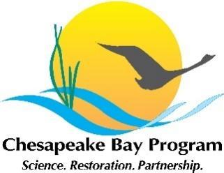
Stewardship Workgroup Meeting

Tuesday January 25th, 2022
1:00-3:00

Virtual Meeting (Zoom): https://umces-edu.zoom.us/j/98920115897?pwd=ek9rLzNJWW03b0ZydU1HWVFBaGM2UT09
Dial in: 301 715 8592
Meeting ID: 989 2011 5897
Passcode: 705313

1:00 pm Welcome and Opening Remarks
1:10 pm Breakout Session #1 – Introductions; Identify effective stewardship elements.
Participants share their thoughts on this topic in small groups, and then input 2-3 word responses into a Mentimeter word cloud and see results when everyone reconvenes:
Think about one of your all-time favorite stewardship initiatives you’ve witnessed or participated in. What do you feel are the most effective components of an exceptional stewardship program?

1:30 pm Laying the Foundation for Action (the Next Two Years)
We will begin to form our next-two year action plan, organizing into main categories of work and a proposed committee structure for developing and implementing the plans.

1:45 pm Breakout Session #2 – Considerations for advancing stewardship efforts.
Participants choose one of 3 categories and use some guiding questions to work together to identify 3 things that should happen to advance work in that area.
Categories:
- Network Development
- Building Stewards (bottom of stewardship ladder on up)
- Gaining Champions (top-down)
Guiding questions:
- What are some current efforts that are addressing this category?
- Consider what you think is missing or needed to help advance this category. What further efforts can this workgroup pursue to address this over the next 2 years? (programs, best practices, policies, partnerships, trainings, funding, etc.)
2:25 pm Breakout Session #3 – Round 2 of the above, participants choose a second category.
2:40 pm Sharing feasible actions for achieving progress (results from breakouts)
2:50 pm Next Steps / Closing Remarks
3:00 pm Adjourn
NEXT QUARTERLY WORKGROUP MEETINGS: Please mark your calendars and plan to join us!
** April 5 (9:00a – 12:00p) ** July 13 (1:00 – 3:00p) ** October 6 (9:00 – 11:00a) **

