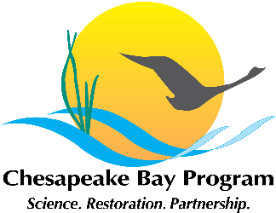

Toxic Contaminants Workgroup
Full Workgroup Meeting
Chesapeake Bay Program Office
Fish Shack
410 Severn Avenue
Annapolis, MD 21403

May 13, 2015
1:00 p.m. – 4:00 p.m.

Conference Line: (866) 299-3188
Conference Code: (410) 267-5731
Web Access: https://epa.connectsolutions.com/tcw/

Actions and Decisions from April:
- Complete: If you are interested in being an external review of the USGS EDC project plan or if you know of anyone else who the team could partner with, please email Kelly Smalling (ksmall@usgs.gov).
- Complete: If you know of other reports or activities related to issues on diversity and toxic contaminants (e.g., subsistence fishing and fish consumption advisories), please send information to Samantha Watterson (watterson.samantha@epa.gov).
- Complete: Anyone able to support the Policy and Prevention reorganization, please email Greg Allen (allen.greg@epa.gov). He will email you with information regarding an upcoming meeting (likely Thursday, April 16).

Agenda

- Welcome, Introductions (1:00-1:10)
Greg Allen, EPA
- Update on workgroup activities since April meeting.

- Discuss Public Comments and Proposed Revisions for Management Strategies (1:10-3:00)
Greg Allen and Scott Phillips, USGS
- Overview of comments received during the public input period
- Discussion and resolution of revisions needed for final version of management strategies.
- Steps to complete review and finalize strategies
Materials:
II.a. – Table of public comments for both research and Policy and Prevention Strategies
II.b. – Summary of major review comments and approaches to address (Powerpoint)
II.c. – Research Draft (Public Comment version, March 16)
II.d. – Policy and Prevention draft (Public Comment version, March 16)
II.e. – Management strategy timeline

- Mercury - Recent Findings in the Bay Watershed (3:00-3:45)
John Sherwell, MD DNR
- Overview of mercury monitoring data and trends in deposition and loading.

- STAC Workshop Proposal Updates (3:45:-3:55)
Greg Allen
- The proposal for a STAC funded workshop on techniques and barriers for high resolution PCB monitoring was not funded. How can we get this work done without STAC funding?
- Research – microplastics STAC counter-proposal.

- Next Steps and Planning for May Meeting (3:55-4:00)
Scott Phillips, USGS

