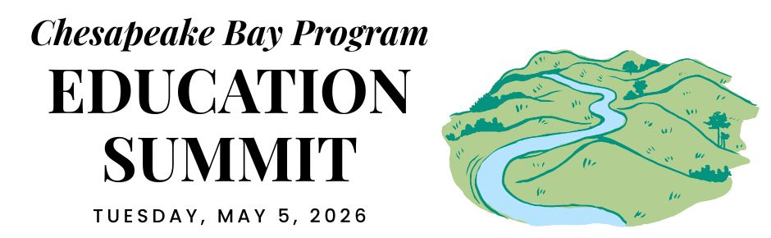
BACKGROUNDER

The Chesapeake Bay Program is a regional partnership that has been guiding the restoration and protection of the nation’s largest estuary since 1983. The Program is led by an Executive Council that consists of the governors of the six watershed states, the mayor of Washington, D.C., the administrator of the U.S. Environmental Protection Agency, and the chair of the Chesapeake Bay Commission (which serves as the legislative voice in the partnership). In 2025, this Executive Council signed an updated Chesapeake Bay Watershed Agreement to inform work through 2040.

Outcomes
The Watershed Agreement’s Engaged Communities Goal includes several outcomes that commit the partnership to work towards enabling students in the region to graduate with the knowledge and skills to protect and restore their local watershed and pursue environmental careers. These outcomes and their associated targets further the education work that has been a foundational part of the Chesapeake Bay Program since its inception. They are as follows:

Student Environmental Literacy Experiences Outcome:
Increase the number of students who participate in inquiry-based environmental literacy instruction with the aim of each student receiving at least one Meaningful Watershed Educational Experience, or MWEE, in elementary, middle and high school. (Target: By 2040, reach state targets to result in at least 75% of public school students being enrolled in a school district that offers a MWEE for all students.)

School District Environmental Literacy Planning Outcome:
Increase the number of school districts that have policies and practices in place that support environmental education and sustainable schools. (Target: By 2040, reach all jurisdictional targets for the number of public school districts that are well prepared to deliver a comprehensive and system-wide approach to environmental literacy.)

Workforce Outcome:
Increase the ability of all job seekers in the watershed to understand, participate in and succeed in career pathways that positively support the Chesapeake Bay watershed. (Target: By 2040, inform and grow implementation of strategies that help students, educators and job seekers become aware of and understand environmental careers and the in-demand skills and pathways to access these opportunities.)

Coordination
The Education Workgroup is responsible for advancing the K-12 portfolio for the Chesapeake Bay Program, including planning and implementing the biennial Education Summit. The group provides technical assistance for state and local network development, maintains the Bay Backpack website to distribute key resources and information, and convenes communities of practice around MWEE implementation, school district planning, and workforce development. The Workgroup also convenes forums focused on helping practitioners work towards these outcomes. The Education Workgroup membership is composed of strategic representatives from state departments of education and natural resource agencies, federal agencies that provide funding, resources, and technical assistance, and other organizations actively engaged in building capacity and partnerships across the region. The Education Workgroup coordinates with the Workforce Workgroup to advance K-12 elements of the Workforce Outcome.

Progress
The Environmental Literacy Indicator Tool (ELIT) monitors the capacity and progress of public school districts toward meeting the Chesapeake Bay Watershed Agreement. It is administered every two years to all local education agencies (LEAs) in the District of Columbia, Delaware, Maryland, Pennsylvania, and Virginia, as well as the 8 LEAs within the Chesapeake Bay watershed in West Virginia. Data has been collected since 2017. The survey collects data about:
- Student Experiences: The level of student participation in MWEEs and related programming during the school year.
- School District Planning: How prepared school districts are to implement comprehensive environmental literacy programming.
- Environmental Literacy Needs: What LEAs need to better support environmental literacy programming.

While the information is most usable at the state and local levels, there are some observable trends at the regional level. Every jurisdiction has systemwide MWEEs and they are in place for about a third of responding LEAs in each grade band. While the pandemic significantly disrupted environmental literacy programs, the region demonstrated an impressive rebound by the 2024 survey, largely returning to or exceeding pre-pandemic levels. When we look at LEAs who reported in both 2022 and 2024, we are seeing substantial growth in their level of preparedness and the availability of MWEEs for their students.

LEAs identified the following critical needs for continued improvement:
- Funding: This is the top priority, specifically for programming, supplies, professional development, and transportation.
- Professional Development: There is a high demand for professional development focused on facilitating outdoor field experiences and student-led action.
- Time and Staffing: LEAs frequently cited a need for more instructional time, dedicated staffing, and substitutes.

In addition to this regional information, information and reports at the state and LEA level are available. The next round of ELIT will happen this fall. Consistent participation in the ELIT survey is vital for accurately tracking progress and identifying challenges.

