Chesapeake Bay Program (CBP) Silvopasture and Alley Cropping Best Management Practices: Implementation Summary
Developed by the Chesapeake Agroforestry Network

The Chesapeake Bay Program (CBP) approved Silvopasture and Alley Cropping as water quality BMPs in 2025. This summary is based on information found in the Chesapeake Bay Program Report: Recommendations Regarding Silvopasture and Alley Cropping Agroforestry Practices. Alley cropping and silvopasture planting projects implemented in accordance with the approved CBP practice definitions and criteria are eligible for nutrient and sediment reduction credits. CBP modified the existing Natural Resource Conservation Service (NRCS) practice definitions to promote confidence in the modeled nutrient and sediment reductions and ensure consistency.

Approved CBP Agroforestry Best Management Practice definitions are as follows:
Alley cropping (AC): Trees or shrubs planted in sets of single or multiple rows integrated with agronomic, horticultural crops or forages produced in the alleys between the sets of woody plants that produce additional products. The NRCS definition was modified to clarify that trees should be integrated throughout the agricultural system.

Key Additional Criteria for AC BMP: Planting rates must achieve a minimum of 25% canopy coverage per acre at maturity. Applicable on all cropland and hayland where trees, shrubs, crops, and forages can be grown in combination.

Silvopasture planting (SP): Establishment and management of desired trees and forages on pasture. The NRCS definition was modified to emphasize that trees should also be managed as part of the silvopasture system and to clarify that the trees should be added to pasture.

Key Additional Criteria for SP BMP: Animals integrated into this system must be managed in accordance with the Precision Intensive/Prescribed Grazing (Grazing Management 528) standards. Planting rates for trees/shrubs must result in a minimum of 25% canopy coverage per acre when mature. Applicable on any pasture that is suitable for the desired forages, trees and livestock. Silvopasture applied to an existing forest is not eligible for CBP credit.

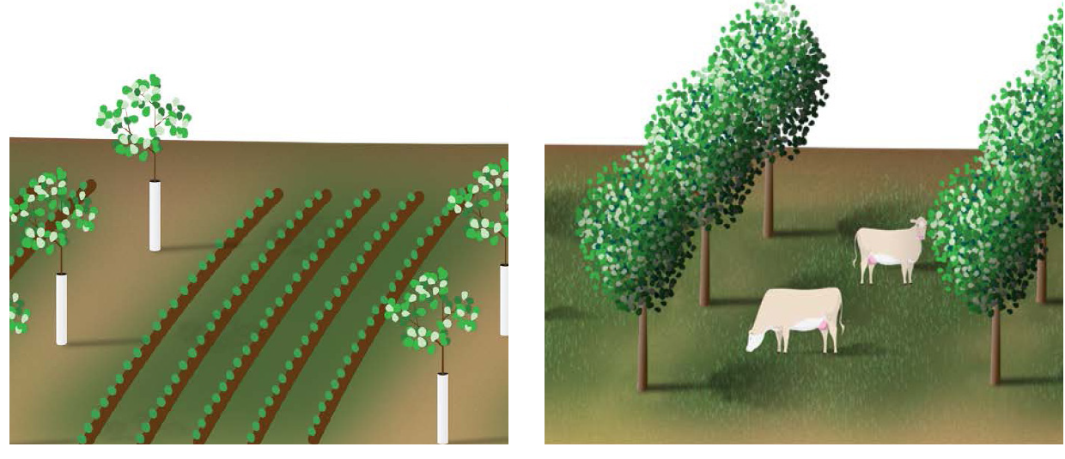
For guidance on planting rates and density, site selection, species selection, establishment, maintenance, and system management, refer to existing NRCS/state practice recommendations for Alley Cropping 311 and Silvopasture 381. (USDA National Agroforestry Center graphic)

Planning and Design: Estimating a Minimum Tree/Shrub Planting Density
When planning the site design for alley cropping and silvopasture practices, the following method translates the required 25% minimum mature canopy density into guidance on trees per acre (TPA), demonstrated across a common size range of woody plants. Spacing recommendations for achieving the minimum plant density were derived from Coder (2023). For more details on the calculations reference Appendix B in the full report.

General Size Categories of Wood Plants:
● Small trees/shrubs: multi-stemmed shrubs or small trees that are < 30’ tall or 30’ wide at maturity (based on a silvics guide).
● Large trees: large trees that are > 30’ tall or 30’ wide at maturity

The percent mature canopy minimum translated to trees per acre (TPA) for each woody plant category:
- Small trees/shrubs: 36 TPA for 20 ft-wide canopies at 20 x 60 ft spacing
- Large trees: 16 TPA for 30 ft-wide canopies at 30 x 60 ft spacing

If alley cropping or silvopasture practices are designed to maintain trees at a less-than-mature state (for example, pollarded locust, coppiced hazels, chestnuts coppiced on long-rotation, fruit trees) the minimum planting density should be increased to achieve the 25% minimum mature canopy density.

Tree Species Planning Guidance:
VA Cooperative Extension Tree Selection Guide for Mid-Atlantic Silvopastures
Summary of the Tree Selection Guide
Number of Trees per Acre by Spacing Distance (Coder 2023)

Reporting these practices for Bay Program Nutrient and Sediment Reduction Credits:
For each completed silvopasture or alley cropping project, the following parameters need to be reported to the Bay Program by jurisdictions in order to ensure Bay Program model credit:
- BMP Name: Silvopasture or Alley Cropping
- Measurement Name/Unit: number of acres planted. Note Silvopasture BMP acres must be reported with an equal number of acres of the associated Precision Intensive Rotational/ Prescribed Grazing BMP to receive credit.
- Land Use the practice was implemented on (based on CBP Land Use definitions):
○ Alley Cropping: Crop or Hayland
○ Silvopasture: Pastureland
- Location: approved Chesapeake Bay Program reporting geographies: Latitude/Longitude (preferred); County; County (CBWS Only-Chesapeake Bay Watershed Only); Hydrologic Unit Code (HUC12, HUC10, HUC8, HUC6, HUC4), State (CBWS Only)
- Date of Implementation: date the project was completed
- Practices can exist with other BMPs on the same acreage (such as nutrient management, conservation tillage, and grazing management)

