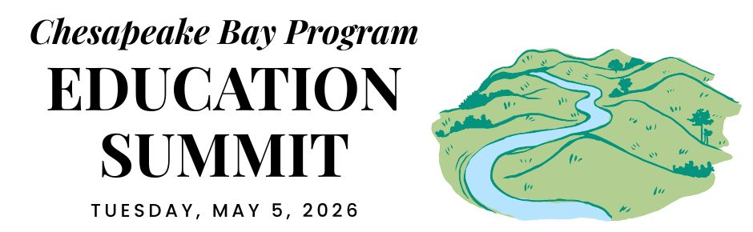

DISTRICT OF COLUMBIA DELEGATION CONVENING

REGIONAL OPENING (virtual)

12:30 PM ARRIVE & SETTLE IN

12:45 PM WELCOME
Pennsylvania is the current state lead for the Chesapeake Bay Program partnership. Hear opening remarks from their leadership to set the stage for cross-jurisdictional collaboration.
- Secretary Dunn, Pennsylvania Dept. of Conservation and Natural Resources

12:55 PM GOAL & OUTCOME OVERVIEW
Explore the new Engaged Communities Outcomes through bright spots that highlight the inspiring work being done across the region.
Facilitator: Shannon Sprague, Chesapeake Bay Program Education Workgroup

Student Experiences Outcome:

Chris Cerino, Sultana Education Foundation

Callie Sams, West Virginia Dept. of Environmental Protection

School District Planning Outcome:

Elise Sheffield, Boxerwood Education Association

Tammie Peffer, Pennsylvania Dept. of Education

Workforce Outcome:

Ashley Duncan, DC Dept. of Energy & Environment

Jon Wickert, Delaware Dept. of Education

1:20 PM INTRODUCTION TO THE REST OF THE DAY
Get a quick roadmap of the upcoming sessions and understand how they integrate into our broader shared goals.

STATE DISCUSSION (in-person)

1:30 PM DISTRICT OF COLUMBIA WELCOME
Join local leadership as they welcome everyone to the site to kick off the afternoon’s sessions.

1:35 PM EDUCATION PRIORITIES AND CONNECTIONS TO ENVIRONMENTAL LITERACY
Take a deep dive into state targets, data, and successful models designed to support student outcomes and environmental literacy in DC, with regional examples.

Rachel Sadlon, Office of the State Superintendent of Education
- Adrienne Farfalla, Department of Energy and Environment

2:10 PM BREAK/TRANSITION

2:15 PM BREAKOUT GROUPS
Collectively identify 1-3 recommendations to scale up environmental education for all students and integrate environmental literacy and sustainability into LEA-wide operations.
- Arielle Conti, Department of Energy and Environment
- Meredith Lemke, Chesapeake Bay Program
- Discussion Questions: Based on the outcomes, outputs, and what we need: What are discreet actions the District can take to achieve the Bay Program Student Environmental Literacy Experiences and School District Environmental Literacy Planning outcomes? Please consider the Bright Spots and successes from other jurisdictions.

2:55 PM BREAK/TRANSITION

3:00 PM REGROUP and SHARE-OUT
Participate in an open forum to synthesize insights from the breakout sessions and brainstorm solutions.

Arielle Conti, Department of Energy and Environment
- Discussion Question: Is there any overlap among the recommendations that came out of each break out group? Discuss the feasibility and impact of each recommendation and come to a conclusion about which ones we want to focus on as a jurisdiction.

3:20 PM NEXT STEPS
Divide up by agency and commit to tangible next steps your agency will take to work towards the identified, agreed upon solutions.
- Julia Wakeling, Department of Energy and Environment / Chesapeake Bay Program
- Discussion Question: What actions can my agency complete in the next two days, two weeks, and two months? Identify a lead for each item.

CLOSING SESSIONS

3:40 PM REGIONAL CLOSING SESSION (virtual)
Join a collective wrap-up where each jurisdiction shares their next action steps to meet our new outcomes.
- Secretary Shirley, Pennsylvania Dept. of Environmental Protection
- Regional Reflection: Share one thing that your state is excelling in, one growth area, and one concept that you plan to follow up on.

4:15 PM JURISDICTION CLOSING (in-person)
Connect for final local reflections and networking to solidify commitments made throughout the day.

4:30 PM END

