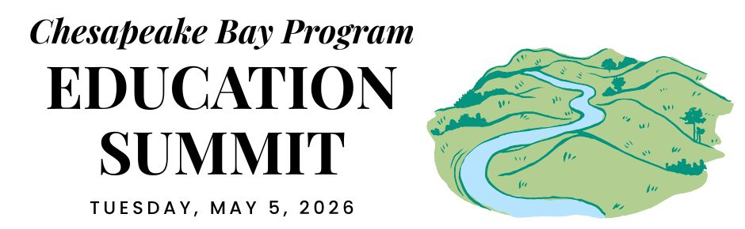

DELAWARE DELEGATION CONVENING

REGIONAL OPENING (virtual)

12:30 PM ARRIVE & SETTLE IN

12:45 PM WELCOME
Pennsylvania is the current state lead for the Chesapeake Bay Program partnership. Hear opening remarks from their leadership to set the stage for cross-jurisdictional collaboration.
- Secretary Dunn, Pennsylvania Dept. of Conservation and Natural Resources

12:55 PM GOAL & OUTCOME OVERVIEW
Explore the new Engaged Communities Outcomes through bright spots that highlight the inspiring work being done across the region.
Facilitator: Shannon Sprague, Chesapeake Bay Program Education Workgroup

Student Experiences Outcome:

Chris Cerino, Sultana Education Foundation

Callie Sams, West Virginia Dept. of Environmental Protection

School District Planning Outcome:

Elise Sheffield, Boxerwood Education Association

Tammie Peffer, Pennsylvania Dept. of Education

Workforce Outcome:

Ashley Duncan, DC Dept. of Energy & Environment

Jon Wickert, Delaware Dept. of Education

1:20 PM INTRODUCTION TO THE REST OF THE DAY
Get a quick roadmap of the upcoming sessions and understand how they integrate into our broader shared goals.

STATE DISCUSSION (in-person)

1:30 PM DELAWARE WELCOME
Join local leadership as they welcome everyone to the site to kick off the afternoon’s sessions. Secretary Gregory Patterson, DNREC.

1:35 PM STUDENT ENVIRONMENTAL LITERACY EXPERIENCES
We will consider available data, and successful models for environmental education in Delaware

Program Model: Sonia Saunders, Red Clay School District
- Available Data Discussion: Angel Burns (DNREC), Bart Merrick (NOAA), and other partners
- Discussion Question: What are the needs to support growth related to this outcome?
- Pulse Check: Support for DE signing on to this outcome

2:10 PM SCHOOL DISTRICT ENVIRONMENTAL LITERACY PLANNING
Explore systemic strategies and successful models for integrating environmental literacy and sustainability into state and district planning efforts.

DE State Environmental Literacy Plan - David Pragoff, Delaware Association for Environmental Education
- Lessons learned from current Environmental Literacy Plan Efforts -David Christopher, Delaware Association for Environmental Education
- Discussion Question: What are the needs to support growth related to this outcome?
- Pulse Check: Support for DE signing on to this outcome

2:45 PM WORKFORCE
Highlight the pathways and partnerships that bridge environmental education with green career opportunities for the next generation.
- Overview of Delaware CTE and Workforce Programs - Sarah Bell, DE Department of Education
- Highlight of Delaware Successes
- Discussion Topics:
  - How can this work support Delaware agencies, labor, and employers?
  - What Delaware strategic plans and economic and workforce priorities align with Chesapeake Bay Agreement objectives?
- Pulse Check: Support for DE signing on to this outcome

3:35 PM DISCUSSION
Participate in an open forum to synthesize insights from the breakout sessions and brainstorm solutions.

CLOSING SESSIONS

3:40 PM REGIONAL CLOSING SESSION (virtual)
Join a collective wrap-up where each jurisdiction shares their next action steps to meet our new outcomes.
- Secretary Shirley, Pennsylvania Dept. of Environmental Protection
- Regional Reflection: Share one thing that your state is excelling in, one growth area, and one concept that you plan to follow up on.

4:15 PM JURISDICTION CLOSING (in-person)
Connect for final local reflections and networking to solidify commitments made throughout the day.

4:30 PM END

