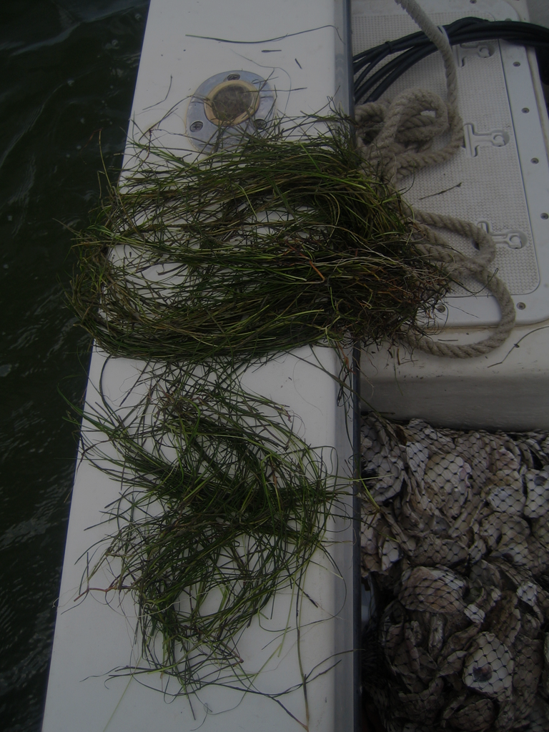
Shallow Water Use Conflict:
Submerged Aquatic Vegetation and Oyster Aquaculture Interactions

Nick Staten, Chesapeake Research Consortium
Thriving Habitats, Fisheries and Wildlife Goal Team Staffer
May 2026

Prepared for Chesapeake Bay Program’s Submerged Aquatic Vegetation Workgroup

Executive Summary

The goal of this literature review was to determine four key pieces of information based on the available in the chesapeake bay region:
- What are the potential mechanisms for which SAV and oyster aquaculture could interact with one another?
- What are the factors that affect the extent to which oyster aquaculture affects SAV beds?
- How does SAV–aquaculture interactions vary by aquaculture method (e.g., bottom culture, water-column gear, floating and fixed structures)?
- How do SAV and aquaculture interactions vary by environmental setting (e.g. salinity regime, depth)?
- What are the current (as of early 2026) permitting, management and regulatory frameworks utilized by Maryland and Virginia when considering oyster aquaculture in areas that are – or could be – occupied by SAV.
Light limitation, water chemistry alterations, and physical alterations of the environment are the three main categories of mechanisms to which oyster aquaculture affects SAV beds. When oysters are grown in the water column above SAV beds, the operation reduces the amount of light available for photosynthesis. As little as [...] light limitation in a [...] amount of time can have significant effects on SAV health metrics (e.g. canopy height, leaf width, bed density). These effects have been shown to often last more than one growing season, even if the aquaculture operation is removed. Chemical alterations have also been seen by the introduction of oysters with both harmful and beneficial outcomes. Oysters filter the water – removing chlorophyll, nutrients, and suspended solids – which benefits water clarity, quality, and can even fertilize the SAV beds as oysters excrete bioavailable compounds as waste. However, the potential benefits have a limit where sediment fertilization can turn to sediment toxification based on the density of oysters and how well the area is flushed out with the tides. Alteration of the physical disturbance of the SAV beds is another primary mechanism of interaction between the two shallow water uses. During maintenance or harvest of the aquaculture operation, trampling from aquaculturists, horizontal movement of gear, and harvest methods such as dredging all have potential for significant negative impacts on the SAV bed. On the other hand, aquaculture structures could dampen wave energy in high current environments which could increase SAV seedling success and reduce turbid conditions, increasing light penetration and therefore benefiting SAV.
The extent to which each of these mechanisms interact with SAV varies by the timing, location, and the gear setup being utilized in the aquaculture operation. Spring is an especially critical time as SAV takes in light and stores it in the form of non-structural carbohydrate (NSC) reserves to be used when the plants are undergoing stress. If aquaculture limits the capacity for this to happen, the beds will be less resilient to stress and therefore be more susceptible to long term negative impacts. The location of the operation has direct implications to whether water chemistry alteration effects will be negligible, positive, or negative. In a highly flushed area of the Bay, any potential fertilization or sediment toxification will be negligible as these compounds will be carried out with the tides. However in an area with low flushing, oyster density will be a major determination of whether bivalve metabolism will positively or negatively influence the SAV bed’s sediment. Lastly, the method of culture/harvest would be a major variable for the potential amount of physical disturbance of the SAV bed, extent of shading caused by gear, or the capability for high current dampening.
The types of gear vary significantly in the Chesapeake Bay, but the aquaculture methods can be binned into four discrete categories: (1) on-bottom direct planting without protective instrumentation, (2) on-bottom cages, and racks holding oyster bags, (3) floating gear on the water’s surface, and (4) suspended gear on longlines (see Appendix A for example pictures of each type)
SAV and aquaculture interactions also vary spatially depending on the environmental setting of the site. As mentioned already, tidal characteristics of the site are important for the extent to which water and sediment chemistry will be altered by oyster culture, but depth and salinity regime are also variables governing the relationship between the two shallow water uses. Due to turbidity limitations in the Chesapeake Bay, most SAV is limited to no deeper than 2 meters, so any aquaculture in areas deeper than this would potentially not interact with SAV whatsoever. However due to oxygen limitations in water deeper than 20 feet, aquaculture leases remain close to shore. Additionally, the species composition in the Bay varies primarily between Eelgrass (Zostera marina) in high salinity and Widgeongrass (Ruppia maritima) in low salinity. Since oysters prefer salty conditions, oyster aquaculture is primarily a concern for areas of Maryland south of the Bay Bridge and Virginian SAV beds. It is unknown how SAV species differ in response to aquaculture operations as most research focuses on the more threatened species – eelgrass.
Currently Virginia and Maryland use very similar frameworks for the permitting of aquaculture in areas supporting SAV. Both jurisdictions utilize the Virginia Institute of Marine Science’s annual aerial SAV survey to define areas where shellfish aquaculture is prohibited, which is defined as anywhere SAV has been observed by the annual aerial survey in any of the previous 5 years. Most shellfish aquaculture is prohibited in these areas, however on a case by case basis, Virginia Marine Resource Commission (for Virginia permitting) or Maryland Department of Natural Resources (for Maryland permitting) can grant permission for an aquaculturist to use an area where SAV is present. Specifically, Maryland is required to “authorize for water column leases the placement of shellfish, bags, nets, or structures in at least 10% of the area where submerged aquatic vegetation is present” (§4–11A–10) – a provision in law that will sunset on June 30th, 2027.

Research Recommendations
- Determine if a 5-6% farm footprint is the upper density limit to avoid long term negative effects on the underlying SAV bed from floating oyster aquaculture? Does this maximum acceptable footprint change by SAV species?
- How does response to aquaculture vary between the two primary Chesapeake Bay SAV species: Eelgrass (Zostera marina) and Wideongrass (Ruppia maritina)?
- Define types of sites in relation to their flushing characteristics and quantitatively describe how manipulating oyster densities affect local water/sediment quality in each site type.
- Investigate the effect of wave/current attenuation for both on-bottom and off-bottom aquaculture gear and describe how it affects SAV health and reproduction metrics. If found, weigh these benefits to the shading and other negative effects caused by gear.
- Explore the feasibility of implementing continuous measurement of SAV bed light availability in oyster aquaculture leases.
- Determine the feasibility of deep water oyster aquaculture through suspended water column systems or floating surface gear.
- Determine if oyster aquaculture-induced macroalgae growth should be a concern when permitting oyster aquaculture.

1 | Introduction
The Chesapeake Bay Watershed is the largest estuary in the United States and the third largest in the world. It is home to over 3,500 species of plants and animals, and includes a growing human presence of over 18 million people (NOAA Fisheries, n.d.; USGS, n.d.). Ever since the emergence of agriculture in the region and the use of fertilizers, mass amounts of agricultural runoff have affected underwater vegetation through changes in water quality and clarity alterations (Chesapeake Bay Program, n.d.-a). Due to this, the region has seen a steep decline in submerged aquatic vegetation (SAV) abundance – limiting the habitat type’s ability to provide its many benefits (Chesapeake Bay Foundation, n.d.; Orth & Moore, 1983).
In 1984, the Virginia Institute of Marine Science (VIMS) began their annual bay-wide aerial survey to map SAV. This dataset has been crucial in monitoring SAV coverage over the past 40 years, its response to management actions, and to inform decisions by resource managers (Chesapeake Bay Program, n.d.-b). Management decisions informed by the survey include permitting of construction projects that may influence an SAV bed, planning of SAV restoration projects, and permitting of aquaculture leases.
At the same time, oyster aquaculture has grown dramatically in popularity over the past few decades. In Maryland, the amount of acres being leased for shellfish aquaculture has more than doubled since 2010 (Link). In Virginia, the amount of oysters sold from aquaculture production has increased over 900% since 2005 (link). While oysters provide many benefits from improving water clarity and quality to creating jobs, the areas used for oyster aquaculture are often where SAV is found. Therefore, potential negative and positive interactions between cultivation of oysters and SAV are of growing interest for resource managers balancing the two shallow water uses.
In this review we present findings reported in literature on many aspects of the interactions between SAV and oyster aquaculture. First we explore the potential mechanisms that oyster aquaculture cultivation could interact with SAV. Second, we cover different methods of oyster cultivation in the Chesapeake Bay and consider their potential influence on SAV. We then discuss the variables influencing the magnitude of an operation’s effect on SAV before highlighting the spatial and environmental considerations when planning an operation that may influence SAV. Lastly we report on the management and regulatory frameworks used in Maryland and Virginia when it comes to potential shallow-water use conflicts between SAV and oyster aquaculture leasing.

2 | Potential Mechanisms of Aquaculture and SAV Interactions

2.1 Light Limitation
In all methods of oyster aquaculture, there is potential for the gear to limit the amount of light reaching the SAV bed. This will in turn limit growth as well as the ability to be resilient to stressors from other sources. The extent and duration of light limitation is a driving factor on how the SAV bed will respond.

2.2 Water Chemistry Alterations
Oysters (as well as the gear itself) have potential for altering the chemical environment of the SAV bed. Oysters filter water, removing excess nutrients, sediments, chlorophyll, and other suspended solids that would otherwise encourage harmful algae blooms and reduce light availability for SAV beds (Wheat and Ruesink, 2013; Lunstrum et al., 2018; Peterson & Heck 2001; Gurbisz et al. 2025). After consuming suspended solids, oysters metabolize them and excrete bioavailable nutrients as waste (Peterson & Heck, 2001; Holyoke, 2008). Depending on the density of oysters and the flushing characteristics of the site, this could fertilize the bed or cause build up of sulfides, ammonia, and other sediment toxifying compounds (Booth & Heck, 2009; Santamaría et al. 1994; Katwijk et al. 1997; Wagner et al. 2012; Holyoke, 2008).

2.3 Physical Alterations of the Environment
Oyster aquaculture structures can reduce wave energy, reducing suspended solids and therefore benefiting water clarity (Smith et al. 2005; Turner 2019). Gurbisz et al. (2025) observed a similar outcome, and hypothesized that the reduced shear stress could enhance SAV propagate recruitment – expanding the SAV bed acreage in areas not shaded by the cages.
On the other hand certain aquaculture methods have the potential for vegetation disruption and sediment disturbance from gear placement and upkeep (Ferriss et al. 2019; Everett et al. 1995). Some researchers show mechanical harvest to be more harmful than other aquaculture methods (Ferriss et al. 2019; Tallis et al. 2009). However, Wisehart et al. (2007) found that dredge and mechanical harvest methods had higher SAV seedling recruitment in comparison to suspended longline hand-harvested aquaculture oysters.

3 | SAV Interactions by Aquaculture Method

3.1 Off-Bottom Aquaculture
There are conflicting findings on the effects of floating gear and their effects on SAV. While Ferriss et al., (2019), a global review study on bi-valve aquaculture and eelgrass interactions, found that off-bottom methods decrease eelgrass density, percent cover, and reproduction, others have found the opposite. Regionally, Shields et al. (2025) found no negative impact to presence/absense, percent cover, nor canopy height of Z. marina. While literature has mostly hypothesized that any negative effects associated with suspended aquaculture to SAV is through shading mechanisms, Shields et al., (2025) – and in other literature (Rumrill & Poulton, 2004; Skinner et al., 2014) – suggest negative effects can be minimized by increasing spacing between floating gear.

3.2 On-Bottom Oyster Aquaculture
In addition to floating aquaculture gear, the aquaculture industry uses on-bottom gear (e.g. oyster cages, racks) or plants juvenile oysters directly on bottom without protective enclosures. SAV concerns for these methods include sediment and plant disturbance from maintenance and harvest of the grown oysters. In the case of on-bottom oyster cages, aquaculturists have to turn cages to avoid scouring of gear and avoid oysters being buried by shifting sediment. Additionally, as harvest and maintenance of these cages are carried out, workers walk alongside cages which could trample SAV (Everett et al., 1995). In the case of planting oysters directly on the bottom without cages, mechanical harvest methods (e.g. dredging) cause concern because of destruction of SAV structure or the complete removal of plants from their substrate. However, Wisehart et al. (2007) have shown dredge methods could be less harmful than hand harvesting from suspended longline cultures.
There have been numerous studies investigating the effects of on-bottom aquaculture – both positive and negative – and their implications on management of these aquatic resources. In the Chesapeake Bay, Gurbisz et al. (2025) found cages attenuate currents and their shear stress which can benefit SAV propagule recruitment and decrease sediment resuspension which could improve water clarity (Smith et al., 2009). Additionally, due to the deposit of organic carbon and denitrification potential of aquaculture operations (Lunstrum et al., 2018), the ability for SAV to colonize new areas could increase if sediment nutrient requirements are not otherwise met (Gurbisz et al., 2025). This finding is consistent with Ferriss et al. (2019) who looked at many studies from around the world and found decreased eelgrass density and biomass from oyster aquaculture, but increased eelgrass growth and reproduction in general.

3.3 A Note about Intensive vs Extensive Aquaculture Practices
In Maryland and Virginia, oyster aquaculture methods are often referred to as either intensive or extensive. Intensive oyster aquaculture is the use of on bottom, suspended, or floating cages/bags (link) [...]. Extensive oyster aquaculture refers to dropping shell on-bottom and later harvesting market sized oysters (Link) [...].

4 | Factors Influencing the Extent of SAV-Aquaculture Interactions

4.1 Hydrodynamic Mixing and Transport
Investigating the influence of biodeposits enriching or creating toxicity in a SAV bed’s sediment has been a major research question in the literature. Gurbisz et al. (2025) found minimal effects on nutrient composition in porewater and surface sediments on both sandy and muddy bottom within their on-bottom caged oyster farms in the Chesapeake Bay. They hypothesized that the area’s wave, tidal, and worker induced resuspension of any oyster biodeposits were sufficient to make any significant nutrient influence undetectable. These findings are consistent with other Chesapeake Bay studies that found minimal effects on local water and sediment quality (Turner et al., 2019), but it should be noted that while nutrient signals have been limited, other researchers have found a potential for organic matter accumulation in low energy environments within the Chesapeake Bay (Holyoke, 2008). Additionally, a positive correlation between epiphyte concentration and oyster stocking concentration above SAV beds has been observed. This suggests a relationship could exist between local nutrient availability and oyster stocking density (Skinner et al., 2014) in areas where tidal movement is not enough to clear byproducts of oyster metabolism. These findings provide the opportunity for future work on the relationship between water transport dynamics and the end outcome of biodeposits from shellfish farms.

4.2 Extent of Light Limitation
SAV relies on light to photosynthesize and aquaculture gear limits the amount of light penetrating the water column. In a few studies on the effects of floating gear, low farm footprint – such as 5% (Bulmer et al., 2012) or 6% (E. Shields et al., 2025) – has shown no overall effect on the studied SAV bed. While there are reductions to abundance and density of SAV directly below floating gear, the availability of light to other parts of the bed allow resilience on a whole bed scale.
Even before the addition of aquaculture gear, light availibility within the Chesapeake Bay are typically limited. While Shields et al. (2025) found a 5% farm footprint acceptable for eelgrass in Virginia, conditions within the Bay are dynamic and change geographically, making a maximum allowable farm footprint within any SAV bed in any location difficult to determine. A potential way to standardize could be the use of subsurface irradiance. Subsurface irradiance (SI), a ratio light passing down through the water column and the light reflected back up through the water column, is a measure of water clarity and amount of light able to be used by phytoplankton, algae and SAV. Understanding the light requirements for the many SAV species in the Chesapeake Bay and continuously measuring SI with cost-effective technology could empower farming above SAV with minimizing negative SAV impact.
Skinner et al. (2014) used a handheld meter (LI1400 Datalogger with LI-192SA Underwater Quantum Sensor, LI-COR Inc., Lincoln, Nebraska, USA) to measure subsurface irradiance 1 cm below the water’s surface. They used this to determine the effects of 3 different aquaculture apparatus on a SAV bed’s biologically relevant health metrics. The researchers have found that SAV were negatively affected in as little as 67 days after exposure to 26% subsurface irradiance (Skinner et al., 2014). These same researchers found that light shading levels representative of floating commercial oyster aquaculture reduced shoot densities and above-ground biomass by 63.1% and 85.9% respectively in the Gulf of St. Lawrence, south eastern Canada with no significant recovery 253 days after the removal of oyster aquaculture equipment (Skinner et al., 2014). A similar or more automated monitoring approach with paired thresholds for different SAV species could be used to minimize effects of light limitation on SAV beds.

4.3 Aquaculture Harvest Method
Assuming the harvest of floating aquaculture gear does not directly affect the below beds (e. g. harvest/removal of gear at high tide) the on-bottom and suspended gear types are of primary concern for SAV-aquaculture interactions during shellfish harvest. For aquaculture planted without cages, mechanical harvest is used in the form of dredging. Out of any harvest method it has been found to have the largest impact and requires the longest amount of time for SAV bed recovery (Ferriss et al., 2019). However, harvesting by hand, on foot, could have significant impact through horizontal movement of cages through worker manipulation, SAV trampling by workers, and sediment resuspension (Ferriss et al., 2019; Gurbisz et al., 2025). Wisehart et al. (2007) showed dredge methods could actually be less harmful than hand harvesting from suspended longline cultures.

4.4 Timing of Shading Initiation
SAV goes through periodic stages of growth, thereby making the timing of shading from aquaculture gear a major determination for the effects on SAV beds. Burke et al. (1996) found that spring is a significant time for plant growth and building non-structural carbohydrate (NSC) reserves. NSCs are utilized when the plants undergo periods of prolonged shading and/or heightened respiration during warmer summer conditions. Limitation to the buildup of these reserves could exacerbate the effects of shading from aquaculture gear (Skinner et al., 2014).

4.5 Oyster Density
The density of oysters in the aquaculture operation directly affects the water chemistry. This variable and the site’s flushing characteristics determine how much oyster biodeposits are accumulated within a site. This concentration has direct implications on sediment fertilization or toxification. Booth and Heck (2009) found that growth rates of Halodule wrightii in Mississippi Sound, Alabama, USA were highest in low (15 ind. m-2) and medium densities (75 ind. m-2) while high densities (150 ind. m–2) negatively affected growth rates, shoot density, and plant biomass. Oyster density and its relationship to site flushing characteristics and SAV species specifically in the Chesapeake Bay is unknown.

4.5.1 A Note On Opportunistic Macroalgae
Macroalgae are a natural part of an aquatic ecosystem, however in abundance can smother SAV as it competes for bottom space, light and nutrients (SAV-Watchers-Monitoring-Program-2024.Pdf, n.d.). Some literature (De Casabianca et al., 1997) has linked eutrophication associated with shellfish farming to increased presence of macroalgae. Others within the Chesapeake Bay (E. Shields et al., 2025) reinforce this observation but state it did not have an effect on percent cover of SAV within the shellfish aquaculture farm. Future research on how local oyster aquaculture-driven nutrient dynamics affect epiphyte loading and macroalgae prevalence would help illuminate the effect this could have on SAV in the Chesapeake Bay.

5 | Interactions by Environmental Setting and Spatial Overlaps with SAV

5.1 Salinity
There is no known literature directly investigating the relationship between SAV-aquaculture interaction by salinity regime in the Chesapeake Bay. However, since the dominant SAV species in the Bay vary by salinity regime (Moore et al., 2000; Orth et al., 2010), salinity should influence SAV-aquaculture interactions. It should be noted that while many studies focus on shellfish aquaculture to the higher salinity SAV species Z. marina, the dominant species within the bay is shifting from Z.marina to Ruppia maritima (Alvaro, 2023; Hensel et al., 2023) as marine heatwaves continue to cause decreases to Z. marina. Additionally, interactions may differ by salinity regime due to oysters recruitment, natural mortality rates, and oyster disease prevalence varying by salinity (Homer et al., 2002). For example, high salinity conditions near the mouth of the Bay leave primarily only sub-market sized oysters unaffected by disease infection (Homer et al., 2002). This could potentially be why we do not see any commercial harvest areas nor oyster aquaculture leases in this portion of the bay (VMRC, n.d.-a).

5.2 High Current Energy Environments
As stated earlier, a determining factor of the extent at which aquaculture interacts with SAV could be the local energy environment. High energy environments hosting SAV could benefit from aquaculture as gear disperses current energy. This could prompt higher seedling success and reduce seed dispersion (Gurbisz et al., 2025) – increasing the bed’s resiliency to other stressors and changing environmental effects. Additionally, any changes in local water quality due to aquaculture operations (either beneficial or harmful for SAV) could be negligible as they are flushed out by currents (Link).

5.3 Competition for Bottom Space
While not necessarily a consideration for floating aquaculture gear (unless especially low tides place floating gear directly on the bottom), spatial overlap of on-bottom cages or direct planting of oyster beds lead to direct competition for bottom space (Tallis et al., 2009, Wagner et al., 2012, as cited in Gurbisz et al., 2025). However, (Gurbisz et al., 2025) investigated the effect of oyster cage arrays in both the Potomac and Patuxent Rivers on important SAV habitat suitability parameters. While acknowledging all on-ground oyster cages were probably direct loss of potential/current SAV habitat, they found significant effects on wave and tidal shear-stress attenuation from the arrays. They hypothesized this could have beneficial effects on SAV through increasing propagule retention and decreasing seedling scour, increasing the colonization in areas not occupied by aquaculture gear (Gurbisz et al., 2025).
In the case of planting directly on bottom without protective cages, Wagner et al (2012) showed in Willapa Bay, Washington that the effects of oysters on eelgrass can exceed the footprint of the oysters, generating strong impacts above a threshold of ~20% oyster cover. To our knowledge, no studies have attempted to characterize a threshold for significant negative outcomes associated with an on-bottom oyster cover nor on-ground aquaculture gear in the Chesapeake Bay.

5.4 Depth
Within the Chesapeake Bay, SAV tends to grow in areas less than 2 meters deep due to light penetration limitations (Orth & Moore, 1988; E. C. Shields et al., 2019). Oyster aquaculture is also practiced in relatively shallow water (Mann et al., 2021) partially due to oxygen-availability concerns in deeper water. Due to this spatial restriction, aquaculture exists right where SAV beds thrive.
The interaction between the two shallow water uses could be minimized if there was more exploration of aquaculture in deeper water. Approximately 76% of the bay is in water deeper than 3 meters (Mann et al., 2021), and suspended systems in the water column or on floats could provide aquaculture industry expansion opportunities and mitigate potential effects on SAV (Mann et al., 2021).

6 | Current Management, Regulatory, and Policy Approaches Used to
Address SAV and Aquaculture Interactions

6.1 Maryland

6.1.1 Maryland’s Regulating Entities
The State of Maryland General Assembly tasks the Maryland Department of Natural Resources to oversee shellfish aquaculture(Natural Resources, n.d.-a). The Department is responsible for the “development and overall management of aquaculture and aquaculture products, coordinating and streamlining the process of applying for a State aquaculture permit, enforcing laws, regulations, and rules related to aquaculture and identifying economic development opportunities related to aquaculture” (Natural Resources, n.d.-b). Additionally, an Aquaculture Review Board and an Aquaculture Coordinating Council is used to promote the aquaculture industry, while an Aquaculture Coordinator – employed by the Department – assists persons in obtaining the permits and licenses necessary to conduct aquaculture in the State.

6.1.2 Maryland Leasing Framework for Aquaculture Operations Potentially Affecting SAV
The Department uses “SAV Protection Zones” to define boundaries of restrictions to shellfish aquaculture leasing that may affect SAV beds. They are defined as an area of submerged aquatic vegetation as mapped in an SAV survey…in 1 or more of the 5 [preceding] years” (Natural Resources, n.d.-c).
The Department utilizes two types of leases to permit aquaculture operations: submerged land lease and water column leases. “Aquaculture Enterprise Zones” in the Chesapeake Bay are designated areas approved for the leasing of submerged land or the water column by the Department in consultation with the Department of the Environment and the Wetlands Administrator of the State Board of Public Works (Natural Resources, n.d.-c). Outside of Aquaculture Enterprise Zones, the Department will consider supplying a submerged land lease as long as it is not in SAV Protection Zones (Natural Resources, n.d.-d). The lease holder is able to place “temporary protective enclosures approved by the Department on the surface of the submerged land, or in any other manner authorized by the Department”(Natural Resources, n.d.-d). Water column leases also cannot be located in a SAV Protection Zone (Natural Resources, n.d.-e).
Both lease types are restricted to outside the bounds of SAV Protection Zones but §4–11A–10 (effective until June 30, 2027) allows water column leaseholders to place shellfish, bags, nets, or structures on submerged aquatic vegetation with prior written approval from the Department of Natural Resources (Natural Resources, n.d.-f).
The criteria for gaining written approval is that the Department:
- may not authorize harvesting by dredge in areas where submerged aquatic vegetation is present;
- shall authorize for water column leases the placement of shellfish, bags, nets, or structures in at least 10% of the area where submerged aquatic vegetation is present;
- and shall authorize harvest by diving in areas on any submerged land lease where submerged aquatic vegetation is present. (Natural Resources, n.d.-f)

6.2 Virginia

6.2.1 Virginia’s Regulating Entities
In the Commonwealth of Virginia, the Virginia General Assembly grants the Virginia Marine Resources Commission (VMRC) the authority to make regulations, establish licenses, and prepare fishery management plans, conduct enforcement, and administer penalties for violation of regulation (Authority of Commission to Make Regulations, Establish Licenses, and Prepare Fishery Management Plans; Accept Federal Grants; Enforcement; Penalty for Violation of Regulation., n.d.). The role of the VMRC as it relates to aquaculture/SAV interactions consists of leasing aquaculture plots and regulating the gear used in these plots.
The Code of Virginia also uses Title 3.2: Agriculture, Animal Care, and Food to give the Commissioner of Agriculture and Consumer Services the authority to regulate aquaculture activities in the commonwealth with the policy advisory assistance of the Aquaculture Advisory Board (Aquaculture Advisory Board; Composition and Appointment of Members., n.d.). The Commissioner of Agriculture and Consumer Services’ responsibilities are:
- To provide information and assistance in obtaining permits relating to aquacultural activities;
- To promote aquaculture including encouraging investment in aquaculture facilities to expand production, processing capacity, and marketing
- To work with appropriate state and federal agencies to review, develop, and implement policies and procedures to facilitate aquacultural development;
- To consult with and assist aquaculture industry groups, aquaculture associations, and academic institutions to develop, maintain, and expand the aquaculture industry; and
- To develop, support, and implement policies beneficial to Virginia aquaculture (Authority of Commission to Make Regulations, Establish Licenses, and Prepare Fishery Management Plans; Accept Federal Grants; Enforcement; Penalty for Violation of Regulation., n.d.).

6.2.2 Virginia Leasing Framework for Aquaculture Operations Potentially Affecting SAV
Similar to Maryland, Virginia also specifies the use of the VIMS annual aerial survey to restrict new leases on areas that have had SAV present in any of the previous 5 years (Guidance_for_SAV_beds_and_restoration_final_approved_by_Commission_7-22-17.Pdf, n.d.). However, encroachment on these beds could be approved by VMRC if all mitigation measures to reduce impacts to SAV are considered and compensation explored (Guidance_for_SAV_beds_and_restoration_final_approved_by_Commission_7-22-17.Pdf, n.d.).
Virginia specifies different permitting applications based on the use of the lease. If you plan to cultivate oysters without gear taller than 12 inches, you can get a general oyster ground lease. If your gear sits more than 12 inches off the bottom, is marked at the surface with buoys, or is floating at the surface, you will need one of the following:
- General Permit #4 – If you have a regular oyster ground lease from the state and wish to grow shellfish in cages or containers greater than 12-inches above the bottomlands and/or to be marked on the surface with buoys.
- Joint Permit Application - If you wish to grow shellfish for sale in floating gear on the surface above state-owned subaqueous bottomlands, whether you have an oyster ground lease or not. This applies to floating upweller systems (FLUPSYs). OR If you wish to place cage structures upon state-owned subaqueous bottomlands, without an oyster ground lease (VMRC, n.d.-b).
General Permit #4 is described in more detail in 4VAC20-1130-10 et seq. and defines regulation pertaining to on-bottom aquaculture gear (Definitions, n.d.). In most cases, no temporary protective enclosure shall be placed in or upon submerged aquatic vegetation beds. However VMRC can permit the placement of protective enclosures in currently unvegetated areas that are documented as historically supporting submerged aquatic vegetation (SAV) beds after consulting with the Virginia Institute of Marine Science. If SAV colonizes within the boundaries of the area designated for the temporary protective enclosures, the authorization for those structures under the general permit shall remain in effect only for the remainder of the term of the lease. The general permit shall be renewed only upon a finding by the commissioner that the placement of the temporary protective enclosures within the lease will not significantly interfere with the continued vitality of the SAV.
The Joint Permit Application which is used for floating gear (VMRC, n.d.-b) is authorized by § 28.2-1205: Permits for the use of state-owned bottomlands (Permits for the Use of State-Owned Bottomlands, n.d.). This statute outlines the intention for the commission to consult with other state agencies, including the Virginia Institute of Marine Science, the State Water Control Board, the Virginia Department of Transportation, and the State Corporation Commission, whenever the Commission's decision on a permit application relates to or affects the particular concerns or activities of those agencies including water quality and submerged aquatic vegetation.

7 | References
Alvaro, L. E. (2023). Changing Foundation Species in the Chesapeake Bay: Implications for Faunal Communities of Two Dominant Seagrass Species - ProQuest. https://www.proquest.com/docview/2851685140?%20Theses&fromopenview=true&pq-origsite=gscholar&sourcetype=Dissertations%20
Aquaculture Advisory Board; Composition and Appointment of Members., Va. Code § 3.2-2602. Retrieved May 4, 2026, from https://law.lis.virginia.gov/vacode/title3.2/chapter26/section3.2-2602/
Authority of Commission to Make Regulations, Establish Licenses, and Prepare Fishery Management Plans; Accept Federal Grants; Enforcement; Penalty for Violation of Regulation., Va. Code § 28.2-201. Retrieved May 4, 2026, from https://law.lis.virginia.gov/vacode/title28.2/chapter2/section28.2-201/
Bulmer, R., Kelly, S., & Jeffs, A. G. (2012). Hanging basket oyster farming: Assessing effects on seagrass using aerial photography. Aquaculture Environment Interactions, 2, 285–292. https://doi.org/10.3354/aei00046
Burke, M. K., Dennison, W. C., & Moore, K. A. (1996). Non-structural carbohydrate reserves of eelgrass Zostera marind. MARINE ECOLOGY PROGRESS SERIES.
Chesapeake Bay Foundation. (n.d.). Bay Grasses. Bay Grasses. Retrieved May 4, 2026, from https://test-cbf-wp.pantheonsite.io/nature/bay-grasses/
Chesapeake Bay Program. (n.d.-a). Nutrient Runoff. Chesapeake Bay Program. Retrieved May 4, 2026, from https://www.chesapeakebay.net/issues/threats-to-the-bay/nutrient-runoff
Chesapeake Bay Program. (n.d.-b). SAV Monitoring Program. Chesapeake Bay Program. Retrieved May 4, 2026, from https://www.chesapeakebay.net/what/programs/monitoring/sav-monitoring-program
Crawford, C. M., Macleod, C. K. A., & Mitchell, I. M. (2003). Effects of shellfish farming on the benthic environment. Aquaculture, 224(1), 117–140. https://doi.org/10.1016/S0044-8486(03)00210-2
De Casabianca, M.-L., Laugier, T., & Collart, D. (1997). Impact of shellfish farming eutrophication on benthic macrophyte communities in the Thau lagoon, France. Aquaculture International, 5(4), 301–314. https://doi.org/10.1023/A:1018308022436
Definitions, 4 Va. Code §§ 20-1130-20. Retrieved May 4, 2026, from https://law.lis.virginia.gov/admincode/title4/agency20/chapter1130/section20/
Everett, R., Ruiz, G., & Carlton, J. (1995). Effect of oyster mariculture on submerged aquatic vegetation: An experimental test in a Pacific Northwest estuary. Marine Ecology Progress Series, 125, 205–217.
Ferriss, B. E., Conway-Cranos, L. L., Sanderson, B. L., & Hoberecht, L. (2019). Bivalve aquaculture and eelgrass: A global meta-analysis. Aquaculture, 498, 254–262. https://doi.org/10.1016/j.aquaculture.2018.08.046
Guidance_for_SAV_beds_and_restoration_final_approved_by_Commission_7-22-17.pdf. (n.d.). Retrieved January 30, 2026, from https://www.mrc.virginia.gov/regulations/Guidance_for_SAV_beds_and_restoration_final_approved_by_Commission_7-22-17.pdf
Gurbisz, C., Testa, J., Hodgkins, C., Muir, S., & Sanford, L. (2025). Oyster aquaculture effects on submersed aquatic vegetation habitat are inconsistent across space and time. Marine Ecology Progress Series, 760, 17–37. https://doi.org/10.3354/meps14833
Hensel, M. J. S., Patrick, C. J., Orth, R. J., Wilcox, D. J., Dennison, W. C., Gurbisz, C., Hannam, M. P., Landry, J. B., Moore, K. A., Murphy, R. R., Testa, J. M., Weller, D. E., & Lefcheck, J. S. (2023). Rise of Ruppia in Chesapeake Bay: Climate change–driven turnover of foundation species creates new threats and management opportunities. Proceedings of the National Academy of Sciences, 120(23), e2220678120. https://doi.org/10.1073/pnas.2220678120
Holyoke, R. R. (2008). Biodeposition and Biogeochemical Processes in Shallow, Mesohaline Sediments of Chesapeake Bay. http://hdl.handle.net/1903/8025
Homer, M. L., McCollough, C. B., Jordan, S., Vanisko, J., & Greenhawk, K. N. (2002). Oyster biomass, abundance, and harvest in northern Chesapeake Bay: Trends and forecasts. Journal of Shellfish Research. https://www.researchgate.net/publication/286998670_Oyster_biomass_abundance_and_harvest_in_northern_Chesapeake_Bay_Trends_and_forecasts
Lunstrum, A., McGlathery, K., & Smyth, A. (2018). Oyster (Crassostrea virginica) Aquaculture Shifts Sediment Nitrogen Processes toward Mineralization over Denitrification. Estuaries and Coasts, 41(4), 1130–1146. https://doi.org/10.1007/s12237-017-0327-x
Mann, R., Berman, M., Wesson, J., & Southworth, M. (2021). Physical Environment: Limitations on Productivity/Aquaculture.
Moore, K. A., Wilcox, D. J., & Orth, R. J. (2000). Analysis of the Abundance of Submersed Aquatic Vegetation Communities in the Chesapeake Bay. Estuaries, 23(1), 115. https://doi.org/10.2307/1353229
Natural Resources, 4 Md. Code Ann. §§ 4-11A-02. Retrieved May 4, 2026, from https://mgaleg.maryland.gov/mgawebsite/Laws/StatuteText?article=gnr&section=4-11A-02&enactments=False&archived=False
Natural Resources, 4 Md. Code Ann. §§ 4-11A-03. Retrieved May 4, 2026, from https://mgaleg.maryland.gov/mgawebsite/Laws/StatuteText?article=gnr&section=4-11A-03&enactments=False&archived=False
Natural Resources, 4 Md. Code Ann. §§ 4-11A-01. Retrieved May 4, 2026, from https://mgaleg.maryland.gov/mgawebsite/laws/StatuteText?article=gnr&section=4-11A-01&enactments=False&archived=False
Natural Resources, 4 Md. Code Ann. §§ 4–11A–06. Retrieved May 4, 2026, from https://mgaleg.maryland.gov/mgawebsite/laws/StatuteText?article=gnr&section=4-11A-06&enactments=False&archived=False
Natural Resources, 4 Md. Code Ann. §§ 4-11A-08. Retrieved May 4, 2026, from https://mgaleg.maryland.gov/mgawebsite/laws/StatuteText?article=gnr&section=4-11A-08&enactments=False&archived=False
Natural Resources, 4 Md. Code Ann. §§ 4-11A-10. Retrieved May 4, 2026, from https://mgaleg.maryland.gov/mgawebsite/laws/StatuteText?article=gnr&section=4-11A-10
NOAA Fisheries. (n.d.). Chesapeake Bay Habitat Science | NOAA Fisheries. (National). Retrieved May 4, 2026, from https://www.fisheries.noaa.gov/topic/chesapeake-bay/habitat-science
Orth, R. J., & Moore, K. A. (1983). Chesapeake bay: An unprecedented decline in submerged aquatic vegetation. Science, 222(4619), 51–53. https://doi.org/10.1126/science.222.4619.51
Orth, R. J., & Moore, K. A. (1988). Distribution of Zostera marina L. and Ruppia maritima L. sensu lato along depth gradients in the lower Chesapeake Bay, U.S.A. Aquatic Botany, 32(3), 291–305. https://doi.org/10.1016/0304-3770(88)90122-2
Orth, R. J., Williams, M. R., Marion, S. R., Wilcox, D. J., Carruthers, T. J. B., Moore, K. A., Kemp, W. M., Dennison, W. C., Rybicki, N., Bergstrom, P., & Batiuk, R. A. (2010). Long-Term Trends in Submersed Aquatic Vegetation (SAV) in Chesapeake Bay, USA, Related to Water Quality. Estuaries and Coasts, 33(5), 1144–1163. https://doi.org/10.1007/s12237-010-9311-4
Permits for the Use of State-Owned Bottomlands, Va. Code § 28.2-1205. Retrieved May 4, 2026, from https://law.lis.virginia.gov/vacode/title28.2/chapter12/section28.2-1205/
Rumrill, S. S., & Poulton, V. K. (2004). Ecological Role and Potential Impacts of Molluscan Shellfish Culture in the Estuarine Environment of Humboldt Bay, CA. Western Regional Aquaculture Center.
SAV-Watchers-Monitoring-Program-2024.pdf. (n.d.). Retrieved January 28, 2026, from https://www.chesapeakebay.net/files/SAV-Watchers-Monitoring-Program-2024.pdf
Shields, E. C., Parrish, D., & Moore, K. (2019). Short-Term Temperature Stress Results in Seagrass Community Shift in a Temperate Estuary. Estuaries and Coasts, 42(3), 755–764. https://doi.org/10.1007/s12237-019-00517-1
Shields, E., Kellogg, M., & Dreyer, J. (2025). Effects of floating oyster aquaculture on a Zostera marina dominated bed in Chesapeake Bay. Aquaculture Environment Interactions, 17, 59–70. https://doi.org/10.3354/aei00494
Skinner, M. A., Courtenay, S. C., McKindsey, C. W., Carver, C. E., & Mallet, A. L. (2014). Experimental determination of the effects of light limitation from suspended bag oyster (Crassostrea virginica) aquaculture on the structure and photosynthesis of eelgrass (Zostera marina). Journal of Experimental Marine Biology and Ecology, 459, 169–180. https://doi.org/10.1016/j.jembe.2014.05.012
Smith, K. A., North, E. W., Shi, F., Chen, S.-N., Hood, R. R., Koch, E. W., & Newell, R. I. E. (2009). Modeling the Effects of Oyster Reefs and Breakwaters on Seagrass Growth. Estuaries and Coasts, 32(4), 748–757. https://doi.org/10.1007/s12237-009-9170-z
Tallis, H. M., Ruesink, J. L., Dumbauld, B., Hacker, S., & Wisehart, L. M. (2009). Oysters and Aquaculture Practices Affect Eelgrass Density and Productivity in a Pacific Northwest Estuary. Journal of Shellfish Research, 28(2), 251–261. https://doi.org/10.2983/035.028.0207
Turner, J. S., Kellogg, M. L., Massey, G. M., & Friedrichs, C. T. (2019). Minimal effects of oyster aquaculture on local water quality: Examples from southern Chesapeake Bay. PLOS ONE, 14(11), e0224768. https://doi.org/10.1371/journal.pone.0224768
USGS. (n.d.). Population Growth | U.S. Geological Survey. Retrieved May 4, 2026, from https://www.usgs.gov/centers/chesapeake-bay-activities/news/population-growth
VMRC. (n.d.-a). Chesapeake Bay Map. Retrieved May 4, 2026, from https://webapps.mrc.virginia.gov/public/maps/chesapeakebay_map.php
VMRC. (n.d.-b). VMRC SHELLFISH AQUACULTURE PERMIT CHECKLIST. Retrieved https://www.aquaculture-va.com/wp-content/uploads/2023/07/map_101_aquaguide_7.5.23-VMRC-Checklist.pdf
Wagner, E., Dumbauld, B. R., Hacker, S. D., Trimble, A. C., Wisehart, L. M., & Ruesink, J. L. (2012). Density-dependent effects of an introduced oyster, Crassostrea gigas, on a native intertidal seagrass, Zostera marina&nbsp; Marine Ecology Progress Series, 468, 149–160. https://doi.org/10.3354/meps09952
Wisehart, L. M., Dumbauld, B. R., Ruesink, J. L., & Hacker, S. D. (2007). Importance of eelgrass early life history stages in response to oyster aquaculture disturbance. Marine Ecology Progress Series, 344, 71–80. https://doi.org/10.3354/meps06942

Appendix

Appendix A: General types of aquaculture methods in the Chesapeake Bay
(1) On-bottom direct planting without protective instrumentation,
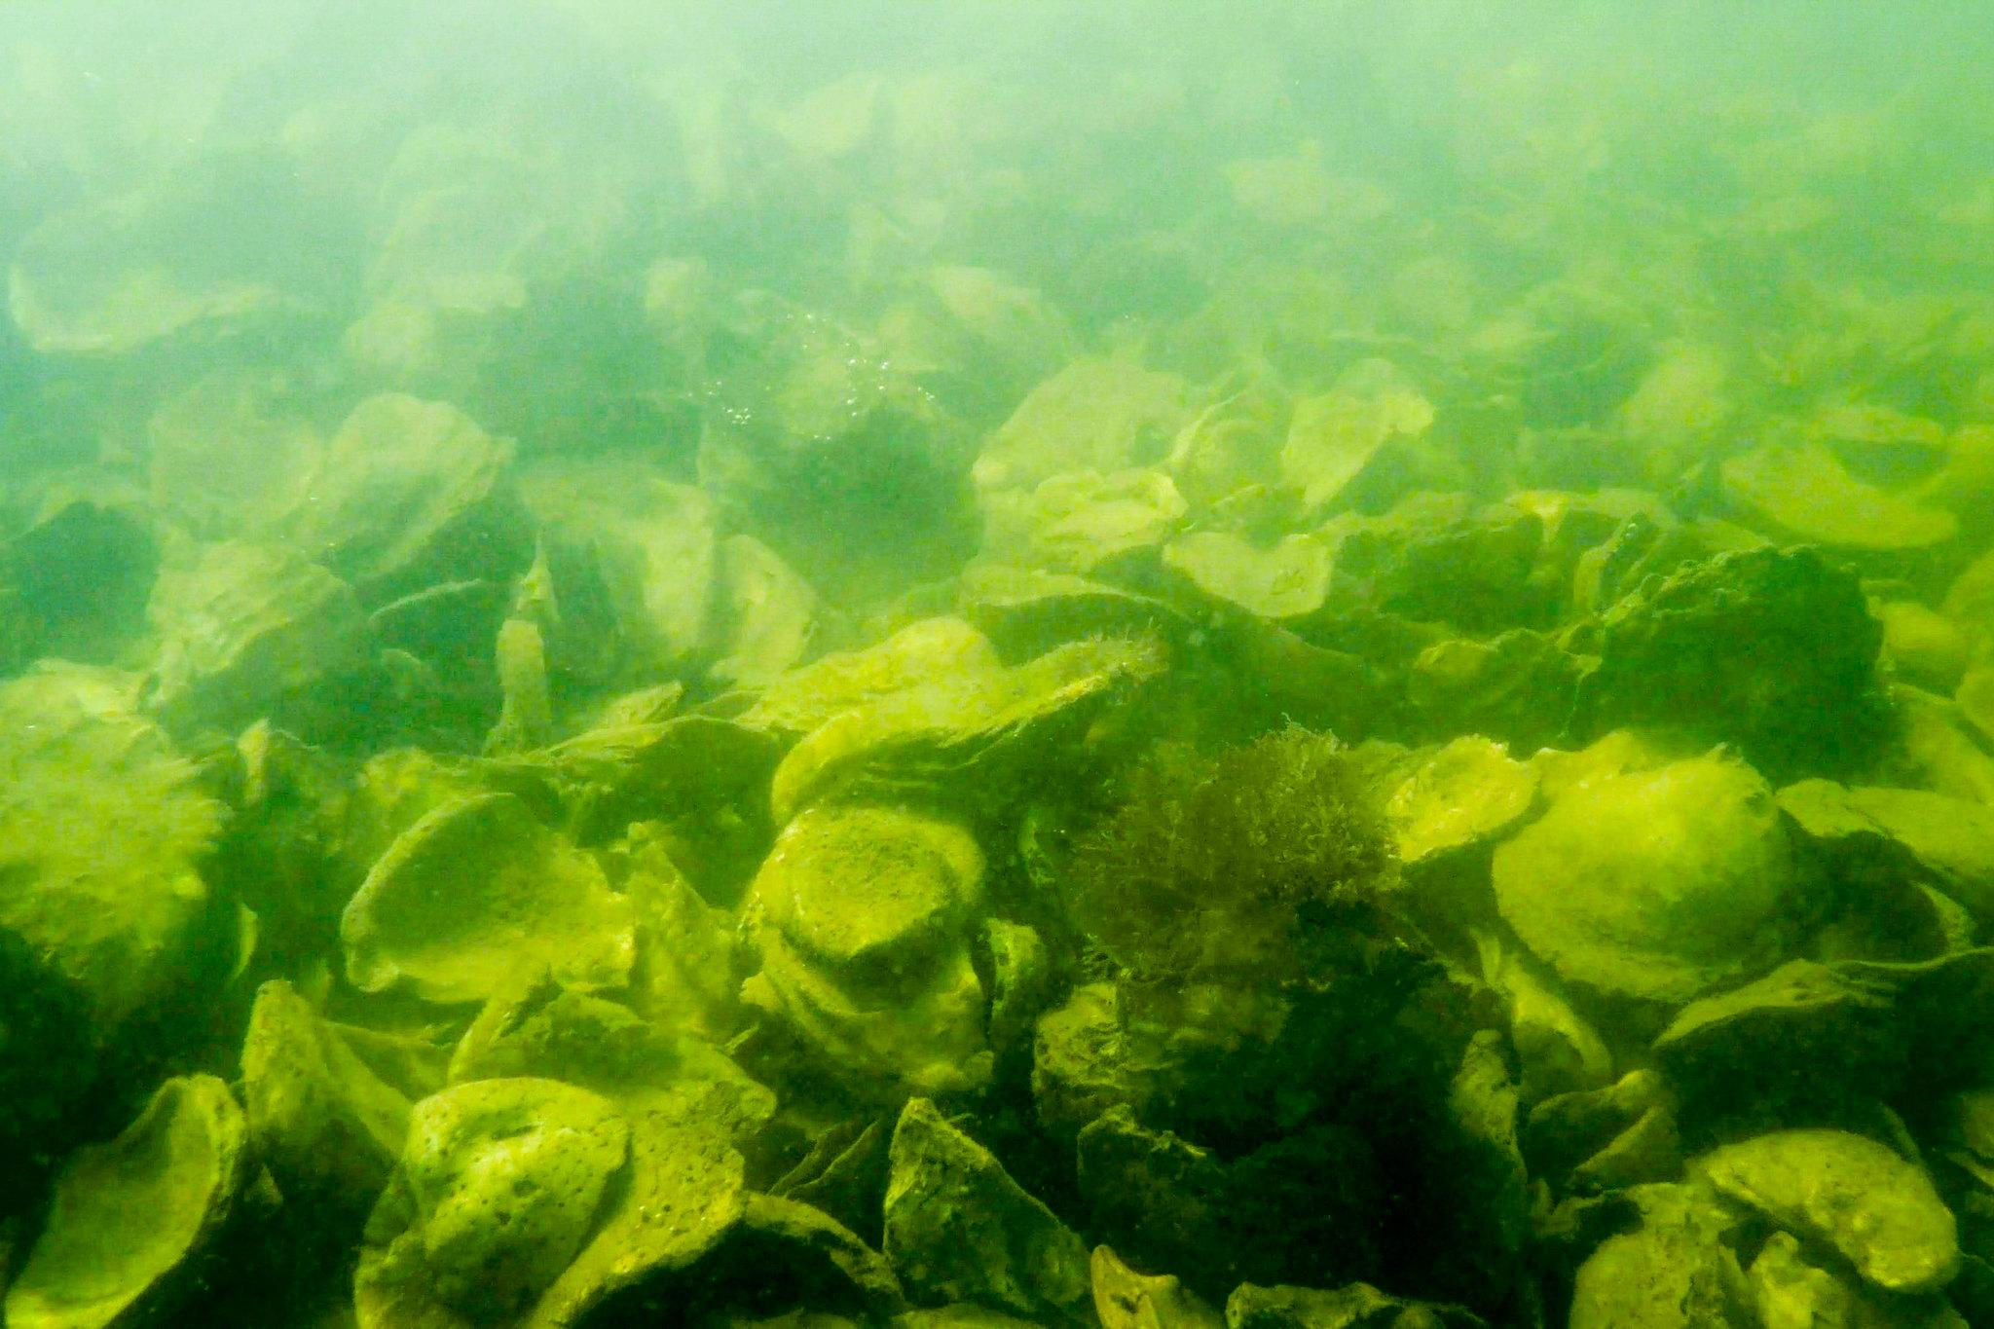
Photo courtesy of The Chesapeake Bay Program https://flic.kr/p/Yn8YCw
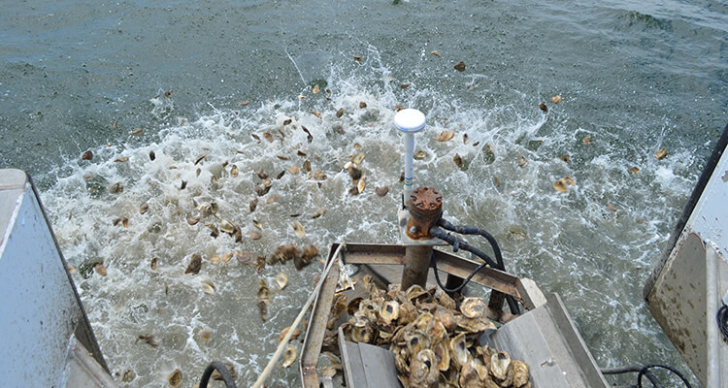
Photo courtesy of Baltimore Magazine https://www.baltimoremagazine.com/section/travel/a-new-partnership-aims-to-add-billions-of-oysters-to-chesapeake-bay/
(2) on-bottom cages and racks,
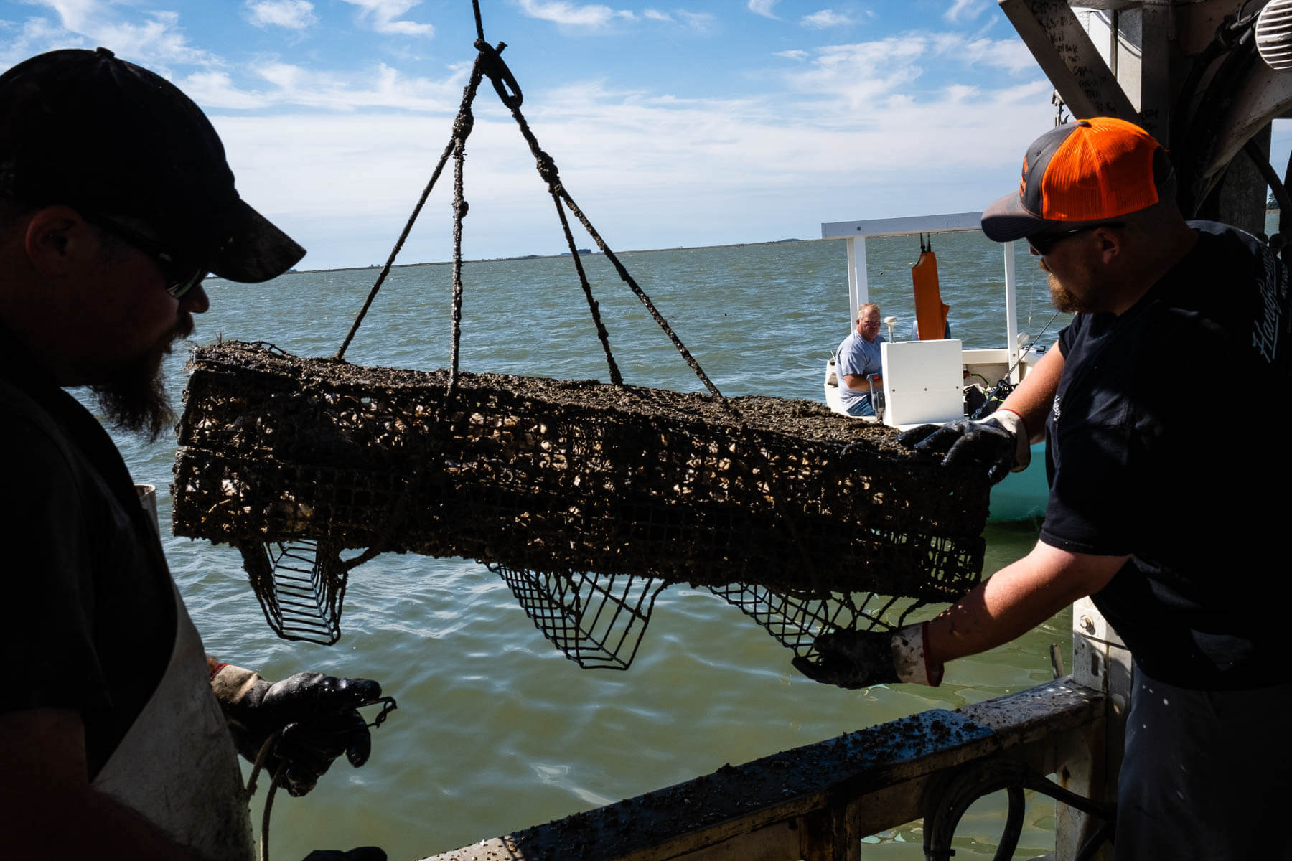
Photo Courtesty of The Chesapeake Bay Program https://www.chesapeakebay.net/news/blog/chesapeake-bay-nonprofits-lend-a-helping-hand-to-oyster-aquaculture

(3) floating gear on the water’s surface,
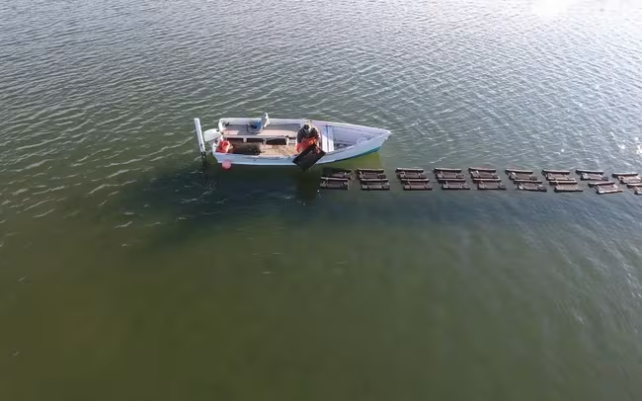
Photo Coutesy of The Nature Conservacy https://thefishsite.com/articles/fast-tracking-recovery-how-oyster-aquaculture-can-make-the-chesapeake-bay-cleaner-faster

(4) Suspended gear
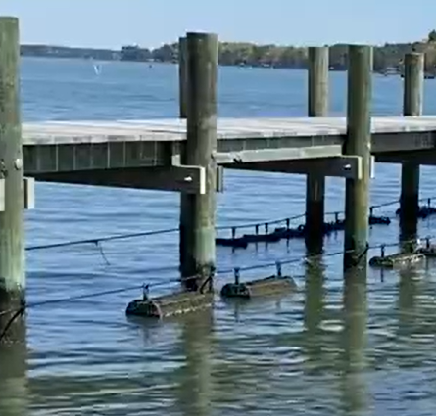
Courtesy of Chesapeake Bay Foundation: https://www.youtube.com/watch?v=FLgW_FZ47Lg&t=16s

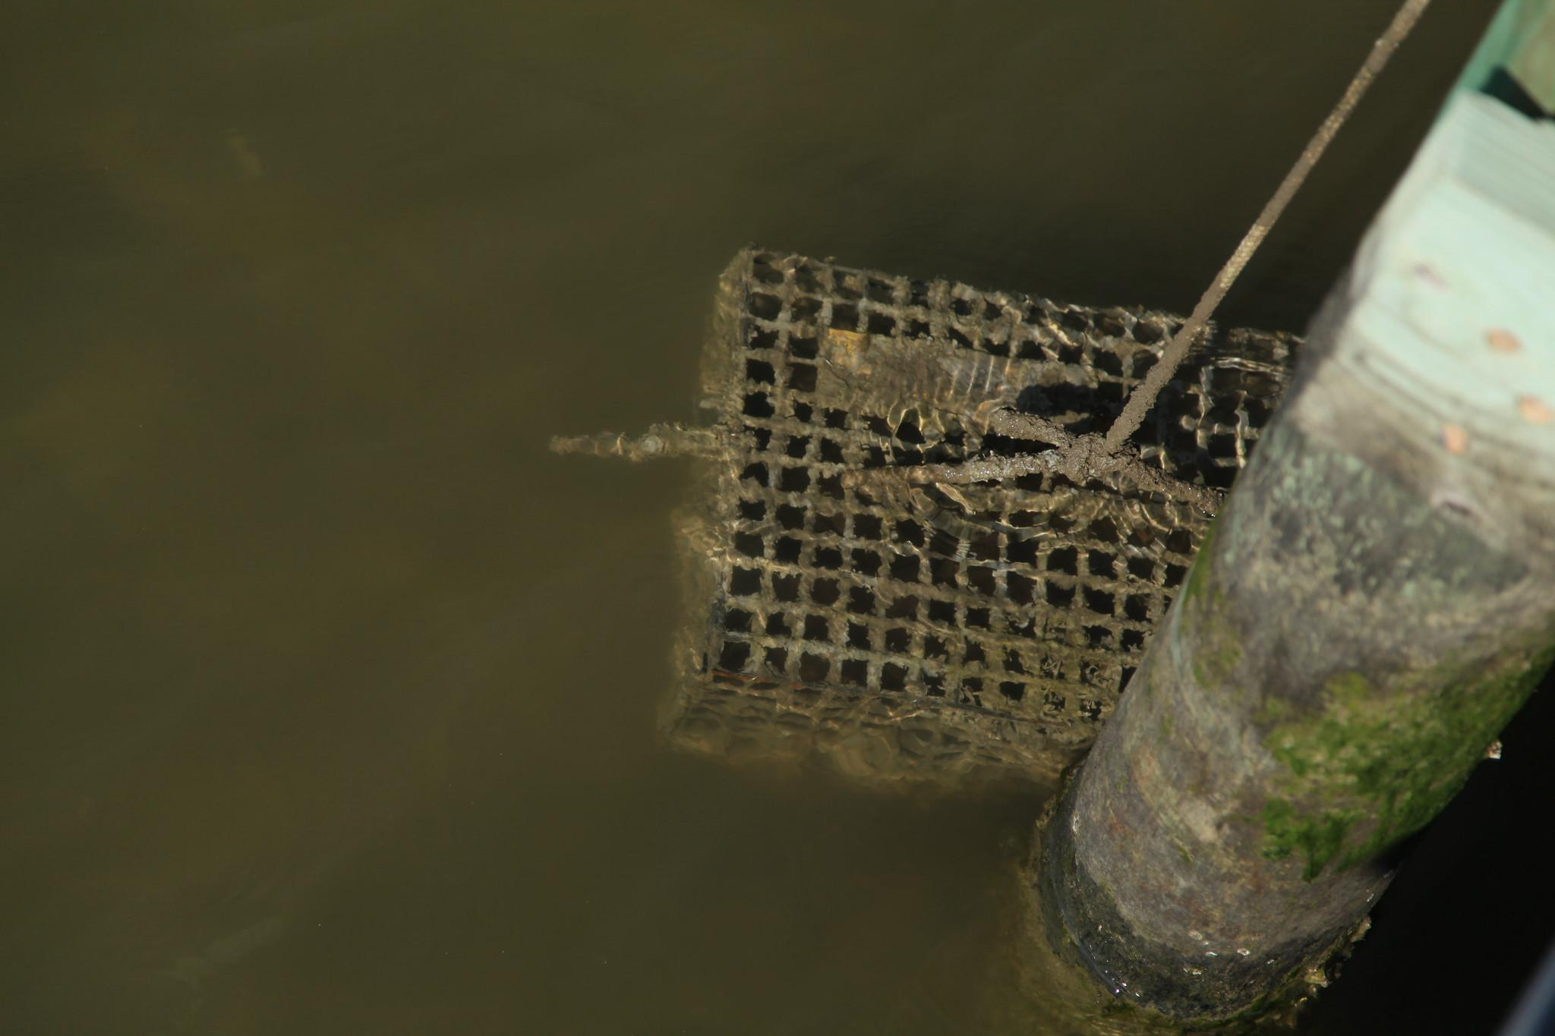
Photo Courtesy of Chesapeake Bay Program https://flic.kr/p/dW8Mn2 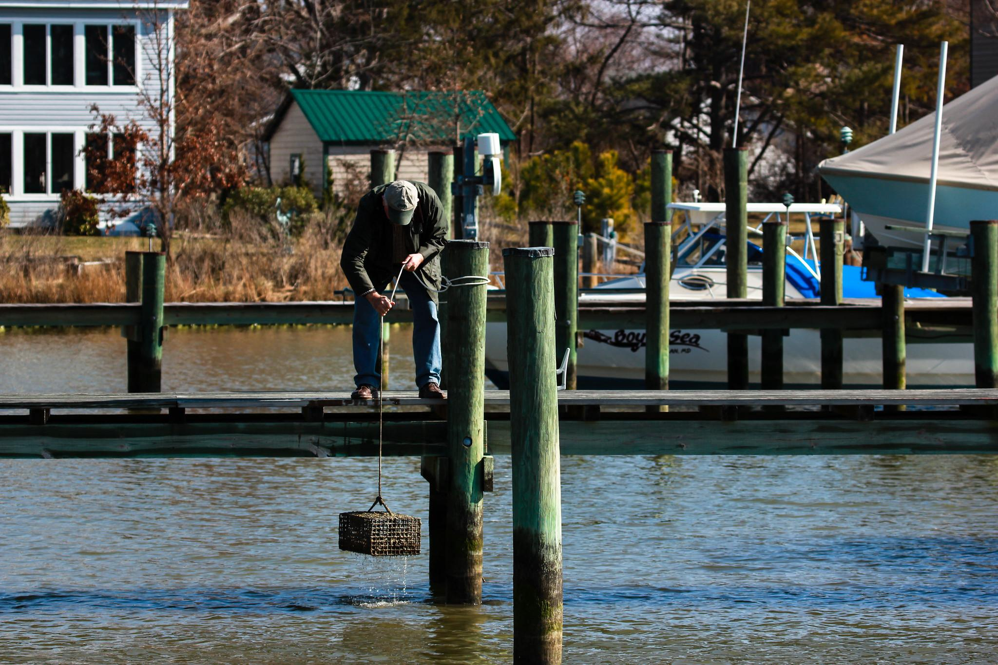
Photo courtesy of Chesapeake Bay Program https://flic.kr/p/dW8M46

