The Role of the Scientific, Technical Assessment, and Reporting (STAR) team in the CBP (working update: March 2023)
Need: The Scientific, Technical Assessment, and Reporting (STAR) team coordinates monitoring, modeling, and analysis across the Chesapeake Bay Program (CBP) partnership to help decision makers progress toward the Goals and Outcome of the 2014 Chesapeake Bay Watershed Agreement (hereafter, Watershed Agreement). STAR has evolved from having a water quality emphasis to encompass a more ecosystem-based science mission required by the Watershed Agreement through supporting the Goal Implementation Teams (GITs) in identifying, organizing, and addressing their science needs. This document represents an update of STAR’s purpose and function, which was last visited in 2015.

Overview of Purpose and Functions
Purpose: Enhance Chesapeake Bay science and capacity by facilitating collaboration among science providers to provide monitoring, modeling, and analysis needed to update, explain, and communicate ecosystem condition and change to support the CBP GITs.

The major functions of STAR (shown on figure 1) include:
- Manage and coordinate the Strategic Science and Research Framework (SSRF) to identify, track, and address the CBP science needs for the Watershed Agreement.
- Interact with GITs to coordinate science partnerships and identify new opportunities to address science needs in SSRF and science capacity for Watershed Agreement outcomes.
- Manage CBP-funded monitoring networks and collaborate with monitoring organizations to utilize and enhance additional networks to address the outcomes in the Watershed Agreement.
- Ensure data comparability, completeness, and integrity.
- Update, and deliver, the status and trends (indicators) of ecosystem conditions.
- Contribute to explaining ecosystem condition and change.
- Conduct modeling to improve water-quality decision-making and better understand and predict ecosystem response.
- Coordinate science support of climate change activities.
- Enhance information management, access, and GIS support.
- Produce synthesis products and reports to better communicate scientific results and aid in science informed management decisions.

Figure 1 shows the relationship to the GITs, Scientific and Technical Advisory Committee (STAC), and major functions of STAR. STAR efforts provide science support to address needs that benefit the full breadth of outcomes in the Watershed Agreement. Additional technical expertise to address these functions further exists within the GITs and with science providers (federal, state, and academic partners) supporting the CBP. STAR facilitates collaboration between science providers and GITs to carry out these functions and address additional science needs. Collaboration is critical to effectively provide the science needed to support the GITs as they monitor, assess, interpret, and report progress towards achieving the goals and outcomes of the Watershed Agreement. STAR helps promote the efforts and products of the CBP science partners to decision-makers to encourage science-informed management decisions. STAR has a collaborative relationship with STAC which provides scientific and technical guidance to the CBP on activities to restore and protect the Chesapeake Bay and its watershed. To provide this guidance, STAC hosts workshops and reviews to produce reports that include recommendations for the CBP and its partners. More information on STAC-STAR roles is provided below.

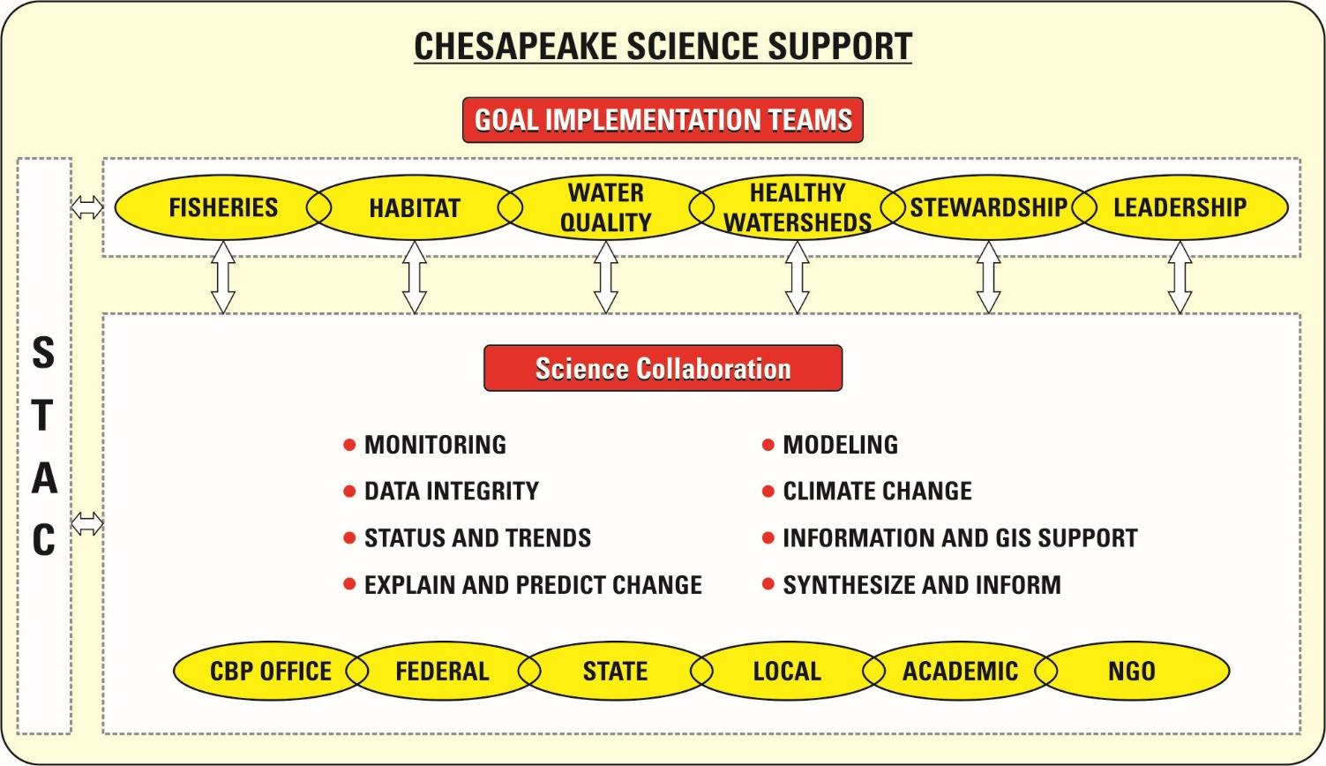
Figure 1: Major functions of STAR and relation between STAR with Goal Implementation Teams (GITs) and the Scientific and Technical Advisory Committee (STAC).

Description of STAR Functions and Workgroups Roles.
The following is a description of STAR membership and major functions of STAR to meet the needs of the CBP. STAR organization structure is shown in figure 2.
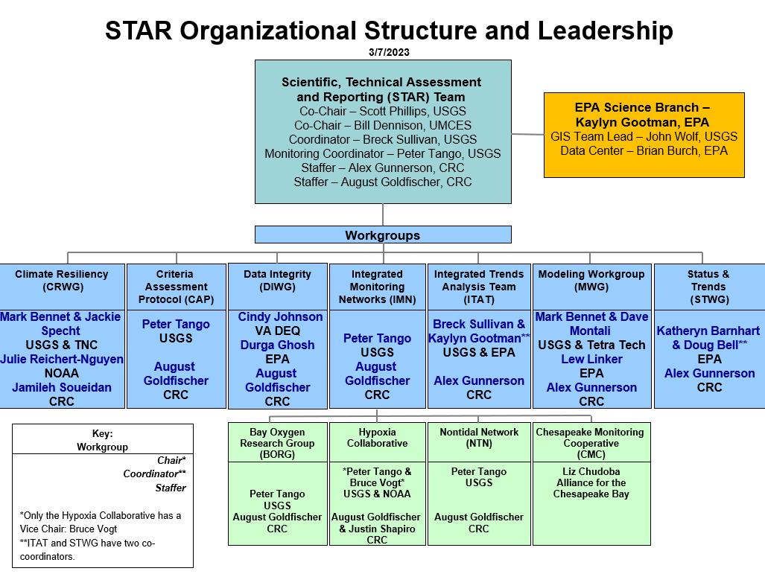

STAR Membership
Core Members:
- Representative from STAR workgroups (7) (ideally being a Chair or Coordinator)
- Representatives from the GIS team, data center and science branch (3)
- Representative from STAC (1)
- GIT coordinators (6)
- STAR leadership team (chairs, coordinator, staffers) (5-6)
- At large members (5-6)
- Chesapeake Monitoring Cooperative representative (1)

Core Membership Expectations:
- Attend ¾ out of all STAR meetings during a given year.
- Contribute information that will help the CBP meet the science needs of all Outcomes.
  - Provide feedback, resources, contacts, contribute directly to enhancing the science and making progress on science needs, and communicate STAR’s work and science needs to their networks.
Interested Parties:
- Anyone who is interested in being on the mailing list, with no minimum attendance or contribution expectations.

Manage and Coordinate the Strategic Science and Research Framework.
The CBP developed the Strategic Science and Research Framework (SSRF), which defines a process to track and update science needs across the 31 outcomes of the Watershed Agreement. SSRF is used to gather short- and long-term science needs consistently and transparently as part of the CBP Strategy Review System (SRS). The SRS provides an adaptive management approach to characterize status and assess progress on achieving each outcome. SSRF is used to (1) assess if needs are being met, (2) help prioritize needs requiring resources, (3) identify science partners that can help meet those needs, and (4) enhance CBP science capacity and knowledge. STAR manages the tracking of the science needs through the continuous update of the CBP Science Needs Database which is used to engage stakeholders and identify opportunities to better align or evolve resources. STAR coordinates the resource assessment to first consider capacity and knowledge of science support teams within the CBP and if additional support is needed, provide a strategic approach for partner resources to address a science need.
Anticipated Needs: Expanded capacity to address the science priorities which requires the engagement of the broader scientific community to (1) translate and disseminate existing science, and (2) encourage and implement additional research to inform effective management options and actions that support achievement of restoration goals for the Chesapeake Bay and its watershed.
Primary Team: STAR

Interact with the GITs to coordinate science partnerships and identify new opportunities to address science needs in SSRF and science capacity for Watershed Agreement outcomes. If support for a science need within the CBP is not possible, the next step is to consider CBP partners, including federal and state agencies, local entities, nonprofit organizations, community science programs, and academic institutions. Request to these partners for the science need may be for funding to execute the need, expanding their staff support to address a need, collaborating as a team, or helping increase the knowledge of a science topic. Each science need requires its own specific action and resources so there is no direct line for which CBP partner to always consider first, but this does allow for the CBP GITs to build relationships with a diverse set of partners. Examples of application of SSRF include CBP GITs using it to identify projects for GIT Funding as well as other funding sources such as the EPA Regional-ORD Applied Research Program (ROAR). Academic institutions have shaped courses and graduate student studies around supporting science needs.
Anticipated Needs: (1) Increase utilization of CBP Science Needs Database by the partnership to address science needs through their grants and proposals developments, strategic management planning, and research direction, and (2) build and strengthen relationships with science partners to support accomplishment of science needs.
Primary Team: STAR

Manage CBP monitoring networks and collaborate with monitoring organizations to utilize and enhance additional networks to address the outcomes in the Watershed Agreement.
The CBP currently manages several monitoring networks – Tidal and Nontidal water quality, tidal benthic macroinvertebrates, submerged aquatic vegetation, community science monitoring, and land use and land cover monitoring, i.e., “the core networks,” which are described in the CBP monitoring report (CBP, 2022). The networks are complex with many federal, state, local, and academic partners collecting and contributing data. Sustained and improved monitoring will allow the CBP partners to assess and evaluate progress from restoration and conservation efforts, while identifying gaps where more attention is needed in the future.

The recent CBP monitoring report (CBP, 2022) identified additional monitoring needs required to address assessment on progress toward achieving the goals and outcomes of the Watershed Agreement. STAR will work with the CBP GITs to support sustaining existing monitoring networks supporting analyses for the assessments for outcomes, improve coordination and efficiency of networks for outcomes with monitoring gaps to meet their decision-making needs, and assist in development of new monitoring design plans for outcomes lacking monitoring networks. Work between STAR and the GITs aims to evaluate and enhance the core CBP monitoring networks and assess options for addressing the monitoring needed for all outcomes in the Watershed Agreement.
- Anticipated Needs: (1) Address the development, maintenance, and improvement of CBP core monitoring networks, (2) identify and confirm long-term funding to sustain enhancements of CBP core monitoring networks, (3) coordinate with multiple GITs and agencies/partners to address monitoring needs for the Watershed Agreement.
- Primary Workgroup: Integrated Monitoring Networks Workgroup (WG)

Ensure information completeness, comparability, and integrity. STAR will lead coordination of CBP partners to ensure the completeness, comparability and integrity of data collected from monitoring networks. An ongoing function is to ensure the quality of data generated from the CBP water-quality networks. An increasing future need will develop approaches to assess and improve comparability of information from additional networks that will be used to support the breadth of outcomes in the Watershed Agreement. Evaluating the use of community-based data will be an important task.
- Anticipated Needs: (1) Extra help with all aspects of data management needed for effectively developing and expanding monitoring networks and the data they generate for the CBP, (2) develop Quality Assurance guidelines for non-traditional partners to use as alternatives for conventional sample analysis methods.
- Primary WG: Data Integrity WG

Update, and deliver, status and trends (indicators) of ecosystem conditions. Many of the GITs and associated WGs have the lead responsibility to update CBP indicators. STAR will collaborate with the GITs and science providers to update indicators, or work to develop, refine, review, approve, and implement additional indicators that are needed for assessing status and evaluating progress toward meeting goals and outcomes of the Watershed Agreement. The CBP GIS team will oversee compilation and support of spatial data related to the indicators. STAR will work with those on the Accountability and Budget Team and the Communications Office to have the results reported on the CBP Chesapeake Progress site and the annual Bay Barometer.
- Anticipated Needs: (1) Develop and maintain new indicators needed for evaluating outcome metric status, and evaluate progress toward meeting targets of the outcomes in the Watershed Agreement, (2) improve streamlining the process through information sharing, and (3) identify influencing factors and their relationship with indicators and their influence on outcome success.
- Primary Workgroup: Status and Trends WG and supporting team, which includes the Indicator Co-Coordinators working with GIT coordinators, GIS team, and CBP Web Team.

Contribute to explaining ecosystem condition and change. Explaining ecosystem condition and change for the entire Chesapeake Bay requires gathering researchers and analysts from various governmental, academic, non-profit, and private organizations to enhance understanding of spatial and temporal patterns. The unique role of STAR is having established relationships with science providers to identify linkages among the ongoing research activities of participating individuals and organizations. STAR also works with STAC, GITs, and science providers to enhance technical expertise and conduct analysis and synthesis of the science on changes in water quality, living resources, and habitats conditions. These efforts are focused on priority science topics identified by the GITs to understand and enhance progress towards achieving their respective outcome in the Watershed Agreement.
- Anticipated Needs: (1) Update methods of trend assessment, (2) prepare and distribute Tributary Summaries to serve as a communication tool on water quality changes with respect to management actions to further inform management decisions, and (3) integrate tidal and nontidal water-quality trend results to understand the relationship between watershed loads and their influence on water quality condition and living resource responses in the estuary.
- Primary WG: Integrated Trends Analysis Team

Conduct modeling to improve water quality decision making and better understand and predict ecosystem response. The current CBP modeling emphasis is focused on predicting water-quality response to nutrient reduction efforts. The Phase 7 modeling efforts plan to better simulate selected processes in the estuary, including shallow-water conditions. Modeling is an integrating tool, and the concept of multiple models will be used to create a collaborative environment for integrating understanding of ecosystem behavior developed from disparate scientific studies. The modeling would need to expand its scope from water quality centric assessments to address/coordinate with ecosystem modeling efforts supporting other goal and outcome needs. Opportunities to better collaborate with CBP science providers from federal and state agencies, academics, and non-profits will be explored to expand modeling capacity. Further effort is needed to support aligning modeling work and its outputs for the broader suite of outcomes with the CBP watershed and estuary modeling frameworks.
- Anticipated Needs: (1) Developing finalized bay and watershed modeling plans through 2025, (2) exploring linkages with the bay and watershed models to include living resources and ecosystem services addressing decision-support needs for the diverse outcomes in the Watershed Agreement, and(3) envisioning the modeling scope and developments needed to provide decision-support across the breadth of Watershed Agreement outcomes beyond 2025, for example enhancing modeling for nearshore, shallow water environments.
- Primary WG: Modeling Workgroup

Coordinate science support of climate change activities.
Climate change is a crosscutting issue that affects all the outcomes in the Watershed Agreement. In many cases, the effect of climate on achieving individual outcomes is not well understood, and in other cases, it is well established and moving forward. Through STAR’s activities in supporting the management of SSRF, it will coordinate the identification of climate science needs with the GITs. STAR will also seek opportunities to provide advisory and scientific support to incorporate climate change considerations in Watershed Agreement outcomes strategies, in coordination with the other GITs. The Climate Resiliency WG will focus on addressing the two outcomes of the Climate Resiliency Goal in the Watershed Agreement.
- Monitoring and Assessment Outcome: to Continually monitor and assess the trends and likely impacts of changing climate and sea level conditions on the Chesapeake Bay ecosystem, including the effectiveness of restoration and protection policies, programs and projects.
- Adaptation Outcome: Continuously pursue, design and construct restoration and protection projects to enhance the resiliency of Bay and aquatic ecosystems from impacts of coastal erosion, coastal flooding, more intense storms, more frequent storms, and sea-level rise.
- Anticipated Needs: (1) Update and develop indicators to assess trends in changing environmental conditions from climate change effects and coordinate with appropriate GITs to connect their application more directly with decision-support for the Watershed Agreement outcomes, (2) increase understanding of climate change effects, such as sea level rise and extreme events, on nearshore, shallow water habitats (e.g., marshes, submerged aquatic vegetation) and build capacity to support design, implementation, and tracking of restoration and protection projects that improve resiliency of these habitats while also maximizing other resilience benefits (e.g., shoreline protection, flood reduction), and (3) coordinate with GITs in identifying climate change science needs and providing advisory support when needed on climate resilience efforts..
- Primary WG: Climate Resiliency WG

Enhance information management, access, and GIS support
The CBP Data Center will continue to enhance data systems and tools to more effectively ingest, manage, share, and access data. The Data Center will continue its core function to manage information to support the needs of CBP. The Data Center will have to expand partnerships with other providers to effectively manage and share information needed by the CBP to address the outcomes in the Watershed Agreement​​. The CBP GIS team will provide a wide variety of geographic information, scientific research and support to the CBP Partnership. They will lead topics on characterizing landscape condition, implications for vulnerability and resilience, and enhanced geospatial data management and visualization through watershed and estuarine geographic science and research, web development, data development, and data visualization and communication projects. All these activities will be communicated and shared with STAR.
- Anticipated Needs: Support the ongoing need for current, high-resolution land use and land cover (LULC) data to support assessing progress of multiple outcomes in the Watershed Agreement and given the costs and preparation time required to produce such data, a long-term production strategy is required. Additional support is needed in technical assistance for GITs and Workgroups for GIT Funding and other initiatives. Finally, additional GIS capacity is warranted to address the need to make geospatial information relevant to local decision making and to better integrate social science information into landscape assessment and geographic targeting efforts.
- Primary Teams: CBP Data Center and GIS team

Contribute to synthesis products and reports to better communicate scientific results aiding science-informed, data driven management decisions. STAR will work with STAR workgroups and GITs to identify technical topics where a synthesis product would help effectively communicate results to decision makers. STAR would work with the GITs, science providers, and CBP Strategic Engagement Team to summarize and message technical results of above efforts, communicate the findings, and share management implications with a wider range of audiences. Prepare communication products that are tailored to specific audiences and ensure the science is correctly portrayed. A focus will be on synthesizing the scientific work of STAR workgroups to explain and communicate the health of and changes in the Chesapeake Bay ecosystem.
- Anticipated Needs: Coordinate the maintenance of existing cooperator relationships and creation of new relationships to support dissemination and utilization of communication products.
- Primary Teams: STAR, CBP Strategic Engagement Team, GIS Team

Relationship between STAR and STAC
STAR has a collaborative relationship with STAC and each has a distinct role:
- STAC provides independent review and recommendations to the CBP to enhance science support (monitoring, modeling, and research) for effective decision-making in restoring Chesapeake Bay.
- STAR coordinates with science providers and GITs to address the monitoring, modeling, and analysis needed to achieve the outcomes in the Watershed Agreement which may include carrying out the STAC recommendations.

STAC supports the CBP adaptive management process through its efforts to identify critical science needs and potential emerging issues through its various proactive and reactive efforts (e.g., workshops, reviews, whitepapers) and connect them back to CBP outcomes (Figure 3). They play a key role in administering the SSRF by using their quarterly meetings as an opportunity for outcome leads to share a subset of their science needs with the academic community to assess current efforts to address any of the science gaps and potentially drive research directions. It also provides STAC members with an opportunity to comment on science needs that may be missing.

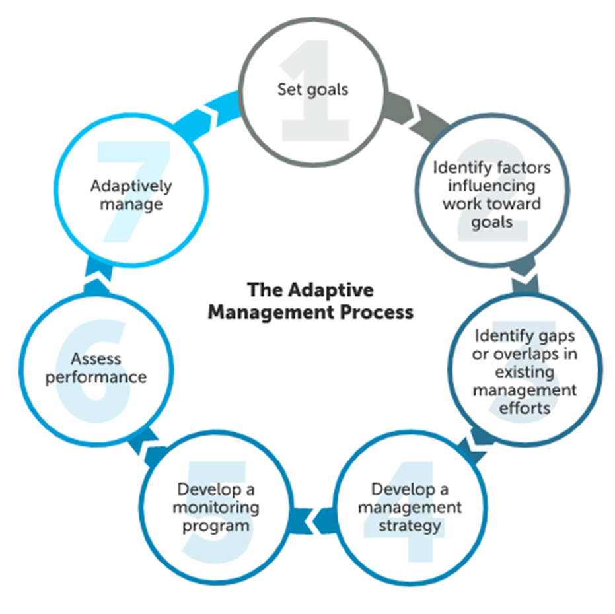
Figure 3. Chesapeake Bay Program decision framework for adaptative management used with STAC

Additional STAC roles in administering the SSRF for CBP may expand to:
- Provide input on outcome science needs through connections to STAC recommendations,
- Use STAC’s network to share the science needs database,
- Advocate for research and associated funding to partners and CBP leaders to address science needs.
Additional STAC member roles in SSRF may expand to:
- Serve as a conduit of capacity for their academic institution,
- Present relevant research findings to GITs,
- Consider new research to address needs,
- Have students consider science needs for internships or graduate work.

Suggestions to enhance steps to implement STAR’s purpose and functions.
- Enhance collaboration with each GIT. STAR will increase collaboration with each Goal Team by (1) having a STAR representative present in GIT meetings for relevant agenda topics to STAR purpose and functions (i.e., efforts supporting science needs, enhancements to tool), (2) working more closely with GIT coordinators and CRC staffers to find resources to meet their science needs and help prioritize unmet GIT science needs, (3) STAR Coordinator will hold office hours/checkups with GITs in between their SRS cycle to ensure the science needs in the database are most update.
- Increase interaction with STAC. STAR will work closely with STAC to identify additional science support it can provide to assist GITs in progress towards measuring, planning, managing, and achieving their outcomes. STAR will also work with STAC and GITs to identify cross-cutting topics and organize technical exchanges or propose workshops to address the topics.
- Increase interaction with CBP Science, Analysis, and Implementation Branch (SAIB). Share science needs from GITs to drive SAIB priorities. Encourage participation of SAIB members in SSRF meetings. Collaborate with SAIB on opportunities to align modeling, monitoring, data management, and GIS needs with GIT science needs.
- Increase collaboration with CBP Partnership and Accountability Branch. Share science needs related to non-water quality related outcomes to increase staff capacity for establishing and maintaining indicators with available funding sources. Emphasize science needs that align with indicator needs and those that go beyond direct outcome attainability.
- Enhance science coordination. Bring new and emerging natural and social science topics to STAR meetings and identify recommendations from the key findings. Based on the recommendations of STAC workshops, STAR will help identify science needs from these recommendations and coordinate with relevant outcomes to track them through SSRF.
- Expand membership. STAR will expand its membership to include science providers to be on its workgroups to carry out each of its major functions. STAR will also work with the GITs to have a representative from them to interact with STAR so they can enhance collaboration, and monitor, assess, and explain ecosystem change. STAR will target additional participants for their meetings based on the topic to expand science providers present. STAR will strengthen relationships with Historically Black Colleges or Universities (HBCUs) and Minority Serving Institutes (MSIs) to encourage key participants to serve as an interested party or at large member of STAR.
- Refine Meetings. STAR will have three types of meetings: (1) full membership meetings (every month), (2) leadership meetings (3 – 4 times per year), and (3) Strategic Science and Research Framework meetings (Cohort presents the month after their Quarterly Progress Meeting to the CBP Management Board). The full membership meetings will focus on supporting and informing the science needs of the GITs. They would have key presentations of findings and collaboration opportunities that should be of interest to multiple GITs. The leadership meetings will focus on reviewing progress of STAR workgroups to provide the science requested by the GITs and synergies of work among the STAR workgroups. SSRF meetings will serve as a venue for a representative from each outcome in the respective SRS cohort to present their updated science needs to STAR members for an in-depth discussion of their needs and discuss potential cross-GIT collaborations, and resources necessary to address support required for meeting those needs.
- Expand Science Capacity. Collaborate with outcome leads to structure science needs in an actionable format to input into the CBP Science Needs Database for partners to understand and support. Continue to engage federal and state agencies and nonprofits to expand science capacity and aim to increase collaboration with these groups. Increase partnerships with academic institutions to support science priorities of the CBP, especially with HBCUs and MSIs.
- Expand Communication Product Awareness. Share products in Quarterly STAR newsletters and reserve time on STAR meetings to announce or present on products. Collaborate with CBP Strategic Engagement Team to have new science highlighted in their blogs, press releases, or social media outlets.

