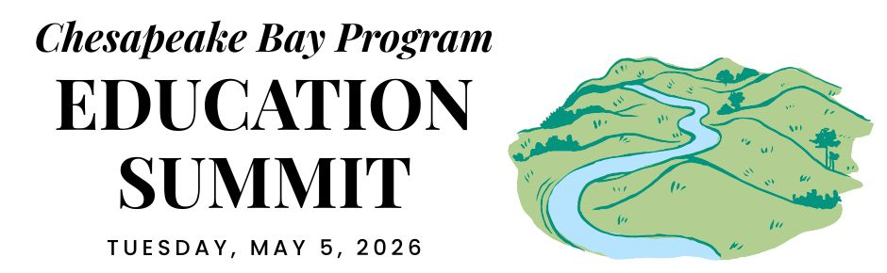

MARYLAND DELEGATION CONVENING

REGIONAL OPENING (virtual)

12:30 PM ARRIVE & SETTLE IN

12:45 PM WELCOME
Pennsylvania is the current state lead for the Chesapeake Bay Program partnership. Hear opening remarks from their leadership to set the stage for cross-jurisdictional collaboration.
- Secretary Dunn, Pennsylvania Dept. of Conservation and Natural Resources

12:55 PM GOAL & OUTCOME OVERVIEW
Explore the new Engaged Communities Outcomes through bright spots that highlight the inspiring work being done across the region.
Facilitator: Shannon Sprague, Chesapeake Bay Program Education Workgroup

Student Experiences Outcome:

Chris Cerino, Sultana Education Foundation

Callie Sams, West Virginia Dept. of Environmental Protection

School District Planning Outcome:

Elise Sheffield, Boxerwood Education Association

Tammie Peffer, Pennsylvania Dept. of Education

Workforce Outcome:

Ashley Duncan, DC Dept. of Energy & Environment

Jon Wickert, Delaware Dept. of Education

1:20 PM INTRODUCTION TO THE REST OF THE DAY
Get a quick roadmap of the upcoming sessions and understand how they integrate into our broader shared goals.

STATE DISCUSSION (in-person)

1:30 PM MARYLAND WELCOME
Join local leadership as they welcome everyone to the site to kick off the afternoon’s sessions.
- Secretary Kurtz, Maryland Department of Natural Resources

1:35 PM STUDENT ENVIRONMENTAL LITERACY EXPERIENCES
Take a deep dive into state targets, data, and successful models designed to scale up environmental education for all students.

Meg Boyd, Howard County Conservancy
- What policies, practices, funding, or other mechanisms in your sphere of influence could be applied to advance the work of student environmental literacy experiences we've discussed?
- What partnerships—state agencies, nonprofits, community groups—could be strengthened to expand student experiences?

2:10 PM SCHOOL DISTRICT ENVIRONMENTAL LITERACY PLANNING
Explore systemic strategies and successful models for integrating environmental literacy and sustainability into district-wide operations.

Suzanne Sullivan, ShoreRivers
- What policies, practices, funding, or other mechanisms in your sphere of influence could be applied to advance the work of student environmental literacy experiences we've discussed?
- What partnerships—state agencies, nonprofits, community groups—could be strengthened to expand district environmental literacy planning?

2:45 PM WORKFORCE
Highlight the pathways and partnerships that bridge environmental education with green career opportunities for the next generation.

Speaker Forthcoming
- What policies, practices, funding, or other mechanisms in your sphere of influence could be applied to advance workforce connections?
- What strategic actions could Maryland take in the next two years to strengthen and expand environmental workforce pipelines?

3:20 PM DISCUSSION
Participate in an open forum to synthesize insights from the breakout sessions and brainstorm solutions.

CLOSING SESSIONS

3:40 PM REGIONAL CLOSING SESSION (virtual)
Join a collective wrap-up where each jurisdiction shares their next action steps to meet our new outcomes.
- Secretary Shirley, Pennsylvania Dept. of Environmental Protection
- Regional Reflection: Share one thing that your state is excelling in, one growth area, and one concept that you plan to follow up on.

4:15 PM JURISDICTION CLOSING (in-person)
Connect for final local reflections and networking to solidify commitments made throughout the day.

4:30 PM END

