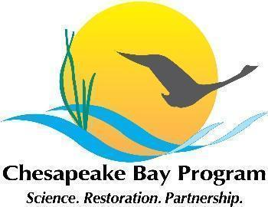

Maryland Oyster Restoration Workgroup Meeting Notes
May 20 2024, 9:30am-12:30pm

Video call link: https://meet.google.com/sco-xehw-vos

Or dial: (US) +1 402-751-0299‬ PIN: 641 735 850‬#

Agenda

- Agenda TBD

