

Modeling Workgroup Quarterly Review
July 9, 2024 – NOTES
Event webpage: Link
For Remote Access – Microsoft Teams Link: Join the meeting now
Meeting number: 295 745 787 863 Password: uyD6uX
Dial in by phone: +1-469-208-1525,,55936759# Phone conference ID: 559 367 59# Find a local dial-in number
To enter the webinar, please open the webinar link first.
This meeting will be recorded for internal use only to assure the accuracy of meeting notes.
=====================================================

10:00 Announcements and Amendments to the Agenda – Mark Bennett, USGS and Dave Montali, Tetra Tech
Thanks to Alex Gunnerson who now works for USGS.
Day 1 is focused on the Watershed Model, Day 2 is more focused on the estuary.
10:05 Review of the STAC Climate Change 3.0 Workshop – Gary Shenk, USGS-CBPO Gary will . the guidance and findings from the STAC Climate Change 3.0 Workshop.
- The 2010 TMDL mentioned, but did not incorporate, climate change.
- 2017 Re-evaluation
  - Incorporated climate change.
  - 2016 STAC climate modeling workshop informed climate projections.
Big recommendation out of first climate modeling workshop was to use observed trends to give a 30 year projection of precipitation.
- 2021 climate effects incorporation
  - 2018 STAC climate modeling 2.0 Workshop
  - Improvements made to Phase 6 Models in 2019
  - Incorporated climate effects in 2021
CBP studied 21 different effects producing an overall lower level of oxygen
2021 Climate Decision - PSC
- Accept updated models.
- Accept recommended adjustments to TMDL planning targets, increasing the level of effort toward nutrient reduction.
- Reassess in 2025 for 2035 climate

CBP Climate Work Plan
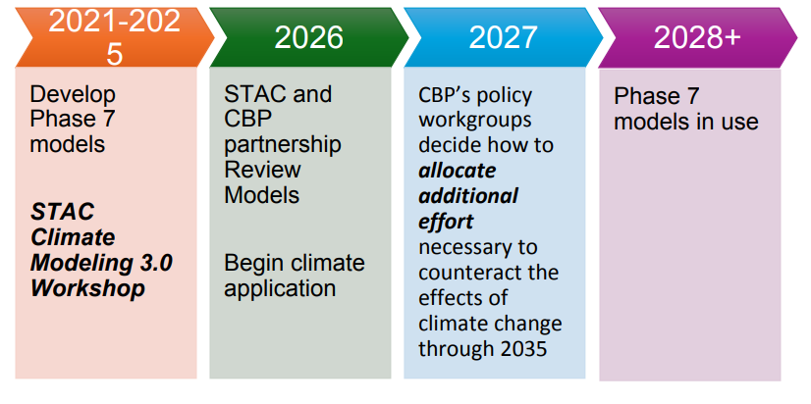STAC- Comprehensive Evaluation of System Response (CESR)
- Living resource focus
  - Water quality criteria were developed according to living resource needs
  - However – Expected living resource response is unknown
- Better incorporate shallow water
  - Important for living resources
  - Where people interact with the Bay
STAC Climate Modeling 3.0 Workshop
- Purpose: Develop recommendations to guide the Chesapeake Bay Program in developing models and methods to estimate the effects of climate change on the Bay TMDL and on living resources.
- CO2 and Longer Growing Seasons
- Reduction in N availability
- Hypoxia Cumulative Uncertainty
  - All factors in the setup of a climate scenario are important for projecting future hypoxia
  - Selecting a single ESM, downscaling method, or WSM may substantially limit the range of outcomes.
- Response to climate is nonlinear - for example, Cobia habitat will get much better before it gets worse.
Vertical (Multi-sector) breakouts findings:
- The CBP should prioritize the development and use of new and existing living resource models.
  - The existence of the water quality outputs and living resource models provides the partnership with an easy path to quick progress in this area.
  - Development should start with existing living resource models at broad spatial scales and work toward location-specific responses and goals.
  - Initial development should focus on selected individual species and life stages.
  - Linkages should be sequential rather than coupled to simplify the work and lower computing time.
- Re-examine the TMDL accountability framework
  - The TMDL baseline is the 1990s. The modeling question is: How would loads have to change from 1990’s such that water quality standards are met.
    - Would this make sense to our successors in 2050?
  - Prioritize restoration of areas where living resource responses could be seen more quickly. (Tiered TMDL Implementation)
- Model evaluation should be tailored to answer questions relevant to management
  - Uncertainty quantification for its own sake does not advance management.
  - The response gap framework of CESR is a useful method of prioritizing effort.
  - Long, continuous runs of the modeling suite
    - Suitably capture tipping points.
      - Estuarine benthic-pelagic shifts, changes in SAV spatial distribution
      - Watershed trends from climate, weather, anthropogenic effects, and time lags.
    - Climate change evaluation methods other than the delta method.
  - Assessing variability rather than just mean
Horizontal (Multi-sector) breakouts findings:
Watershed
- Incorporate climate-related change in transport, storage, and loss,
  - Denitrification, soil moisture effects, etc.
  - Validate predictions relevant to climate for flow, N, P, and S - difficult task
- Identify hot spots, moments, and actors and how they change for climate
  - Sub-field to watershed; hourly to annual.
  - Investigate targeted theory-based synoptic sampling.
- Advice for analysis climate effects on BMP performance
  - Separate into structural, hydrologic, biochemical transformation, and buffers
  - Look for more refined process-based small-footprint models
    - SWMM, SWAT, and HSPF are not ideal as they do not have the processes represented
Management
- Tiered TMDL Implementation
  - Shallow water
  - Include Co-benefits

- Modeling
  - A good central tendency is more important than an uncertainty-based range.
  - Beyond Phase 7, consider more precipitation events, and more extremes of drought and flood.
  - Excited about living resource modeling.
Estuarine
- Hydrodynamics working! Now need to focus on WQ model –
  - Make use of new data
    - southern ecosystems, shallow water, NSF/NOAA projects, satellite data
  - Still concern about temperature control functions in WQ model, both for autotrophic and heterotrophic processes
  - pH and acidification – Key for living resources
  - Explore use of ML/AI techniques
  - Need to account for extreme events and tipping points
    - storms (rain and wind)
    - droughts
    - Uncertainty quantification still important
Living Resources
- Start with strategic approach - see CESR for framework approach
  - table of living resource sensitivities to key climate drivers; include tradeoffs, include stakeholders, what can we manage around…
- The delta method of including climate change does not capture seasonal changes driving living resources.
- Add carbon module for acidification, provide max/min, variance, marine heat waves, include which spp & habitat distributions will change, etc.
- Develop/improve methods to identify geographic sources of water quality changes that impact living resources at scales relevant to restoration activities.
Top Line Takeaways – extremely draft
- Models are in pretty good shape after prior 2 workshops.
- Continuing uncertainty⬄validation⬄evaluation conversation.
- Tiered TMDL Implementation, which includes shallow water simulation.
- Living resource modeling – let's get started!
10:25 Discussion of the STAC Climate Change 3.0 Workshop
Lew: The tiered TMDL is perhaps one of the important changes that may take place, and I wonder if it’s worth some discussion in terms of how we would be presenting that in 2026. – in terms of how we roll it out and how it may change things with respect to management in the Bay program.

Gary: So number one is that it doesn't affect the TMDL. The TMDL is the TMDL and the planning targets meet all water quality standards. If it doesn't meet all the water quality standards, it is not a TMDL, so the tiered TMDL is envisioned for now, as the identification of those areas that would be most important for living resources and would be responsive to management actions. So you know, if there are areas of the Bay that are just beyond repair in the next few decades, it makes no sense to focus on those. If there are areas of the Bay that are already good, it makes no sense to focus on those, so let's find the places that are almost good and let's bring them over the edge and start to build up the living resources in those areas.So that's how I understand it.

Lew: That's a useful distinction, and I think also if we apply water quality standards everywhere in the 93 segments, and one of our first responsibilities when we have all the models calibrated would be -
- Where can we apply the model?
- Can we in fact apply it in open water reliably with the high fidelity of observations and all 93 segments, including the small embasements – think Sassafras river?
If we in fact reduce nutrients to achieve TMDL goals, then that may be beneficial to living resources and it may move the TMDL responsibility around a bit, is that consistent with your thinking?

Gary: So yeah, I mean, if we find that we can't meet water quality, so we have not really, truly evaluated water quality standards for open water in all areas.Some of the things we said, we just don't have the models to deal with now. It could be that we need to do more in some areas So I think it's two different things –
- One thing is how do we set the planning targets so that all standards will eventually be met and then the other is the tiered team of the implementation. What do we do first?

Dave Montali: I'd like to add that this concept is kind of included in some of the Beyond 2025 work as well. It may be that the tiering could have other reasons other than living resources, jurisdiction based initiatives. We're gonna have a model in 2026 that folks are gonna be asking us to use to identify a slate of segments, segment pollutants, etc. Let's try to get this done first or this done by 2030 and this done by 2032 or whatever and it certainly could be for a living resource need, but it could be for other needs, so that concept is in some of the draft recommendations of Beyond 2025 and the Clean Water Group.

Clifton Bell: I had a question about this – when we get to shallow water and showing that some areas just are not gonna be responsive to TMDL type allocations, you know, for example shallow waters that are just not gonna meet open water standards.
- Is that a part of this process to identify where ou're just not gonna go after that area with the planning targets?
Lew: That is the kind of the naming of the parts of responsibility, the modeling work group will do the technical tools to look at shallow water and do the assessment.
But yeah, we could rattle off a few of the shallow water monitors. I'm sure you've got your favorites Clifton, where it's DO super saturation during the day but DO is hitting the deck (in terms of DO concentrations going towards 0) especially in the early morning after a long night of respiration.
And we also have, I think, discernment because many of those local stations may be due to, say, tidal wetlands and their loads.
- So I'd say: some mix of application of the tools we have and some discernment here with more decision makers and less with the modeling workgroup if that makes sense to you.

Gary: Yeah, I think that's exactly right. We're putting together the best tool that we can to measure change in water quality constituents

Richard Tian: I think there are 2 questions. What will the climate change impact be on TMDL? We must use 1995 as the baseline, because that was the baseline for TMDL. But if we’re asking what is the best way to change the modeling targets it might not be model change from 1995, it might be model change from now.
Lew: I was struck by that long continuous period.
- I think that captured the imagination of some of the participants that the climate change workshop.Yesterday, Gopal was able to update the estuarine modelers with loads up to 2022 from Phase six. So that sweeps from 1985 to 2022 and as we get into the next year we'll be updating the timeline further and also updating to Phase 7 by the midpoint of 2025 I would think.
- So from the very high loads to those lower loads that we have going forward and all of the changes, it is a wonderful history of the degraded eutrophic estuary and its recovery. So whether it's for the insights into the Bay by the Bay Program or insights for other PIs I think that that is a real treasure- that long time series of information

Guido Yactayo: You mentioned in one of the recommendations that there are some climate related changes in transport and storage, specifically denitrification and soil moisture. Is Phase 6 currently including these sensitivities or processes? Will this be incorporated in Phase 7?

Gary: We don't have a process model of climate change for nutrient processes. We have a process model for hydrology and sediment. And so what we did to incorporate climate change is, we did alerts or survey of the dozens of people who had done process based models of climate change. They had changes in denitrification and changes in soil moisture in their models. And we used the average effect of that rather than just using one model, and we found that there was no change in concentration. So more flow means more nitrogen for nitrogen. Since that time, there have been some empirical model models and generated sparrow models that say that actually denitrification is greater than the increase in flow effect. And so actually these process-based models are underrepresenting the amount of denitrification.
So I think we're going to take another look and say- do we update that assumption? So we won't directly incorporate it, but we will directly incorporate all the other people who have done it in process and empirical models.

10:35 Phase 7 Watershed Model Overview – Gary Shenk, USGS-CBPO Gary will provide an updated timeline for completion of the Phase 7 Model in time for the 2026 partnership review.
There is a Phase 7 Model Development webpage. Austin Smith (EPA) is taking on the Gant charting of the entire process.

We are in the middle of the “improving model” part of the process.
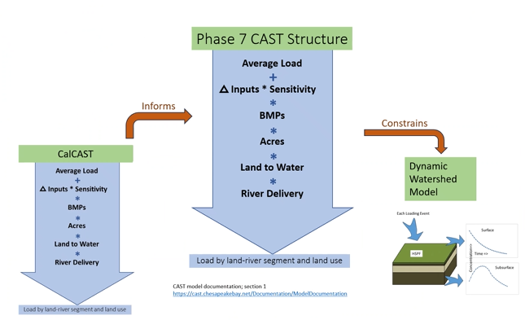

CAST is the management model. CalCAST is the statistical version of the management model that informs it by essentially giving it the parameter.
We talk about CalCAST as if it is one thing, but it’s actually 13 different things.
There are 3 different types of temporal models:
- the average annual model,
- an annual flow normalized model,
- an annual true condition model.
So there’s 15 possibilities and 13 of them are being developed.

Model Types – Average Annual
- One calibration value per station
- Long history of use in Sparrow models
- Used in P6 (CB Sparrow version 4) to predict
  - Land to water
  - Stream to river
  - Inform sensitivities and average load
- Plan A for generating CAST parameters
- Currently use to constrain the Dynamic Watershed Model
  - Flow, baseflow, Nitrogen, Phosphorus, and Sediment
Model Types – Annual Flow Normalized
- One calibration value per year per station.
- Fewer similar SPARROW models.
- Incorporates lag time.
- Research Model
  - Potentially generating understanding of trend differences between CAST and USGS estimates of flow-normalized trend.
- Plan B for parameterizing CAST and constraining the DWM.
Model Types – Annual
- One calibration value per year per station.
- Incorporates lag time.
- Research Model
  - Are different factors important in high flow vs low flow years.
- Plan C for constraining the DWM.
  - May inform annual predictions at NHD catchments directly loading shallow water

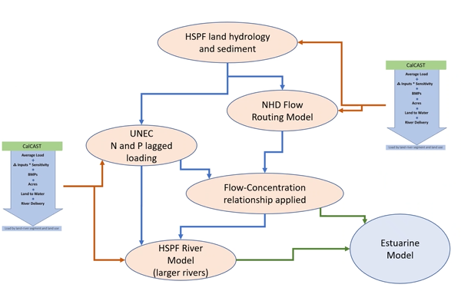

10:50 Discussion of the Phase 7 Model Overview
Lew: In earlier versions of this slide we had feedbacks. Are we thinking that we’re now in a linear system? Or are we allowing feedbacks? Question is related to this slide:
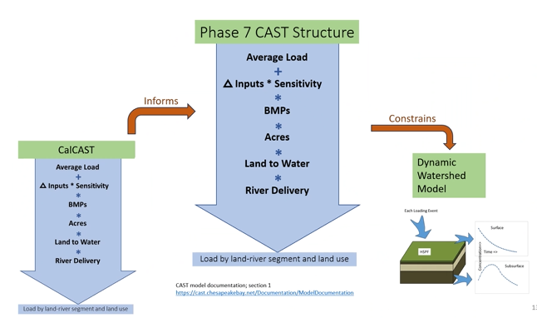
Gary: The earlier ones with the really explicit feedback were really sort of Phase 6. We didn't have a flow model in Phase 6 that was doing base flow, you know empirical flow model in Phase 6 that was separating base flow and the storm flow. And so we used HSPF which has positive and negative parts to that. And then we used the river delivery in Phase 6 which was split between small stream delivery and river delivery and we used the dynamic model for river delivery. It is a linear system, although there are feedbacks.
So if Gopal says to Isabella, “I cannot calibrate this model”, it is not matching the data. I can think of a few exact examples, but cannot calibrate this model. There's something wrong with CalCAST and in Phase 6 it was - I can't do the Eastern Shore. Your phosphorus loads are way too high and we found in SPARROW that it was double count or way too low. I think that it was double counting the soil phosphorus effect essentially. And so we pulled that out of SPARROW and we pulled some other things out of SPARROW. So it was not a coupled feedback, it was a, “Hey, there's something wrong, we need to try something else.”

- 11:00 Update on CalCAST Development – Isabella Bertani, UMCES-CBPO Isabella will describe the progress made in work on improving CalCAST with a focus on updating and expanding land uses and load sources to match those used in CAST.
Isabella Bertani: I will provide an update on our CalCAST activities for this quarter.
- One of the main things that we've worked on this quarter is to expand the load source and land use representation in CalCAST. If you remember what we've had so far in CalCAST is a relatively simpler representation of land than what is actually represented in CAST. So far we've modeled 13 land classes for which we have 1 meter x 1 meter scale data from 2013, and those were the land uses that we had in CalCAST. Those classes are represented here. They are broadly grouped into four major broad classes: cropland, pasture, developed, and natural.

- This was sort of a placeholder for us because what we really wanted to do is have CalCAST as similar as possible to CAST and so have CalCAST explicitly represent all of the load sources that are represented in CAST. In this quarter, we have made that step; we expanded our land use and load source representation. We moved from having a representation of 13 land classes to a much more blown out table of all of the 40-some load sources that are represented in CAST.

- We have also expanded our time series.
- So far we've been calibrating CalCAST to inputs up to 2014, and now we've expanded with the most recent downscaling product that Jess has provided us and we've expanded to 2023. Now we have a much better match to what is represented in CAST.

- Dave: I was just wondering, for efficiency, a lot of these individual load sources are not unique. So you know you have, for instance, permitted and non permitted feeding space and in CAST they all load the same way; and similarly on the developed side you have regulated. They're more of classifications rather than unique land load sources.
  - For efficiency, would you pair this down or is it better to have them all listed?

- Isabella: I already am pairing them down for computational efficiency. For example MS-4 and CSS or anything that currently has an identical loading rate. Feeding space is a very good example. It's currently grouped together once it enters CalCAST. And we do have the option of unpairing them if we ever decided that some of these groups do have different loading rates. But based on what we found in Phase 6 and that these, as you say, are more classifications than actually unique, they're currently paired once they enter CalCAST.
- We've represented these load sources and we've essentially rerun our models and what I'd like to focus on today is an example of our annual models since Gary has also mentioned that we have both flow normalized and true condition annual models. So I'm going to give a few examples of this new representation and how it works with our total nitrogen model.
- And we're currently working on building similar annual models for phosphorus and sediment.

- Example: Total Nitrogen Annual Flow-Normalized
- 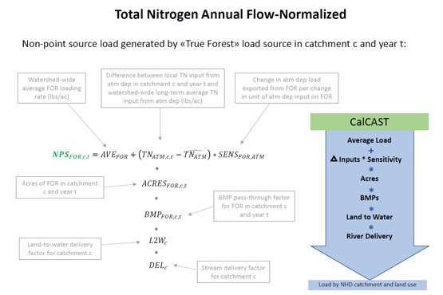
- The way we estimate nonpoint source loads for an example load source in a catchment, and at a certain time T, is just like it was done in CAST. We estimate a watershed-wide average loading rate for that load source. In this case, I picked forest. It's a simple load source because it receives only one input, which is atmospheric deposition. So we estimate one value for the whole watershed and across the years that gives us the average pounds per acres that are exported by this load source. This watershed-wide average is modified locally at each catchment by the inputs. The local inputs (in this case pounds per acre of atmospheric deposition) are expressed as difference once again from the watershed-wide average and we have time varying inputs. Thanks to the work that Jess did, we are using the exact same inputs as CAST. Then the inputs are multiplied by sensitivities that essentially convert a unit input into a unit of load exported. Then these pounds per acres at each catchment are multiplied by the acres of that particular load source in that particular catchment, and for each year we modified the loads by the BMP pass through rates that were downscaled by Jess from the county scale to the catchment scale. And then we account for the effect of landscape properties and watershed characteristics on low delivery by using catchment specific land to water factor and then stream delivery factors.
One thing that Gary mentioned is that in the annual models in CalCAST, just like in the dynamic model and this does not happen in CAST, we try to account for lags in nutrient transport.
- So we know that only a fraction of the nonpoint source load that is introduced to a catchment in a certain year will actually be delivered in the same year because we know that there are lags in nutrient transport depending on the flow path, whether it's surface flow or groundwater.
So essentially what we do in CalCAST and the nonpoint source loads that are delivered in a particular year is actually the sum of fractions of nonpoint source loads that were introduced in previous years as well. And we have tried to implement a very similar lag formulation as what was used in the dynamic model in Phase 6. We may modify this, but that's how we're doing it right now.

- Example: How we would estimate the nonpoint source load delivered in a particular year.
- I picked 2014, assuming that that year's load is influenced by the load introduced in three previous years, and so the nonpoint source loads delivered in 2014 is the sum of the loads introduced in 2012, 2013, and 2014, each multiplied by a fraction that quantifies the fraction of the load that is introduced in a particular year and that is delivered a few years later. And those lag parameters were derived from Phase 6. We also try to account for the fact that loads that come from different flow paths will undergo different lag times. Each nonpoint source load from each year is split into two flow paths, surface and groundwater. And this split is currently done by using the estimated percent storm flow and base flow that we get from the CalCAST storm flow model. So we get a percent for each catchment of the flow -- storm flow versus space flow -- and we apply those percentages to split our load as well. We know that this is a simplification because it only accounts for a flow split, not concentration, and so again this may be subject to revisions/ improvements, but this is how we have it set up as our first draft.

- So this is how our annual model flow normalized results look like.
  - What I'm showing here is on the X axis, the observed total nitrogen load to the left and the yield to the right. Load divided by a station drainage area and what I mean by “observed” here is really WRTDS flow normalized.
  - So it's not truly observed, it's a statistical estimate of the flow normalized load.
  - And on the Y axis we have the predictions from CalCAST and can see that we are generally on the graph especially when it comes to load. When it comes to yield, we generally do pretty well in differentiating spatial load delivery. But when it comes to trend, we know that we have challenges and so we have stations where we definitely have a hard time capturing the “observed”/ WRTDS estimated flow normalized trend.
One thing that I do wanna mention is that here I'm showing all of our calibration stations, but some of these calibration stations have a relatively low number of years. We know from a lot of WRTDS work (and also how the nontidal network results are generally provided) that relying on WRTDS trends or flow normalized trends for stations with less than 10 years is a little tricky and there's a lot of uncertainty that comes with it. For example, nontidal trend loads and flow normalized trends are only shown for stations with up to more than 10 years, because we have a little more confidence also in the WRTDS estimates.

As a comparison here I'm showing the same figure as before, but here I'm only considering 150 stations for which we have at least 10 years of data and one might argue that it is more prudent to look at stations with at least 10 years of data because we know we can trust the WRTDS loads, our observed data, a little more. This is an example of some time series of predicted and observed flow normalized loads that we get with our total nitrogen annual model. So for example, we have stations with very little yield at the Appomattox and also stations with large total nitrogen yield expressed in pounds per acres like the Conestoga.

- And so the CalCAST predicted flow normalized loads are in orange, the WRTDS flow normalized are in blue and you can see that there are stations where we capture the trend relatively well.
- For example the Patuxent, but also the Potomac, there are stations where there's still bias in our predictions and we know that we still have to improve our spatial representation of load delivery.
- There are also stations where we clearly are not able to match the WRTDS flow normalized loads or the broad trend that WRTDS indicates. This is an example of four stations that I picked and for which I downloaded the time series from our metric from this TMDL indicator tool. So for each of these stations you have the WRTDS total nitrogen load, the CAST prediction, and then the dynamic model prediction in blue after flow normalization.

- So to make it as close as possible to WRTDS, and in this case the time series, its represented as percent of the 1995 load. So all of these time series are matched for 1995 and this data is easily downloadable from the website that I put here on the bottom. And this is our TMDL indicator
- And so we can put our CalCAST predictions in the context of these lines. That’s what I did here.
- I've taken the same for stations and I have plotted the TMDL indicator lines so we have the green line represents the words flow normalized and I have superimposed the 90% confidence interval.

- The dynamic model flow normalized in blue and then the CalCAST predictions in red, so you can see that there are stations like the Potomac or the Rappahannock where CalCAST matches Phase 6 flow normalized loads pretty well. There are other stations where our currently CalCAST predicted loads are somewhat different than what the flow normalized dynamic model shows and also there are stations where we match WRTDS loads much better like Potomac and stations where we know we're not able to capture what WRTDS is currently telling us. But so this is a way to just put our CalCAST prediction in the context of the TMDL tool that I think people are looking at more and more.

Here I'm showing a way of looking at trend agreement. By trend agreement I mean how well do we match the WRTDS flow normalized trend. And by trend we mean the difference between the load estimated in the last year of the time series minus the load estimated in the first year of the time series.
- So what has been the changing load between the beginning and the end of the monitoring period?
We estimate the changing load at each of these stations from WRTDS. We can also include a 90% confidence interval around that changing load. That gives us an estimate of how uncertain the WRTDS trend estimates are. And then we can look at whether the changing load that we predict with Cal cast is within that 95%, that 90% confidence interval estimated by WRTDS or whether it lies above or below. The purple stations are stations where the changing load that we estimate with CalCAST is within the uncertainty bounds of the change in load estimated by WRTDS flow normalized. So we can say within a certain range of uncertainty, we are pretty close to the change in load estimated by WRTDS for yellow stations. It means that our changing load estimated by CalCAST is significantly lower than what has been estimated by or is below the 90% confidence interval, so it lies outside the range of uncertainty of WRTDS and in green it is the opposite. We lie above the 90% confidence interval, so generally the yellow and the green are stations are where we're doing not as well in matching WRTDS flow normalized loads.

- And here again, I'm only showing the stations with at least 10 years of data, including all stations would generally lead to a more optimistic picture because stations with less than 10 years tend to have really broad confidence intervals. And so the CalCAST estimates all almost always lie within those confidence intervals. And so it gives us the impression that we're doing really well, but it's largely because we have very broad uncertainty in WRTDS. And so I think it's just more meaningful to focus on stations with a substantial number of years.

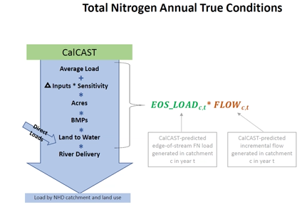

- Annual true conditions load where we also consider the influence of interannual variability in hydrology. The way that we've built this model is essentially by using the same structure and the same loads that we get from the annual flow normalized models. We do everything as I’ve shown before the equations and the structure of the model and what we do is once we estimate the edge of stream load at each catchment and that's a flow normalized load, then we multiply by the annual flow that's predicted by CalCAST and that's generated within each individual catchment. So we superimpose essentially the variability due to hydrology to our flow normalized nitrogen loads.
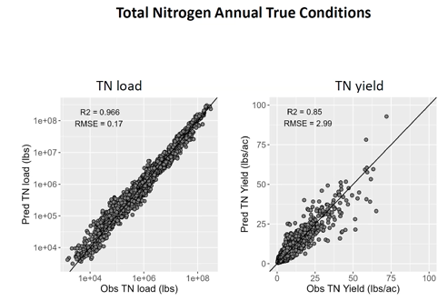
- The X axis, as the observed total nitrogen load in the left and the observed total nitrogen yield to the right.We are looking at annual true condition as estimated by WRTDS and the Y axis as how our prediction both for load and for total nitrogen yield and as a comparison I’ve compared our current performance with what we did in Phase 6.

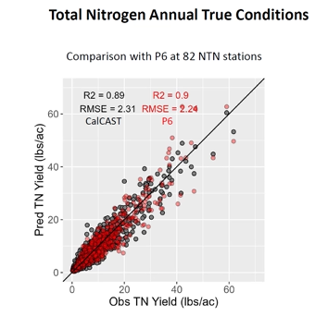
- There are 82 stations among the stations that we used to calibrate CalCAST for which we also have Phase 6 annual load results. I'm plotting those two datasets here. Basically, observed versus predicted total nitrogen yield where the Gray dots are CalCAST predictions and the red dots are Phase six annual load predictions. And this is again restricted to 82 stations for which we currently have our Phase 6 predictions. And so you can see that we're doing pretty similar - we were able to achieve a pretty similar model performance as was what was done in Phase 6, at least for those stations that we can compare to.

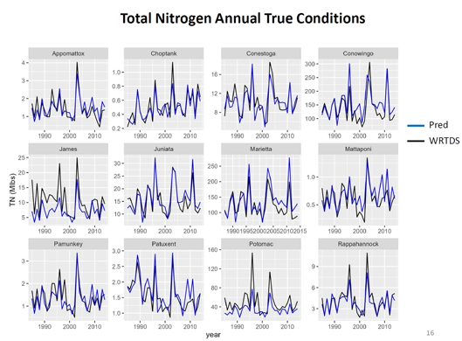
- An example of time series of predicted and observed total nitrogen loads annual true conditions. You can see the variability in hydrology. Here we have CalCAST predicted time series in blue and observed in black and you can see that there are stations where we're doing better and stations where we need to improve.We can compare our time series to Phase 6, at least as our sort of benchmark and see how we're doing compared to how we did in Phase 6.
- There are stations where CalCAST definitely needs to improve and stations where we are able to match basic performance relatively well.

Next Steps
- Finalize annual models for TP and TSS
- Improve all annual models
- Examples of areas of potential improvement/refinement:
  - Sensitivities
  - Land to water/stream delivery
  - Lag formulation

11:20 Discussion of CalCAST Development
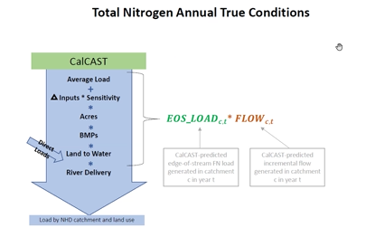
Lew: would it make sense to use the dynamic model flow?
Isabella: So the way that we have designed the interactions is that CalCAST annual flow or average annual flow depending on what plan we end up choosing would constrain the dynamic model.
Then the dynamic model would perform the temporal disaggregation. I'm not sure if we're eventually going to explore other options like what you mentioned, but that's how we have it designed at the moment.
Lew: That sounds fine, and if the hydrology is as good or better than Phase 6, then we don't have to say anything. It'll basically be the constraint of the CalCAST in terms of the hydrology as formulated here, but getting the hydrology right is key to getting the loads right.

Lew: Related to slide 4 – What about a longer growing season or temperature oriented sensitivity?

Isabella: Well, not at the moment, as I think most of the parameters where this could happen are static, so they're not changing over time. We have also discussed at the workshop to have, for example, certain parameters like even the loading rate become dynamic and change over the years or the land to water factors could become dynamic and change over the years? So right now we don't have that provision and we've also discussed having that as something that's handled by the dynamic model since the seasonality is something that also will be addressed there. But I think it's something that has come up as a discussion also at the Climate Change Workshop and so something that keeps coming up and we should definitely consider that.

Gary: But I think the probably the best way to do what you're suggesting is to make sure that the climate inputs are in the base model, that we don't have to have a regular CAST, and a climate change version. It's just CAST and if there is a change that's climate related, it would be part of the sensitivity already.
Gary: Slide 12 – On slide 12, I like this a lot and the reason that I like this a lot is that for decades we didn't say quite this way, but we were making the argument that because we can adjust HSPF River river parameters to match a cumulative frequency distribution of concentrations, we can therefore predict the change in due to land use and inputs and BMP's. And that was sort of the way that the modeling work group would approve the model. Now we can say that we're gonna ask the modeling work group to approve the model eventually because we can predict the change in load due to land use and BMP's. This is a demonstration of validation for the actual prediction that management is interested in.

Dave: When do you think this will be able to help us with phosphorus?

Isabella: This quarter. I aim to have this coming quarter, but maybe even sooner. And I already have begun to work on the annual phosphorus and sediment, I just don't have the completed version but definitely within the end of this quarter they will be ready.

Chat:
- Olivia Devereux: BMPs are quite variable based on reg/not regulated and MS4 vs. CSS vs. nonregulated.
- Gary: That's a good point. I think that Jess and Isabella worked together to get the right weighted average for each catchment to collapse the land uses.
- KC Filipino: Do you mean BMP type or BMP efficiency are variable based on MS4/unreg/CSS?
- Olivia: Number and type of BMPs applied to land. Most municipalities report MS4 area BMPs with fewer BMPs on nonregulated area. Hence, the importance of regulation. To anthropomorphize the BMPs, they are not aware if they are regulated so behave the same either way.

11:30 Progress in Phase 7 WSM Development – Gopal Bhatt, Penn State-CBPO The NHDplus 100K scale Phase 7 Dynamic Watershed Model (DWM) is using a nested model segmentation of streams and rivers with a hybrid structure for the simulation of water quality processes using HSPF and non-iterative routing models. Gopal will survey the progress being made on the step 1 mechanics of water quality calibration and plans for step 2 during the next quarter for linking of watershed model flows and loads with the estuarine model.
See Slides: Phase-7-WSM-Development-Modeling-WG-July-2024.pdf (d18lev1ok5leia.cloudfront.net)
Purpose
- NHD Scale Dynamic Watershed Model (DWM)
  - Inputs for the estuarine models (MBM/MTMs)
  - Watershed model calibration and scenario applications
  - Support research and collaboration activities
Nitrogen example:
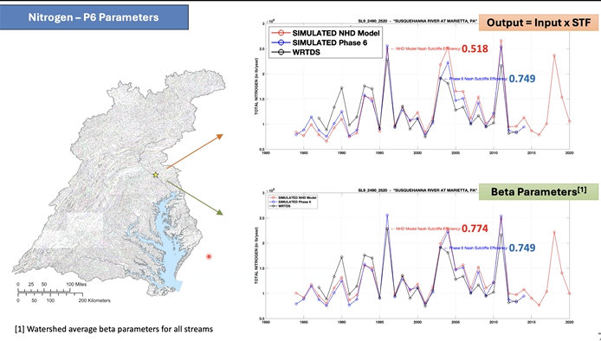
Gopal: When we changed the small stream routing from this simple model to a maybe slightly more complex version of the model, we saw a significant improvement and in fact it was enough to top the efficiency that we had in Phase 6.
Lew: This is very promising.

11:50 Discussion of Phase 7 WSM Development Progress
Lew: Related to slide 15 – Is this the importance of watershed attributes seen on an annual basis or on a daily basis or weekly basis? Are these attributes over what time period?

Gopal: These are watershed averages for the most part. The wetness index is a function of topography, so it’s kind of static. Base Flow index is also a USGS product, kind of an average TNM is what we are modeling out of CalCAST and list goes on. So as you see that you know all of these are average watershed characteristics to explain average beta 2 parameter.

Lew: I think some of these will come naturally into the equation in terms of the TN yield of course will be something that we're tracking. The percent developed land use at the NHD scale is something we would be tracking within the structure.

Lew: I'm wondering how much phosphorus is going to be a storage story that is a drawdown of stores and getting storage as correct as we can.
- For example, urban land use doesn't have a drawdown necessarily from low urban stores of phosphorus in the soil. If it came from agricultural land juice, perhaps it had a much higher, umm, uh store drawdown and just the uncertainty of course is large and in terms of what we have there. But those phosphorus stores could play a role in that sense, and it could also play a role in we've had land use changes over the decade in terms of agricultural land going to forest land, and I wonder if that forest land should also inherit some of the phosphorus characteristics if, for example, the intensive farming in the 1940s was very different than the footprint we have now. Or I should say the less intensive agriculture, which is much wider practice over an area is different from the more intensive land use now. So anyway, some initial thoughts after some other questions I might wanna ask about tackling beta three if there's any hope there, but I'm going to defer to Gary for now.

Gary: I just raised my hand to bookend my comment that I made during Isabella's presentation after Isabella's presentation of saying that we used to look at that CFD and say OK, we can model change in the watershed and now we're looking at change in the watershed and say we can model change in the watershed. But the importance of the CFD is that we are saying that with this dynamic model we can load the estuarine model and so the fact that we're getting that, I mean there's there are two big purposes of this modeling (1) to estimate the change due to anthropogenic efforts and then (2) to correctly load on small temporal and spatial scales, the estuarine model.
- And so both of these are, you know, the highest priorities that we always have to have our eyes on and the ability to replicate that CFD, which we're starting to see that we can do with this new system.

Lew: Is beta 3 seasonality?
Gopal: Beta 3 and beta 4 provide the seasonality and they are equally important.
Lew: would it make sense to look at a beta three and four seasonality in the same way that we've looked at beta 2 for flow?
Gopal: I completely agree. So I think it's indispensable because we, you know, one of the charges for the dynamic watershed model is to get the event scale response right.
Gopal: The final slide in the appendix shows a clear pattern in seasonality. As we are learning and building these models, I’m cautiously optimistic that we’ll be able to use some of those techniques for explaining the variability in the beta 3 parameter as well.
Lew: Perhaps most of the blue and red areas are either in snowpack regions that we have and that in the HSPF where we need to keep track of snow to keep track of flows or or downstream of those snowpack areas.

12:00 LUNCH
1:00 Development of Efficient Multi-Objective Optimization Procedures – Kalyan Deb, Pouyan Nejadhashemi, Gregorio Toscano, and Hoda Razavi, MSU
Progress on the integration of web-user and decision-making interfaces, and tasks for multi-state implementation using machine learning and parallel computing platforms will be presented.
- Innovization: Create new knowledge from optimization solutions
- The land-use based BMP selection approach - urban agriculture
- Balanced BMPs - low cost and effective
- Ranking strategies
  - 1) Rank top BMP based on implementation changes
  - 2) Rank top BMP based on percentage of maximum allowable acreages
  - 3) Rank top BMP based on amount of N reduction per dollar spent
- Innovization 1: This method simplified the BMP selection process
- Innovization 2: This approach was validated across various regions
- Reoptimization with reduced BMPs
  - Purpose to ensure the simplified BMPs are effective and efficient
  - Confirm that the selected BMPs from innovization are capable of achieving desired outcome
  - Efficiency gains from faster run times and reduced computational effort
- Re-optimization strategies: control, static, dynamic, and preferred
  - Static: According to the innovization analysis only 7 BMPs provide the best benefit
  - Preferred: new BMPs
- Validation with hypervolume ratio: preferred approach outperformed the other approaches
- Transfer learning is efficient, consistent, and scalable
- Applying transfer learning BMPs
  - Select new counties
  - Similarity measure: use a measure to determine how similar…
  - Transfer BMPs
- Suggests preferred strategy is a good compromise in multi county scenario
- Conclusions
  - Real world large scale application with dozens of potential users
  - Innovization helps to reduce computational effort
  - Re-optimization validated the use of reduced variables
  - Transfer learning reduces time…
- Next Steps
  - Scale up to watershed level optimization
  - Parallel computing platform
  - Workshop with CBP users for feedback and improvement approaches
1:20 Optimization Discussion
- Lew Linker: When do you think the webinar would be to solicit CBP user feedback? September?
  - Pouyan: We are planning for October or early November. What is the best way of dissemination? A live presentation that is recorded? We are flexible and looking for any feedback.
- Lew Linker: The types of counties suggested were: urbanized (Anne Arundel, Montgomery, etc.), agricultural (Lancaster, etc.), low resource (lack of resources to apply the optimization). We welcome feedback and ideas on different counties.
- Pouyan: Which county do you recommend for the low resources?
  - Lew: I would suggest a rural low population county which has low public sector infrastructure. Example would be Richmond county in VA.
- Pouyan: When we have the presentation ready we would like to present it beforehand to this group for feedback.
  - Lew Linker: An initial list would be myself, Dave, Gary, and Olivia. More detailed list to follow.
- Sam Canfield: One of the counties in WV that the tool was developed upon would be interesting/good. (Morgan, Jefferson, Morgan, Mineral, Hampshire, Grant, Hardy, Pendleton)
- Dave Montali: I suggest creating a poll asking who from each jurisdiction would like to be involved. Once they have been identified they can pick a county to focus on.
- George Onyullo: It would also be a good idea to consider a fully built-up urban environment such as a DC.
- Pouyan: If there is something already implemented in a county then we can use that as a starting point.
- Dave Montali: For my state we didn't do the county level. We looked at all 8 together. It will be interesting to see how our perception compares with your tool.
- Clint Gill: I'm not the DE rep in this group, but Sussex County has the most acreage in the CBWS. We've only got three counties total, so it's a bit easier for us.
- Lew Linker: NEXT STEPS: 1) Develop draft webinar and send it to Lew to convene an initial review group; 2) Invite those in CBP who want to be involved; 3) Ask the convened group for CB county suggestions.
1:30 Stormwater Management in a Changing Climate SWM & AG BMPs – Michelle Miro and Krista Grocholski, RAND
Progress on applying existing, well-documented, open source, and public domain stormwater and/or watershed models under different future climate hydrologic conditions to determine relative change in pollutant removal efficiency in existing CBP-approved stormwater management BMPs under future climate conditions will be discussed.
- Project Objective: create an integrated toolkit to incorporate climate considerations into designs
- Activity 4: BMP Climate Sensitivity Modeling
  - Research design: literature review and stakeholder input
  - Implementation: baseline scenario, future climate scenario, output analysis
  - Synthesis of Outputs
- Proposed modeling approach
  - Model development: simplified representation of physiographic regions and land uses using prior calibrated parameters; allows for more complex design of experiments
  - Designs of sensitivity experiments
    - Climate (2 future hydrologic regimes, base period), physiographic (4 types), land use (ag and urban), BMPs
    - Hydrologic regimes - Baseline (1991 - 2000), Future 1 (2035), Future 2 (2065)
1:45 Discussion of Stormwater Management in a Changing Climate SWM & AG BMPs
- Gary Shenk: I don't see how using the 5.3 model will work. It is a biogeochemical model, but it does not assimilate BMPs so adding climate change won’t change those reduction percentages.
  - Lew Linker: We are looking at how different hydrologies would impact a particular BMP. We need to construct the BMPs and we’ll compare the different hydrologies to the baseline.
  - Gary Shenk: Cover crops is the only way I can see this being done. I would like to see the results from the literature review to see what others have done.
- Clifton Bell: Is there an effort to look at the recommendations from the workshop? N retention effects of vegetated practices.
  - Lew: I think we can also say that all continuous models don't have the BMP processes included.
  - Clifton: Is there a way to implicitly include BMP, if not explicitly?
- Normand Goulet: Krista, now that you're back let's revise the talk of maybe using the existing Four Mile Run SWMM model. BMPs are already incorporated into the model.
  - Lew Linker: Do we want to swap out the hydrology being used for the Four Mile Run SWMM model with the base hydrology to look at the relative differences?
- Tanya: On slide 5 you mentioned some climate scenarios under implementation. What are you using to drive the climate for the hydrological models?
  - Krista: Climate from the MARISA IDF curve tool that was created a couple of years ago and CMEP (???) 5.
- Dave Montali: Should we align our climate scenario with this project or is it out of the question?
  - Lew Linker: It's on the table.
- Krista Romita Grocholski: If you want to reach out with suggestions/feedback, please send me an email at kristarg@rand.org! Want to know if we are using the right land uses, physiographic regions, and BMPs.

2:55 Updating and Improving Loading Sensitivity to Inputs, Phosphorous Loading Processes, and Related Activity Update – Joseph Delesantro, ORISE-CBPO We will discuss a proposed plan for improving load sensitivity to N inputs based on relevant literature and models. We will also discuss phosphorous (P) loading processes and highlight potential opportunities to improve P modeling. Finally, progress in improving N application estimation to crops and inclusion of sanitary sewer exfiltration and marine discharges to N inputs will be reviewed.
- Crop yield calculations for estimating nutrients applications
  - Crop yields have been increasing dramatically across the watershed
  - Yield and nutrient applications are tied together - looking to capture how difference in crop yield compare to nutrient application
- Wastewater Treatment Group
  - Boat pump out BMPs
  - Combined sewer overflows
  - Treatment plant data accuracy
  - Sanitary sewer exfiltration
    - If exfiltration is included in models loads can be properly appropriated
    - Total urban N load into the Chesapeake Bay that is sanitary sewer exfiltration is 3.28% - 10.93%
- Updating and Improving Loading Sensitivity to Inputs
  - Sensitivity is defined as the change in export load per change in input load
  - Addressing sensitivity: Identify new info → assess certainty → compare to old information → new sensitivity value
  - Identifying new information: modeled values from literature, direct measures of sensitivity from literature, non-direct measures from literature, process knowledge from literature, empirical analysis
  - Prioritizing assessment and update of sensitivities
    - Identified priorities: Agricultural and urban P, urban N, greater use of field data, effect of phenology changes due to climate change, manure
- Addressing the Phosphorus Modeling Gap
  - Working parallel to sensitivities we will be evaluating all aspects of P modeling
  - Working with the geospatial team to better connect land and water factors in models
3:15 Discussion of Updating and Improving Loading Sensitivity to Inputs, Phosphorus Loading Processes, and Related Activity Update
- Lew Linker: What do you think the timeline on exfiltration or marine loads would be?
  - Joseph Delesantro: Don’t have an answer but we will push for timelines when reconvene with the group.
  - Lew Linker: Something like crop yields and exfiltration would be important to get an initial product earlier in the timeline so we can incorporate that into the model.
- Clint: I would say even watershed-wide, 1% load that we didn't know about is significant. Thanks for the work Joseph.
3:25 ADJOURN

Modeling Workgroup Quarterly Review
July 10, 2024 - NOTES
Event webpage: Link
For Remote Access – Microsoft Teams Link: Join the meeting now
Meeting number: 295 745 787 863 Password: uyD6uX
Dial in by phone: +1-469-208-1525,,55936759# Phone conference ID: 559 367 59# Find a local dial-in number
This meeting will be recorded for internal use only to assure the accuracy of meeting notes. =====================================================

10:00 Announcements and Amendments to the Agenda – Dave Montali, Tetra Tech and Mark Bennett, USGS
- Lew announced AGU will be in DC December 9 - 13th.
- Nicole earned an appointment at Yale. Her ORISE position will be reopened.
- Gregorio is moving to a ten year track with Catholic University, but he will continue to serve as a sub for the optimization.
- Alex Gunnerson has earned a new position with USGS at the Chesapeake Bay Program.
- The Chesapeake Bay Report Card was released yesterday and the grade was a C+.
10:05 Update on Main Bay Model (MBM) Progress – Zhengui Wang and Joseph Zhang, VIMS Progress on the MBM water quality (ICM) living resource modules of oysters, SAV, and tidal marshes will be presented.
Presentation: Zhengui began by walking through improvements to the MBM over the last quarter, specifically the development of living resource modules including submerged aquatic vegetation (SAV), tidal wetland/marsh, oyster/clam, and benthic algae. The new features of the modules include 2D spatially variable inputs, activation in certain regions, and multiple modules can run simultaneously. Zhengui then explained how they conducted the first test of the clam module. The model configuration is largely based on Phase 6 model input and used five oyster/clam species in the simulation. The results indicate reasonable representation of processes but need more validation. of Zhengui provided an update on the exploratory study for ocean boundary condition. It’d be more convenient to use the original ocean boundary for climate change studies, and the model seems to get reasonable results at the Bay mouth, except for lower nutrient concentrations. However inside the Bay, the model results with boundary condition needs more improvements. Zhengui concluded with a summary of improvements and next steps for MBM development.

10:35 Discussion of the Main Bay Model (MBM) Progress
Discussion:
Lew Linker: Thank you for the process improvements made in this work. I want to make sure factors impacting the oysters/clams are included. The boundary condition is very important and we need to make sure there is improvement from the Phase 6 approach.
Zhengui: For the factors on clams like TSS and Temperature, they do have it included in the module. For the boundary condition, they just did an exploratory study but they haven’t decided if they should switch from the current approach.
Carl: Speaking of the boundary condition, I think pushing to the outer edges of the grid isn’t worth it because there is no data from the outer boundaries to the Bay mouth. With the boundary titled nudging, it is already pretty far from the Bay mouth.
Joseph: We had this discussion early on, the goal of the future of climate change scenarios. Placing the boundary too close to the Bay mouth, parameters such as temperature will not be fully captured. They appreciate the comment, but they are juggling potential solutions.
Marjy: We have done a lot of looking at future impacts of climate change on hypoxia with using the ocean boundary. They have changed it a lot and it has very little effect on hypoxia compared to air temperature and other factors.
Richard: Additional information on the open boundary, what we did in climate change for temperature and salinity was based on a larger domain simulation. For water quality, I agree with what Carl said that we really don’t know the boundary condition for the continental shelf. For climate change, we can do the larger domain simulation for the open boundary to determine the salinity and temperature at the Bay mouth and use that to nudge for a small domain.
Action: Set up small group for correct treatment and placement of aquaculture and oysters.
10:45 Phase 7 Update of Model Criteria Assessment – Richard Tian, UMCES-CBPO Richard will provide progress on a water quality assessment of the entire tidal Bay.
Presentation: Richard provided very preliminary work on Phase 7 criteria assessment. Compared to Phase 6, they double the stations in Phase 7 included in the criteria assessment. Richard explained methods to modify the data based on model scenarios to compute the criteria assessment and results for Deep Channel, Deep Water, and Open Water. He then showed a comparison of the hypoxia volume between observation data and calibration. For Deep Channel, Phase 7 does better than Phase 6, but they both under-represent the observed data. Deep Water comparison is similar to Deep Channel, but with a little better representation. Phase 7 for Open Water does a good job of representing the observed data. Richard also showed results for 2025 summer average hypoxia volume in the whole Bay under the WIP condition. Sea level rise has a stronger influence for Open Water than Deep Channel. Richard concluded on next steps for testing and improvements.

11:00 Discussion of Whole Bay Criteria Assessment.
Discussion:
Lew Linker: When we are looking at these observed hypoxia volume, how are we looking at all the stations? How is it generated?
Richard Tian: It used the new 700 stations.
Lew Linker: How many of those stations should we count is the question the larger Bay Program will need to help answer.
Joseph Zhang: What do you mean by calibration?
Richard Tian: It is calibration run 9.
Tish Roberston: On slides 6, 7, 8, did you do the quantile mapping or just regression?
Richard Tian: The quantile wasn’t used. Quantile is only used for climate change.
Tish Robertson: There is special criteria for the pamunkey fresh, and I wanted to make sure it was used.
Richard Tian: Yes, it was used, but the results are not final because this is preliminary results.
Tish Roberston: I have the assessment procedure for the James for CHLA. We do not assess James CHLA with CFD. Will it be runned over the same simulation period?
Richard Tian: For this preliminary work, it will be the same period. In the future, we need to consider Tish’s new method.
11:10 Decarbonization Sensitivity Scenarios on GLIMPSE-GCAM-CMAQ – Jesse Bash, Chris Nolte, and Dan Loughlin, EPA-ORD Initial work on decarbonization sensitivity scenarios on the atmospheric chemistry models of GLIMPSE, GCAM, and CMAQ will be described. Once estimated nitrogen deposition loads under estimated conditions of reduced carbon emission from stationary, mobile, and area sources are available from CMAQ the Phase 6 Watershed and Estuary Models will be run to understand the influence of reduced atmospheric nitrogen loads on water quality.
Presentation: Jesse began by reviewing the modeling framework used to calculate the atmospheric deposition estimates under different decarbonization scenarios. This included an overview of the GCAM, the variation used in these analyses, and the GLIMPSE. GLIMPSE is an EPA decision support system that allows for consideration of policy and non-policy levers. He then described the application of these models to multiple scenarios: reference, state targets, and netzero EV. Jesse previewed the national CO2 and NOx projections from GCAM under the three scenarios, including the spatial distribution of NOx reductions. Jesse next walked through the connection from GCAM to the CMAQ model to understand implications for atmospheric deposition. This included a presentation of results for the multiple scenarios and discussion of potential implications.
11:30 Discussion of Decarbonization Sensitivity Scenarios
Discussion:
Lew Linker: It is time for us to look back on what we did before and compare it what we are doing now.
Jesse Bash: There has been changes with the model and the simulations and the projection time period has not passed, so it would be interesting to see how the results stack up the observations now. We could learn more about the uncertainty of our future projection.
Dave Montali: The effect of the reference condition is what jumped out to me. We absolutely need to look at assumptions we made prior.
ACTION: Lew Linker would like to get an update on this work at the next quarterly meeting. Jesse said they are halfway done with the simulations, but he should be done with them relatively soon.
11:40 Overall Review of CBP MTM Work and Progress on the East Coast Tracer Model – Nicole Cai, ORISE-CBPO Nicole will reprise her work with the CBP Multiple Tributary Models as well as progress on a regional cross-scale model of US East Coast estuaries. The purpose of this study is to investigate the connections among different water bodies, which will provide useful information and insights such as a quantified approach to assess the influence of coastal ocean atmospheric deposition to nitrogen loads at the Chesapeake Bay boundary.
Presentation:
- During her first year at the program there was a push to develop the ‘next generation’ of models.
- The need for a more advanced model, that represents accurate land features and demonstrates increased resolution, lies in that the Chesapeake Bay is complex.
- Nicole displayed a comparison of charts demonstrating the importance of bathymetry and finer resolution in accurate modeling.
- There is a push to use unstructured grids for shallow water areas because of consistent shoreline evolution and the complexity of where shoreline and open water connect. Shallow water areas require more MTM.
- Combined Multiple Tributary Models (MTMs)
  - Motivations -
    - First time to have a fine grid covering all tributaries and shallow regions
    - Quantitatively synthesize the interactions between each sub-tributaries
- Her demonstrations of recent improvements in modeling and goals for modeling in the future include models of the James River and the Potomac River.
  - In the models of the James river, the team used contours of nine to six meters, depending on the location, to generate the inner layers of arcs. For this model there was a good amount of sensitivity test. The reason is because the of the general knowledge that the James river has a lot of hidden channels. The group emphasizes the need to use previous nautical charts to understand the true minimum depth. In the past years there were more than three side projects. One example is a model on the water intake on fish level and mortality.
  - Similar to the James River is the modeling done on the Potomac River. For this modeling, the team has combined the results of the CH3D and old MBM models. The team now uses a grid construction. The group can capture the saltwater intrusion in the upper potomac and reasonable source stratification on the middle and lower stations.
- USEC Model - Delaware and Narragansett Bays
  - There have been a couple version updates. Currently there is a more realistic capture of shallow water processes.
  - The first version was not reflective of the National Weather Model. This was updated in version 1.
  - There was also a need to include the entire gulf of maine, which was included in version 2.
  - The current version is version 3, doubling previous model elements.
  - The target project will update the linkage between the blue carbon ecosystems and the coastal carbon cycling.

12:00 Discussion of East Coast Tracer Model
Lew Linker: Thanks to Nicole for all she has done with the CBP. We appreciate your help in making advances in shallow water simulations.
Dave Montali: Thanks to Nicole for all that you have done for the program.
12:10 Documentation of Algal Temperature Correction for Algal Growth – Carl Cerco, Arlluk Carl will describe progress on the documentation of algal temperature correction for algal growth.
Presentation:
Carl presented on the topic of observed chlorophyll concentration and temperature in Chesapeake Bay tributaries. Currently there is a report, with this information, in the hands of the CBP.
The goal of the research was to look at the temperatures of 35 or higher centigrade and observe the levels of Chlorophyll. There are 3 distinct data sets: Eyes on the Bay from Maryland , VECOS from Virginia, and the conventional Bay monitoring system from the CBP. The Eyes on the Bay and VECOS are continuous modeling.
When looking at the results from Eyes on the Bay, the median levels out at 29 to 30 degrees. The maximum diminishes at 30 to 31. Thus we can say that the assumption that chlorophyll increases with temperature is not valid. We recognize that Individual stations have a great deal of variance demonstrating this point. However we see that The chlorophyll concentration generally drops off when temps exceed 31 to 32 degree C.
Tish performed quantile regression. Divided data to below and above 32 degree C. There were 20 stations and two regressions. 75% of these analyses indicated that the chlorophyll concentration either leveled off or declined above 32 C. So when we look at sort of the upper end, the maxima, 75% of them decline above 32 centigrade. Below 32 C chlorophyll decreases.

12:25 Discussion of Algal Temperature Correction for Algal Growth
Discussion:
Carl: When do we want to release the documentation?
Lew Linker: Once the updates have been made to the graphs, we should get this out to the modeling workgroup. By October, if not sooner, there will be a definitive decision on the impacts of temperature on Chlorophyll. If there is dissension against the current findings this is an opportunity to come forward with evidence to the workgroup.
Carl Cerco: the documentation will be sent to Lew and the team and they can decide when and how to release it.
Dave Montali: Should there be a time at the meeting in october to incorporate dissenting opinions on the data/observations? Is a final decision in October too late?
Lew Linker: The workgroup will need to touch base with Joseph Zhang and the MBModeling team for their opinion.
Joseph: We can incorporate this information. The MBM can focus on calibration.
The group: Discussed how to present the data and settled that there should be one curve demonstrating a drop off/plateau of chlorophyll at certain temperatures. The current curve, demonstrated in the report, will be sent to Joseph to be calibrated. The MBM team has an intent to work with Carl and his team.
12:35 Lunch

1:10 Initial Progress With the Patapsco-Back MTM – Harry Wang, VIMS and Jeremy Testa, UMCES The Patapsco-Back MTM Team, one of the three MTMs supported by a five year grant, will describe progress on the MTM.
Presentation:
Update on Patapsco Back River Tributary Model for simulating effects of SSO under Climate change conditions. This presentation was given in June at the Chesapeake Research Symposium .
There are two motivations for this research:
- Baltimore is a metropolitan city with lower absorbency surface, making it already a risk for urban runoff into surrounding bodies of water. In Jan 2024, the Baltimore sewer system was overwhelmed, due to heavy rain and snow accumulation. The result was an overflow of 14 million gallons of raw sewage water into inner harbor. The nitrogen level of this raw sewage water was 10 times the TMDL, around 35 to 40 mil per liter.
- The second motivation was the change in precipitation rates due to climate change. Warmer average global temp will cause a higher risk of flooding, as well as more intense heavy rain. In the city that is already overwhelmed and overflowing, heavier and more intense precipitation events could be cause for concern.
Information on the Fine scale Tributary Model:
- The model starts with Cam point and goes all the way to the Susquehanna river.
- Overall resolution 50-100 m with total of 61 k grid cells.
- The intent is to capture the nutrient run off when there are flash floods, like of that in January 2024.
- Can translate to MBM and intended to be coupled with the MBM.
- With the fine detail this model can be used not only for BP, but also for engineers

Information on SCHISM Hydrodynamic model preliminary calibration:
- The data is being compared/validated against current and historical data from NOAA.
  - The data demonstrates temperature, salinity, and velocity. There is some confidence in this NOAA data validation.
- There was a new gauge installed by NOAA after the bridge collapse. The group received new data from April 2024 as a result.
- What we know
  - Water level is affected by wind.
  - There is an intrusion of fresh water from the Susquehanna river, as well as an intrusion of saltwater through the channel. These two waters merge inside the harbor. This is demonstrated by three layer circulation. The fresh water is on the surface.
  - Flash urban runoff comes in very short spikes. Because the city is urban the water is not going into the ground/soil. This urban runoff has impacts on salinity levels on the inner harbor.
The next step is to make the calibration better.

1:25 Discussion of Patapsco-Back MTM
Discussion:
Lew:
- Are we using the MBM for the boundary conditions around Kent Island for the Patapsco back?
- For Patapsco, Jones falls, Whens Falls is that watershed model inputs or from precipitation fields?
Harry:
- Using MBM for velocity, elevation, salinity and temp and nudging into it. For right now it is not directly coupled. The group is using USGS data/gauge. Eventually it will be coupled with MBM.
Gary Response: We can't easily supply the outputs for the watershed model to the entire grid. It would create difficulty loading all the way up on the grid rather than just loading at the T/NT interface. Putting the sanitary overflow in at the head of tide wouldn't make much difference since it would be on at high flow conditions. The group is currently working on this issue. Can’t put one model in one place and another in another area.
ACTION: There will be a continued discussion on how to best apply these models to account for the flow of nutrients and the impact of tidal and non tidal interface.
1:35 Progress on the Rappahannock MTM – Qubin Qin, East Carolina University and Jian Shen, Zhengui Wang, Pierre St-Laurent, VIMS Progress on the Rappahannock MTM will be reviewed by the Rappahannock MTM Team.
Presentation:
Overview:
- This presentation will cover recent efforts in assessing 2035 climate change risks to TMDL in the Rappahannock River (RR) using SCHISM.
- The goal of this is to develop and calibrate a high resolution hydrodynamic-water quality model for the RR, which can investigate and assess the water quality of the river.
- Specifically the team aims to use the model to forecast the potential risks to TMDL due to climate change by the year 2035
Updates
- The modeling team has completed tasks 1, part of task 4, and is currently working on linkage between MBM and TMA (tasks 2 and 3).
- The model has collected data from spring and summer along the RR. The model charts surface and bottom levels of:
  - Chl and DO
  - DIN and PO4
  - DOC and DO
- Linkage between MBM and RR MTM model
  - MBM at hourly resolution: forcing hydrodynamics and WQ
  - Can run both coupled and decoupled modes
  - Run hydrological model and save dynamics fields
  - Run water quality model using decouple model
Mean Residence Time Findings
- When tidal fresh there is relatively fast flow, the middle portion increases in residence time, with a slower time towards the mouth of the RR. There was no explanation provided on why this occurs.
Modal Data Comparisons
- Two different stations across RR, from years 1991-95. The charts show Chl and DO, DOC, and other nutrients.
- In the case of ammonium, nitrate, and PO4, these three have been log transformed, which means that if you're seeing minus one, it means 0.1 milligrams per liter.
- The goal was to emphasize that at some times at the very least of concentrations can be very low.
- On the charts, blue indicates surface, red indicates bottom, and the curves are model results and observations are in blue.
- There's a detection limit for those measurements that were done in the 1990s.
- While the data did measure some significant event of chlorophyll during the summer season, there appears to be a low bias in chlorophyll at station 3.1. This can compare this with the station on the right 3.2, which is a little bit downstream.
- For dissolved oxygen the model tends to overestimate.
- For nutrients, there is some clipping for the concentrations. In the case of phosphorus, it is difficult to say whether the model underestimates the loading of nutrients. It is a possibility that the low chlorophyll could be due to an underestimation of nutrients in the tidal fresh portion of the tributary.
- There is not much data for a POC and DOC in the lower left panel. Nevertheless, we get the same impression as for chlorophyll, which is that the model is underestimating organic matter. At station TF 3.1 and seems to be doing better once we migrate toward TF 3.2 in the lower right.
- It is possible that the group overestimated dissolved oxygen that early 3.1. And perhaps a little bit better at LE 3.2 in the right panel. And here this time the nutrients ammonium and O2 and NO3 seems to be doing a better job and more on the ballpark than in the previous station. Then 3.3 and 3.4. It's interesting that 3.4 being the one that is the most downstream. You definitely start to see in your observation some values of 1, 2, or 3 milligrams per liter. So there is a signal of hypoxia in the downstream most station, which the model tends to capture a little bit, but not as low values as observed.
Conclusion:
The revision of the model grid will be completed. The hydrodynamics have been presented in the previous Modeling presentations.They have started these preliminary water quality comparisons with the data. Next steps for the group include modeling the linkage between the BMB Model and the tributary. The group is currently using the same set of biogeochemical parameters as the main Bay model. Data comparison genes suggested that perhaps we could use local parameters that are specific to the Rappahannock and not try too hard to be exactly the same as the main Bay model.

1:50 Discussion of Rappahannock MTM Progress
Dave: In our model do we have a deep channel or is this a scenario where we only have open water and deep water?
Lew: No, we do not have a deep channel.
Dave: that is similar to a problem we have had in the MBM segment
Lew: I'm thinking back, there's deep water, there is a sill. There is a modest commercial ship channel, but it seems to be mostly for deeper draft say fishing boats, not for ocean going ships. There is a modest amount of deep water with hypoxia there. There were issues in the mid 90s, as a result of monitoring inefficiencies, with detection limits in smaller estuary rivers. If you are under LOD, no worries. The goal is to put the two models together and have similar results. We should not be focused on separate calibrations.
Richard: What is the new limitation, is it nitrogen or phosphorus?
Pierre: I do not have an answer to this at this time
Lew: It may be too early at this time to say. We could look at the half saturation constants we have for nitrate and and for phosphate ammonia and maybe get a sense.
Richard: show the result of POC and DOC, the change or cycles of these two defer from other bio variables. In year two it picked up versus other years.
Pierre: I don't see a clear seasonal cycle with DOC. Perhaps it's reflective of terrestrial inputs. Give me time to answer those questions and get back to you.
Lew: wasn't 93 a wet year?
Dave: We may need to defer that question to another day.

2:00 Progress on the Choptank MTM – Jian Zhao, William Nardin, Elizabeth North, Larry Sanford, Jeremy Testa, UMCES and Jiabi Du, Texas A&M Initial work on the Choptank MTM will be described by the Choptank MTM.
Presentation:
This presentation is on the progress of choptank MTM. Jian is representing UMCES. Included in the work are individuals from Texas A&M, as well as the MBM team from CBP. Choptank is on the Maryland Eastern Shore. Currently the modeling team is working on 5 tasks, which were presented on today.
The group is working on developing and examining hydrodynamics simulations based on different grid models. They are currently in the developing Phase of their current model and are concerned with connecting the MBM model to the Choptank model, as well as improving previous resolution standards. The modeling team is using similar open boundary conditions similar to MBM. They are considering nudging zones near the bottom and mouth of the river.
The group is working on temperature validation; this has been relatively easier to capture by the model. The model includes bottom temp and surface temps for the river.
The group noted that salinity validation needs further improvement, with consideration of stratification and salt intrusion. Overall the salinity has seemed to improved since the previous model. They see that the current models are underestimating the current salt intrusion. An idea is to widen the channel or modify the water depth on the current model. Another idea is to address possible biases in bathymetry and address possible issues in freshwater flux.

2:20 Discussion of Choptank MTM Progress
Discussion:
Lew: This is really good diagnostic work on that salinity and that upper station. It would be useful to look at accumulation of observed and simulated flow. That is how much additional flow is the watershed model adding over the USGS station.
Jian: Agreed
Lew: Phase 7 is coming and we would hope to do as good or better than Phase six, but it does look like if there's a possibility for the accumulation of flow to to to drive down that drive down, that salinity, umm, so, well, well done. The boundary conditions are also interesting at the mouth of the chop tank, there was, I won't say endless discussion, but there was a lot of discussion at the beginning of the Choptank multiple tributary model of do we do and arc of a of a boundary condition because Choptank is so open to the Bay.

Lew: If we do an arc, how wide of an arc or do we go ahead and suffer essentially 2 boundary conditions? It looks like maybe the two boundary conditions may have some particular advantages, so well done and all of these diagnostics. Are we Nudging? Are we using the boundary conditions straight from the MBM?
Jian: the line directed here is from the MBM. We may not want to translate directly from the MBM as it may cause issues.
Lew: It may be best to put in the parking lot whether or not and how to nudge.

ACTION: Whether to nudge and how best to nudge for a future meeting to discuss?
2:30 Eliminating Surprises: Climate Change Impacts in the Chesapeakea Region Beyond Mid-Century – Lew Linker, EPA-CBPO; Gopal Bhatt, Penn State-CBPO; Richard Tian, UMCES-CBPO; Ray Najjar, Penn State; and Tom Johnson, EPA-ORD An initial examination of the impacts of climate change in the Chesapeake region beyond 2055 will be examined with the Phase 6 suite of climate, land use, watershed, and estuary models.
Presentation: Lew Linker presented on what happens with an estimate of climate change beyond the mid century.
- There was a special issue of the Journal of American Water Resources on Climate Change and the Chesapeake, and we were looking at climate change.
- In 2025 and the full suite of the Phase 6 models, we were looking at climate assessment in 2035.
- The question that could have been raised is, are we seeing an ever increasing load target in the Chesapeake in order to defend the water quality standards against climate change? This was explored up to the mid century, decade by decade.
- There have been some encouraging trends of CO₂
  - Primarily estimations from IEA, which took a look at where we are now and what we have projected for 2025, and then ask this question: at what point do we declare scenarios feasible in terms of climate change? In terms of beyond the midcentury.
  - Feasible wouldn’t deviate more than 0.1 percent or 0.3 percent per year.
  - The IEA estimates of current observed global CO2 emissions show climate mitigation policies tracking slightly higher and proposed mitigation policies slightly lower than the RCP 4.5 scenarios. The RCP 4.5 scenario is equivalent to the newer SSP2 scenario of the forthcoming CMIP6 scenarios. Both are plausible and concurrent with observed GHG emissions. Both estimate a 2.5 degree C increase in global temp by 2100.
  - Sea level rise is on its own global time scale; it is increasing but the slope of the increase is not different between the later part of the century and early 2100. Even sea level rise out to 2150 is estimated to have a similar slope. There is not the same break in SLR as in temperature.
  - We do see a decrease in hypoxia levels parallel with the increase in SLR.

2:45 Discussion of Climate Change Impacts in the Chesapeake Region Beyond Mid Century
Dave and Lew: indicate that it's important to look beyond Phase 7, especially for decision makers.
2:55 ADJOURN

