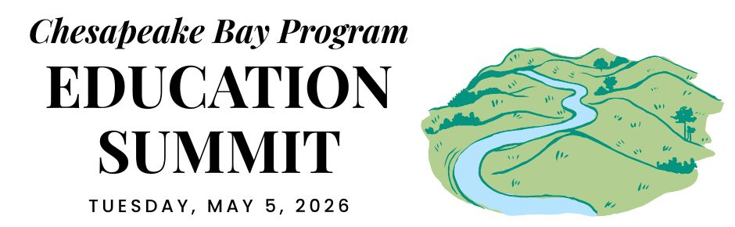

PENNSYLVANIA DELEGATION CONVENING

REGIONAL OPENING (virtual)

12:30 PM ARRIVE & SETTLE IN

12:45 PM WELCOME
Pennsylvania is the current state lead for the Chesapeake Bay Program partnership. Hear opening remarks from their leadership to set the stage for cross-jurisdictional collaboration.
- Secretary Dunn, Pennsylvania Dept. of Conservation and Natural Resources

12:55 PM GOAL & OUTCOME OVERVIEW
Explore the new Engaged Communities Outcomes through bright spots that highlight the inspiring work being done across the region.
Facilitator: Shannon Sprague, Chesapeake Bay Program Education Workgroup

Student Experiences Outcome:

Chris Cerino, Sultana Education Foundation

Callie Sams, West Virginia Dept. of Environmental Protection

School District Planning Outcome:

Elise Sheffield, Boxerwood Education Association

Tammie Peffer, Pennsylvania Dept. of Education

Workforce Outcome:

Ashley Duncan, DC Dept. of Energy and Environment

Jon Wickert, Delaware Dept. of Education

1:20 PM INTRODUCTION TO THE REST OF THE DAY
Get a quick roadmap of the upcoming sessions and understand how they integrate into our broader shared goals.
- Secretary Rowe, Pennsylvania Dept. of Education

STATE DISCUSSION (in-person)

1:30 PM PENNSYLVANIA WELCOME
Join local leadership as they welcome everyone to the site to kick off the afternoon’s sessions.

1:35 PM STUDENT ENVIRONMENTAL LITERACY EXPERIENCES
Take a deep dive into state targets, data, and successful models designed to scale up environmental education for all students.

Carrie Lankford, Red Lion Area School District
- Discussion Question: How can each of our agencies help more school districts offer Environmental Literacy experiences?

2:15 PM SCHOOL DISTRICT ENVIRONMENTAL LITERACY PLANNING
Explore systemic strategies and successful models for integrating environmental literacy and sustainability into district-wide operations.

Ellen Freedman Schultz, The School District of Philadelphia’s GreenFutures
- Discussion Questions: How can we support school districts in creating their Environmental Literacy Plans? What programs or capacities do we have that support or complement these efforts?

2:55 PM WORKFORCE
Highlight the pathways and partnerships that bridge environmental education with green career opportunities for the next generation.

Penn College of Technology
- Discussion Questions: How can K-12 workforce awareness and training support the jobs your agency needs? How can we support schools integrating workforce awareness into curriculum?

3:35 PM DISCUSSION
Participate in an open forum to synthesize insights from the breakout sessions and brainstorm solutions.

CLOSING SESSIONS

3:40 PM REGIONAL CLOSING SESSION (virtual)
Join a collective wrap-up where each jurisdiction shares their next action steps to meet our new outcomes.
- Secretary Shirley, Pennsylvania Dept. of Environmental Protection
- Regional Reflection: Share one thing that your state is excelling in, one growth area, and one concept that you plan to follow up on.

4:15 PM JURISDICTION CLOSING (in-person)
Connect for final local reflections and networking to solidify commitments made throughout the day.

4:30 PM END

