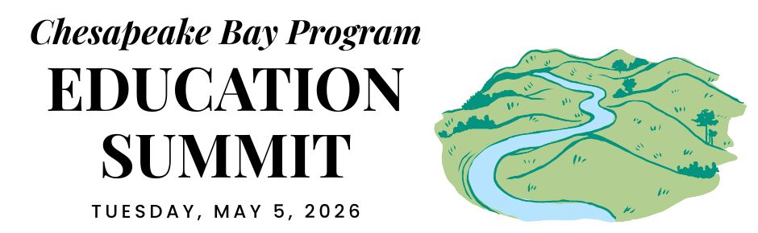

PENNSYLVANIA DELEGATION CONVENING

REGIONAL OPENING (virtual)

12:30 PM ARRIVE & SETTLE IN

12:45 PM WELCOME
Pennsylvania is the current state lead for the Chesapeake Bay Program partnership. Hear opening remarks from their leadership to set the stage for cross-jurisdictional collaboration.
- Secretary Dunn, Pennsylvania Dept. of Conservation and Natural Resources

12:55 PM GOAL & OUTCOME OVERVIEW
Explore the new Engaged Communities Outcomes through bright spots that highlight the inspiring work being done across the region.
Facilitator: Shannon Sprague, Chesapeake Bay Program Education Workgroup

Student Experiences Outcome:

Chris Cerino, Sultana Education Foundation

Callie Sams, West Virginia Dept. of Environmental Protection

School District Planning Outcome:

Elise Sheffield, Boxerwood Education Association

Tammie Peffer, Pennsylvania Dept. of Education

Workforce Outcome:

Ashley Duncan, DC Dept. of Energy and Environment

Jon Wickert, Delaware Dept. of Education

1:20 PM INTRODUCTION TO THE REST OF THE DAY
Get a quick roadmap of the upcoming sessions and understand how they integrate into our broader shared goals.

STATE DISCUSSION (in-person)

1:30 PM PENNSYLVANIA WELCOME
Join local leadership as they welcome everyone to the site to kick off the afternoon’s sessions.
- Secretary Rowe, Pennsylvania Dept. of Education

1:35 PM STUDENT ENVIRONMENTAL LITERACY EXPERIENCES
Take a deep dive into state targets, data, and successful models designed to scale up environmental education for all students.

Carrie Lankford, Red Lion Area School District
- Discussion Question: How can each of our agencies help more school districts offer Environmental Literacy experiences?

2:15 PM SCHOOL DISTRICT ENVIRONMENTAL LITERACY PLANNING
Explore systemic strategies and successful models for integrating environmental literacy and sustainability into district-wide operations.

Ellen Freedman Schultz, Fairmount Water Works Interpretive Center / PWD
- Discussion Questions: How can we support school districts in creating their Environmental Literacy Plans? What programs or capacities do we have that support or complement these efforts?

2:55 PM WORKFORCE
Highlight the pathways and partnerships that bridge environmental education with green career opportunities for the next generation.

Secretary Redding, Pennsylvania Dept of Agriculture

Dr. Michael J. Reed, President and Dr. Alison Diehl, Vice President of Workforce Development Pennsylvania College of Technology
- Discussion Questions: How can K-12 workforce awareness and training support the jobs your agency needs? How can we support schools integrating workforce awareness into curriculum?

3:35 PM DISCUSSION
Participate in an open forum to synthesize insights from the breakout sessions and brainstorm solutions.

CLOSING SESSIONS

3:40 PM REGIONAL CLOSING SESSION (virtual)
Join a collective wrap-up where each jurisdiction shares their next action steps to meet our new outcomes.
- Secretary Shirley, Pennsylvania Dept. of Environmental Protection
- Regional Reflection: Share one thing that your state is excelling in, one growth area, and one concept that you plan to follow up on.

4:15 PM JURISDICTION CLOSING (in-person)
Connect for final local reflections and networking to solidify commitments made throughout the day.

4:30 PM END

