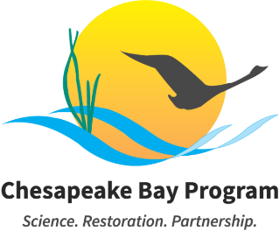

Stream Health Workgroup Meeting - August 2026

Friday, August 7, 2026
10:00am - 12:00pm EST

Meeting Link: Join the meeting via Microsoft Teams
Meeting ID: 251 980 149 917 106 Passcode: fU7BQ3wz
Call: +1 469-208-1525 Phone Conference ID: 641 493 117#
Visit the meeting webpage for meeting materials and additional information.

This meeting may be recorded for internal use only to assure the accuracy of meeting notes. To turn on closed captioning, click on the three ellipses (More actions), then click on “Turn on live captions” (preview). To request accommodations, please contact Meredith Lemke at mlemke@chesapeakebay.net.

Please read the following information carefully, as our meeting policies have changed:

- All meeting attendees' cameras and microphones will be muted at the start of the meeting.
- To request access to the microphone and camera, all meeting participants will be required to use the raised hand feature on Teams. Once access has been granted by the meeting organizer, you will then be allowed to unmute your mic and turn on your camera. Unless instructed otherwise, once a participant has microphone or camera access, they will have this permission for the remainder of the meeting.
- Access to chat will be provided as well. Should it be necessary, the Q&A feature on Teams will be utilized to field participant questions.

Compromised Meeting Plan: If the meeting's privacy is compromised, the meeting staffer and coordinator will send an email to all Members, alternates, staffers, coordinators, and interested parties. Within the email, you will find a new meeting link, instructions on sharing this information with external partners, and any necessary adjustments to the meeting schedule. Please do NOT share this information publicly or post it to the Chesapeakebay.net webpage.

Purpose: To discuss the Stream Health Workgroup’s new Management Strategy draft.

Agenda
- Introductions and Announcements (10:00 – 10:10)
The Stream Health meeting will begin with announcements of brief Chesapeake Bay Program updates, and introductions of any new members or attendees.

Requested Action: Non-decisional
Lead: Alison Santoro (MDNR), Brock Reggi (VA DEQ)
Materials: N/A

- Discussion: Management Strategy Development (10:10 – 11:50)
The workgroup will have a collaborative discussion about the new Management Strategy draft.

Requested Action: Non-decisional
Lead: Alison Santoro (MDNR), Brock Reggi (VA DEQ)
Materials:
- Draft SHWG Management Strategy - Clean Version July 2026
- Previous Stream Health Management Strategy (updated 2024)

- Wrap-Up and Adjourn (11:50 – 12:00)
Lead: Alison Santoro (MDNR), Brock Reggi (VA DEQ)

Next Meeting: October 16th, 2026 10:00 AM - 12:00 PM

