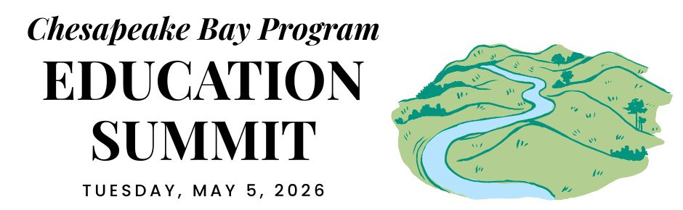

VIRGINIA DELEGATION CONVENING

REGIONAL OPENING (virtual)

12:30 PM ARRIVE & SETTLE IN

12:45 PM WELCOME
Pennsylvania is the current state lead for the Chesapeake Bay Program partnership. Hear opening remarks from their leadership to set the stage for cross-jurisdictional collaboration.
- Secretary Dunn, Pennsylvania Dept. of Conservation and Natural Resources

12:55 PM GOAL & OUTCOME OVERVIEW
Explore the new Engaged Communities Outcomes through bright spots that highlight the inspiring work being done across the region.
Facilitator: Shannon Sprague, Chesapeake Bay Program Education Workgroup

Student Experiences Outcome:

Chris Cerino, Sultana Education Foundation

Callie Sams, West Virginia Dept. of Environmental Protection

School District Planning Outcome:

Elise Sheffield, Boxerwood Education Association

Tammie Peffer, Pennsylvania Dept. of Education

Workforce Outcome:

Ashley Duncan, DC Dept. of Energy & Environment

Jon Wickert, Delaware Dept. of Education

1:20 PM INTRODUCTION TO THE REST OF THE DAY
Get a quick roadmap of the upcoming sessions and understand how they integrate into our broader shared goals.

STATE DISCUSSION (in-person)

1:30 PM VIRGINIA WELCOME
Join local leadership as they welcome everyone to the site to kick off the afternoon’s sessions.

1:35 PM STUDENT ENVIRONMENTAL LITERACY EXPERIENCES
Take a deep dive into state targets, data, and successful models designed to scale up environmental education for all students.

Laura Casdorph, Virginia Dept. of Education
- Lori Schoenwiesner, Virginia Dept. of Conservation and Recreation
- Krista Weatherford, Maymont
- Courtney Hallacher, Virginia Dept. of Wildlife Resources
- Discussion Questions: What policies, practices, funding, or other mechanisms in your sphere of influence could be applied to advance the work of student environmental literacy experiences we've discussed? What partnerships—state agencies, nonprofits, community groups—could be strengthened to expand student experiences?

2:15 PM SCHOOL DISTRICT ENVIRONMENTAL LITERACY PLANNING
Explore systemic strategies and successful models for integrating environmental literacy and sustainability into district-wide operations.

Laura Casdorph, Virginia Dept. of Education
- Lori Schoenwiesner, Virginia Dept. of Conservation and Recreation
- Clark Seipt and Tori Dandridge, Virginia Environmental Literacy Network
- Courtney Hallacher, Virginia Dept. of Wildlife Resources
- Discussion Questions: What policies, practices, funding, or other mechanisms in your sphere of influence could be applied to advance the work of student environmental literacy experiences we've discussed? What partnerships—state agencies, nonprofits, community groups—could be strengthened to expand district environmental literacy planning?

2:55 PM WORKFORCE
Highlight the pathways and partnerships that bridge environmental education with green career opportunities for the next generation.

Grayson Shultz, Virginia Office of Natural and Historic Resources and Megan Bascone, Virginia Department of Environmental Quality

Ellen Powell, Virginia Dept. of Forestry

Kendall Tyree, Virginia Soil & Water Conservation Districts

Katie Shepard, Virginia Dept. of Conservation and Recreation

Elise Sheffield, Boxerwood Education Association
- Discussion Questions: What policies, practices, funding, or other mechanisms in your sphere of influence could be applied to advance workforce connections? What strategic actions could Virginia take in the next two years to strengthen and expand environmental workforce pipelines?

3:35 PM DISCUSSION
Participate in an open forum to synthesize insights from the breakout sessions and brainstorm solutions.

CLOSING SESSIONS

3:40 PM REGIONAL CLOSING SESSION (virtual)
Join a collective wrap-up where each jurisdiction shares their next action steps to meet our new outcomes.
- Secretary Shirley, Pennsylvania Dept. of Environmental Protection
- Regional Reflection: Share one thing that your state is excelling in, one growth area, and one concept that you plan to follow up on.

4:15 PM JURISDICTION CLOSING (in-person)
Connect for final local reflections and networking to solidify commitments made throughout the day.

4:30 PM END

