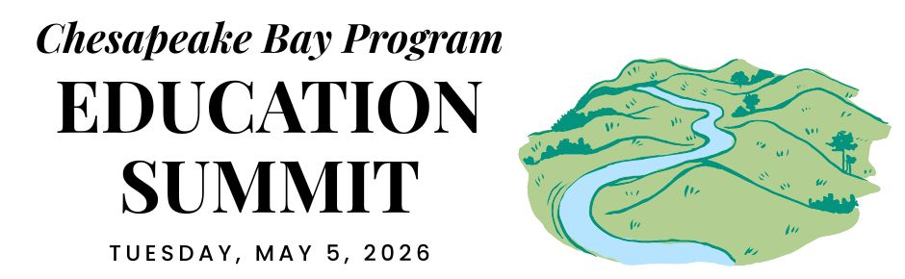

WEST VIRGINIA DELEGATION CONVENING

REGIONAL OPENING (virtual)

12:00 PM ARRIVE & REFRESHMENTS

12:45 PM WELCOME
Pennsylvania is the current state lead for the Chesapeake Bay Program partnership. Hear opening remarks from their leadership to set the stage for cross-jurisdictional collaboration.
- Secretary Dunn, Pennsylvania Dept. of Conservation and Natural Resources

12:55 PM GOAL & OUTCOME OVERVIEW
Explore the new Engaged Communities Outcomes through bright spots that highlight the inspiring work being done across the region.
Facilitator: Shannon Sprague, Chesapeake Bay Program Education Workgroup

Student Experiences Outcome:

Chris Cerino, Sultana Education Foundation

Callie Sams, West Virginia Dept. of Environmental Protection

School District Planning Outcome:

Elise Sheffield, Boxerwood Education Association

Tammie Peffer, Pennsylvania Dept. of Education

Workforce Outcome:

Ashley Duncan, DC Dept. of Energy & Environment

Jon Wickert, Delaware Dept. of Education

1:20 PM INTRODUCTION TO THE REST OF THE DAY
Get a quick roadmap of the upcoming sessions and understand how they integrate into our broader shared goals.

STATE DISCUSSION (in-person)

1:30 PM WEST VIRGINIA WELCOME
Join local leadership as they welcome everyone to the site to kick off the afternoon’s sessions.

Introductions around the office. Many people have never met so be prepared to briefly introduce yourself, your organization, and your work.
- Introduction to what brought us together:
  - Callie Sams: WV Chesapeake Bay Program
  - Frank Rodgers: WV OLNI

1:45 PM STUDENT ENVIRONMENTAL LITERACY EXPERIENCES
Discuss the current state of environmental literacy across WV (5 minutes each with Q&A, alphabetical by program). Please be prepared to share budgets, staffing, locations, number of students, etc.
- Beth Henry-Vance: WVDEP Youth Environmental Program
- Heather Duncan: WV Envirothon
- Kristen Beverage: Experience Learning
- Laurel Schwartz: Potomac Valley Audubon Society’s Watershed Education Program
- Linda Carnell: WVDOF Project Learning Tree

Stephanie Banik: Review of 2025-26 Meaningful Watershed Educational Experiences
- Tomi Bergstrom: WVDEP Project WET
- Discussion Questions:
  - Where can our programs reinforce one another?
  - Where can we share resources?

2:30 PM BREAK

2:40 PM OLNI ENVIRONMENTAL LITERACY PLANNING & PROFESSIONAL DEVELOPMENT
Final planning for teacher PD (June 11-12)

Stephanie Banik & Sonja Melander: Agenda & enrollment
- Discussion Questions: Is anything missing? From the discussion on reinforcing and sharing resources, what can we improve?

2:50 PM WORKFORCE
Highlight the pathways and partnerships that bridge environmental education with green career opportunities for the next generation.

Jessica Kolek: Introduction to the Applied Laboratory Technical/Environmental Science Technician
- Discussion Questions: What other workforce programs exist? How can we benefit from the new Workforce Goal in the Chesapeake Bay Agreement?

3:20 PM CONCLUSION
Prepare a list of next steps to present to the Regional Session.

Set a follow up meeting date.
- Roundtable: What can your organization commit to contributing to a state-wide E-Lit effort?
- Roundtable: Can we facilitate information exchanges or “ride-alongs”?
- Roundtable: Who can we engage to learn more about workforce development?

CLOSING SESSIONS

3:40 PM REGIONAL CLOSING SESSION (virtual)
Join a collective wrap-up where each jurisdiction shares their next action steps to meet our new outcomes.
- Secretary Shirley, Pennsylvania Dept. of Environmental Protection
- Regional Reflection: Share one thing that your state is excelling in, one growth area, and one concept that you plan to follow up on.

4:15 PM JURISDICTION CLOSING (in-person)

