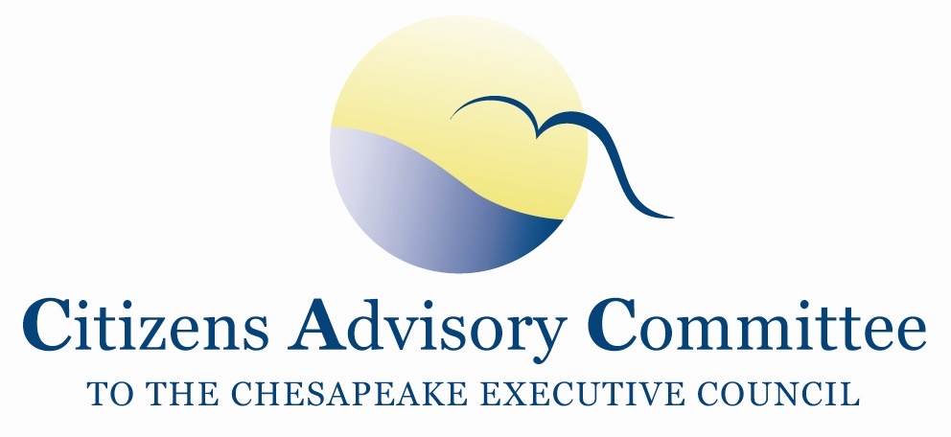
Citizens Advisory Committee
Meeting Agenda
December 3-4, 2020

______________________________________________________________________________________________________________________________________

Virtual Meeting
This meeting will be recorded for internal use to assure the accuracy of the meeting notes.

Meeting Goal: Learn and discuss Committee advice and action on environmental priorities for the new Administration and the draft Conowingo Watershed Implementation Plan.

Thursday, December 3: From Your Remote Office

1:00 p.m. Call to Order and Welcome…………………….…………….……….…..Matt Ehrhart, Chair

1:15 p.m. Virginia Leadership………………………………………..………….Secretary Matt Strickler
Virginia Secretary of Natural Resources

Virginia is chairing the Executive Council and Principals’ Staff Committee. Secretary Strickler will speak to recent Virginia actions to advance watershed restoration and share thoughts on leading the Chesapeake Bay Program.

2:15 p.m. Environmental Priorities in the New Administration

Shannon Frede, Environmental Policy Counsel, Office of U.S. Senator Ben Cardin (MD)
Alyssa Charney, Environmental Issues, Office of U.S. Senator Casey (PA) (invited)
Peter Marx, Federal Affairs, Choose Clean Water Coalition

Panelists will share their thoughts and perspectives on Priorities of the Congressional Delegation with respect to the Bay Watershed in 2021 and How the Biden Administration can help advance restoration of the Chesapeake and challenges for doing so.

3:45 p.m. Break

4:00 p.m. Business Meeting
- Approval of September Meeting Minutes
- Updates on the BMP Verification ad hoc workgroup (Matt)
- Updates on DEIJ Action Team (Julie)
- CAC Officers Elections
- Staff Updates
  - Introduction to CAC Subcommittee Revamp
  - Follow-up from Public Health and Environment Quality Panel
  - Potential New Cohort of CAC Members
  - DocuSign overview
  - Preview of CAC Shared Folder for Resources
- Member Updates

5:00 p.m. Meeting Recess

5:30 p.m. Optional Virtual Reception and Networking
Friday, December 4: From Your Remote Office

1:00 p.m. Chesapeake Bay Program Updates…………………...………………………….. Jim Edward,
Deputy Director, EPA Chesapeake Bay Program
- Updates on DEIJ Action Team and the Community Advisory Board
- CBP action around 2020 CAC EC Recommendations
- FY2021 Budget

1:30 p.m. Draft Conowingo WIP Strategy…………………………………………….....……Matt Rowe,
Assistant Director, Water and Science Administration,
Maryland Department of the Environment

Bryan Seipp,
Senior Project Manager, Center for Watershed Protection

Matt Rowe, a co-chair of the Conowingo Watershed Implementation Plan (WIP) Steering Committee, and Bryan Seipp, with the Center for Watershed Protection, grantee to help develop the WIP, will present key elements of the draft Conowingo WIP. Comment period open until January 20 (new extended deadline).

2:15 p.m. Conowingo Dam: Stakeholders’ Perspectives…………………….……..………..Beth McGee,
Director of Science and Agricultural Policy,
Chesapeake Bay Foundation

Betsy Nicholas,
Executive Director, Waterkeepers Chesapeake

Guests, Beth McGee and Betsy Nicholas, have been closely following issues on the Conowingo Dam for years. They will offer stakeholder’s perspectives on the draft WIP, the Conowingo Settlement with the State of Maryland and Exelon, Corp., and other topics of interest.

3:00 p.m. Break

3:15 p.m. Updates from the other Advisory Committees to the Bay Program
- Ann Simonetti, LGAC Chair and Pennsylvania Member
- Andy Miller, STAC Chair and Maryland Member

The LGAC and STAC Chairs will share their Committee’s unique perspectives, briefings on special projects, Committee topics of interests, and future focuses and priorities.

4:00 p.m. Reflection, Discussion and Action Items
- Suggested Topics from the Meeting:
  - Virginia leadership
  - New Administration Environmental Priorities
  - CBP updates
  - Conowingo WIP Strategy
- Other thoughts on future topics and action items

5:00 p.m. Adjourn

Next CAC Meeting February 25-26, 2021

