Draft

Executive Summary (Greg Allen, Mike Focazio and Scott Phillips)

Introduction (Greg Allen and Mike Focazio)
- 2012 Report Introduction and Purpose
Executive Order 13508 (2009) committed federal, state and nongovernmental stakeholders to the task of furthering the efforts towards protecting and restoring the waters of the Chesapeake Bay and its tributaries under the Clean Water Act. The 2010 “Strategy for Protecting and Restoring the Chesapeake Bay Watershed” (“Strategy”), combined with the commitments by Chesapeake Bay Program (CBP) partners outlined in the “Toxics Reduction Strategy” (2001), identified the need to further define and reduce the impact of toxic contaminants on the Bay and its headwaters. Furthermore, continued presence of toxic contaminants in the Bay, the emergence of new contaminants, and the observed impact of fisheries (such intersex conditions in the watershed and human health advisors for fish consumption) highlight the importance of addressing toxic contaminants in addition to the emphasis on nutrient and sediment pollution control strategies.
The need for a toxic contaminant summary report for the Chesapeake Bay and its watershed is the first step in a three part process toward addressing the impacts of toxic contaminants. In order to establish relevant and meaningful objectives for addressing toxic contaminant reduction, the Chesapeake Bay Program partners must first produce this summary report on the extent and seriousness of the toxic contamination problem in the Bay and its watershed by November 2012. The Strategy commits federal partners (EPA, DOI and NOAA), in collaboration with the Bay states, the District of Columbia and watershed stakeholders, to develop these toxic contaminant reduction goals by 2013. The third commitment of the “Strategy” is for the federal, state and other stakeholders to develop an approach, by 2015, which will reduce toxic contaminants in the Chesapeake Bay and its watershed. The contaminant reduction strategies may include the prioritization of existing programs, additional enforcement measures and/or other multi-regional initiatives that comprise an effective approach toward meeting the goals set in 2013.
The 2012 Toxic Contaminant Summary Report, as defined by the 2010 Strategy, summarizes the extent and seriousness of the toxic contaminant problem in the Chesapeake Bay and its watershed (i.e., estuary, rivers, and streams). Using information gathered from the most recent Integrated Watershed Reports of Bay states and the District of Columbia, as well as findings from additional scientific investigations, the report assesses the presence of toxic contaminants in the water column, sediments and fish tissues in the waters of the Bay and its watershed. Additional elements of the report describe observed biological impacts on fish and wildlife.. Finally, the 2012 Report makes suggestions regarding additional data collection and/or research, and considerations for developing reduction goals to facilitate the preparation of contaminant reduction goals in 2013 and toward the development of reduction strategies in 2015.
  - Executive Order 13508
  - EO Strategy

- Previous Initiatives
  - 1981 Chesapeake Bay Agreement Overview
  - 1994 Basin-wide Toxics Reduction and Prevention Strategy Overview
  - Toxics 2000 Strategy Overview
- Report Format Overview

Extent and seriousness of toxic contaminants (Melanie Culp and Ashlee Harvey)

Summarizing information from state integrated assessment reports
There are six states that lie within the watershed of the Chesapeake Bay: New York, Pennsylvania, Maryland, Delaware, Virginia, and West Virginia. Like all states, these six, along with the District of Columbia, evaluate their surface waters biennially to produce a report that complies with the assessment requirements of the Clean Water Act (CWA). One report, the integrated water quality report, evaluates the quality of surface water segments with a specific state or jurisdiction.
These Integrated Reports classify stream and river segments based on the individual segments status related to compliance with its documented designated use. Although each state has been delegated the authority by EPA to develop state-specific designated uses, there are generally four main types of uses by which a surface water segment is designated: aquatic use, fish consumption use, recreational use and public water supply use. Once a segment has been classified, the state makes a status assessment by comparing reported quantitative and qualitative field data with the designated use in order to categorize the segments. Table 1 describes the 5 main categories which are based on the extent to which the designated use is met or not met (impaired). An impaired segment is a portion of a surface water body that does not meet its designated use as prescribed by the CWA. Those water segments that fall within the impaired categories (generally Categories 4 and 5) comprise the 303 (d) list of impaired segments. The 303 (d) and 305 (b) reports are generally combined into a single document – the integrated assessment or integrated water quality report (from here, Integrated Report)– establishes the nature and extent of impairments to the nation’s surface water bodies on a state level.
Table 1- EPA Defined Categories of Waterbodies within the Integrated Report
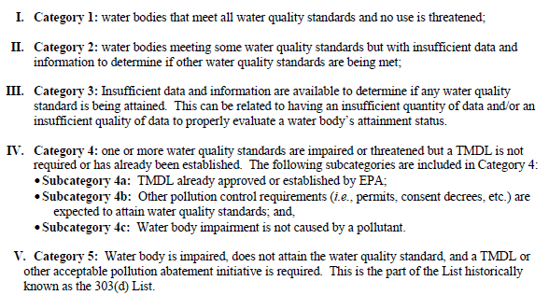
Although nutrient loading is the predominant factor in water quality impairments, biological (diseases, bacteria, etc…) and toxic chemical contamination are other factors that contribute to poor water quality in the Chesapeake Bay. This report is an effort to summarize the extent and seriousness of toxic chemical contamination within the waters of Chesapeake Bay and its tributaries.
The information found within the seven Integrated Reports of the six Bay States and the District of Columbia has been compiled here to define the extent and seriousness of toxic contaminant pollution within the waters of the Chesapeake Bay and its tributaries. Although each state has the authority to establish water quality standards and designated uses for the surface waters under their jurisdiction, all of the integrated reports generally present information in similar, systematic way. The state-specific reports evaluate and list the total number of impaired miles for each priority nutrient and contaminant and for each identified designated use. These methodologies seek to represent the total impact of each contaminants as a distinct factor in the impairment of the waterways, thus it is possible for impaired segments of multiple contaminants to overlap geographically. Therefore, the sum of impaired miles and unimpaired miles does not necessarily equate to the total miles of a water segment.
Discuss overall or similar methodologies (Ashlee)
Each state promulgates water quality criteria for surface waters so that they may evaluate each segments ability to meet its designated uses. Some states use screening criteria , in the absence of defined standards, to identify toxics of concern in sediments (VA DEQ and DCR, 2010). In general, both the promulgated water quality standards and screening criteria for the three water media assessed (water column, fish tissue and sediments) are risk-based calculations. Standards for contaminants found in the water column are set based on the risk to aquatic life, while fish consumption impairments (and subsequent advisories) are calculated based on the human health risk associated with the intake of contaminated fish tissues. The “weight of evidence” approach, used in Maryland Virginia for sediment contamination measures, analyzes impacts from sediment bioassays, changes to resident biota or benthic community structure, and ambient sediment chemistry. This triad approach allows researchers to make a calculated decision of the overall toxicity and impact of chemical contaminants in sediment (MDE and MD DNR, 2010).

Summary of Basin

Geographic Area
The watershed of the Chesapeake Bay spans over 64,000 square miles, and includes land within seven major jurisdictions of the Mid-Atlantic Region in the United States: Delaware, the District of Columbia, Maryland, New York, Pennsylvania, Virginia and West Virginia. 150 major rivers and streams collect to form this, the largest estuary in North America and the third largest in the world (Chesapeake Bay Program, 2012). With a population surpassing 17 million people and with 11,000 miles of shoreline, it is understandable that some anthropogenic impacts deriving from the Bay States and the District combine with naturally occurring contaminants to affect the water quality in the Bay watershed. The following is a summary of the Bay watershed within each of the seven jurisdictions.
The Chesapeake Bay drainage area is the second largest in Delaware, encompassing about 41% of the state’s land area or approximately 511,000 acres (Delaware DNREC, 2010). Flowing from New York to Maryland, the Susquehanna River Basin, a major tributary of the Chesapeake Bay, is the second largest river basin east of the Mississippi River and the largest on the Atlantic seaboard (NYSDEC, 2009). Nearly half a million residents live in the 3.5 million acres of the Susquehanna Basin of New York. The Susquehanna and Potomac River portions that flow through the Commonwealth of Pennsylvania account for approximately 22,000 square miles (14.1 million acres) of the total Chesapeake Bay watershed. Ninety-four percent of the land in the state of Maryland is in the Chesapeake Bay Watershed; Maryland’s portion of the watershed is roughly eighteen percent of the total watershed, or 6.2 million acres. (CWP for MDNR, 2006). One hundred percent of the District of Columbia, or 69 square miles (44,000 acres), is within the watershed. Virginia hosts forty percent of the watershed, or approximately 13.8 million acres (VA DCR, 2012), while only fourteen percent of West Virginia (still 2.2 million acres) falls within this watershed (VA DCR, 2012).
What TOCs are being monitored?
List or summarize state standards (refer to Appendices) for water column, screening criteria is used for sediments….What is used for fish tissue? Some sort of human health standard?

Which TOCs are being detected? Methodologies (weight-of-evidence, triad)
PCBs, PAHs, Pesticides…Metals reach some level of toxicity in some waterbodies.
What order of streams does each state analyze to establish the summaries in a 303(d) report for each basin (it’s it the main stem of the Susquehanna River or all tribs included too?)
Maryland modified its analysis of fish tissue in the 2010 Integrated Report:
“C.2.2 Toxics Assessment Methodology
Changes to the Toxics Assessment Methodology were relatively minor for this cycle. The most important changes involved slight refinements/clarifications in the fish tissue portion of the methodology. Specific language was added to more clearly define what size of fish and what parts of the fish are to be used in the analysis.” (MDE and MD DNR, 2010)

How do these concentrations compare to federal/state benchmarks?
Give an overview that water column samples are compared to defined water quality standards; sediment samples are compared to screening levels and are reported in NOAA’s sediment assessment for the tidal portions of the Bay; fish tissue samples are based on human health impacts.

What are the main drivers for listing of impairments?

Contaminant Detection Summaries
        - Organic Compounds
Organic Compounds are a classification of contaminants that are generally found…..and have the potential to cause….Some of the more prevalent organic compounds found in the waters of the Chesapeake Bay and its tributaries are identified below, including polychlorinated biphenyls (PCBs), polycyclic aromatic hydrocarbons (PAHs) and several compounds that result from pesticide/herbicide usage in the watershed. The state of Delaware reports no organic contaminants entering the Chesapeake Bay watershed from its tributaries (Delaware DNREC, 2010).
          - PCBs
Polychlorinated Biphenyls, or PCBs, are organic compounds that are manufactured as ….. and, when released into the aquatic environment tend to bioaccumulate in fish tissue which can …
            - In Water Column
Virginia and Maryland are the only states that have impairments due to PCB concentrations in the water column. In the Commonwealth, there are 9 impaired river miles and 1 impaired square estuary mile from PCBs, while Maryland has 1 listing for this contaminant. Although found in water and sediments (see next section), PCBs present a more significant risk to human health through accumulation in fish as discussed in the section below in the section on Fish Tissue (MDE and MD DNR, 2010) (VA DEQ and DCR, 2010).
            - In Sediments
High concentrations of PCBs in sediments of the Chesapeake Bay lead to bioaccumulation (storage) of the contaminant in fish tissue, and results in impairments of the region’s waterways. NOAA’s report on the contaminated sediments in the Bay’s tidal regions shows that PCB levels in sediments reach their highest concentration along the mouth of the Bay at the Elizabeth River, but total mass of PCBs in sediments is highest in the Northern Bay and in Tangier Sound. This study reports on the Effects Range Median (ERM) and Effects Range Low (ERL) of biological effects in sediments, demonstrating that exceedances of the ERM and ERL for a contaminant is predictive of observed effects probably being seen and possible being seen, respectively (Hartwell, 2007). PCBs found in sediments in Maryland’s rivers and streams, cause impairments and result in Category 5 listings for two segments of the Patapsco River and portions of Baltimore Harbor (MDE and MD DNR, 2010). NOAA’s report reveals historic data that suggests that concentrations of PCBs in the Bay’s tributaries tend to be higher than in the main stem of the estuary. The two parts of FIGURE 1 shows the sediment concentrations of Total PCBs throughout the tidal Chesapeake Bay (Hartwell, 2007). Some contaminated sites in the Anacostia River in the District of Columbia released PCBs into the adjacent sediments and are part of an ongoing cleanup process to remediate the area (DDOE, 2010).

Figure 1 - Concentration of measure PCBs in the Chesapeake Bay mainstem. Selected locations are noted. Horizontal line indicates ERL concentration (Hartwell, 2007).
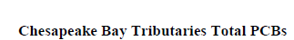
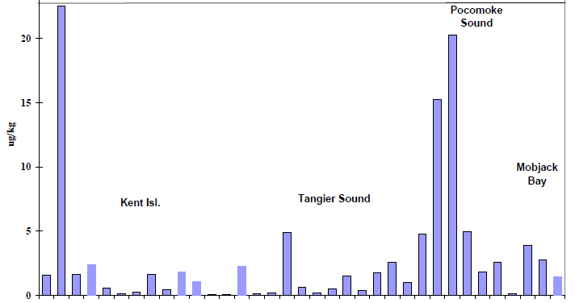
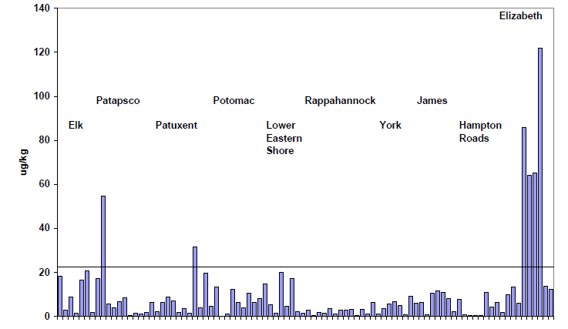
            - In Fish Tissue
PCBs are of most risk to human health through consumption of contaminated foods, specifically fish, due to the bioaccumulation of the organic compound in the tissues of fish that live in PCB contaminated rivers and streams. Historic deposition of PCBs into streambeds leaves a legacy of contaminated sediments that continue to release PCBs into the aquatic environment, while new releases of PCBs into the environment make them a persistent contaminant of concern.
Virginia’s five Chesapeake Bay tributary basins show significant impacts from PCBs in fish tissue. A total of 456 river miles and 2011 square estuarine miles have documented impairments from this organic. The James River has the most river miles of impacts from PCBs (247 miles), whereas the Chesapeake Bay/Atlantic Basin accounts for approximately 1600 square miles (79%) of the total estuarine impacts (VA DEQ and DCR, 2010). In the Susquehanna River Basin of Pennsylvania, PCBs account for approximately 94 miles of impaired streams and rivers due to the contaminant levels found in fish tissue. PCB and mercury contamination in the waters of Pennsylvania, as well as some areas of fish that remain untested or have unidentified contaminants, resulted in a statewide fish advisory for recreationally caught sportfish (PA DEP, 2010).
Maryland also shows impairments from PCBs in fish tissue; three Category 4 and thirty-two Category 5 water segments are listed for this contaminant and have fish consumption advisories in place to protect human health (MDE and MD DNR, 2010). In the District of Columbia, surveys have shown elevated levels of PCBs in the tissue of certain fish species, and, in 1994, the District Department of Health issued a district-wide fish consumption advisory due to PCBs in fish tissue (US EPA, 2012). Assessments of total PCBs ranked high on the priority list for TMDL development in the District and the TMDL for PCBs was established in 2007, moving the listings for the two Anacostia River PCB contaminated segments from Category 5 to Category 4a (DDOE, 2010).
West Virginia has a general statewide advisory on the consumption of sportfish due to low-level PCBs contamination, but have documented 127.5 stream miles impaired by PCBs in the South Branch Potomac Watershed. No Chesapeake Bay watershed specific data was available (WV DEP, 2010). Only Koppers Pond in the Chemung River Basin of is listed for PCB impairment in New York’s portion of the Bay watershed (NYSDEC, 2009).
          - PAHs
Polycyclic aromatic hydrocarbons, or PAHs, are….
            - Water
Only 1 square estuary mile in the Commonwealth of Virginia is impaired due to PAHs found in the water column (VA DEQ and DCR, 2010). In Maryland, two segments of the Patuxent River are listed for PAH contaminants resulting from an oil spill in 2000. The District of Columbia has a Category 4a listing for PAH1, PAH2 and PAH3 in more than one dozen stream segments as part of the District’s Organics TMDL (DDOE, 2010). There are no reported impairments in West Virginia, Pennsylvania or New York resulting from PAH contamination (WV DEP, 2010) (PA DEP, 2010) (NYSDEC, 2010).
            - Sediments
PAH results in the Chesapeake Bay were similarly distributed across regions to the PCB findings. The ERL for biological effects from PAH were exceeded for most of Maryland’s sediment monitoring program, with significant concentrations in tributaries like the Elizabeth River, in Baltimore Harbor, and in the deep trough of the Susquehanna Flats. FIGURE 2 shows the total concentration of PAHs in sediment samples, with spikes evident throughout and the highest concentrations in the tributary sediments (Hartwell, 2007).

Figure 2- Total PAH concentrations in Chesapeake Bay sediment samples. Dashed line indicates ERL concentration. (Hartwell, 2007)
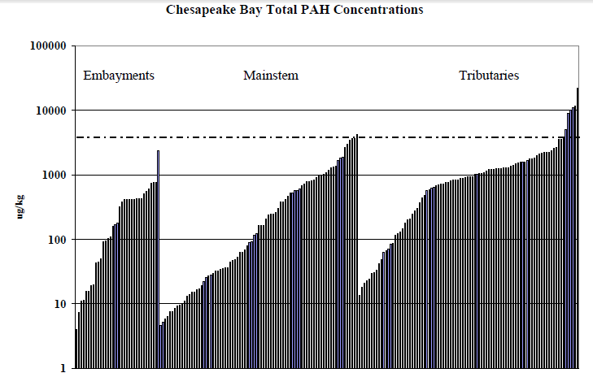
            - Fish Tissue
Virginia has 7 river miles and less than 1 square estuarine mile impaired for fish consumption of PAH (Benzo[k]fluoranthene) contaminated species (VA DEQ and DCR, 2010). There are no reported impairments in West Virginia or New York resulting from PAH contamination (WV DEP, 2010) (NYSDEC, 2010).
          - Pesticides/herbicides
Pesticides and herbicides are used ... Runoff from agricultural and urban areas leads to overloading of pesticide contaminants in the rivers and streams of the Chesapeake Bay region. The impacts from high concentrations of pesticides in a water body are …
            - Water
Pesticides and herbicides are found in various segments of the Chesapeake Bay tributaries due to direct runoff or releases from contaminated sediments in rivers, streams and lakes. In Virginia, along the Potomac and Shenandoah Rivers, there are 7 impaired river miles from the insecticides, Heptachlor Epoxide (five impaired segments) and Chlordane (2); the James River basin has listings for Chlordane (3 impaired miles) and from other insecticides, Aldrin and DDE/DDT, totaling 9 impaired river miles; Mirex, also an insecticide, impairs 5 river miles in the James River and 49 miles in the Rappahannock (VA DEQ and DCR, 2010).
Maryland waters also have trace evidence of pesticide use in the watershed. There are two river segments, the Back River and the Baltimore Harbor, and one impoundment, Lake Roland, which are listed as Category 4 waters for Chlordane. Maryland’s Northwest portion of the Anacostia River has one listed segment for Heptachlor Epoxide contamination (MDE and MD DNR, 2010). The District of Columbia also observes elevated levels of pesticides as part of its Category 4a list in numerous branches of the Potomac and Anacostia Rivers, included in the District’s Organics TMDL. These include: Chlordane, DDE, DDD, DDT, Dieldrin, and Heptachlor Epoxide (DDOE, 2010).
Unidentified pesticides are responsible for 17 river miles of impairments in the Susquehanna River Basin of Pennsylvania (PA DEP, 2010). New York and West Virginia do not report any pesticide contamination entering the Chesapeake Bay from their portions of the watershed (NYSDEC, 2010) (WV DEP, 2010).
            - Sediments
NOAA’s Contaminated Sediment report identifies organophosphate-type pesticides as the highest yield of all organic materials present in tidal sediment, with the most significant concentration spikes reported in the Choptank and Nanticoke Watersheds of Maryland during spring runoff. Elevated levels of insecticides including, chlordances, heptachlors, nonachlors, aldrin, dieldrin, endrin and endosulfan were found in the Elizabeth River of Virginia, and in trace amounts throughout the other tidal portions of the Bay. Hexachlorocyclohexane (HCH) was not elevated in the Elizabeth, but in the Patuxent, Potomac and Eastern Shore tributaries of Maryland. The legacy pesticide, DDT, was found throughout the Bay, mainly concentrated in the Upper Bay but only exceeding the ERM in the Elizabeth River. Other pesticides observed were: Mirex, Chlorpyrifos, butyltins, tributyltin (TBT) and chlorinated benzenes (Hartwell, 2007).
            - Fish Tissue
In the District of Columbia, surveys have shown elevated levels of Chlordane in the tissue of certain fish species across many portions of the Anacostia and Potomac Rivers. Chlordane is included with other pesticides in the district-wide Organic TMDL mentioned previously (DDOE, 2010).
          - Other Organics
            - Water
In New York, Total Phenols exceeded screening values for water quality, although further testing revealed no aquatic toxicity in the Chemung River due to these TOCs (NYSDEC, 2007), while dioxins have impaired 3 square miles of estuarine waters in the Commonwealth of Virginia (VA DEQ and DCR, 2010). The District of Columbia has many water segments listed in Categories 4 and 5 for organics, although the specific toxins are undefined (DDOE, 2010). Maryland has some impaired segments due to point source releases of cyanide (MDE and MD DNR, 2010). Pennsylvania identifies organics as the cause of 2.3 miles of impairments within the Susquehanna Basin (PA DEP, 2010). West Virginia does not report any additional organic contaminants entering the Chesapeake Bay watershed from its waters (WV DEP, 2010).
            - Sediments
            - Fish Tissue
        - Metals and Compounds
The toxic metals found in surface water, sediments and fish tissue of the Chesapeake Bay basin are chemical elements that have been released into the water system or those that have been released into the atmosphere and deposited into the watershed, although some naturally occurring levels exist. Mercury contamination in fish tissue is the most prevalent metal reported in the waters of the Chesapeake Bay and its tributaries, and is the driver for the fish consumption advisories in regions streams, rivers, lakes and reservoirs in Maryland, Pennsylvania and Virginia. Of the seven Bay jurisdictions, only Delaware reports that no elevated levels of Mercury or other metals are present in the state’s Chesapeake tributaries (Delaware DNREC, 2010).
          - Mercury
            - Water
Maryland has one Category 4 listing in the Patapsco River, resulting from an industrial point source discharge to the surface water (MDE and MD DNR, 2010). Mercury is not reported as a toxic contaminant of concern for the Chesapeake Watershed portions of the District of Columbia (DDOE, 2010).
            - Sediments
Mercury has been found in sediments of the Susquehanna River Basin of New York, although it was determined that it did not cause chronic toxicity to those organisms that live in the sediment, and showed no significant reproductive effects or mortality nor any acute toxicity effects (NYSDEC, 2009). This toxin is also found in waters in the western part of Virginia, near the border of Tennessee, but is only documented as a concern in the South River (Shenandoah River) in the portion of Virginia leading to the Chesapeake (VA DEQ and DCR, 2010).
            - Fish Tissue
A general advisory on the amount of sportfish (including the walleye) consumed in the State of New York exists due to the “common occurrence of some chemicals (including Mercury) in fish and the inability to test all waters” (NYSDEC, 2009). No sources in the basin have been identified other than wastewater and industrial effluent – point sources that have been actively removed from the region (NYSDEC, 2009). The lower main stem of the Susquehanna River Basin was listed in 2006 as Category 5 as impaired for Mercury, but were subsequently moved to Category 4 of the 303 (d) List in 2008 due to the approved Northeast Regional Mercury TMDL (NYSDEC, 2009). Atmospheric deposition is the sole identified source of the Mercury in the Susquehanna River Basin, leading to impairments in rivers and streams as well as surface water impoundments throughout New York and Pennsylvania. In the Susquehanna Basin of Pennsylvania, roughly 2600 acres of lakes and 376 river miles are impaired for consumption of mercury contaminated fish (PA DEP, 2010).
Data from Maryland’s Department of the Environment shows an elevated level of mercury in the tissue of gamefish and bottom-feeders in the state’s waters (MDE and MD DNR, 2010). As a result, the State issues consumption advisories for fish species that cannot be consumed more than 4 times a month; advisories translate to impairments here, as a river segment with consumption advisories does not meet the “fishable” designated use. Maryland documents approximately thirteen impaired lake/reservoir segments within the Category 4 and 5 lists, and 276 non-tidal stream miles on the Category 2 list, impacted by Mercury in fish tissue; Category 2 waters are those waters that meet some water quality standards but the State requires additional information to fully assess the impacts and extent of the toxin.
Virginia, like other Bay states, has significant impairments related to Mercury in fish tissue. 301 river miles and 5 square estuarine miles are impacted in tributary waters of the Bay from this state, with the most impaired miles in the Potomac/Shenandoah Basin. Impairments are also present for fish consumption of mercury contaminated species in several lakes and reservoirs in Virginia, totaling several thousand acres (VA DEQ and DCR, 2010).
Although West Virginia has a general statewide advisory on the consumption of sportfish due to low-level mercury contamination, there are no segments that are impaired for this specific toxin. The State is in the process of assessing previously listed waters for mercury as they take a closer look at the methodology used to assess fish tissue for mercury contamination. It is difficult at this time to ascertain the extent of mercury contamination throughout the state (WV DEP, 2010).
Mercury in fish tissue is also the driver for the impairment of many surface water impoundments (lakes and reservoirs) in the Bay watershed. In Pennsylvania, Maryland and Virginia, atmospheric deposition is the leading cause of Mercury loading in the impoundments.

          - Other Metals
            - Water
Abandoned mine drainage (AMD) impacts over 1940 riparian miles in the Susquehanna River Basin and constitutes the second largest source of impairment to aquatic life in this watershed. AMD causes an increased presence of aluminum, iron and manganese in the water column, increasing acidity to the aquatic environment (Susquehanna RBC, 2012). Metals (other than Mercury) are the cause of 233 miles of impaired streams and metal runoff from abandoned mines accounts for 12 acres of impairment in Pennsylvania’s portion of the Susquehanna Basin (PA DEP, 2010).
In some areas of the Susquehanna in New York, Iron is found in the water column at levels that “constitute parameters of concern”, but further testing shown that this naturally occurring substance does not have any water quality impacts nor is it detrimental to aquatic life in the segments tested (NYSDEC, 2009). Although iron levels exceeded screening values for water quality, further testing revealed no aquatic toxicity due to these TOCs (NYSDEC, 2007). New York’s Chemung River also has some evidence of elevated nickel levels in sediment, but NYSDEC concluded that the metal does not exist at levels that would cause chronic impacts to aquatic life (NYSDEC, 2007). Acid mine drainage has demonstrated impacts on water quality in the Tioga River of New York. Some buffering of water with poor quality occurs in the Tioga-Hammond Reservoir, but evidence of continued impacts below the reservoir is shown (NYSDEC, 2007).
Copper has impaired 1 river mile in the Chesapeake Bay/Atlantic Ocean and Small Coastal Basin of Virginia, but dissolved metals criteria are rarely exceeded in the Commonwealth’s rivers and streams; the metal, however, is responsible for the listing of all 258 acres of the Harwood Mills Reservoir of the same subbasin as well as Contrary Creek in the York River Basin (VA DEQ and DCR, 2010). In Maryland, Copper is the cause of two listings in Maryland’s Categories 4 and 5 waterways, while impacts from other metals including Manganese, Zinc, Aluminum, Iron, Nickel and Chromium are also limited (MDE and MD DNR, 2010). The District of Columbia has a Metals TMDL for the majority of segments leading into and including the Anacostia and Potomac Rivers that includes arsenic, copper, lead and zinc (DDOE, 2010).
West Virginia has more than 5000 stream miles statewide that are impaired by elevated levels of metals, including (in decreasing order): Iron, Aluminum, Manganese and Selenium; however, no metal-specific impairments are listed for the Chesapeake Bay tributaries in the State. The report does indicate that 4% of the Ridge and Valley ecoregion (within the Bay watershed) is impacted by abandoned mine drainage, that generally leads to elevated levels of metals and sulfates in the water (WV DEP, 2010).
            - Sediments
According to the NOAA sediment report, metals were most heavily distributed in the deep trough area of the Susquehanna Flats in the northern Bay. Some elevated concentrations of chromium were found in isolated samples of the Baltimore Harbor and Susquehanna Flats sediments; the Elizabeth River area joined the two aforementioned regions in the category of high zinc level areas (Hartwell, 2007).
            - Fish Tissue
        - Other Contaminants
The toxic contaminants listed in previous sections have demonstrated impacts on the health of human life and the environment, and are more easily reported in water quality assessments because sampling and analysis practices are established for these classes of compounds. While the primary drivers of water quality degradation in the region are known, the states find evidence of additional contaminants which have significant impacts to the watershed and contribute to a toxic aquatic environment. This section discusses the known and unknown contaminants that impact the waters of the Chesapeake Bay.
Delaware, Virginia and West Virginia report no incidences, identified or otherwise, of any contaminants that would be included in the category “Other Contaminants” (Delaware DNREC, 2010) (VA DEQ and DCR, 2010) (WV DEP, 2010).
          - Known
            - Water
In Maryland and the District of Columbia, portions of the Anacostia River are listed as impaired due to the impacts of debris, floatables and trash in the surface water. Also in Maryland, ammonia is the cause of a single impaired segment, while sulfates and chlorides impact approximately one dozen stream segments (MDE and MD DNR, 2010). Chloride is also the source of 5 river miles of impairments in Virginia’s Rappahannock River Basin and 6 miles of the Susquehanna River Basin (VA DEQ and DCR, 2010) (PA DEP, 2010).
            - Sediments
            - Fish Tissue
          - Unknown
            - Water
There are some segments (e.g., Newtown Creek and the Canisteo River) of New York’s Susquehanna-Chemung River Basin that show impacts to aquatic life stemming from “nutrient enrichment and aquatic toxicity” from upstream nonpoint urban runoff and nutrient loadings. This unknown toxicity was determined to be the primary factor impacting water in the impaired segment, creating a moderate impact on the water conditions in some areas (e.g. Diven Creek) where industrial sources and several hazardous waste sites in the area are the identified sources (NYSDEC, 2007). While the COCs (PCBs and metals) have been clearly identified for the hazardous waste sites, the toxicity of surrounding waterways have not been fully demonstrated to correspond to these specific toxics (NYSDEC, 2007).
Unknown contaminants are the predominant cause of Category 5 impaired waters in the State of Maryland, more than any other single contaminant, totaling nearly eighty impaired segments. One additional Category 5 segment is listed for unknown “toxics” near Aberdeen Proving Grounds in the Upper Bay (MDE and MD DNR, 2010). In the Commonwealth of Pennsylvania, unknown causes impair 235 river miles of the Susquehanna River Basin that feeds the Chesapeake Bay (PA DEP, 2010).
            - Sediments
            - Fish Tissue
- Occurrence of additional contaminants of emerging concern
Some of the unknown toxicity and impacts on aquatic systems may be attributable to a class of contaminants EPA considers “contaminants of emerging concern”. The following paragraphs are a few areas of contamination of emerging concern that stakeholders have been applying additional scrutiny towards in assessing toxicity in the Chesapeake Bay and its watershed.
  - Marcellus Shale-gas extraction and contaminants
  - Pharmaceuticals (take back programs)
  - Population Impacts?
Delaware’s 2010 Report indicates that a “human induced” increase in the daily maximum temperature of freshwaters is allowable because it stress aquatic life. Furthermore, the toxicity of certain metals and compounds is impacted by temperature and pH fluctuations in water. Increased temperature can be a result of stream modifications and changes to habitats)
- State Summaries
Toxic substances in fish lead to fish consumption advisories in the northern part of Delaware and reports indicate that there is a tendency for lakes and ponds in the State to accumulate pollutants. However, no segment in the Chesapeake Basin of Delaware was identified as impaired by toxics; the impairments to these segment result from nutrients and bacteria overload, as well as low dissolved Oxygen and habitat stress (Delaware DNREC, 2010).
Surface water in the District of Columbia continues to be impaired due to elevated levels of PCBs and pesticides in fish tissues, as well as persistent toxins evident in sediment of the Potomac and Anacostia Rivers. Additional information provided in the 2010 Water Quality reports indicates that no river/stream segments in DC’s jurisdiction meets the aquatic life or fish consumption designated uses, with a District-wide fish consumption advisory in place; insufficient information was available for an assessment of the swimmable and recreational contact uses (DDOE, 2010). 4 of the 6 total square miles of estuaries in the DC area do support the aquatic life designated use, although all of the area is impaired for fish consumption. Thirty-eight percent of waters in the District are impaired for debris, floatables and trash. The sources of impairment in DC are attributed to combined sewer overflows (CSO) and urban and storm sewer runoff. Municipal point sources and some contaminated sites also contribute to toxic releases that impact the DC waters. Many of the impairments in the District are listed in Category 4 of the 303(d) list, as the District has successfully established extensive TMDLs for organics and metals (DDOE, 2010).
In Maryland, the Harbor of Baltimore remains the most contaminated area of the Bay, with impacts resulting from a variety of toxic metals, pesticides and organic contaminants (Hartwell, 2007).The majority of the Category 5 listed impaired segments in Maryland are result of unknown pollutants and/or the status of the segment is undetermined based on the information collected (Category 2). Bioassessments of fish and the benthic community indicate impairments from unknown toxicity, as well as support widespread fish consumption advisories from Mercury and PCBs. The State’s Integrated Report identifies multiple sources of contamination contributing to impaired water quality, including: industrial point source discharges, unknown sources, contaminated sediments and atmospheric deposition of metals (mainly mercury). Pesticide contamination is present in the Back River and in the waters of Baltimore Harbor (MDE and MD DNR, 2010).
More than 85% of the Susquehanna River in New York fully supports uses with no more than minor impacts; two-thirds of the segments have no reported impacts. Toxic contaminants in New York’s portion of the Chesapeake Bay Watershed are present in surface water impoundments, such as lakes and reservoirs, specifically those areas near industrial and hazardous waste sites (NYSDEC, 2007). Areas of the Chemung and Susquehanna River Basins experience minor impacts to water quality from various pollutants, with a tendency for impacts to increase closer to the border with Pennsylvania (NYSDEC, 2007). The Chemung River, a major tributary of the Susquehanna River, is defined as a Class A drinking water source for Elmira, NY; threats to this resource, from agricultural pesticide use, would cause significant impacts to some 65,000 residents (NYSDEC, 2007). Although iron levels and total Phenols exceeded screening values for water quality, further testing revealed no aquatic toxicity in the Chemung River from these TOCs. Mercury in fish tissue found throughout the state’s waters led to a statewide fish consumption advisory and completion of a Northeast Regional Mercury TMDL which includes the Susquehanna River. As yet, no sources of the contaminant were identified within the Chesapeake Basin but are attributed to the atmospheric deposition of the metal. (NYSDEC, 2007).
Pennsylvania reports that “the three largest sources of reported impairment for aquatic life are abandoned mine drainage, agriculture, and urban runoff/storm sewers”, leading to water/flow variability, siltation, and the overloading of metals and organic materials. The source of contamination for fish tissue is mostly unknown because sources cannot be traced, although contaminants are pervasive in the soil, groundwater, sediments and could stem from point sources along the waterbody. Mercury loading from atmospheric deposition in the Commonwealth is responsible for the fish consumption listing of over 2000 acres of surface water impoundments and 376 river miles. A statewide fish advisory is in effect, although impairments are listed based on observed levels of toxicity. The primary toxics of concern, in decreasing order of significance, are PCBs, mercury, chlordane and dioxin (in decreasing order of significance) (PA DEP, 2010).
The number one impairment (both nutrients and toxics) of rivers and estuaries in Virginia is a result of unknown sources. Other significant sources of impairment include: nonpoint and point source discharges, waterfowl and wildlife, riparian habitat loss, agriculture, and atmospheric deposition of nutrients and toxins (VA DEQ and DCR, 2010). All five of Virginia’s Chesapeake Bay tributary basins show impacts from PCBs in fish tissue, while three of the basins report impairments due to various insecticides. The Potomac/Shenandoah River Basin in Virginia has the most impaired river miles due to Mercury in fish tissue.
Surface waters in West Virginia show impacts from acid mine drainage, leading to an increased presence of metals in lakes, rivers and streams of the state. Although impairments from mine drainage are more prevalent in the Central Appalachian region of the state – west of the Chesapeake Bay drainage basin – there are elevated levels of iron, manganese and aluminum throughout West Virginia (WV DEP, 2010).
The majority of sediment sampling data reported here derives from the 2007 NOAA report, which summarizes the extent of toxic sediment contamination in the tidal waters of the Chesapeake Bay. A summary of the toxicity response of the biological community compiled by this report is shown in FIGURE 3.
Figure 3- Distribution of toxicity score values in Chesapeake Bay sediments. Color scale represents percentile rank.
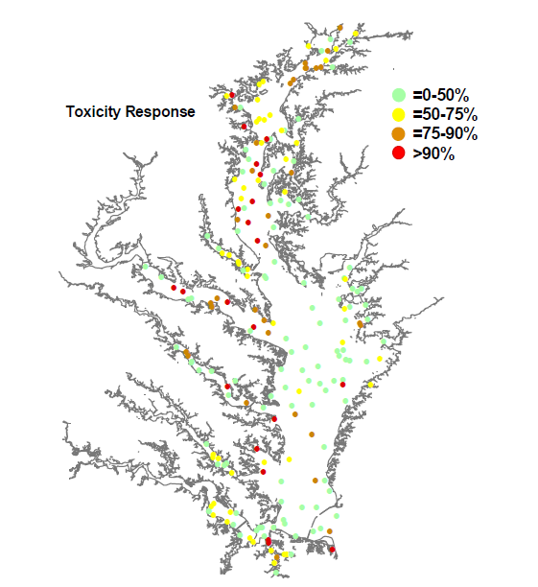
- Overview of biological impacts on fish (Vicki Blazer, USGS; Fred Pickney, FWS; and a representative from NOAA)
- Overview of impacts on wildlife (Barnett Rattner, USGS)
- Next Steps (Greg Allen and Scott Phillips)
            - Suggestions for improved monitoring and research
Focus on new and emerging contaminants – we know where and how the pesticides, PAHs, and PCBs are coming from.
Delaware suggests “additional research and assessment efforts … to better understand the response of aquatic systems to certain pollutants” (Delaware DNREC, 2010).
            - Possible discussion of existing or pending regulations and/or initiatives that would impact attainment of water quality standards (focused on a set number of pollutant classes?)
      - Considerations for developing federal-state toxic reduction strategies
Identify continuing sources of the big three toxics (PCBs, PAHs and pesticides) to develop strategies for reduction of continuous pollution
Delaware utilizes a “Whole Basin Management” strategy that includes 5 basins, including the Chesapeake Basin which began its management activities in 1997. This basin-wide approach includes monitoring, analysis, evaluation and strategies for resource protection (Delaware DNREC, 2010). Delaware is in the process of developing TMDLs for PCBs and other toxics.
New York – NYSDEC and the NYS Environmental Facilities Corporation have been working with local communities to identify funding to address water quality impacts, specifically those resulting from failed septic systems (NYSDEC, 2009).
DC – wetland and river habitat creation and restoration programs, low-impact development, other pollution abatement programs, and educational outreach (DDOE, 2010).

- Appendix of section: Progress toward Chesapeake 2000 Toxic Reduction Strategy (Greg Allen)

THINGS TO ADD/RESEARCH:
          - Finish the descriptions of general sources and impacts of each contaminant class/compound to be included at the beginning of each segment.
          - Things to highlight during jurisdictional summaries: effects of acid mine drainage, flue gas desulfurization at coal-powered plants, and mountaintop mining on surface water quality; also include the three focus areas discussed in the strategies (Elizabeth, Patapsco, Anacostia) within each jurisdiction.
          - Methodologies, compare and contrast general approaches across the jurisdictions. Specifically look at fish tissue sampling and impairment determinations.
          - Add a chart comparing water quality standards across the states, for the major bay contaminants. Do they differ?
          - White paper, “Pesticides in Chesapeake Waterways”

GENERAL QUESTIONS FOR STATE REPS/OTHER STAKEHOLDERS/ACTION TEAM:
          - Do we include data for freshwater impoundments (lakes, reservoirs) in this inventory of toxic contaminant impacts?
          - MD states that it generally sticks to chemical pollutants that result from anthropogenic sources, is this the same for other states?

QUESTIONS FOR MDNR:
          - Are all of the Streams and Rivers analyzed tributaries of the Chesapeake Bay, or are western watersheds and coastal watersheds included? If not, is there a summary section or data for just the Bay portions?
          - Are all of the estuary sizes given in square miles (Table 21, page 65 of 2010 report has no units)?

QUESTIONS FOR WV:
          - Do you have Bay watershed specific information?

Bibliography
Chesapeake Bay Program. (2012). The Chesapeake Bay Watershed. From Chesapeake Bay Program: Science, Restoration, and Partnership: http://www.chesapeakebay.net/discover/baywatershed
CWP for MDNR. (2006). A Users Guide to Watershed Planning in Maryland.
DDOE. (2010). The District of Columbia Water Quality Assessment.
Delaware DNREC. (2010). State of Delaware 2010 Combined Watershed Assessment Report 305(b) and Determination of the Clean Water Act Section 303(d) List of Waters Needing TMDLs.
Hartwell, S. a. (2007). Magnitude and Extent of Contaminated Sediment and Toxicity in Chesapeake Bay. NOAA Tehnical Memorandum NOS NCCOS 47. 234pp.
MDE and MD DNR. (2010). The 2010 Integrated Report of Surface Water Quality in Maryland. Annapolis: Maryland Department of the Environment and Maryland Department of Natural Resources.
NYSDEC. (2007). The 2004 Chemung River Basin Waterbody Inventory and Priority Waterbodies List.
NYSDEC. (2010). The Final New York State 2010 Section 303(d) List of Impaired Waters Requiring a TMDL/Other Strategy.
NYSDEC. (2009). The Susquehanna River Basin Waterbody Inventory and Priority Waterbodies List.
PA DEP. (2010). 2010 Pennsylvania Integrated Water Quality Monitoring and Assessment Report.
Susquehanna RBC. (2012). State of the Susquehanna. From The Susquehanna River Basin Commission homepage: http://www.srbc.net/stateofsusq/index.htm
US EPA. (2012). National Listing of Fish Advisories. Retrieved from http://water.epa.gov/scitech/swguidance/fishshellfish/fishadvisories/archive/2006_tech.cfm
VA DCR. (2012). Virginia Conservation Lands Database. Retrieved from Virginia Department of Conservation & Recreation: http://www.dcr.virginia.gov/land_conservation/tools02a.shtml
VA DEQ and DCR. (2010). Virginia Water Quality Assessment - 305(b)/303(d) Integrated Report. Richmond, VA: Virginia Department of Environmental Quality and Conservation and Recreation.
WV DEP. (2010). 2010 West Virginia Integrated Water Quality and Monitoring Assessment Report.

For the purposes of this report, the Chesapeake Bay “watershed” is defined as the waters of the Chesapeake Bay and the waters of the tributaries that supply it.
The 305 (b) report is the National Water Quality Inventory Report submitted to Congress by each state on a biennial basis.
The April 7th, 2000 oil spill resulted from a break in a Pepco pipeline; there are two segments that have yet to meet the Phase I or Phase II cleanup status: Craney Creek and Buena Vista.
Nutrients and sedimentation combine to form the largest impact on streams in the Basin.
Unknown sources of contamination reported by the jurisdictions in the 2010 Integrated Reports are included in this report because they have the potential to be classified as toxic contaminants upon further investigation.
Non-Chesapeake Bay waters in Delaware, specifically the Delaware Bay, are impaired by PCBs, Arsenic, Dioxins, Mercury, and Chlorinated Pesticides. (Delaware DNREC, 2010).

