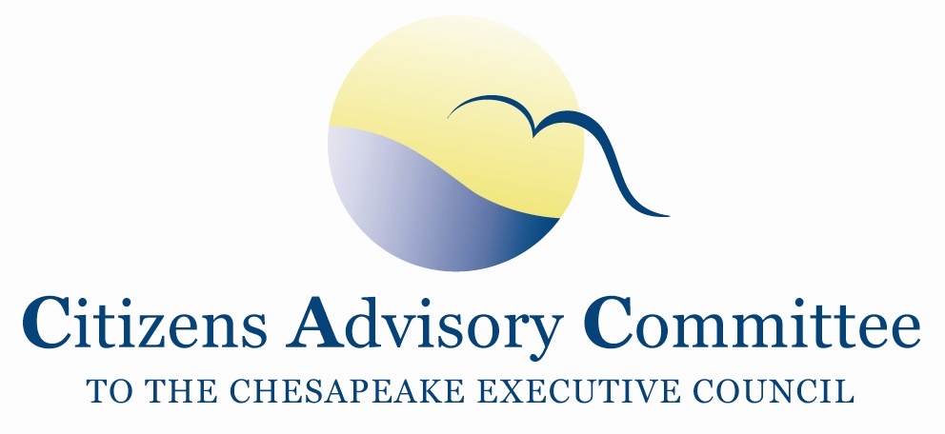
Citizens Advisory Committee
Meeting Agenda
February 17-18, 2016

_______________________________________________________________________________________________________________________________________

Courtyard Alexandria Pentagon South
4641 Kenmore Ave
Alexandria, VA 22304

Proposed Theme: Urban Restoration and Protection Efforts with a focus on Urban Tree Canopy
Goal: Understand the programs and players affecting change in urban environments
Potential Outcomes: Identify successes and challenges of urban restoration programs; methods of community engagement; needs/ideas for achieving the Watershed Agreement’s Urban Tree Canopy Goal; comment on incentivizing Urban Tree Canopy and its role as a BMP for water quality targets.

Wednesday, February 17- Capital Rooms I, II, III

11:00 a.m. Call to Order…………………………………………………………….…..Charlie Stek, Chair Welcome and Introductions of Members and Guests
Welcome New DC Appointments
Opening remarks about the theme

11:05 a.m. Opening Remarks: Chris Karakul, Federal City Council
Doug Siglin, Anacostia Waterfront Trust

12:00 p.m. Working Lunch
Jim Cummins, Director of Living Resources,
Interstate Commission on the Potomac River Basin

1:00 p.m. CAC Priority: Urban Tree Canopy
Julie Mawhorter, Mid-Atlantic Urban and Community Forestry Coordinator, Chesapeake Bay Program, U.S. Forest Service
Julie will provide an overview of how Urban Tree Canopy helps improve water quality, Urban Tree inclusion in the State/District Watershed Implementation Plans, an overview of the Urban Tree Management Strategy, and other updates.

Insights and Perspectives from Local Practitioners
The Honorable Mayor Jacqueline Goodall, Mayor Forest Heights, MD
Anne Little, Founder and President, Tree Fredericksburg

EJ Screen and Diversity across Agreement Outcomes, Jim Edward, EPA CBPO
Jim will preview an online tool the Diversity Action Team is piloting that shows EJ Screen with GIS overlays of demographic indicators and place-based Watershed Agreement Outcomes like, Urban Tree Canopy, Stewardship, Public Access and Toxic Containments.

2:45 p.m. Break

3:00 p.m. Virginia Report and Legislative Updates…………………………………….……Russ Baxter,
Deputy Secretary of Natural Resources for the Chesapeake Bay
- Basic progress report on Virginia’s clean-up
- How does this year’s legislation relate to Virginia’s Watershed Implementation Plan
- What is the process and plan to update overdue MS4 permits?

3:45 p.m. CAC Priority: Oysters as a BMP, continued discussion
- CAC Vice-Chair, Paula Jasinski and Executive Committee member, Christy Everett will lead a discussion on the Oyster BMP Expert Panel.
- Lucinda Power, Water Quality Goal Implementation Team Coordinator, will provide perspectives on process on behalf of the WQ GIT.

4:30 p.m. Trash Free Maryland programs and initiatives……………….Julie Lawson, CAC Member

5:00 p.m. Debrief and Committee Discussion

5:30 p.m. Meeting Recess

7:00 p.m. Dinner- on site: Capital Room IV
Members will engage in informal discussion about Bay Restoration and Protection issues.

Thursday, February 18- Capital Rooms I, II, III

8:30 a.m. Working Breakfast and Call to Order……………………………..Charlie Stek, CAC Chair

8:35 a.m. Business Meeting and CAC Member Updates
- Approval of November 2015 Meeting Minutes
- Preparation for NFWF grant discussion
- CAC Stewardship Subcommittee Chair Vacancy
- Membership and Diversity Discussion
- Member Updates

9:30 a.m. Chesapeake Bay Program Updates…………………………………...….………..Jim Edward,
Associate Director, EPA Chesapeake Bay Program
- Summary of Improvements EPA recommends for State BMP verification plans
- EPA Bay Program Budget Overview
- Review of Mid-Point Assessment and Two-Year Milestones calendar
- Potential topics for the March 2016 PSC meeting
- Draft Workplan Comment Period
- Release 2015 Bay Barometer progress report

10:30 a.m. Break

10:45 a.m. 2016 RFP for Small Watersheds and Innovative Nutrient and Sediment Reduction Grants
Jake Reilly, National Fish and Wildlife Foundation
Jake will provide an overview of the EPA Chesapeake Bay funds that NFWF administers for competitive grants, review NFWF priorities, and ask CAC members for guidance on the next round of grants and the review process.

11:30 a.m. Discussion, Action Items and Meeting Wrap-up

12:00 p.m. Adjourn

