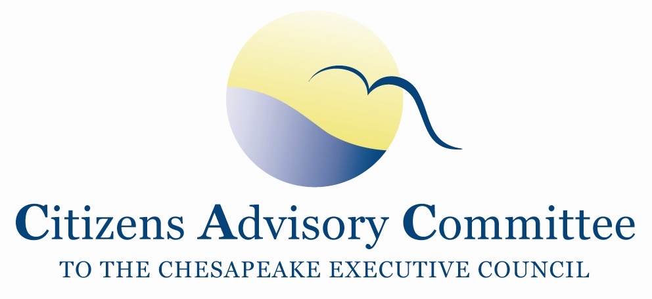
Citizens Advisory Committee
Meeting Agenda
February 22-23, 2018

______________________________________________________________________________________________________________________________________

Chesapeake Bay Program Office
410 Severn Ave
Fish Shack Conference Room
Suite 117
Annapolis, MD 21403

“We are each a river with a particular abiding character, but we show radically different aspects of our self
according to the territory through which we travel.”
― David Whyte

Meeting Goal: Learn updates on water quality, stewardship and diversity, and BMP verification to set CAC 2018 priority focuses for meetings and recommendations.

Thursday, February 22- Fish Shack

11:00 a.m. Call to Order………………………………………………………….…..Paula Jasinski, Chair
- Introduction of Members and Guests
- Opening Remarks about the meeting and objectives

11:15 a.m. Annapolis Environmental Priorities……………………...…..The Honorable Gavin Buckley,
Mayor of Annapolis
- Environmental vision and top priorities for the city of Annapolis​​
- Concerns or needs to meet those priorities
- Insights on climate change and adaptation and they influence the vision for Annapolis waterfront
- Thoughts on the potential relocation of around 175 federal and NGO workers if the EPA staff is removed from the Chesapeake Bay Program partnership office in Annapolis

11:45 a.m. Highlights of the Bay Barometer…………………………….…………..………Rachel Felver,
Director, Chesapeake Bay Program Communications Office,
Alliance for the Chesapeake Bay
12:00 p.m. Lunch

1:00 p.m. Citizen Monitoring Cooperative……………………………………..…...………Liz Chudoba,
Water Quality Program Manager, Alliance for the Chesapeake Bay

- Partnership with the goal to provide technical, logistical, and outreach support for the integration of citizen-based and non-traditional water quality and macroinvertebrate monitoring data into the Chesapeake Bay Program (CBP) partnership
- Upcoming Principals Staff Committee (PSC) decision for MOU with states to acknowledge the Quality Assurance Plan the Bay Program is using to accept citizen science data and encourage the states to use it for their policy making decisions

1:45 p.m. Updates from Chesapeake Bay Program……………………………...………….Jim Edward,
Acting Director, EPA Chesapeake Bay Program
- Decisions from the December Principals Staff Committee (PSC) Retreat
- Budget updates
- Briefing on Chesapeake Bay Accountability and Recovery Act funding submissions

2:30 p.m. Updates from EPA Region 3………………………………...Administrator Cosmo Servidio,
EPA Region 3 Administrator
- As the new Region 3 Administrator, what is your vision and approach to restoring and protecting the Chesapeake Bay Watershed?
- What are the near and mid-term plans for EPA Chesapeake Bay funding and staffing?
- What are your thoughts about the skills and talents for the open position of the EPA Bay Program Director?
- What are your insights on a proposed move of the EPA staff from the co-located federal and NGO partner campus in Annapolis?

3:15 p.m. Break

3:30 p.m. Discussion with Maryland Secretary of the Environment…………Secretary Ben Grumbles,
MD Department of the Environment
- Approaches for Phase III WIP local area planning goals
- Pros and Cons of Nutrient trading and a brief highlight of new trading regulations
- MD Bay Cabinet Priorities- Is environmental education among them?
- Thoughts on the potential re-location of EPA staff from the Chesapeake Bay program partnership campus?
- Thoughts on the federal funding cut of the Bay Journal

4:15 p.m. Diversity, Equity and Inclusion Updates and Discussion
- Updates from Choose Clean Water Coalition……………Chante Coleman, CAC Member
Executive Director, Choose Clean Water Coalition

- Updates from the Bay Program Diversity Workgroup…………………….….Darius Stanton
Diversity Workgroup Coordinator, Chesapeake Bay Program

5:00 p.m. CAC Discussion: Reflections and Debrief from the day’s meeting

5:15 p.m. Recess / Check-in at Annapolis Waterfront Hotel

7:00 p.m. Dinner- Blackwall Hitch
Members continue to discuss local river and Chesapeake Bay issues in an informal setting

Annapolis Waterfront Hotel
800 Compromise Street
Annapolis, MD 21401

Friday, February 23- Arnold Meeting Room
Breakfast will be served in the meeting room starting at 8:00am.

8:30 a.m. Working Breakfast
Call to Order…………………………………………………….…….…..Paula Jasinski, Chair
Business Meeting
- Approve November 2017 Meeting Minutes
- Announcements
- CAC Member Updates

9:00 a.m. Updates on BMP Verification…………………………………….………………..Rich Batiuk,
Associate Director for Science, EPA Chesapeake Bay Program
- Overview of BMP Verification Framework and protocols
- State submissions and EPA comments on their verification plans
- Discussion on Clean Water Act legality of using in-water practices for pollution reduction

9:45 a.m. Oyster BMP Expert Panel Update…………………………………………….…Ward Slacum,
Oyster BMP Expert Panel, Oyster Recovery Partnership
The Oyster Recovery Partnership is a 501(c)(3) non-profit that designs, promotes and implements consensus-based and scientifically-sustainable shellfish ecological restoration, aquaculture and commercial fishery activities to improve the environment and expand economic opportunities in the Chesapeake and Coastal Bays and beyond.

10:30 a.m. Break

10:40 a.m. CAC Subcommittee Break-out Sessions and Priority Setting
- 20 minute brainstorming sessions by subcommittees to list topics and priorities for 2018
- 5 minute reports by each subcommittee
- Majority voting by members for top priorities

11:30 a.m. CAC Discussion, Final Thoughts and Action Items
- What are the findings and action items from the discussion?
- How can CAC engage on these topics after the meeting?
- Ideas for May CAC meeting agenda

12:00 p.m. Adjourn
Next CAC Meeting is May 23-24, 2018 in Lancaster, PA
in conjunction with the Choose Clean Water Coalition Annual Conference.

