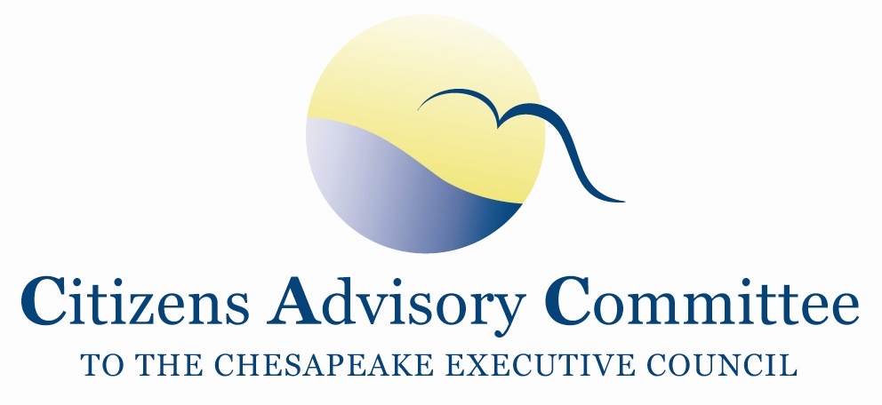
Citizens Advisory Committee
Draft Meeting Agenda
May 22-23, 2019

______________________________________________________________________________________________________________________________________

Baltimore Marriott Inner Harbor at Camden Yards
110 S. Eutaw Street
Baltimore, MD 21201

Meeting Goals:
- Outline topics for CAC’s Annual report to the Executive Council. Report due August 21, 2019.
- Learn about urban stormwater.

Wednesday, May 22- Stadium Ballroom Salon 1 (2nd Floor)

11:00 a.m. Call to Order………………………………………………………….…..Matt Ehrhart, Chair
- Introduction of Members and Guests
- Opening Remarks about the meeting

11:15 a.m. Discussion and Updates on Chesapeake Bay Program……………………….….Dana Aunkst
Director, EPA Chesapeake Bay Program
- CBPO Priorities
- Members to share recent CAC priority topics

12:00 p.m. Lunch with the Choose Clean Water Coalition
Conference Plenary- Diversity, Equity, Inclusion and Justice across the Chesapeake

1:15 p.m. Reflections on the Plenary Session

1:30 p.m. Briefing on the first BMP Verification Assessment…........................…………Lucinda Power
Implementation and Evaluation Team Leader, EPA CBP

2:15 p.m. Urban Stormwater 101…………………………………………. Andrew Der, CAC Member
- Urban Stormwater Management
- MS4s
- Forest Conservation
- Regulatory Compliance

2:45 p.m. Addressing Stormwater in Baltimore……………………………...…………….Jessie Hillman
Stormwater Program Manager, Blue Water Baltimore

3:30 p.m. Break

3:45 p.m. Conversation with PSC Chair Ben Grumbles
- High level briefing on Maryland’s Phase III WIPs
- PSC updates- signing of EC Directives
- Current thinking on Conowingo Dam

4:30 p.m. CAC Member Observations and Closing Remarks

5:00 p.m. Meeting Recess

6:30 p.m. Dinner
Members continue to discuss local river and Chesapeake Bay issues in an informal setting

Thursday, May 23- Stadium Ballroom Salon 1 (2nd Floor)
Breakfast buffet available in meeting room at 8:00am (Check out of the hotel before the meeting begins.)

8:15 a.m. Call to Order / Working Breakfast………………………..….…….…..Matt Ehrhart, Chair
- Subcommittee Break-out Sessions and Reports
- Approve February 2019 Meeting Minutes
- Review draft Code of Conduct and Guidelines
- CAC Member Updates and Announcements

9:15 a.m. Follow-up on 2018 CAC Recommendations to the Executive Council
Learn status of actions, where there is no action and why, offer solutions/ideas to roadblocks
Conversation with Sally Claggett, US Forest Service Liaison, CBP
Forest Buffers
- included in Phase III WIPs as co-benefits;
- technical assistance and education on multi-functional riparian buffers on ag lands, like nuts and fruit trees;
- Communication strategy on cost savings in protecting drinking water
- reformulation of Section 319 Clean Water Act Grants programs and State Revolving Loan Funds for forest buffers on non-ag lands;
- Simplification of web access and process for landowners on state websites for CREP and Wetlands Reserve
Environmental Education and Literacy:
- Updates on the June 27 Summit hosted by Pamela Northam, First Lady of VA
- Workforce development for living wage green careers

10:00 a.m. Draft Topics for the proposed Sept 2019 Executive Council Meeting……...….Rachel Felver
Alliance for the Chesapeake Bay
Communications Director, Chesapeake Bay Program partnership
10:30 a.m. Break

10:45 am Discussion on topics for CAC recommendations to the Executive Council

11:45 a.m. CAC Discussion, Final Thoughts and Action Items
- Review Action Items and Next Steps
- Ideas for September 2019 CAC meeting agenda in Pennsylvania

12:00 p.m. Adjourn

Remaining 2019 CAC Meeting Dates:
September 18-19 in PA; November 21-22 in DC

