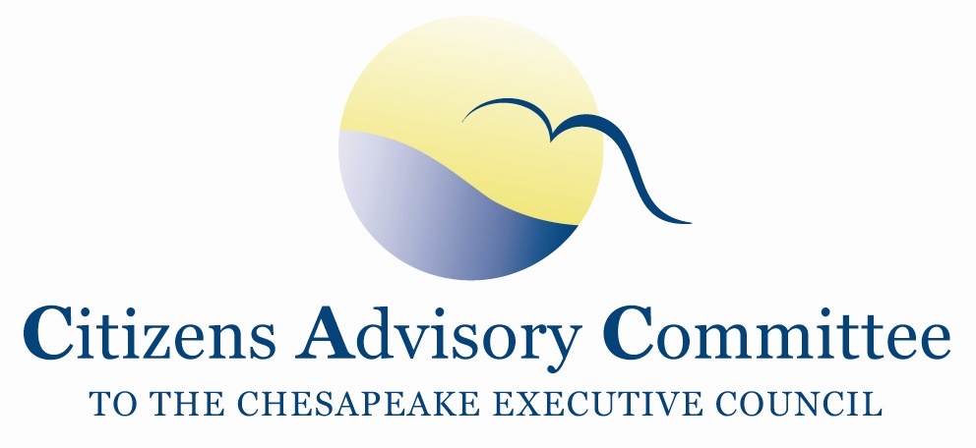
Citizens Advisory Committee
Draft Meeting Agenda
November 29-30, 2018

______________________________________________________________________________________________________________________________________

Monique Johnson Pumphouse
Earth Conservation Corps
1520 First Street, SE
Washington, DC 20003

2018 Year of the Anacostia River:
“A yearlong invitation to honor history, celebrate progress, and enjoy the Anacostia River and its surroundings as we envision an inspiring future”

Meeting Theme:
A Tale of Two Cities: How the use and restoration of the Anacostia River divide or unify communities with each other and with nature.

Thursday, November 29- Pumphouse Meeting Room

11:00 a.m. Call to Order………………………………………………………….…..Paula Jasinski, Chair
- Introduction of Members and Guests
- Brief Member Announcements

11:10 a.m. Opening Remarks by the CAC DC Delegation

11:20 a.m. The Story of the Anacostia River………………….…………………….……….Krista Schlyer
Conservation Photographer and Writer

12:00 p.m. Lunch

12:45 p.m. Welcome from the Earth Conservation Corps………………………….….Tommy Lawrence
Managing Director, Earth Conservation Corps
Rodney Stotts, Falconer,
Raptor Program Coordinator, Earth Conservation Corps

1:30 p.m. Updates on the District’s Watershed Implementation Plan……….……...…Katherine Antos
Chief, Partnering and Environmental Conservation Branch, DOEE

2:15 p.m. DC Water Clean Rivers Project…………………….……………...……David Gadis, (invited)
General Manger and CEO, DC Water
2:45 p.m. Break

3:00 p.m. Equitable Development in DC………………………………………………….Vaughn Perry
Equitable Development Manager, 11th Street Bridge Park
- Initiatives to reduce displacement of established residents

4:00 p.m. Chesapeake Bay Program Updates………………………………………….....…..Jim Edward
Acting Director, EPA Chesapeake Bay Program Office
4:45 p.m. Discussion

5:00 p.m. Meeting Recess / Check-in at Residence Inn Marriott

6:30 p.m. Dinner- Blue Jacket
Members continue to discuss local river and Chesapeake Bay issues in an informal setting

Friday, November 30- Pumphouse Meeting Room

Hot breakfast served at the hotel for overnight guests starting at 6:30am.
Check out of the hotel before the meeting begins.

8:45 a.m. Call to Order / Working Breakfast………………………..….…….…..Paula Jasinski, Chair
- Approve September 2018 Meeting Minutes
- CAC Officer Elections
- Reflections on the previous day
- Updates from Members

9:30 a.m. Panel Discussion on the Conowingo Dam
Betsy Nicholas, Executive Director, Waterkeepers Chesapeake
Ted Evgeniadis, Lower Susquehanna Riverkeeper
Nicki Kasi, PA DEP Co-Chair, Conowingo WIP Steering Committee
Beth McGee, Chesapeake Bay Foundation

10:45 a.m. Break

11:00 a.m. CAC Discussion, Final Thoughts and Action Items
- CAC Member Updates
- What are the findings and action items from the discussion?
- How can CAC engage on these topics after the meeting?
- Ideas for February 2019 CAC meeting agenda

12:00 p.m. Adjourn

2019 CAC Meeting Dates:
February 20-21 in VA
May 22-23 in Baltimore
September 18-19 in PA
November 21-22 in DC

