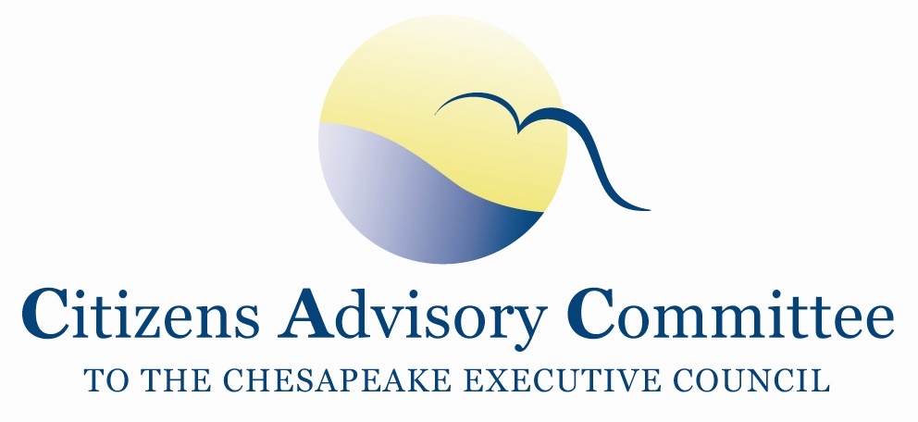
Citizens Advisory Committee
Meeting Agenda
May 18-19, 2016

_______________________________________________________________________________________________________________________________________

Chesapeake Bay Foundation
The Brock Environmental Center
3663 Marlin Bay Drive
Virginia Beach, VA 23455

Theme:
CAC Priorities of Environmental Literacy and Citizen Stewardship

Meeting Goals:
(1) Learn of the progress and opportunities for advancing environmental literacy and citizen stewardship goals from a watershed wide effort of decision makers and examples of local programs.
(2) Identify potential points of CAC Annual Recommendations to the Executive Council for their annual meeting and identify related informational needs for September 7-8, 2016 CAC Meeting.

Wednesday, May 18- Oyster Room

10:00 a.m. Call to Order…………………………………………………………….…..Charlie Stek, Chair Welcome and Introductions of Members and Guests
- Welcome new DC CAC Member, Joanna Lewis
- Welcome new CAC Assistant, Jennifer Starr
- Opening remarks about the meeting theme and objectives

CAC Priority: Stewardship Goal
Context: Chesapeake Bay Watershed Agreement Stewardship Goal: Increase the number and diversity of local citizen stewards and local governments that actively support and carry out the conservation and restoration activities that achieve healthy local streams, rivers, and a vibrant Chesapeake Bay.

10:15 a.m. Chesapeake Bay Citizen Stewardship Index………………….. Steve Raabe, Opinion Works
- The Fostering Stewardship Goal Implementation Team (GIT) received funding to develop a citizen stewardship indicator that will measure and track over time individual decision-making that impacts water health.
- Opinion Works is the contractor who developed a phone survey that measures individual behaviors; the likelihood to change behaviors; and the behaviors most susceptible to change.
- The presentation will share the results of the pilot survey.

11:00 a.m. CAC Discussion
- CAC’s role and orientation to CAC operations
- Quick Review of CAC’s Past Year of Action Items

Local Orientation and Meeting Context
11:30 a.m. Orientation to Local Area and Meeting Context...……….….Christy Everett, CAC Member
Chesapeake Ecological Atlas……………………….………..….Paula Jasinski, CAC Member

Working Lunch: Snapshot of Local Organizations
12:00 p.m. Elizabeth River Project, Joe Rieger, Senior Scientist and Deputy Director of Restoration
Lynnhaven River NOW, Laurie Sorabella, Oyster Scientist

CAC Priority: Environmental Literacy
Context: Chesapeake Bay Watershed Agreement Environmental Literacy Goal: Enable students in the region to graduate with the knowledge and skills to act responsibly to protect and restore their local watershed.

1:15 p.m. Watershed Approach
Shannon Sprague, Environmental Literacy Manager, NOAA Chesapeake Bay Office
Findings of the April 20, 2016 Meeting of the Bay Watershed State Environmental Education Cabinet Members and representatives from the U.S. Department of Education. The meeting was held to:
- Explore how states can assist local education agencies in creating and sustaining high-quality environmental literacy programming as a part of their ongoing education reforms and to meet commitments under the 2014 Chesapeake Bay Watershed Agreement
- Examine opportunities provided by the environmental education provision of the recently enacted Every Student Succeeds Act to support state and local environmental literacy programming.

1:35 p.m. Example of a Local Approach
Dr. Aaron Spence, Superintendent, Virginia Beach City Public Schools
Highlights of Virginia Beach’s model program
- What are they doing now?
- Why are they doing it?
- How can it be replicated?
- What is the role of the VA No Child Left Inside Coalition?

2:00 p.m. Guest Speakers and CAC Member Discussion
What are the critical components for a successful Environmental Literacy program?
What is needed?
What are the opportunities for the No Child Left Inside Coalition?

An Example of a Federal Role in Watershed Restoration
2:40 p.m. Department of Defense Commitment to Chesapeake Bay Restoration………....Sarah Diebel
U.S. Navy, Chesapeake Bay Coordinator
Discussion of DoD led restoration projects on military installations

Educational Boat Trip
3:15 p.m. Break and Gather at the Dock

3:30 p.m. Guest Speaker and Tour Guide:
Chris Moore, Hampton Roads Senior Scientist, Chesapeake Bay Foundation
- Local Water Quality Conditions
- Fish Trawl
- Oyster Restoration
- Oyster Aquaculture

6:30 p.m. Return from Boat Trip and Tour of the Brock Center

Reception and Dinner

7:00 p.m. Chesapeake Bay Foundation Deck
Members will engage in informal discussion about Bay and River Restoration and Protection.

Thursday, May 19- Oyster Room
Breakfast will be available in the meeting room starting at 8:15am

Working Breakfast
8:45 a.m. Call to Order……………………………………………………….....Charlie Stek, CAC Chair
- Debrief Discussion
- CAC Member Updates

Chesapeake Bay Program
The Chesapeake Bay Program is a regional partnership that leads and directs Chesapeake Bay Restoration and protection. Bay Program Partners include federal and state agencies, local governments, and non-profit organizations and academic institutions.
9:15 a.m. Chesapeake Bay Program Updates…………………………………...….………..Jim Edward,
Deputy Director, EPA Chesapeake Bay Program
- Elements of the Chesapeake Bay Accountability and Recovery Act
  - Budget Recording
  - Independent Evaluator
- Brief review of the Environmental Finance Symposium
- Brief Highlights of the Executive Order Progress Report
- Updates on the Mid Point Assessment
- Diversity Demographics Profile

CAC Business Meeting
10:15 a.m. Business and Critical Advisory Responsibility
- Approval of February 2016 Meeting Minutes
- Looking Ahead for CAC’s Annual Recommendations to the Executive Council
  - Brainstorm Three Points of Recommendations
  - CAC Agenda Items for September 7-8, 2016 Meeting in PA

Oyster BMP Policy and Communications
Context: As a result of the February 2016 CAC meeting, CAC sent a letter to Nick DiPasquale, the Management Board Chair, recommending the Bay Program determine how to address policy considerations that fall outside the purview of the scientific charge of the Expert Panel examining the use of Oysters as BMPs.

10:45 a.m. Process to Address BMP Policy Issues: A Conversation with the CBP Management Board
CAC will remotely join via web connect and conference phone to the Chesapeake Bay Program’s Management Board Meeting (already in progress) to learn and discuss how the Partnership can work to resolve related policy issues that emerge from the current 19 BMP Expert Panels or future Expert Panels.

11:25 a.m. Communications Discussion………………………………………..………….…Rachel Felver,
CBP Communications Director, Alliance for the Chesapeake Bay
Rachel will ask the CAC Members to share their insights and advice on elements for a communications product / factsheet to simply convey the results of the Oyster BMP Expert Panel.

Meeting Wrap-up
11:45 p.m. Final Thoughts and Review of Action Items

12:00 p.m. Adjourn
Upcoming Meetings:
Choose Clean Water Conference: May 24-25, 2016 Annapolis, MD
Bay Program Principals’ Staff Committee Quarterly Meeting: May 26, 2016, DC
Local Government Advisory Committee Forum and Quarterly Meeting: June 9-10, 2016 Gettysburg, PA
Fall CAC Quarterly Meeting: September 7-8, 2016, PA, location TBD
Annual Chesapeake Watershed Forum: September 30-October 2, 2016, Shepherdstown, WV

