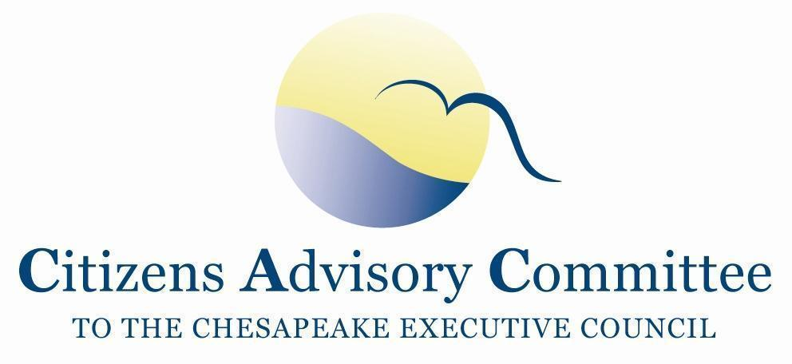
Citizens Advisory Committee
Meeting Agenda
May 19-20, 2021

______________________________________________________________________________________________________________________________________
Virtual Meeting
This meeting will be recorded for internal use to assure the accuracy of the meeting notes.

Meeting Goals:
- Explore how the CAC can be most effective in advising the Chesapeake Bay Program on outreach and engagement.
- Inform CAC members about policy issues where CAC may want to advise the Principals’ Staff Committee and Executive Council.

Background:
CAC’s primary mission is to serve as advisors to the leadership of the Chesapeake Bay Program. Traditionally CAC advice is in the form of letters to the Executive Council /Principals’ Staff Committee. This is an important function that should continue, especially as we near the 2025 Bay TMDL goal.

However, while CAC Members have identified the need for more targeted communications, outreach and engagement, CAC letters to elected and appointed officials alone may not be the most effective in advancing this need. This meeting is designed to explore if there are other ways CAC members can influence and advise on outreach and engagement. The scope will only focus on the Chesapeake Bay Program partnership, not the outreach efforts led individually by the federal, state, local governments, funders, or nonprofit organizations.

Meeting Objectives:
- Learn and discuss CBP’s capacity for and examples of communications, outreach and engagement.
- Learn and discuss CAC members’ case studies of outreach and engagement campaigns.
- Explore ideas in small groups on how CAC members can advise the CBP on outreach and engagement.
- Learn and discuss two key topics for the PSC: Climate Change and Financing the Conowingo WIP.

Wednesday, May 19: From Your Remote Office
11:00 a.m. Call to Order and Welcome…………………….…………….……….…..Julie Lawson, Chair
- Introduction of members and guests
- Opening remarks about meeting goal and objectives

11:10 am CAC Business Meeting
- Approval of February 2021 Meeting Minutes
- Chair Updates
  - CBP Diversity Workgroup GIT Funded Project: “Cultivating and Strengthening Relationships with Underrepresented Stakeholders”
  - DEIJ Action Team and updated timeline
  - CBP 2021 Biennial Strategy Review System meeting*
- Staff Updates
  - CAC Subcommittee Action Team Update
- CAC Member Announcements

11:30 a.m. Briefing and Background for the Afternoon’s Session on Outreach and Engagement
- Definitions and terminology debrief………………………...…. Daphne Pee, CAC Member
  - (communications, outreach, engagement, and stewardship)
- Description of CBP’s role………………….……………...……..…………Kristin Saunders
Cross Program Coordinator, CBP
University of Maryland Center for Environmental Science
  - Distinctions between CBPO Staff (# and roles) and CBP Partnership (#, % affiliations, roles)
  - CBP’s role in science support, information sharing, tracking and reporting, and collaboration

Noon Lunch Break

1:00 p.m. Stewardship and Social Science at CBP………………………………………… Britt Slattery
Coordinator, Fostering Chesapeake Stewardship
National Park Service
- Watershed Agreement Stewardship Goal and Outcomes
- About the CBP Stewardship Workgroup
Amy Handen,
Local Implementation Programs Coordinator, CBP EPA
- Draft Social Science Strategy
- Stewardship Index overview
- How behavior change concepts are used by the CBP

1:40 p.m. Outreach and Engagement with Local Decision-Makers ……..…….……Laura Cattell-Noll,
Coordinator, CBP Local Leadership Workgroup
Jennifer Starr
Coordinator, Local Government Advisory Committee
- Concepts and approaches to connecting with local audiences
- Local Government Advisory Committee’s interaction with the Local Leadership Workgroup

2:00 p.m. Examples of CBP Communications and Outreach

A Local Government Guide to the Chesapeake Bay...……………..…….....…Paula Jasinski,
President and Founder, Green Fin Studio
- Demonstration of the modules
- Module Distribution, Use and Impact

Fish Consumption Advisory………………………………………………...Caitlyn Johnstone,
Outreach and Communications Specialist, Chesapeake Bay Program
Rachel Felver
Communications Director, Chesapeake Bay Program
    - Communications Office role with CBP Goal Implementation Teams and the Advisory Committees
    - Fish Consumption Advisory Development
    - Advisory Distribution, Use and Impact

3:00 p.m. Break

3:15p.m. CAC Members’ ‘Lightning Round’ Case Studies
Each Member Address:
- What was your goal when you started reaching out to your audience?
- Who were your partners?
- What creative solutions did you use?
- Do you feel it was an overall successful campaign or were there obstacles that held it back?

4:00 p.m. Small Group Discussion with Presenters and Guests
Discussion Questions:
- What stood out to you in the examples and presentations?
- Do you see any of those examples that could be replicated or scaled up?
- What is a critical topic or message that should be communicated and to whom?
- What opportunities are there for CAC to advise on outreach and engagement?
- If CAC were to serve as a focus group for testing messages, what would the Committee need to effectively evaluate proposed messaging?

4:45 p.m. Highlights from the Group Discussion

5:15 p.m. Meeting Recess

Thursday, May 20: From Your Remote Office

1:00 p.m. Call to Order………………………………….….…………….……….…..Julie Lawson, Chair
- Reflections from CAC Members

1:30 p.m. Conversation with EPA…………..…………………...……….…..………………Diana Esher,
Acting Region 3 Administrator, EPA
- Status of hiring a new CBP Director and potential Bay Czar
- EPA's plan to help or intervene with jurisdictions falling behind in the Bay TMDL
- What happens if the 2025 water quality goals are not met?
- EPA's priorities for the Chesapeake Bay Watershed

Key Issues on the Principals’ Staff Committee (PSC) Agenda
2:00 p.m. Conversation with Virginia…………………………………………..…...……Ann Jennings,
Virginia Deputy Secretary of Natural Resources
- Overview of the draft EC Directive on Climate Change**

2:45 p.m. Break

3:00 p.m. Conowingo Watershed Implementation Plan*** Financing Strategy……….……. Dan Nees,
Center for Global Sustainability, University of MD
- Brief Background (Matt Ehrhart, CAC Member)
- Key elements of the financing strategy
- Reactions to EPA comments on the Conowingo WIP

To view previously recorded CAC meeting presentations as more background on the Conowingo WIP, please view the CAC December 2020 Meeting. The timestamps for the presentations are: 38:00 - Draft Conowingo WIP Strategy and 1:31:56 - Conowingo Dam: Stakeholders' Perspective.

3:45 p.m. Member Discussion, Action Items, and Closing Remarks

4:30 p.m. Adjourn

5:30 p.m. Optional Virtual Member Reception

Next CAC Meeting: Thursday, September 16 - Friday, September 17, 2021 (Location TBD)

Additional Briefing and Background:
*The CBP Management Board (MB) uses a Strategy Review System (SRS) to learn how to adaptively manage their approaches to reaching the outcomes in the 2014 Chesapeake Watershed Agreement. The Goal Implementation Team workgroups present their progress, lessons learned, barriers and challenges to the MB throughout a two-year cycle. This helps the workgroups to adjust their action plans. At the end of the two-year cycle, the MB reflect on the work and refine the process for the next two-year cycle.

**Executive Council Directives are action statements signed by the members of the Executive Council (EC) in between formal Chesapeake Watershed Agreements

***Each Bay Watershed State and DC have individual Watershed Implementation Plans (WIPs) that outline actions to meet their pollution targets allocated by the Bay TMDL. When the Bay TMDL was created in 2010 it was understood at the time that the hydro-electric Conowingo Dam in Maryland would continue to trap sediment and pollutants behind its dam wall, thereby essentially serving as a Best Management Practice (BMP). However, the sediment capacity trapping of the dam is full and when there are big rain events, the dam must open its water gates to release water and with it comes the sediment and pollution that flows into the Susquehanna River. The Chesapeake Bay Program’s Principals' Staff Committee (PSC) decided to create a separate WIP to address this additional Conowingo Dam pollution.

