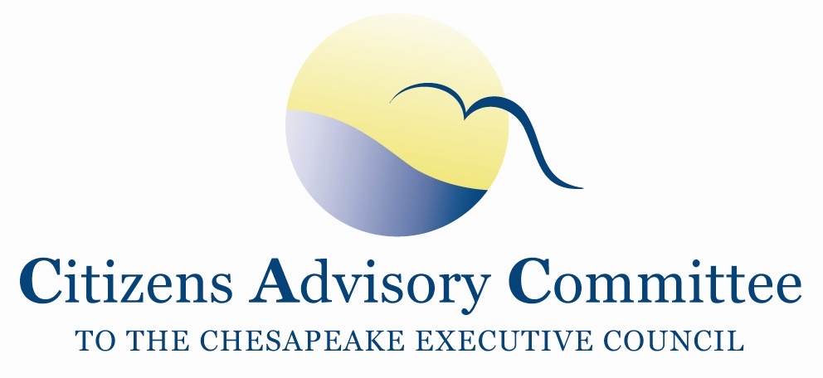
Citizens Advisory Committee
Meeting Agenda
May 21, 2020

______________________________________________________________________________________________________________________________________

Virtual Meeting

Meeting Goal: Offer suggestions to the CAC Executive Committee on annual recommendations to the Chesapeake Executive Council.

Thursday, May 21- From Your Remote Office

10:00 a.m. Call to Order and Welcome…………………….………………….…..Matt Ehrhart, Chair

10:10 a.m. Housekeeping, Engagement Rules and Roll Call

10:20 a.m. Chesapeake Bay Program Updates………………………….…………...………..Jim Edward,
Associate Director, EPA Chesapeake Bay Program
- COVID-19 Impacts on State Implementation
- State and Federal Agency draft Milestones Evaluations
- CBP Budget Updates
- DEIJ (Diversity, Equity, Inclusion and Justice) Statement

10:45 a.m. COVID-19 Impacts on the Bay Watershed……………………..………………Ann Swanson,
Executive Director, Chesapeake Bay Commission

11:30 a.m. Introduction to Public Health and the Environment………………………………Surili Patel
Director, Center for Climate, Health and Equity
American Public Health Association
12:00 p.m. Lunch Break

1:00 p.m. Business Meeting
- February Meeting Minutes
- Discussion on Notices of Intent to sue EPA
- Briefing on PSC Agenda and Executive Council Theme

1:35 p.m. Review of Past 3 Years of CAC Letters and Recommendations………….…Chuck Herrick,
CAC Stewardship Subcommittee Chair

1:50 p.m. Discussion on Topics for 2020 CAC Annual Report…………………..Matt Ehrhart, Chair

2:20 p.m. Closing Remarks and Next Steps

2:30 p.m. Adjourn
2020 CAC Meeting Dates:
September 17-18
December 3-4 in MD half day with LGAC

